

User Manual

Version:



**Kaltura Business Headquarters**

200 Park Avenue South, New York, NY. 10003, USA

Tel.: +1 800 871 5224



Copyright © 2012 Kaltura Inc. All Rights Reserved. Designated trademarks and brands are the property of their respective owners.

Use of this document constitutes acceptance of the Kaltura Terms of Use and Privacy Policy.

# Contents

Preface 11

About this Manual 11

Audience 11

Document Conventions 11

Related Documentation 12

Chapter 1 KMC Overview 13

What Can I Do with the KMC? 13

Media Management and Workflow 13

Widget and Application Studio 14

Getting Started 14

Chapter 2 Uploading and Ingestion 16

What is a Kaltura Entry? 16

Browser-based Ingestion 16

The Kaltura Uploader 16

The Upload Tab 16

Upload Media 17

Upload from Desktop 17

Record from a Webcam 18

Import from Web 18

Prepare Entry 19

Prepare Video/Audio Entry 19

Prepare Live Stream Entry 20

Creating Draft Entries 20

Key Benefits and Functionality 21

Hosting Videos at your Preferred Location and Linking to Kaltura 22

Replacing Video Assets for a Kaltura Entry 22

Uploading and Modifying Related Files 22

Bulk Upload and FTP Upload 23

What is Bulk Upload? 24

Entries XML Bulk Upload 24

Submit Bulk Options 25

Downloading Bulk File Samples 26

Automated Content Ingestion via a Drop Folder 26

Using a Drop Folder 26

Drop Folder Control Panel 26

The Dashboard Tab 28

Uploading Content Using the Content Tab 28

Tracking Your Uploads 28

Your Uploads 28

Bulk Upload Log 29

Chapter 3 Transcoding and Processing 31

Converting Videos into Multiple Flavors (Optimized Output Files) 31

Editing and Creating Transcoding Profiles 32

Adding a Transcoding Profile 33

Quick Publishing 34

Editing Options for Flavors in a Transcoding Profile 35

Assigning a Transcoding Profile to a Bulk Upload 36

Useful Tips for Working with Transcoding Profiles 36

The Flavors Tab 37

Add Video/Audio 38

Upload Files 39

Import Files 39

Link to Remote Storage 40

Match Files from Drop Folder 41

Replacing Media 41

Supported Source Formats 43

Supported Source Codecs 43

Target Formats/Codecs 44

Chapter 4 Creating and Customizing Playlists and Players 45

What is a Playlist? 45

Playlists Tab 45

Creating a Manual Playlist 45

Creating a Rule Based Playlist 47

Defining a Rule 47

Multiple Rules Based Playlist - Advanced Mode 48

Additional Playlist Configuration 51

Creating a Player with Multi-tab Playlists 51

Deleting a Playlist 52

Removing Videos from a Playlist 52

Customizing Additional Features for Playlists 52

Designing and Configuring a Player 53

Player List 53

Select the Type of Player 54

Configuring the Player Basics Settings 54

Editing a Player 54

Adding Content to a Player 55

Duplicating a Player 55

Deleting a Player 56

508-Compliant Video Player 56

Configuring the Player Advertising Settings 57

Configuring the Player Features 57

Features List 58

Configuring the Player Style 66

Chapter 5 Managing Metadata 67

Entry Metadata 67

Types of Metadata 67

Metadata Actions 67

Uploading Content and Setting Metadata 68

Upload a Media File and Set Its Metadata 68

Ingest a Media File Bundled with Metadata (CSV, XML, API) 69

Prepare a Metadata-only "Draft" Entry for Future Ingestion of Media Files 69

Metadata and Related Files 70

Kaltura Custom Metadata Functionality 70

Managing Schemas 72

Adding a Schema 72

Adding Custom Data Fields 72

Setting Values for Custom Metadata Fields - Per Entry 74

Setting Values for Metadata Fields - Per Category 76

Related Videos Gallery 77

Related Videos Source 78

Configure Autoplay for Related Videos 78

Chapter 6 Locating Content in the KMC 80

Searching Through Entries 80

Filtering Content in the Entries Table 80

Using Categories as Filters 80

Using Additional Filters 81

Performing a Search Based on Metadata Fields 82

Entries Table Filter Indications 83

Searching Through Categories 83

Filtering Categories in the Categories Table 83

Using Categories as Filters 83

Using Additional Filters 85

Categories Table Filter Indications 85

Searching Playlists 85

Chapter 7 Managing Access Control Profiles 86

Access Control Profiles 86

Creating an Access Profile 87

Editing an Access Profile 88

Restricting Domains 89

Restricting Countries for Viewing 90

Restricting Views by IP Address 91

Restricting Views with a Kaltura Session 92

Pay-Per-View 93

Assigning an Access Control Profile to an Entry 93

Assigning an Access Profile to a Bulk Upload 93

Content Scheduling 94

Chapter 8 Managing Content Entitlement 95

Kaltura’s Entitlement Model 95

Category’s Entitlements Tab 95

Setting the Entitlement Settings 96

Content Privacy 97

Visibility of Content Associated with Multiple Categories 98

Visibility of Content in Outside of the Application 98

Category Listing 99

Contribution Policy 99

Specific End-User Permissions 99

Managing Categories Specific End-User Permissions 100

Bulk Actions for Managing Categories Specific End-User Permissions 101

Additional Category Entitlement Settings 102

Chapter 9 Managing Categories 104

Defining and Assigning Entry Categories 104

Categories Table 104

Adding/Editing a Specific Category 104

Adding Metadata to a Category 106

Editing the Entitlement Settings of a Category 107

Reordering Sub Categories 108

Editing Multiple Categories in Bulk 109

Add Tags to Categories 110

Remove Tags from Categories 111

Move Categories 111

Change Content Privacy 112

Change Contribution Policy 113

Change Category Listing 114

Change Category Owner 114

Delete Categories 115

Updating Categories’ State 115

Chapter 10 KMC Users and Roles 117

Roles and Permissions 117

Adding a User 117

Editing a User 118

Deleting and Blocking Users 118

Purchasing a License for Additional Users 119

Creating Custom Roles 119

Role Management 120

Chapter 11 Moderation and Editorial Workflows 122

Content Moderation Workflows 122

The Moderation Tab 122

Previewing Content using the Moderation Tab 123

Rejecting Content using the Moderation Tab 123

Chapter 12 Using Subtitles and Captions 125

Caption File Types 125

Searching within Captions 125

Subtitles and Captions Terminology 125

Adding Captions to an Entry 126

Editing a Captions File 127

Setting Up Captions for Display 127

Viewing an Entry with Captions in a Player 128

Captions Options 130

Chapter 13 Live Streaming 131

Live Streaming Using the KMC 131

Workflow for Setting up Live Streaming 131

Setting up the Hardware and Software 131

Creating a Live Streaming Entry in the KMC 132

Multiple Bitrate Encoding 133

Configuring the Live Stream Parameters in the KMC 134

Setting up the Broadcasting Computer 135

Viewing the Broadcasting Setup (Optional) 136

Advanced Live Streaming Configuration Options 137

Chapter 14 Content Authoring Tools 139

The Content Tab 139

Entries Tab 139

Entries Table 139

Set Scheduling 140

Set Access Control 141

Edit - Add Tags to and Entry 142

Edit - Remove Tags from an Entry 142

Edit - Add Categories 143

Edit - Remove Categories 144

Add to New Category 145

Add to New Playlist 145

Change Entry Owner 145

Download Files 146

Delete Multiple Entries 146

Preview and Embed 147

Editing Entries 147

Edit Entry Tabs 148

Clipping and Trimming Media Files 149

Troubleshooting Trimming and Clipping 151

Users Tab 151

Choosing a Thumbnail for your Video 152

Chapter 15 Publishing to your Site 154

Embedding a Player with a Single Entry on your Site 154

Embedding a Player with a Playlist on your Site 155

Video Delivery Settings 157

HTTP Progressive Download Delivery 157

Adaptive Streaming RTMP Delivery with Adaptive Bitrate 158

Secure Transport RTMPE 159

Akamai HD Network – Allows adaptive bit-rate 160

Adding the Flavor Selector Module 160

Mobile Support 161

Chapter 16 Distribution and Syndication 162

Kaltura Distribution Module 162

Key Benefits: 162

How Does Distribution Work? 163

Adding a Distributor to an Entry 164

Scheduling a Video Package 165

Validating a Video Package 167

Removing a Distributor from a Video Package 171

Managing Distributor Details 172

Content Syndication 172

How Does Syndication Work? 173

Syndicating to a Standard MRSS Feed (Yahoo) 173

Search Engine Optimization (SEO) 174

Key benefits 174

Setting Up Syndication 174

Syndicating to Google 175

Google Webmaster Tasks 175

KMC Publisher Tasks for Google Syndication 176

Syndicating to TubeMogul 178

KMC Publisher Tasks for TubeMogul Syndication 178

TubeMogul Webmaster Tasks 180

Syndicating to iTunes 180

KMC Publisher Tasks for iTunes Syndication 180

Syndicating to Yahoo 182

KMC Publisher Tasks for Yahoo Syndication 183

Yahoo Webmaster Tasks 183

Flexible Feed Format 185

Chapter 17 Advertising and Ad Networks 186

Player Branding 186

Connecting with an Ad Server 186

Kaltura Player and Ad Plugins 186

Supported Ad Servers 187

Ad Terminology 187

Creating Kaltura Video Ads 187

Adding the VAST Ad Server 187

Configuring VAST Ads 187

Configuring VAST Pre-roll Ads 188

Configuring VAST Post Rolls 189

Adding a Midroll 190

Adding an Overlay 192

Creating Bumper Ads 193

Configuring Third Party Ad Plugins 195

Tremor Media 195

Tremor Media Added Functionality 196

AdapTV 198

Configuring Companion Ads 199

Companion Ads in HTML 200

Companion Ads in Flash 201

Targeting with an Ad Server 204

Targeting per Viewer 205

Ad Targeting via ad plugin 206

Ad Targeting with Tremor 206

Advertising for Mobile Devices 207

DFP 207

AdapTV (via VAST) 208

Connecting with Ad Servers and Networks via Adap.tv 209

Connecting with Tremor Media 211

Different Types of Ad Servers 212

Kaltura Player Additions Related to Ads 212

Troubleshooting 212

Chapter 18 Creating and Tracking Analytics 215

Content Reports 215

Top Content Reports 215

Specific Entry Report 217

Content Drop-off Reports 218

Specific Entry Content Drop-off Reports 219

Content Interactions Reports 220

Specific Content Interactions Report 221

Content Contributions Reports 222

Specific Entry Media Source Contributions Report 223

User and Community Reports 224

Top Contributors Report 225

Geographic Distribution Reports 225

Specific Geographic Region Distribution Reports 226

Top Syndications 227

Specific Syndicator Reports 228

User Engagement Reports 228

Specific User Engagement Report 229

Bandwidth Usage Reports 230

Publisher Bandwidth and Storage Report 230

End Users Storage Report 231

Storage Report for a Specific User 232

Date Ranges for Analytical Reports 233

Exporting Analytics to a CSV File 234

Sending Analytics Events to Third Parties 234

Kaltura Player Supported Plug-ins 234

.Chapter 19 Account Information 235

Account Settings 235

Integration Settings 236

Account Info 236

Entitlement Settings 237

Notifications 238

Access Control 240

Transcoding Settings 240

Custom Data 240

My User Settings 240

Account Upgrade 240

# Preface

|  |
| --- |
| This preface contains the following topics:   * About this Manual * Audience * Document Conventions * Related Documentation |

## About this Manual

This document provides an in-depth description of the KMC basic concepts and usage.

|  |  |
| --- | --- |
|  | NOTE: Please refer to the official and latest product release notes for last-minute updates  Technical support may be obtained directly from: [Kaltura Support](mailto:partnersupport@kaltura.com). |

Contact Us:

Please send your documentation-related comments and feedback or report mistakes to the [Knowledge Management Feedback group.](mailto:Knowledge@kaltura.com)

We are committed to improving our documentation and your feedback is important to us.

## Audience

This guide is primarily intended for content managers and Kaltura Management Console users and also contains useful information for developers, integrators, and operations and site administrators using the Kaltura platform.

## Document Conventions

Kaltura uses the following admonitions:

* Note
* Workflow

|  |  |
| --- | --- |
|  | NOTE: |

|  |  |
| --- | --- |
|  | Workflow: Provides workflow information |

## Related Documentation

In addition to this guide, product documentation is available on the [Kaltura Knowledge Center.](http://knowledge.kaltura.com/page/kaltura-products-and-services-documentation)

Chapter

# KMC Overview

The Kaltura Management Console (KMC) is a media asset management front-end application to the Kaltura Platform. The KMC provides publishers all the tools necessary to manage and publish their media assets, in one intuitive interface.

## **What Can I Do with the KMC?**

You can:

* Upload content and perform bulk ingestion
* Transcode and manipulate media assets
* Manage metadata profiles and high-precision temporal-metadata
* Design and customize branded media players
* Control and manage end-user entitlements to content in applications such as Kaltura MediaSpace
* Create static and dynamic rule-based playlists
* View analytics and gain insights about how well your content is performing
* Configure live streaming web broadcasts
* Syndicate and distribute content across the web
* Configure ads and leverage ad networks
* Manage access control profiles and limit access to published media
* Manage your Kaltura account settings
* Create Kaltura users, roles and assign permissions

and more…

## Media Management and Workflow

The KMC provides full media management so that you can organize and track your online video system, functions and rich-media content. The following presents a simple workflow to manage content.

* Uploading and Ingestion- upload and ingest video, audio, images and docs, bulk or individual file uploads, via browser, desktop applications, email or mobile.
* Transcoding and Processing **–**convert videos into multiple flavors (optimized output files) and create transcoding profiles to ensure optimal viewing experience on all devices.
* Creating and Customizing Players and Playlists **-** control player size, color, fonts and branding. Add or remove buttons, enable subtitles, sharing, and more. Create manually or dynamically generated playlists.
* Managing Metadata and Categories **-** leverage metadata fields to tag, manage, search and expose content. Populate out-of-the-box fields, or create your own custom metadata schema. Create content packages, including a set of video transcodes, multiple thumbnails in different sizes, metadata, subtitles, scheduling data, and more.
* Locating Content in the KMC - use categories, tags, and any of your custom metadata fields to locate any file, or search caption files for phrases [within the video](http://corp.kaltura.com/products/Features/Video-Management).
* Managing Access Control Profiles  **-** control exactly when and where your content is published; **decide who can do what within the KMC.**
* Configuring KMC Users and Roles **- use out-of-the-box roles and permissions or create your own custom roles with granular permissions.**
* Managing Content Entitlement - -control and manage end-user entitlements to content in applications such as Kaltura MediaSpace.
* Managing Categories - provide a logical structure for your site and assist with content management.
* Moderation and Editorial Workflows- [review content](http://corp.kaltura.com/products/Features/Video-Management) to eliminate spam and abusive content in UGC portals. Implement complex editorial workflows for your various team roles.
* Using Subtitles and Captions - upload multiple caption files (SRT, XML) and transcripts (TXT), or reference an external link. Viewers can toggle between different language captions.
* Live Streaming- schedule and [broadcast live events](http://corp.kaltura.com/Products/Features/Video-Publishing). Includes all the features of on-demand video.
* Content Authoring Tools **-**trim videos, string videos or clips together, add subtitles and cue points.
* Publishing to your Site **-** manage content, create playlists, preview and [embed to your sites](http://blog.kaltura.org/best-practice-js-kdp-embed-recipe). Provide the optimal viewing experience across all devices with seamless mobile and tablet support.
* Distribution and Syndication **-**distribute content to your channels on partner sites such as YouTube, Hulu, and DailyMotion, or create video feeds for third-party platforms such as Google, Yahoo! and iTunes.
* Advertising and Ad Networks **-**advertise, integrate with ad networks, and enable payment models.
* Creating and Tracking Analytics - get the insight you need on viewer behavior with built-in reports.
* Account Information- **modify user information, integration settings and registration information**

## Widget and Application Studio

Kaltura’s application studio enables you to configure your player instances. The application studio is accessed through the KMC **Studio** tab. \

* Player designs - design your player skin - select the size, color, fonts, etc.
* Player branding - include your logo on the player as a watermark.
* Player functionality and added features - decide what buttons to display on the player, create your own custom buttons, and decide what features to enable as part of playback (for example, subtitles, sharing, etc.)
* Player templates - select pre-defined player templates, or create your own.

## Getting Started

* To login to the KMC

1. Go to the Kaltura Management Console (KMC) at: <http://www.kaltura.com/index.php/kmc>.
2. Log-in with the credentials you received in the “Kaltura Registration Confirmation” email.

The KMC Dashboard is displayed.

Chapter

# Uploading and Ingestion

This section describes the uploading and ingestion process.

## What is a Kaltura Entry?

A Kaltura Entry is a logical reference to your media asset. An entry encapsulates all physical media files generated during ingestion (source, “flavors” and thumbnails), standard and custom metadata, captions, scheduling settings, advertising cue points, specific access control settings and all other components relating to the content. An entry is generated immediately, and your source media file starts uploading and transcoding begins. For more information, see the Entries Table.

## **Browser-based Ingestion**

You can upload files from your computer, record a video with your webcam, or import from a selection of online repositories, or submit a bulk upload request via Kaltura formatted CSV/XML all from within the Kaltura Management Console. See The Upload Tab.

## **The Kaltura Uploader**

You can use the Kaltura Uploader, also known as the Kaltura Contributor Wizard (KCW) to upload any type of rich-media file, from any location (computer, websites, record from webcam).

You can upload content through the:

* Upload Tab
* Dashboard
* Content Tab

## The Upload Tab

The Upload tab presents a list of ingestion options and capabilities to choose from and is used to upload content to Kaltura. The Upload tab opens over any page within the KMC.

You can upload content using the following options:

* Upload Media
* Prepare Entry
* Submit Bulk

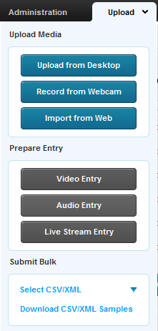

### Upload Media

* Upload from Desktop: Opens a file browser and allows you to select multiple files.
* Record from a Webcam: Allows you to capture video content from a webcam connected to your computer.
* Import from Web: Allows you to search for videos to ingest from video repositories such as Metacafe and others, depending on the feature set enabled in your account.

### Upload from Desktop

Use this option to quickly upload files. You can continue working on other tasks while files are uploading, and resume the file upload in case of connection failure.

* To upload media files from your desktop

1. Select the Upload tab.
2. Click Upload from Desktop (or click Upload from Desktop in the Dashboard.)
3. Select one or more media files. Use the Ctrl key to select multiple files.

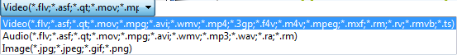

The Upload Settings window is displayed.

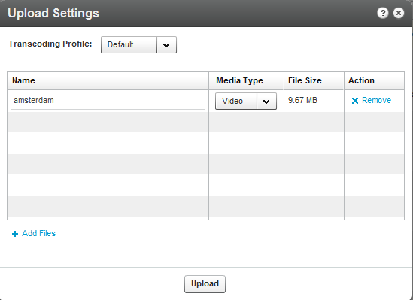

1. Select the Transcoding Profile. See Transcoding and Processing.
2. Modify the Media Type if needed. The media type is automatically detected from file name extension. The media types allowed are: video, audio or image.
3. Click Add Files. (Optional).
4. Click Upload.

### Record from a Webcam

You can upload media that you record from your webcam via the easy-to-use Kaltura Uploader.

* To upload media files recorded from a webcam

1. Select the Upload tab.
2. Click Record from Webcam.
3. Select the Transcoding Profile and click Next. See Transcoding and Processing.
4. Select a webcam from the dropdown list and click Allow.
5. Press Record to record your media file.
6. When done, click Next.
7. Enter a Name and all other relevant information for the webcam recording and click Next.

The recording is processed and added to the Entries table.

### Import from Web

You can import video, audio and photos from common online media websites and applications. The Metacafe option for importing videos, may address your needs if you are searching for specific content quickly and easily assuming you want to import videos that are hosted in Metacafe. The video’s properties (description, running time, brief summary, etc.) can be revealed by mousing over the thumbnail.

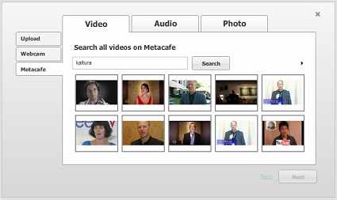

The audio options are Jamendo and CCMixter; the photo options are Flikr and NYPL.

* To import content from the web

1. Select the Upload tab.
2. Click Import from Web in the Upload tab.
3. Select the Transcoding Profile and click Next. See Transcoding and Processing.
4. Click Search to search through videos on Metacafe, or select the Audio or Photo tab and search through your data.
5. Select the content to upload and click Next.
6. Enter or modify the descriptive information and click Next.

### Prepare Entry

You can prepare a video entry without including the media content in advance. Creating a No Media entry may be useful when metadata settings and media perpetrations are managed separately and possibly by different operational teams This scenario is used for media that may be included at a later stage, for example, in a drop folder. See Using a Drop Folder.

The following options are available:

* Prepare Video Entry
* Prepare Audio Entry
* Prepare Live Stream Entry

### Prepare Video/Audio Entry

Use this option to prepare metadata and publishing settings for a video/audio entry before its related media files are ready for upload. This option enables a flexible entry preparation workflow and is especially useful when video files are:

* Transcoded by a local transcoder
* Processed while content editorial work is being done in the KMC
* Processed after content editorial work is completed in the KMC

|  |  |
| --- | --- |
|  | Preparing a Draft Entry Workflow:  Prepare a draft entry in the KMC and fill in its metadata and publishing settings. See Prepare a Metadata-only "Draft" Entry for Future Ingestion of Media Files.  Add the media source file or the locally generated Transcoding Flavors to the entry. Use the entry’s Flavors tab to add files or flavors. See The Flavors Tab. |

The ingestion status of an entry that you create with the **Prepare Video/Audio Entry** option automatically is set to No Media. The status remains **No Media** until one or more media files are added to the entry.

An entry that you create with the Prepare Video/Audio Entry option is saved as a Draft entry in the Kaltura system until you add content.

A Draft entry remains available in the **Content** tab Entries table for further editing.

### Prepare Live Stream Entry

Use the **Live Stream Entry** option to provision a live stream on the CDN. The live stream should be configured with your encoder IP address.

After the live stream is provisioned, you can set the entry metadata and specific broadcasting settings in the KMC's **Content** tab Entries tab.

For more information see Workflow for Setting up Live Streaming.

## Creating Draft Entries

Draft entries are entries created without actual content, and are used as a container for adding content.

|  |  |
| --- | --- |
|  | **Note:** You can add or attach content at a later time, by using the [BaseEntry->addContent](http://www.kaltura.com/api_v3/testmeDoc/index.php?service=baseentry&action=addcontent)  action and use one of the KalturaResource [resources](http://www.kaltura.com/api_v3/testmeDoc/index.php?object=KalturaResource). See [Kaltura API](http://www.kaltura.com/api_v3/testmeDoc/index.php?object=KalturaResource) documentation. |

* To create a Draft Entry

1. Select the Upload tab.
2. Select **Video Entry** or **Audio Entry**.
3. In the New Entry Window:

Name (required).

Description

Tags

Categories – use the pencil icon to select a category from the existing category list.

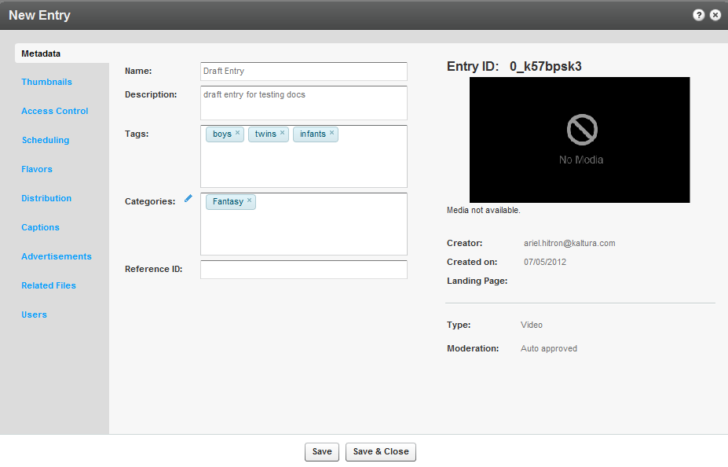

1. If you have Custom Data for entries, you can edit the Custom Data fields for the entry. For multiple schemas, use the drop down Jump To menu to select the schema for the entry. See Managing Schemas for more information.
2. Click Save and Close.

The ingestion status for a Draft entry is No Media. The following is an example of a Draft entry in the KMC.

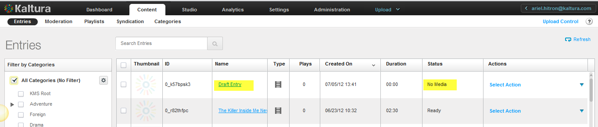

### Key Benefits and Functionality

You can control the order of ingestion, create a No Media entry with metadata and attach video later. You can prepare a Kaltura media entry and add the relevant media files after uploading content, to enable an efficient and fast paced content ingestion operation. You can create a new media entry in the KMC and set its metadata and publishing information beforehand, or in parallel, to the actual media processing. You can then add the related media files to the existing entry when ready. For more information see Metadata and Related Files.

You can use your own transcoders, and ingest the output flavors to Kaltura. See The Flavors Tab.

Publishers can ingest media assets/files that have already been transcoded locally into multiple flavors and then ingest the files into a Kaltura entry managed from the KMC. This is a Premium option that can be configured by your Account Manager. Ingestion can be done via uploading through the KMC UI, linking to an existing hosting site, submitting an XML with file links or using the Kaltura API.

### Hosting Videos at your Preferred Location and Linking to Kaltura

This use case is typically combined with transcoding performed on the publisher’s side, after which the output files are pushed directly to CDN hosting, or to a local intranet delivery source.

In this case, Kaltura essentially only manages the metadata while media files themselves are delivered directly from the publisher through a CDN to the viewer.

Linking between the files and a Kaltura entry can be done through the KMC, API, or drop folder XML ingestion. See Using a Drop Folder.

## Replacing Video Assets for a Kaltura Entry

Publishers can replace media files of an existing media entry when needed.

This feature:

* Is especially useful when media assets need to be re-edited by the publishers following ingestion to Kaltura.
* Enables seamless replacement of media even if media is already published/ syndicated/distributed – media is replaced in all published instances.
* Replaces all multiple-bitrate media assets flavors **in one transaction**.
* Allows review and approval of new media prior to the actual replacement.
* Is an integral part of the entry life-cycle and content management workflow

For more information see Replacing Media.

## Uploading and Modifying Related Files

You can attach files (documents, media) to your entries. Uploaded files will not create new entries but will receive a unique Kaltura Asset ID. Use the **Related Files** tab to upload files associated to entries. Related files are not stored with the entries on the Kaltura platform and are referenced using an Asset ID.

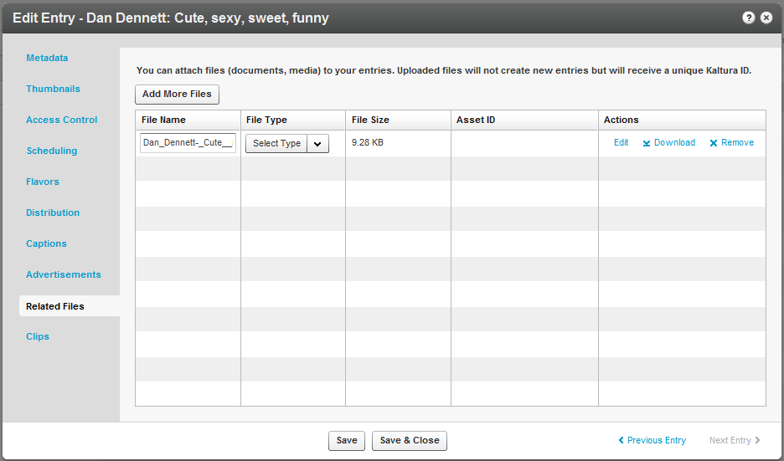

* To upload related files

1. Select the Content tab and click on an entry.
2. Select the Related Files tab and click Add More Files.
3. Select a file and click Open.
4. Select the File Type from the drop down menu.

The related file will immediately begin uploading. After the upload is complete, you can edit the file details (title, description), download the file, or remove it.

1. Click Save.

* To edit related files

1. Select the Content tab and click on an entry.
2. Select the Related Files tab.
3. Select a File and select Edit, Download, or Remove.

## Bulk Upload and FTP Upload

You can import multiple files per session via a simple comma separated file (CSV) or an XML file. With these options, you can also ingest files from your own FTP server, or any publicly accessible file’s host. Metadata fields can be populated from CSV/XML.

The CSV Bulk Upload file is a simple format. You can use the CSV format for simple content ingestion based on imported source media files and their related metadata. Each entry is added from a single line in the CSV file. Each line includes a path to a media file that will be uploaded and each uploaded media file creates an entry. We recommend a maximum of 500 lines/uploaded media files included within one CSV file.

The XML Bulk Upload file is based on Kaltura’s MRSS format schema for content ingestion. The XML format enables bulk ingestion of complex video or audio packages.

Complex packages may include:

* Multiple bit-rate Transcoding Flavors already transcoded by a local transcoder
* Multiple thumbnails
* Related metadata and publishing options

### What is Bulk Upload?

Bulk Upload enables you to ingest multiple entries and files to the Kaltura server in a single action using a single file. The greatest benefit for bulking uploads is:

* Importing multiple files in one action thus automating the ingestion process.
* Ingesting large files which you cannot upload from the desktop via the KMC (larger than 2GB).
* Populating metadata fields with no need to enter them from the KMC.

Bulk upload streamlines publishing, providing the basis for automated bulk ingestion of files and metadata and overcomes browser and client upload limitations allowing for larger file size ingestion.

There are two methods to upload bulk content: the simple method where you use a [CSV](http://en.wikipedia.org/wiki/Comma-separated_values) file (Comma Separated Value) and the advanced method where you use an [XML](http://en.wikipedia.org/wiki/XML) file, which has many extensive bulk upload features. You can customize the structure to the metadata and elements that are part of your account specific workflow. Using the XML file bulk upload is the recommended method due to its structured hierarchy, allowing for nested objects and metadata and is easily extended.

For information on how to download bulk file samples see Downloading Bulk File Samples.

### Entries XML Bulk Upload

XML Bulk Upload supports full CRUD (Create, Read, Update, and Delete) operations, allowing for ingestion of entries, updates to existing entries, and deletion of bulk entries using an XML format. XML Bulk Upload is the recommended bulk upload option.

In addition, XML supports a hierarchical structure while CSV does not. You can define a complete content package using the XML Bulk Upload feature that includes the video source file, its metadata, its custom metadata profiles, distribution profiles, set of transcoding flavors ( for cases when you are using your own transcoders), thumbnails and other additional relevant data.

The advantages of using XML Bulk Upload are:

* Simplified integration with other systems (for example, migrating media files including their complete metadata from one server to another).
* A streamlined ingestion mechanism, by using XML it is easy to create automated processes to ingest content.
* More comprehensive ingestion models that allow you to manipulate all of the media entry object attributes and their related objects (such as flavors, custom metadata, access control and distribution profiles, etc.).

The full sets of features supported by the XML Bulk Upload are described in the [XSD](http://www.kaltura.com/api_v3/xsdDoc/?type=bulkUploadXml.bulkUploadXML) (the XML template).

An example XML file can be found [here](http://www.kaltura.com/api_v3/xsdDoc/?type=bulkUploadXml.bulkUploadXML) (or downloaded from the KMC Upload tab).

The bulk upload status is monitored through the bulk upload log under the Uploads control tab, see Tracking Your Uploads. A log file and a copy of the CSV file are made available for troubleshooting or for historical records of uploaded content.

Whether you are a medium sized video publisher or if you're a media giant, you should consider the Bulk Upload option.

### Submit Bulk Options

Kaltura provides bulk services and CSV formatted schemas for enabling automatic setup and on-going updates for end-user’s details and content entitlement settings. Bulk services can be used to streamline the setup and administration of Kaltura MediaSpace™ based media portals, and may also be used for convenient submission of bulk operations on the following entities.

There are four types of CSV files available:

* Entries CSV – use to upload multiple entries.
* Categories CSV – use to create, update or delete a large amount of categories. See [Categories CSV](http://knowledge.kaltura.com/node/465/edit) for more information.
* End Users CSV – use to upload multiple end-user account. See [End Users CSV](http://knowledge.kaltura.com/node/464/edit) for more information.
* End-User Entitlements CSV – use to set, update or delete specific end-user permissions to categories. End-user entitlements can be set to multiple categories through a single CSV file. See [End User Entitlements CSV](http://knowledge.kaltura.com/node/466/edit) for more information.

Although CSV bulk uploads are less structured and have fewer features than the XML bulk upload, CSV bulk upload is easy to use for simply ingesting video files and their related metadata.

CSV files are easy to edit using Microsoft Excel, Google Docs or similar spread sheet applications.

To specify the fields and their order in the CSV file, the first line in the CSV file should start with an ‘*’ (asterisk sign) followed by the list of field names, separated by a commas. Lines with‘#’ (hash sign) will not be processed, as these are essentially comment lines.

Each line after the fields definition line (which starts with an ‘*’ sign) represents an entry to be ingested and should include the values of every field. Every line is a new entry. All entry fields are processed according to the definition line and according to the order of the fields.

A full list of fields and example CSV file can be downloaded from the KMC Upload tab. See Downloading Bulk File Samples.

* To submit a CSV or XML file

1. Select the Upload tab.
2. Select the type of CSV/XML file from one of the following,

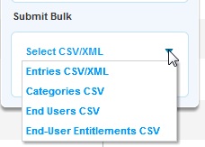

or click Download/Submit CSV/XML in the Dashboard.

1. Click Open.

A message stating that your import request has been submitted is displayed.

* To track bulk uploads
* See Tracking Your Uploads.

### Downloading Bulk File Samples

* To download a sample bulk file

1. Select the Dashboard tab.
2. In the Upload Content section click Submit CSV/XML Samples.

or

1. Select the Upload tab.
2. Click Select CSV/XML Samples.

The samples include specific format descriptions and guidelines.

## Automated Content Ingestion via a Drop Folder

You can add your media and metadata to a drop folder (on-premise or on the Kaltura servers) and the Kaltura system will activate an ingestion workflow tailored to your needs.

You can also upload metadata only and deliver media directly from your CDN, or on-premise storage.

## Using a Drop Folder

The Kaltura Drop Folders are used to automate the ingestion of content into the Kaltura platform. The Drop Folder service constantly watches each drop folder for new content, and activates automatic ingestion of new content to the specific account.

Kaltura offers multiple configuration options for setting each drop folder to a specific workflow. To learn more read about Drop Folders see [Kaltura Drop Folder Service for Content Ingestion](http://knowledge.kaltura.com/sites/default/files/Kaltura_Drop_Folder_Service_for_Content_Ingestion.pdf).

### Drop Folder Control Panel

This section applies only after the Kaltura Drop Folder service is set up.

In the KMC Content tab, publisher administrators can use a control panel to monitor and troubleshoot media files in drop folders. Access to the Drop Folders control panel can be granted to specific administrators through the administrator's user role definition.

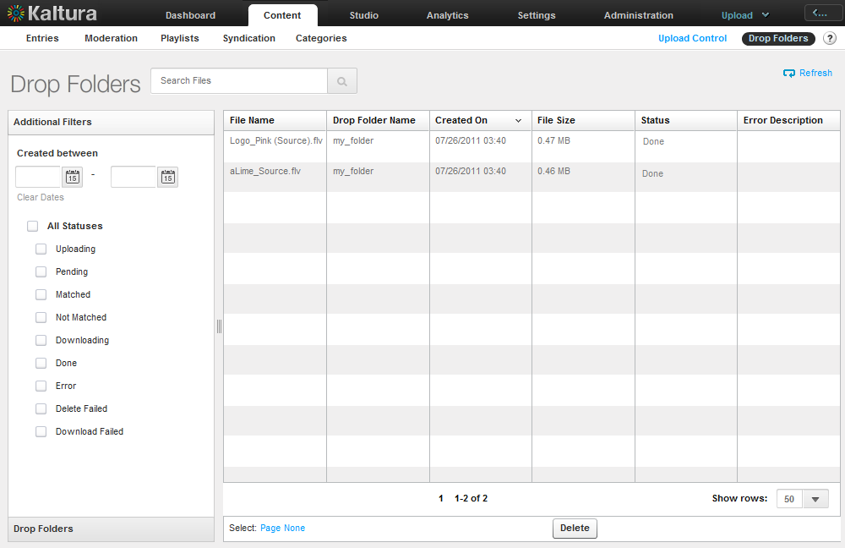

The Drop Folders control panel includes the status of each file in the drop folder, and an option to filter the file display for a specific drop folder, status and creation date range.

An additional option to manually delete files from the drop folder can be granted separately only to authorized administrators.

#### Media Files Table

The Media Files table in the Drop Folder Control page lists all media files currently available in the account’s drop folders. Current details of each file are available within the table. In the filter bar on the left side of the page, you can filter the files by:

* Search criteria
* Drop folder
* File creation date
* Drop folder status

If you need to delete files from the drop folder, click Delete.

#### Drop Folder Statuses

* **Uploading** – File upload to the drop folder is not complete yet. Upload completion is detected by the drop folder watcher when the file size continues growing during a pre-defined time interval.
* **Pending** – File uploading to the drop folder has completed but the file was not yet handled by the drop folder engine.
* **Matched** – The file was matched to an existing entry in Kaltura and remains in the drop folder until other files related to the entry’s media package also are matched. Note that this status appears only when a drop folder is configured to match media files to an existing entry.
* **Not Matched** – The file was not yet matched to an existing entry in Kaltura and remains in the drop folder until a match occurs. Note that this status appears only when a drop folder is configured to match media files to an existing entry.
* **Done** – File ingestion is complete. The file was not yet deleted from the drop folder.
* **Error** – An error occurred while processing a file in the drop folder. When in an error state, an error description is available in the Media Files table.
* **Delete Failed** - An error occurred while trying to delete a file from the drop folder.

Commercial users, please contact your account manager to enable this feature in your account.

## The Dashboard Tab

You can upload data video, audio or photo files through the Dashboard.

* To upload media files from your desktop

1. Click Upload from Desktop in the Dashboard.
2. Select the files to upload and click Open.
3. Select the Transcoding Profile. See Editing and Creating Transcoding Profiles.
4. Select the Media Type and click Upload.

## Uploading Content Using the Content Tab

You can upload data through the Content tab. You can add video or audio media to an entry you prepared (when the entry status is No Media, add new transcoding flavors, add metadata, or replace content information. See The Flavors Tab.

## Tracking Your Uploads

You can track the upload processing in the Content tab.

### Your Uploads

The Your Uploads table lists all the in-progress and pending upload tasks. The list only shows media file uploads from the desktop that you performed during the current KMC session.

For each uploaded file, you can view details such as:

* File name
* File size
* ID of the Kaltura entry that this file is added to

You can use the table to:

* Track the progress of each upload task.
* Reorder upload tasks that are waiting to be processed.
* Retry failed tasks.

Since file uploads are controlled by the KMC web application, closing or refreshing the browser page terminates all upload tasks that currently are in progress.

* To track the upload progress from your desktop

1. Click the Content tab and select the Entries tab.

The Upload Control feature, located on the upper right of the screen, indicates the number of uploads in progress.

1. Click **Upload Control** to display the file uploads and to view additional information.   
   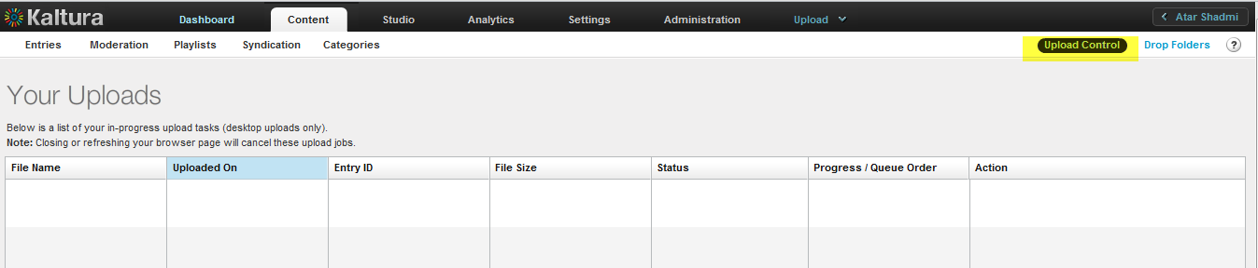

### Bulk Upload Log

The Bulk Upload Log table shows the completed and in-progress bulk upload jobs for your KMC account. You can:

* View information related to each bulk upload job.
* Download original bulk upload files.
* Download a results log file of each bulk upload job.
* To track the Bulk Upload progress from your desktop

You can display completed and in-progress bulk upload jobs. (optional)

1. Click the Content tab and select the Entries tab.

The Upload Control feature, located on the upper right of the screen, indicates the number of uploads in progress.

1. Click **Upload Control** to display the file uploads and to view additional information.
2. Click **Switch to Bulk Upload Log,** located on the bottomleft corner of the screen.

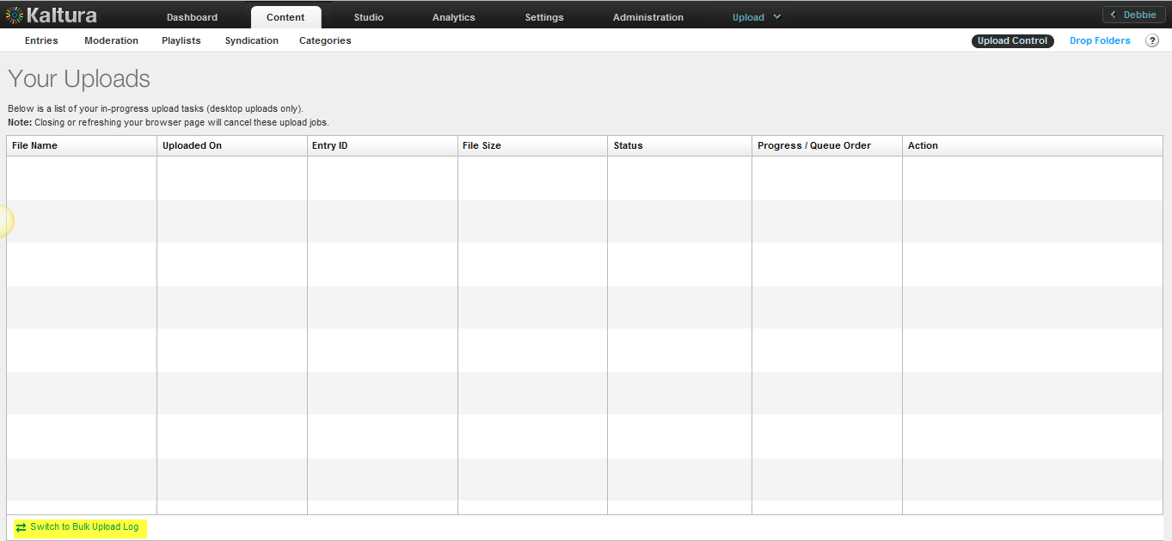

The Bulk Upload Log is displayed.

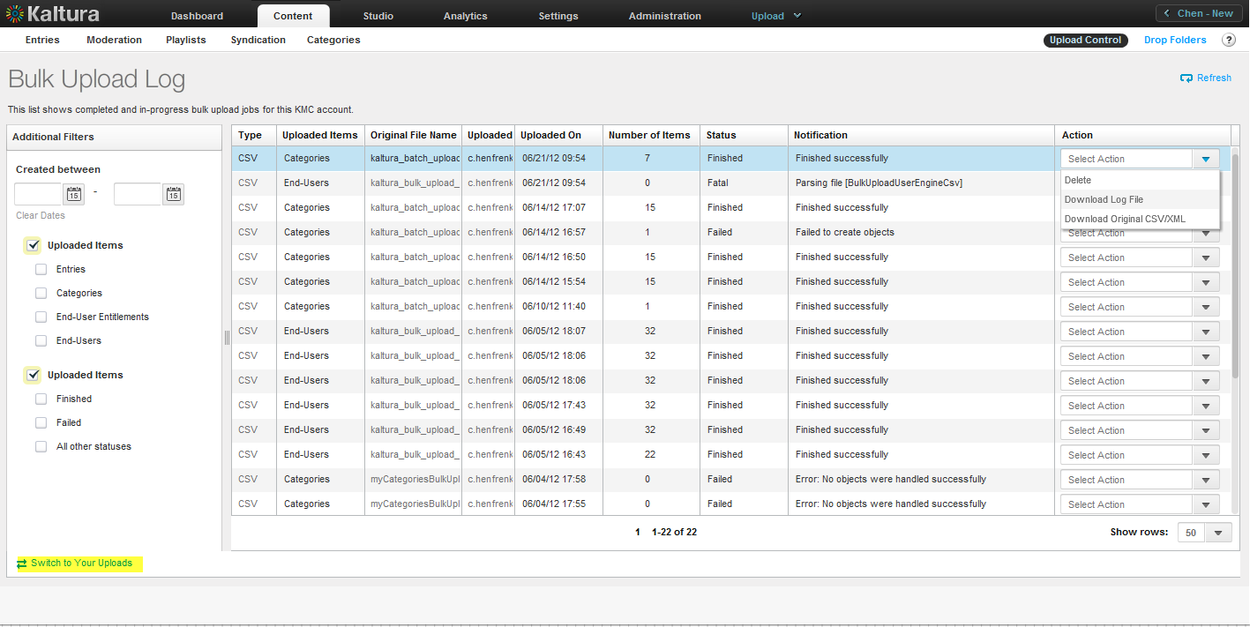

You can track the bulk jobs as well as download bulk job related files (original CSV and log files).

* To download bulk job related files

1. Click the Content tab and select the Entries tab.

The Upload Control feature, located on the upper right of the screen, indicates the number of uploads in progress.

1. Click **Upload Control** to display the file uploads and to view additional information.
2. Click **Switch to Bulk Upload Log,** located on the bottomleft corner of the screen.
3. In the Actions column select **Download Log File** or **Download Original CSV/XML**.

* To revert back to Upload Control
* Click **Switch to Your Uploads located** on the bottomleft corner of the screen.

After the upload process is complete, media is managed through the **Content** tab.

Chapter

# Transcoding and Processing

When a video is uploaded to the KMC, the video is associated with a conversion profile, also known as a Transcoding Profile. A Transcoding Profile may be comprised of a single flavor or multiple flavors. For each upload session, you should select the Transcoding Profile. You can also set a default Transcoding Profile.

A transcode is made from taking an encoded piece of video and converting it into one or more newly compressed streams that can then be played in a player on a computer or mobile device depending on the settings and methods used. The main purpose of the reconversion is to create a match for the required target platforms and distribution methods,

Kaltura flavors represent the required renditions of the source file with distinct codecs, frame sizes and bitrates. You can select to generate or add multiple flavors to an entry, including flavors geared towards displaying media on mobile devices (low bandwidth, small screens, and/or HTML5 supporting devices). An asset is a single output file with its specific file type, video/audio codecs, bit-rate, GOP size, that may be used for playback, download or editing.

The Kaltura platform supports ingestion of all forms of rich media (including video, images, audio, PDF, an others), and allows you to define different transcoding profiles, depending on your publishing needs.

Additional transcoding flavors can easily be added for publishing across different devices, network bandwidths and screen sizes. Kaltura's transcoding decision layer engine supports more than 60 video and image formats as well as 140 video and audio codecs.

When you upload content you determine what type of flavors you want to associate with your output.

There are three transcoding profiles that are automatically created for new accounts:

* **Default** - the flavors included in the default transcoding profile of the account. These flavors appear in the main Transcoding Settings page.
* **Source Only** - uploads the source file, but does not transcode it; the source is the original file uploaded as is. Other flavors will not be created.
* **All Flavors** - transcodes uploaded files into all of the flavors defined in the main Transcoding Settings page. See Transcoding Settings Page.

### Converting Videos into Multiple Flavors (Optimized Output Files)

Kaltura’s player provides optimal playback by using adaptive bitrate technology that automatically selects the most appropriate flavor asset for playback, based on the viewer’s specific connection and other parameters.

Getting content onto the platform is the first step and transcoding processing is part of the upload session. For a quick and simple upload, use the default flavors that are provided and that can be enabled/disabled from the transcoding profile you want to use.

* To display the default flavors for transcoding your content
* Select theSettings tab and then select Transcoding Settings.

The Default Transcoding Flavors window is displayed which contains the flavor selection of the Default Transcoding profile. Each file uploaded to the system is transcoded into the flavors that are checked.

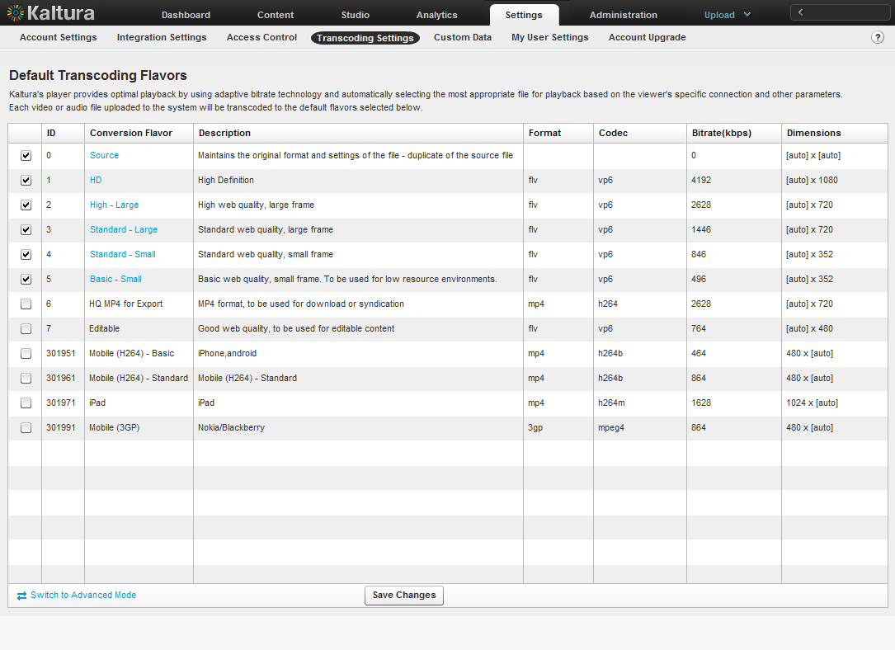

### Editing and Creating Transcoding Profiles

* To edit a Transcoding Profile

1. Select the Settings tab and then select Transcoding Settings.

The Default Transcoding Flavors window is displayed showing the flavors you selected for the Default Transcoding profile.

1. On the lower left corner, click Switch to Advanced Mode.  
   [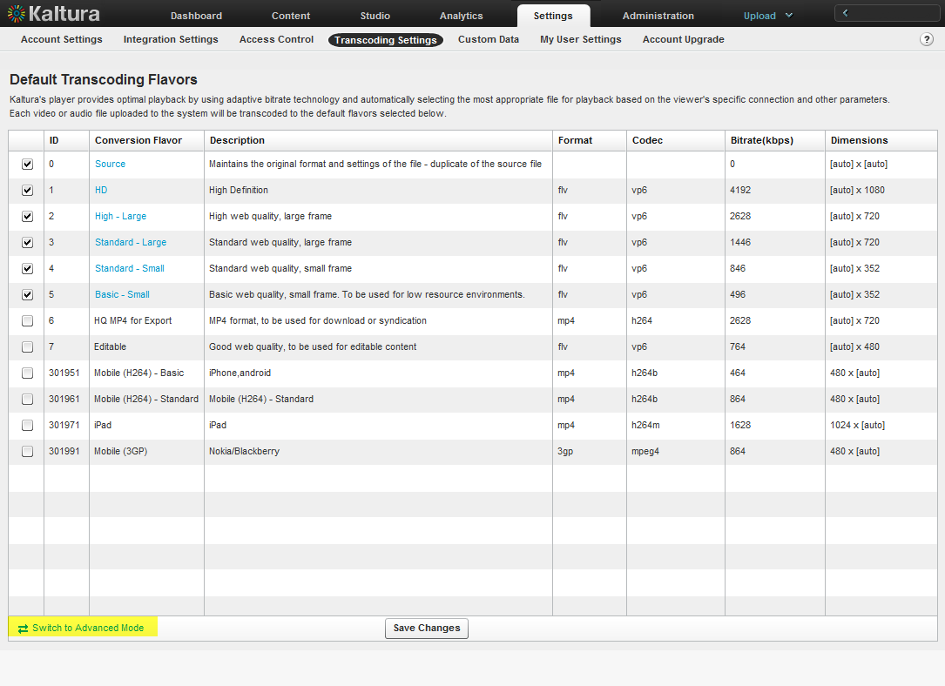](http://blog.kaltura.org/wp-content/uploads/2011/10/AdvanceTranscoding.png)

The Transcoding Profiles window is displayed.

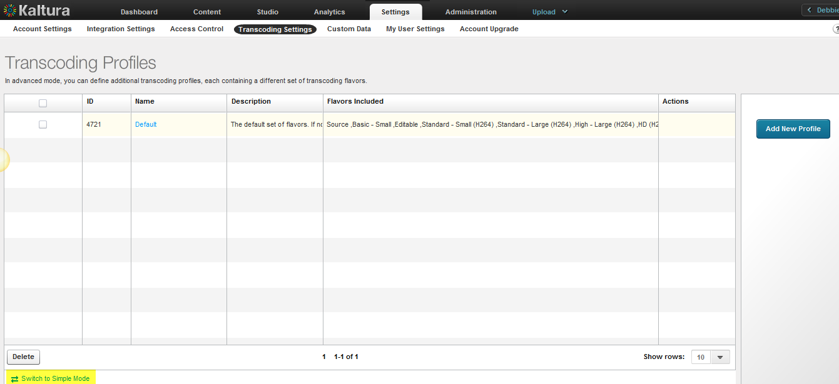

1. Click a Transcoding Profile (Name) to edit or click Delete to remove a transcoding profile.

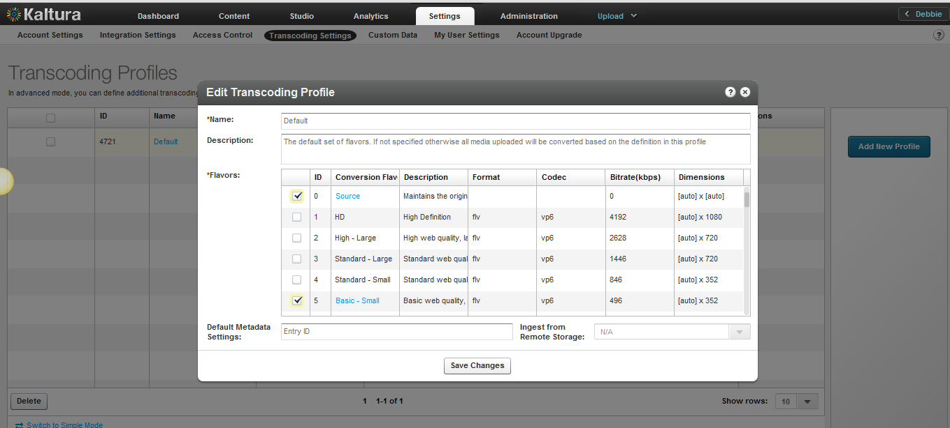

1. Use the checkbox to select flavors to add or remove.
2. Enter the Default Metadata Settings Entry ID (Optional). This feature is useful if you want to set default metadata settings such as tags/categories to files you ingest. See Upload a Media File and Set Its Metadata. If your account is used and configured to ingest content from Remote Storage- select the remote storage name from the menu (Optional).
3. Click Save Changes.

## Adding a Transcoding Profile

* To create a Transcoding Profile

1. Select the Settings tab and then select Transcoding Settings.
2. On the lower left corner, click Switch to Advanced Mode.
3. Click Add Profile.

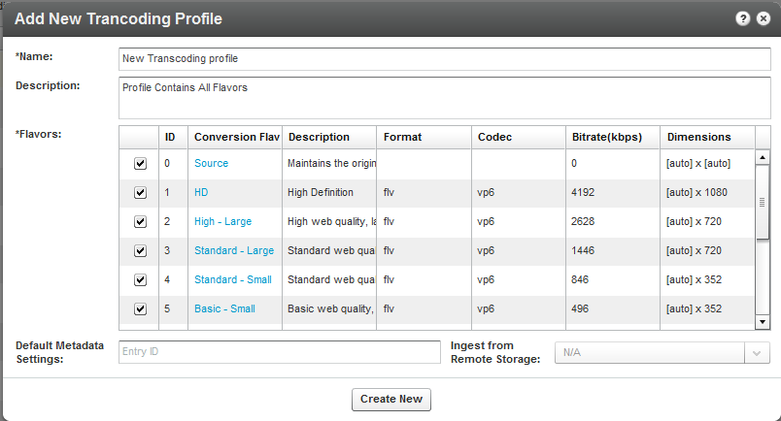  
The Add New Transcoding Profile window is displayed. You can view the available transcoding flavors, or add new Transcoding Profiles and create profiles for different use cases.

1. Enter a Name and Description for the Transcoding Profile.
2. Select the flavors out of the available flavors on your account, to apply to the source video you upload.

The flavors you select become active.

1. Edit the flavor’s options. (Optional). Click an active flavor name to open the flavor settings in this Transcoding Profile.
2. For extra fast publishing, set the Impact On Entry Readiness field to Required, for the minimum set of flavors and the rest of the flavors to Optional.(optional)

Use this option to publish your content even faster. See Quick Publishing .

1. Enter the Entry ID for the Default Metadata Settings. (optional) See Uploading Content and Setting Metadata.

The entry’s metadata fields are added to the transcoding profile. Each new entry that is transcoded using the profile will include those metadata fields. (You can create a “Metadata template”.) You can use The Metadata entries as “metadata templates” for adding metadata to multiple files. See Useful Tips for Working with Transcoding Profiles.

1. Select the Remote storage name, for linking new entries to media assets located on your CDN or remote storage, if applicable, to your workflow. Otherwise this feature is disabled with a N/A indication. See Link to Remote Storage.
2. Click Create New to create the profile or Save changes if you are editing the profile.

### Quick Publishing

A popular requirement for news websites and video publishers is to publish videos as quickly as possible. Kaltura allows you to control video asset readiness speed by allowing you to configure the ingestion process to your needs.

By default, a video entry is not at the ‘Ready’ status (for publishing) until all of the required flavors (by default the required set of flavors is the minimal set of flavors required for web playback) are created. If many flavors are included in the transcoding profile, the conversion process may take many minutes, which is often not fast enough for breaking news videos.

You can configure whether a certain flavor’s readiness is required or not, so that you can publish your content quickly.

For example,assuming the source flavor is a web-playable entry created using h264 for web and mobile. You can configure h264 as the required flavor, while all other flavors are optional. The entry will receive the “Ready” state for publishing immediately after the upload is complete. The other flavors will then be processed and added to the entry in the background subsequently, after a short processing period. Failure of a required flavor causes failure for the entire entry.

See <http://blog.kaltura.org/extra-fast-publishing> for more information.

|  |  |
| --- | --- |
|  | NOTE: The same flavor may have different settings in a different transcoding profile, which allows for greater publishing flexibility). |

## Editing Options for Flavors in a Transcoding Profile

The following options may be edited for each transcoding flavor selected in a Transcoding Profile:

* **Impact on Entry Readiness** –Determines the impact of each specific transcoding flavor on entry readiness for publishing. See Quick Publishing.

The options are:

* **Required** – The entry will not be set to a Ready state until the processing of the specific transcoding flavor is complete. To expedite video readiness we recommend applying the ‘Required’ setting to a single flavor that is required for playback on each required environment. For example, if the source file is an MOV that cannot be played on the web, flagging only one lowest quality FLV or MP4 flavor as ‘Required’ will ensure the video will be published as quickly as possible while the other flavors are being prepared.
* **Optional** – The entry may be set to a Ready state before the processing of the specific transcoding flavor is complete. When no other Transcoding Flavor within the Transcoding Profile is set as required, completion of the processing of any Optional flavor sets the entry to the Ready state. We recommend using this option for most flavors to increase speed of readiness.
* **No Impact** – Determining entry readiness is not affected by the presence of this transcoding flavor. This is usually the default setting for the “Source” transcoding flavor.
* **Use Kaltura Transcoding** – Determines whether to use the Kaltura transcoding engine for generating each specific transcoding flavor. This option is enabled only when your account is set to support the ingestion of multiple bit-rate transcoding flavors generated by your local transcoder. If Kaltura performs transcoding of all flavors except the ‘source’ file, this option should be set to **Always**.

The options are:

* **Always** – Kaltura’s transcoding engine always is used for generating the specific Transcoding Flavor.
* **Never** – The Kaltura transcoding engine will not generate the specific transcoding flavor. This is a fixed setting for the “Source Flavor” which always is added to the entry with no additional processing. This option should also be used when your account’s content ingestion workflow relies on a local transcoding engine and when the ingestion of the previously transcoded Flavor to Kaltura should always take place, bypassing Kaltura’s conversion processing.
* **As a Fall-back** – The system expects to add this transcoding flavor from a local transcoding engine, but will use Kaltura’s transcoding engine as a fall-back to convert to this flavor when the flavor is not received as part of the ingestion request. This option adds flexibility when you want to use your local transcoding engine while utilizing Kaltura’s transcoding engine as a fall-back option.
* **System Name (Optional) –** The system name is used to identify the flavor in client-side applications. For example, to mark a specific flavor as suitable for playback on iPad devices, the system name was set to iPad.
* **Flavor Generation Policy** – You can bypass Kaltura’s transcoding optimization, and force specific flavors to be generated even when they are detected as redundant by the Kaltura transcoding optimization module.
* Use Kaltura’s Optimization - Kaltura’s optimization routine decides whether it is worth-while to create a flavor (For example if the source video is of lesser quality than the flavor, the optimization routine will not create the flavor).
* Force Flavor generation –Select this option to override the Kaltura optimization routine and create a flavor regardless of whether or not it is redundant quality wise (For example, when a publisher has to distribute the video through a broadcast channel that requires specific flavor specifications, the flavor must be created.)

## Assigning a Transcoding Profile to a Bulk Upload

A default Transcoding profile is included with the KMC. After you create a Transcoding Profile, an ID is created and listed in the Transcoding Profiles page.

* To assign a transcoding profile other than the default profile, to a bulk upload
* Set the ID from the Transcoding Profiles to the conversionProfileId in your CSV.
* Set the ID from the Transcoding Profiles List to the conversionProfileId in your XML file.

## Useful Tips for Working with Transcoding Profiles

If you want to configure your KMC account to support automated content ingestion workflows, you can optionally add default metadata settings from an existing entry. The default entry metadata setting automatically will populate the new content when using each specific transcoding profile.

For example, you want to target two distinct audiences with your videos, the first is public facing videos and the second is internal company videos.

You can create two transcoding profiles, one for each of your target audiences, even though you might convert them to the same flavors you can use different “default metadata settings” so your public facing videos will have their specific metadata values, while the internal company videos can have different fields or data. All this is done automatically after you prepare one template entry for the process.

* ****To use metadata settings with transcoding profiles****

1. Create the template entry you want to use:

Create a “Draft” entry, using the Upload tab. See Creating Draft Entries.

1. Prepare the metadata. See Prepare a Metadata-only "Draft" Entry for Future Ingestion of Media Files.

For example: Template Entry for Transcoding Profile X”.

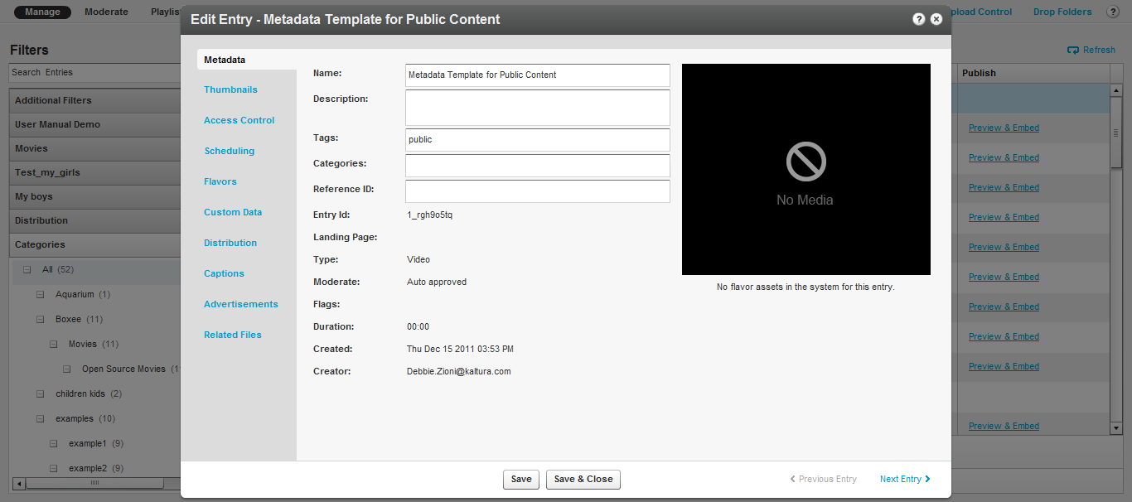

1. If you use custom metadata, edit the entry metadata fields. For example you can enter data that reflects the template data for your company, such as your “company name” field since your company name is unlikely to change.

If you do not use custom metadata, click [here](http://www.kaltura.com/api_v3/testmeDoc/index.php?service=metadata_metadata)to learn more about it.

You next have to set the template entry on the transcoding profile.

1. Go to the Settings tab and select the Transcoding Profiles tab.
2. Select the flavors of your default transcoding profile.
3. Click Switch to Advanced Mode link at the bottom of the page.
4. Edit the transcoding profile you wish to create a template entry for, by clicking on it.
5. In the Edit Transcoding Profile window, enter the Entry ID you want to set as the template entry in the Default Metadata Settings field.

## The Flavors Tab

The Flavors tab in the Edit Entry window allows you to manage the *flavors* that are available as well as replace media files and their transcoding flavors.

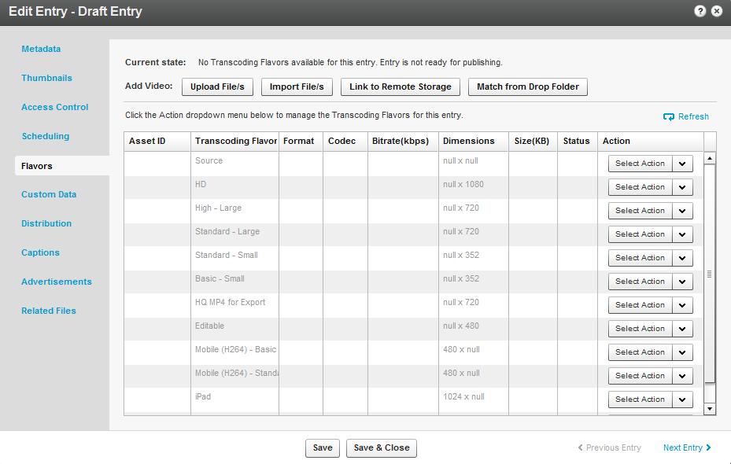

Use the Flavors tab to:

* Add video or audio media to a new entry you created (when the entry status is No Media).
* Replace the media of an existing entry (when the entry status is Ready or Error).
* View the list of flavors that the system created for an entry and apply the following actions:
* Preview or delete a flavor.
* Download the transcoded file to your desktop.
* Upload a file from your desktop you that transcoded on your own, to serve as a flavor for an entry.
* Upload a file from a drop folder to set as the transcoding flavor
* Import the flavor from a URL.
* Convert or reconvert to transcode an entry to additional flavors.

After the transcoding process is complete, the new file replaces the old file and the original file is deleted.

When your KMC account supports direct ingestion of multiple bit-rate Transcoding Flavors, you can use the Action menu to add or replace a single Transcoding Flavor in an entry.

### Add Video/Audio

The Flavors tab displays several Add Video/Audio options when an entry is not yet associated with any media that is, the entry status is No Media. See Prepare Entry. For more information see Replacing Media|topic=Replacing Media.

### Upload Files

Use this option to add media to an existing entry by uploading one or more files from your desktop.

* To upload content and flavors to a Draft entry

1. Click on the Draft Entry and then select the Flavors tab.
2. Click Upload File/s to open a standard desktop file selection window.

The uploaded file is treated as the source for generating the required Transcoding Flavors in Kaltura. When your KMC account supports direct ingestion of multiple bit-rate Transcoding Flavors, you can select multiple flavor files for the Transcoding Profile.

1. Select the files from your desktop, confirm your selection, and set the relevant Transcoding Flavor that the uploaded file will be transcoding by.

The Transcoding Flavor options in the menu are set from the selected Transcoding Profile and its flavor settings.

1. Click Upload to confirm your upload request.

The KMC immediately starts processing the file uploads. The uploaded file is added to the entry and flavor conversion processing starts.

### Import Files

Use this option to add media to an existing entry by importing a media file from your existing web host or FTP server. The option is displayed when the entry status is No Media.

* To import content and flavors to a Draft entry

1. Click on the Draft Entry and then select the Flavors tab.
2. Click Import Files to set your media file URL.

The imported media file is treated as the source for generating the required Transcoding Flavors in Kaltura. When your KMC account supports direct ingestion of multiple bit-rate Transcoding Flavors, you can set multiple URLs.

1. Set the relevant Transcoding Flavor that the imported file will be transcoded by. The Transcoding Flavor options in the menu are set from the selected Transcoding Profile and its flavor settings.
2. Click Import to confirm your import request.

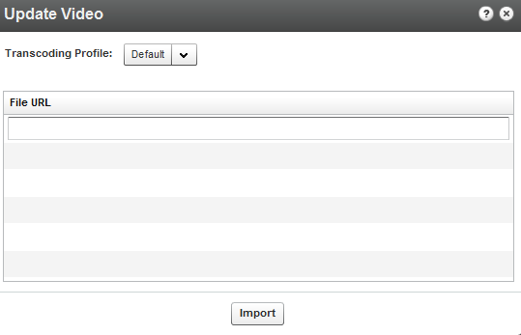

An import request is submitted to the Kaltura server. The imported file will be added to the entry and flavor conversion processing starts.

### Link to Remote Storage

Kaltura’s Remote Storage and Delivery solution enables publishers to manage their video assets and account settings on Kaltura’s hosted video platform while actually storing the content on their own remote network storage location, and delivering the content from the same remote location. Kaltura’s remote storage and delivery capabilities are fully integrated with the platform’s ingestion, transcoding and publishing work­flows, and provide system fl­exibility for addressing publishers’ specific storage and delivery needs.

You can link content to remote storage from the KMC User Interface. The Link to Remote Storage option is useful for partners that use their own transcoder and also host and deliver content on/from a remote storage (e.g. CDN storage, internal organization storage). The partner’s transcoder generates the flavors. After the files are uploaded directly to the remote storage it is only necessary to indicate which flavors to link to an entry in Kaltura. The connection of the remote storage profile to the transcoding profile is used for this purpose.

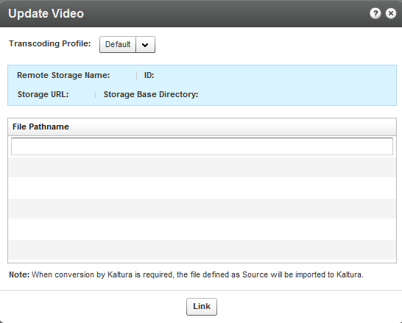

Contact your Kaltura account manager to learn more about how this feature can simplify your workflow, and to activate and configure remote storage on your account.

### Match Files from Drop Folder

Use this option to match media to an existing entry from your account’s drop folder. This option is displayed when your account is set with a drop folder configuration. For more information see [Kaltura Drop Folder Service for content Ingestion](http://knowledge.kaltura.com/sites/default/files/Kaltura_Drop_Folder_Service_for_Content_Ingestion.pdf).

### Replacing Media

You can replace media content when an entry is ready for publishing or when a media processing error occurred. The entry itself, with its current metadata, entry ID, and analytics information, remains unchanged.

All Transcoding Flavors are replaced as one unit to ensure that inconsistency errors do not occur between old and new Transcoding Flavors at any given time.

You can review the Transcoding Flavors of the new media file in a temporary entry that is available for this purpose only. After you approve media replacement, all of the entry’s existing Transcoding Flavors are deleted and are replaced by the new ones.

* To replace media

1. Select the **Content** tab and click on an entry.
2. Select the Flavors tab and click on an entry.
3. Select the replacement method.

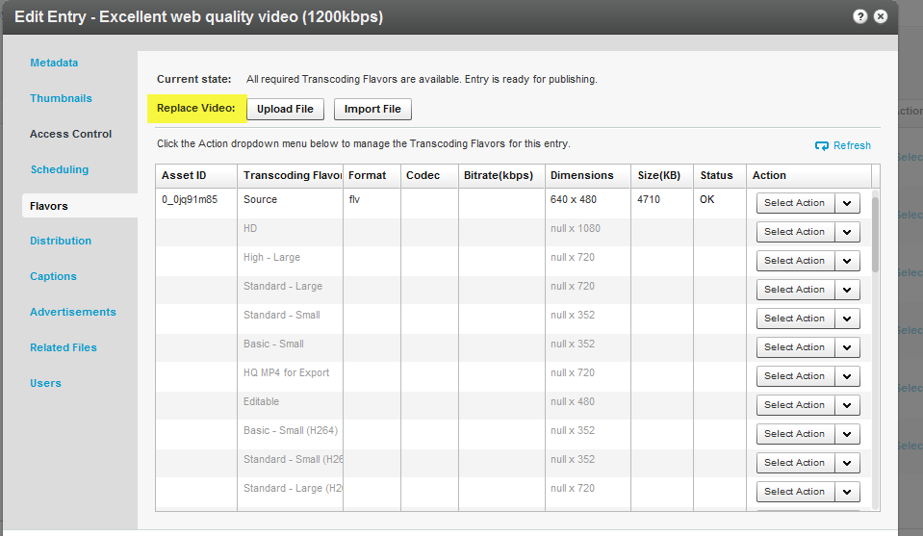

See Upload Files, Import Files, Link to Remote Storage or Match Files from Drop Folder.

After you trigger the action, a link to review the new Transcoding Flavors generated for the new media becomes available on the Flavors tab.

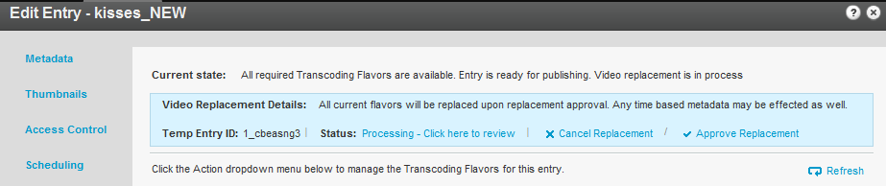

1. Click on Processing - Click here to review to see the transcoding process.

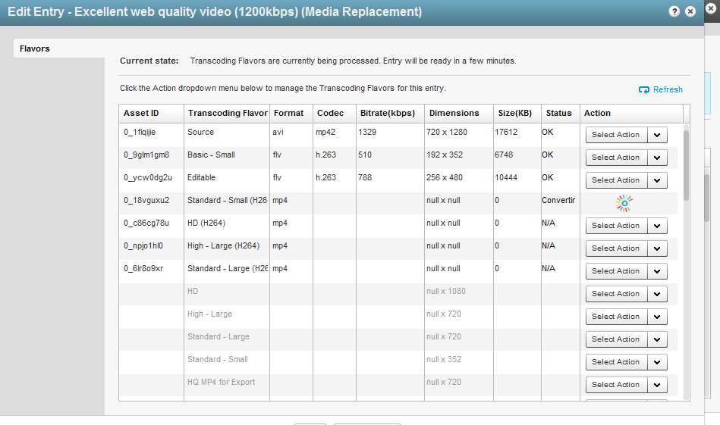

1. Click Approve Replacement. All current flavors are replaced when you approve the replacement or click Cancel Replacement to cancel your actions.

When you trim an entry, you trigger a similar process that replaces existing flavors with the trimmed version.

## Supported Source Formats

The following source formats are supported and may be ingested by the Kaltura platform:

FLV/F4V, MOV/MP4/QT/M4V, AVI, 3GP, ASF/WMV, MPG/M1V/M2V/MPEG-TS, MKV, Ogg, RM, WEBM

Additional formats may be supported as well but have not been verified.

### Supported Source Codecs

The following codecs are supported (Additional codecs may be supported as well but have not been verified):

Input Video Codecs

Dvix (Div3/4/5)/DX50, DV, H263, H264/AVC, MPEG-4 Visual, MPEG-1/2, MJPG, MP42/3, IV40/50 (Indeo codecs), RV30/40, RMVB, FLV1/4, VP3/5/6/7/8, SVQ1/3 (Sorenson), XVid, Theora, WMV1/2/3, VC1, VP8, ProRes 422, ICOD, DVCPRO. PXLT

Input Audio Codecs

MP3, MP1/2, AC3, AAC, Vorbis, AMR, PCM, WMA7/8/9, WMSpeech, FLAC, QDM2, RA, Nellymoser, Cook, GSM, SPEEX.

### Target Formats/Codecs

The following target formats and codecs are supported– i.e. formats and codecs that can be managed and/or displayed using the Kaltura platform:

Target Formats

FLV, MP4, AVI, 3GP, OGG, MKV, WMV, Silverlight Smooth Streaming. WEBM, MPEG, MPEG TS

Target Video Codecs

H264, H263/FLV1, Theora, MPEG-4 Visual, WMV1/2, VC1, VP6, VP8, MPEG-2

Target Audio Codecs

MP3, AAC, Vorbis, WMA/Pro, AMR NB, AC3

Delivery-specific Formats

In addition to Progressive Download and RTMP delivery methods, Kaltura supports RTSP streaming (for Blackberry devices), Akamai HD Network and Apple HTTP Live Streaming as well. Akamai HD Network and Apple HTTP Live Streaming require specially adapted target formats, which Kaltura supports as well.

Chapter

# Creating and Customizing Playlists and Players

This section describes how to create and cutomize \\playlists and create and cusomtize players.

## What is a Playlist?

A playlist is a list of media items (videos, audios, images) that can be embedded with a player in your website. Playlists can serve as the basis for RSS feeds, content feeds to over the top devices or integrations such as Roku, Boxee. See Content Syndication.

## Playlists Tab

There are two types of playlists available in the KMC:

* Manual
* Rule Based

Manual playlists allow you to select a static list of items, while Rule based playlists are dynamic, and automatically update based on what's currently available in your media library and what rules define the playlist. After you've created your playlist, you can assign a playlist to a player. See Designing and Configuring a Player.

A manual playlist can have a maximum of 150 entries. A rule based playlist may have a maximum of 50 entries, however, when the playlist is used in a syndication feed the limitation is 10,000 entries.

### Creating a Manual Playlist

To create a manual playlist, you manually select a group of videos to be played in the desired order. The order in which videos are played can be changed in manual playlists at any time, by using the up down arrows to set the video to the desired location within the playlist.

* To create/add a manual playlist

1. Select the Content tab and then select the Playlists tab.
2. Select Add Manual Playlist.

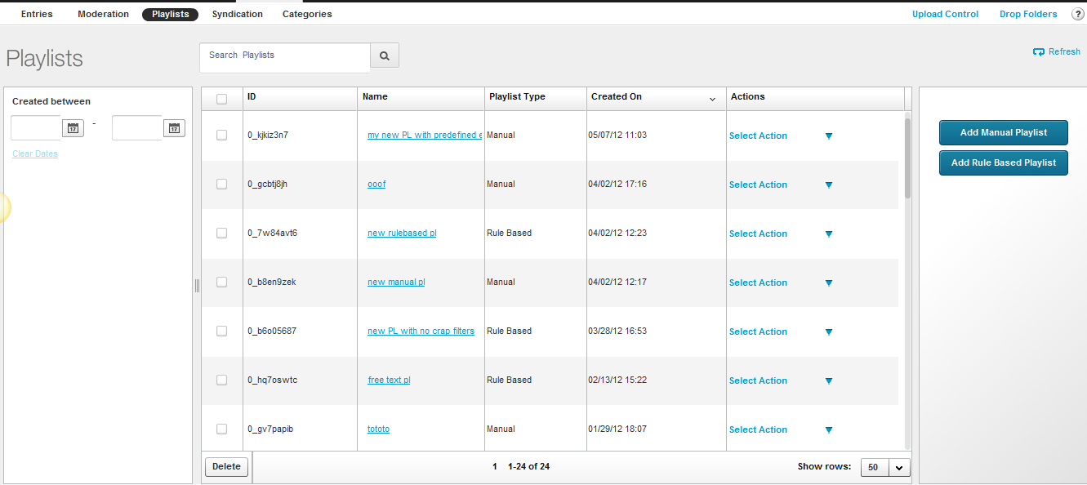

1. Enter an informative **Name** for your playlist.
2. Use the Filters to search for entries you want to include. See Locating Files – Content Search.

The results are displayed in the Entries Table.

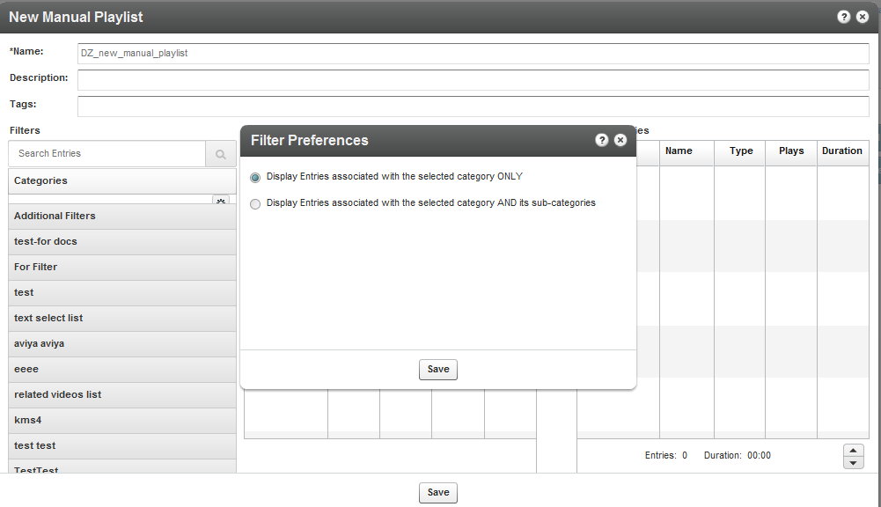

1. Add entries to your playlist by moving the desired entries from the Entries Table to the Playlist Entries. Use the horizontal arrows.
2. Set the order of the entries using the vertical arrows.

Highlight the entry and then use the up down arrows to place the entries in their appropriate order. Clicking on the entry will open it for editing.

1. Click **Save** to complete the process.

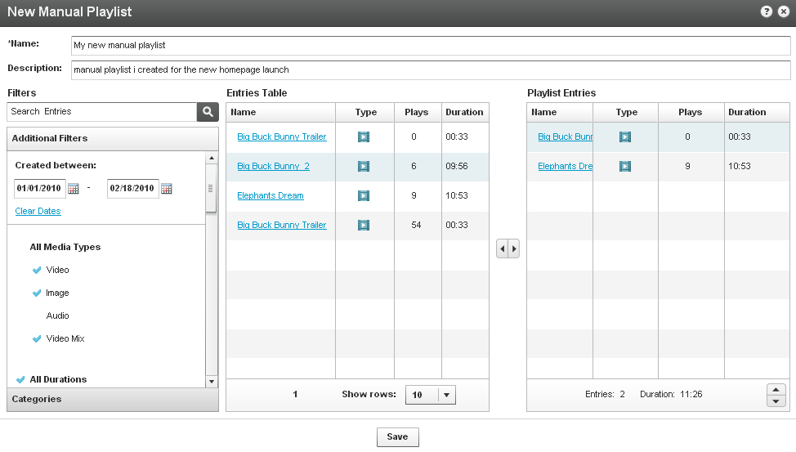

### Creating a Rule Based Playlist

A rule based playlist is a dynamic playlist that is automatically updated when content is uploaded or edited. To create a rule based playlist, you create a rule that selects the videos to include in the playlist. The rules may be based on the tags assigned to the videos, or you can create rules for ordering the videos and for the maximum number of videos to include. For example, you can create a “Most Viewed” playlist, a “Most Recent” playlist, as well as a playlist based on single or multiple filters, such as “videos tagged with “dogs” and created during January 2010”.

As you upload videos that match the rule, they are automatically added to the playlist.

### Defining a Rule

You can define a rule that will result in your playlist content. You can use any number of filters: you can define a list of clips that all have the same tag (for example, if you enter the term "dog" into the search box and click search, a new rule-based playlist is created for all the clips that have the "dog" tag). This list will dynamically change each time a clip is added or deleted to/from your account.

For example, you can define a rule-based playlist that consists of all the 0-4 minute video clips that were created in the past week. In addition to filtering, at the bottom of the window, you can define a preferred order for your playlist. You can order it by Most Viewed (overall, last week or last 24 hours) or Most Recent (for example, most recently added to the KMC).

If, for example, you would like to create a dynamic playlist that at any given moment consists of the most viewed clips in the last week, all you need to do is create a new filter and select the "Most Viewed 7 Days" option from the "Order by" drop-down menu.

On the bottom of the playlist you can see the number of entries in the playlist and their total length. You can automatically limit the number of entries that are included in the playlist by adjusting the counter positioned to the right of the "Order by" drop-down menu.

Your playlist can be based on a single rule or multiple rules. If you want to apply more than one rule to your playlist, click the "Switch to Advanced Mode" link at the bottom of the window. Note that this will clear all previous information that you have saved in your playlist.

* To create/add a single rule playlist

1. Select the Content tab and then select the Playlists tab.
2. Select Add Rules Based Playlist.
3. Enter an informative Name for your playlist (required).
4. Using the Filters, search for the entries you would like to include.

The results are displayed in the Entries Table.

You can choose more than one type of filter (for instance, text search + date + media type), the logical relationship between fields will be an "AND" relationship.

1. Select your preferred video order from the Order By drop-down menu.
2. Select the total number of entries you would like to include in the playlist via the Limit Playlist result box.
3. Click Save Changes to complete the process.

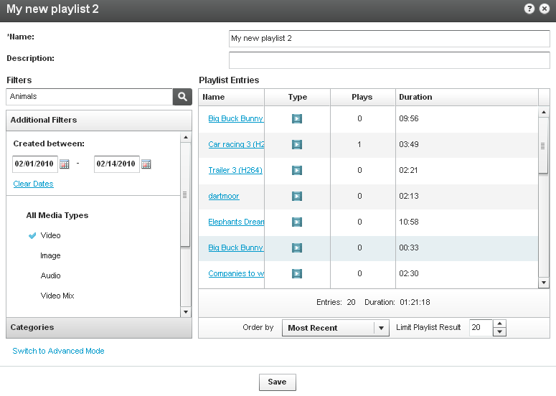

### Multiple Rules Based Playlist - Advanced Mode

Use the Advanced Mode to create playlists based on multiple rules.

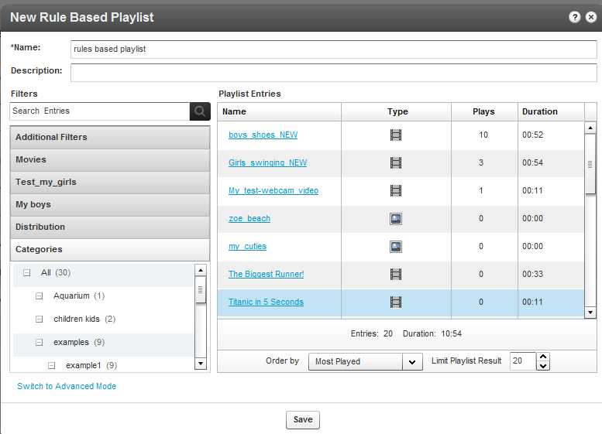

* To create/add a multiple rules based playlist

1. Select the Content tab and then select the Playlists tab.
2. Select Add Rules Based Playlist.
3. Click Switch to Advanced Mode.
4. Enter a Name for your playlist (required).
5. Click Add Rule to create a new playlist rule. (See Creating a Rules Based Playlist to learn about creating rules.)

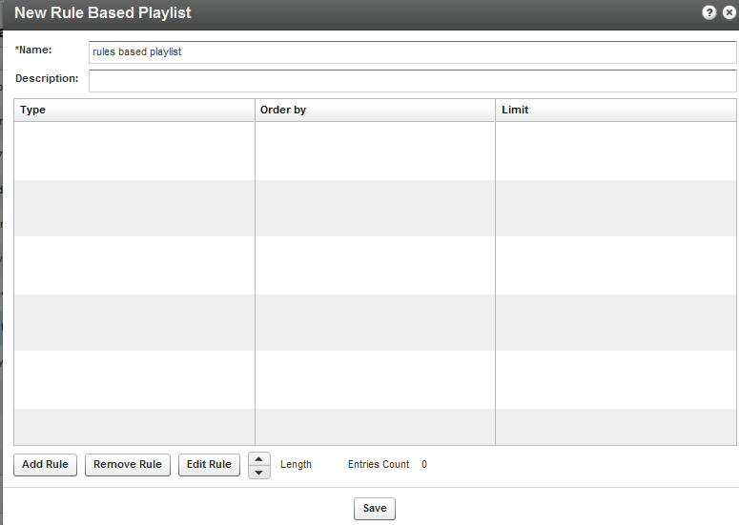

1. Add additional rules.
2. Use the Remove Rule and Edit Rule buttons to make changes to your list of rules.

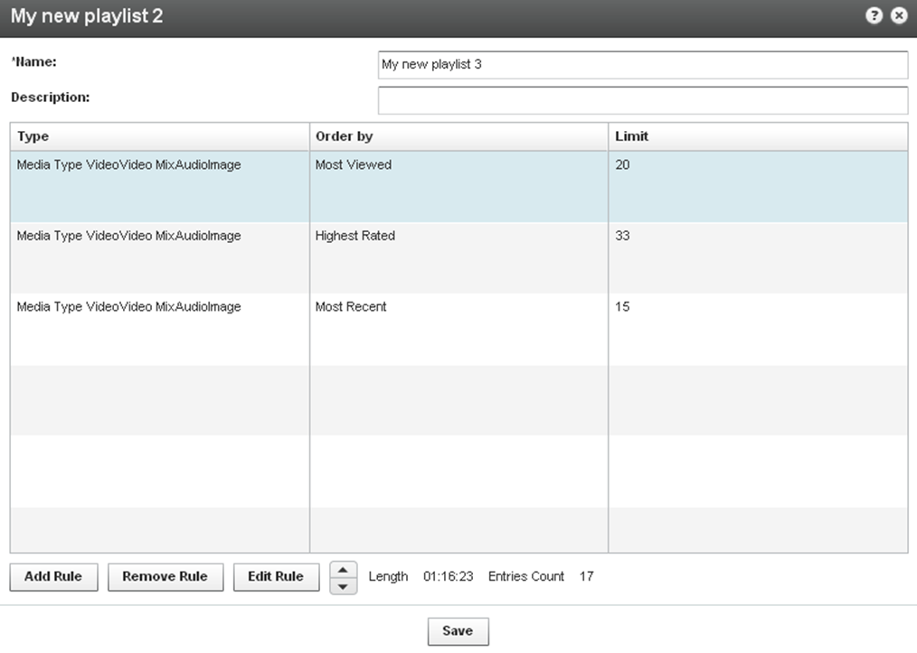

Rules are applied to the playlist in the order they appear. Use the arrows to change the order of the rules.

### Additional Playlist Configuration

Other actions that you may apply to playlists include:

* Creating Multi-tab Playlists
* Deleting a Playlist
* Removing Videos from a Playlist
* Customizing Additional Features for Playlists

### Creating a Player with Multi-tab Playlists

A Multi-tab Playlist contains multiple tabs, each containing a different playlist.

* **To create a multi-tab playlist**

1. Select the Studio Tab and then select New Player – Multiple Playlist.

The **Basics** tab is displayed.

1. Design and configure your playlist. See Designing and Configuring a New Player or Playlist.
2. Select the Content tab and add pre-existing playlists to your new Multiple Playlist.

Use the arrows to select from the list of All playlists and move them to the Playlist tabs list.

1. Save Changes to complete the process.

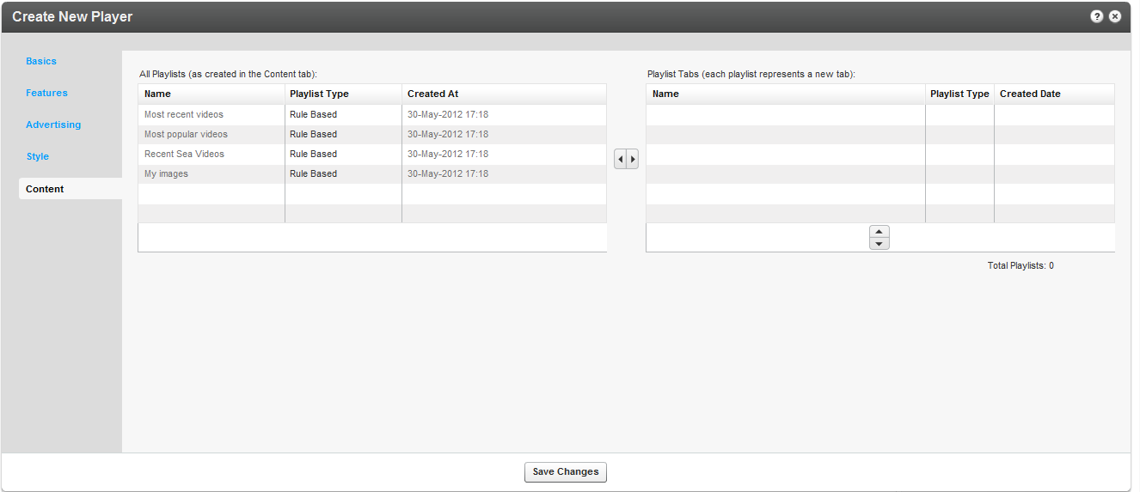  
  
The players will appear in the Multiplayer List. Each playlist is displayed in a new tab.

### Deleting a Playlist

* To delete a playlist

1. Go to the Content tab and then select the Playlists tab.
2. Select the playlist in the workspace and click Delete.

### Removing Videos from a Playlist

* To remove videos from a manual playlist:

1. Go to the Content tab and then select the Playlists tab
2. Select the playlist.
3. Select one or more videos from the Playlist Entries and use the horizontal arrows to move them to the Entries table.

Removing a video from a playlist does not delete it from your content library.

You cannot remove a video from a rules based playlist directly. Instead, you can:

* Modify the tags of the video so that the video no longer has any of the rules based playlist's tags.
* Modify the tags of the playlist so that they no longer include any of the video's tags.
* Delete the video.

### Customizing Additional Features for Playlists

When creating a playlist (either with one or multiple tabs) you will see additional configuration options under the Playlist Items section. Various types of information for each of the playlist items, such as number of plays, tags, rank etc. are displayed.  
  
Use options in the Features section to customize the player's design.

## Designing and Configuring a Player

A playlist is a collection of videos that are grouped together in a particular order for playback in the Kaltura Player. After you've created your playlist, you can assign your playlist to a player. Use the Studio tab to create configurations and design players and playlists. You can add, remove and adjust multiple buttons and features, and create a look to match your site.

### Player List

The Studio tab displays the list of the players defined in the system. The default players that are included within the system, as well as players defined and created by administrators via the KMC are displayed. A default playlist is automatically created for a new player based on the most played entries for the Partner ID.

The Studio contains the following templates of players:

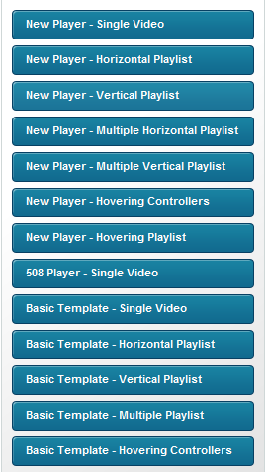

A studio template is a collection of features of a specific Kaltura Player configuration. The template is actually a collection of the player uiConf and another .xml file called features.xml. For more information, see [here](http://www.kaltura.com/api_v3/testmeDoc/index.php?object=KalturaUiConf).

|  |  |
| --- | --- |
|  | Workflow:   1. Select the Type of Player. 2. Configure the Player Basics Settings 3. Configure the Player Features. 4. Configure the Player Style. |

### Select the Type of Player

* To create a player

1. Select the Studio tab.
2. Select the type of player to create.

The Create New Player window is displayed.

## Configuring the Player Basics Settings

* To configure the player’s Basics settings

1. Select the Basics tab and enter an informative Player Name (required).
2. Set the Video Ratio – select to keep or stretch your media to fit the player when the media and player aspect ratios are different.
3. Select Auto-play features.
4. Select the Playlist’s controls.

If you are creating a Player and a Playlist you will also see the Playlist Controls. Check Automatically continue to the next entry, to play the playlist media consecutively.

For playlists with images, set the duration for images to be displayed during the continuous play of the playlist.

Playlist controls do not apply to the 508 Player.

### Editing a Player

The changes you make to an existing player will propagate to all sites where the player has been embedded, including syndicated players on other sites.

* Toedit a player

1. Select the Studio tab.
2. Click on the relevant player in the Player List.

Players created manually through Kaltura's professional services cannot be edited in this area.

1. Select Edit from the Select Action drop down.

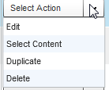  
The player configuration Features tab is displayed. See Player Control Options.

1. Check the control options for the player and then Save Changes.

### Adding Content to a Player

* To add content to a player

1. Select the Studio tab.
2. Highlight the relevant player in the Player List and select Select Content from the Select Action drop down.

  
The Entries table from the Content tab is displayed.

1. Select an Entry. You can preview the entry using the player you started off with.
2. Click Preview and Embed and then grab the embed code and copy it to publish the player to your site.
3. Click Save and Close.

### Duplicating a Player

* To duplicate a player

1. Select the Studio tab.
2. Click on the relevant player in the Player List.

Players created manually through Kaltura's professional services cannot be edited in this area.

1. Select Duplicate from the Select Action drop down.

  
The player configuration Features tab is displayed. See Player Control Options.

1. Check the control options for the player and then Save Changes.

### Deleting a Player

Deleting a player eliminates it from all the locations where the player has been previously embedded. For example, if you have embedded a player using this design on your site or an external site, after you delete it from the Player List, the player will no longer appear and a blank area is displayed on the website.

* To delete a player

1. Select the Studio tab.
2. Click on the relevant player in the Player List.
3. Select Delete from the Select Action drop down.



## 508-Compliant Video Player

The 508 compliant video player includes functionality and interface design that support federal accessibility requirements as outlined in the Voluntary Product Accessibility Template. Please note that the 508 compliant player has limited functionality.

* To create the 508 player

1. Select the Studio tab.
2. Select 508 Single player Video,

The Create New Player window is displayed.

1. In the Basic tab:
2. Enter an informative Player Name (required).

Set the Video Ratio – select to keep or stretch your media to fit the player when the media and player aspect ratios are different.

Select Auto-play features.

1. In the Features tab:
2. Select the Player Controls.

Select the Subtitles and Transcriptions Options.

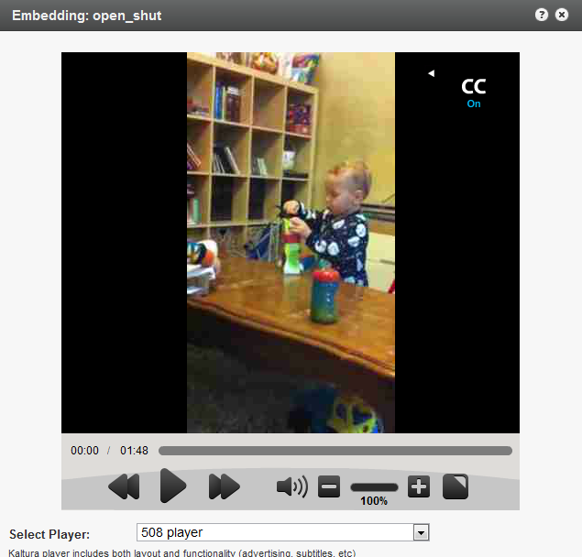

The player includes:

* Support for captions file in timed text or SRT formats for the video/audio file
* Support for an audio description in a standardized format for the video/audio file
* Hidden text elements for every non-text element (for screen readers)
* Tooltips
* Keyboard tabbing and controls
* No color coding information
* High contrast controls
* No draggable controls

## Configuring the Player Advertising Settings

* To configure the player advertising settings

1. Select the Studio tab and then select the Advertising tab.
2. Select the Player.
3. Toggle on Yes to Request ads for this player. See Advertising and Ad Networks.
4. Fill in the fields that define how the player handles advertisements, and click Save Changes.

## Configuring the Player Features

The **Features** tab is made up of different sections, controlling the various features of the player.

Use the options in this tab to select the features (buttons, layers and modules) to be included in your player. The main screen is divided into the Features List on the left and the Preview Pane on the right. As you select your features from the list, you can preview the changes in real time in the preview pane on the right.

### Features List

The Features List contains the list of configurable features (buttons, layers and modules) available for this player. Checking the box next to any feature allows you to preview it in the Preview Pane. Most of the features have in-depth configuration options.

* To view and customize the player different features

1. Select the Studio tab and then select a player.
2. Select the Features tab.
3. Click the options link next to each feature name.

Features are grouped by their type/usage:

#### Controls

The Controls area includes basic player features, such as title text, play, scrubber and more. You can also access each of these features using the JavaScript API.

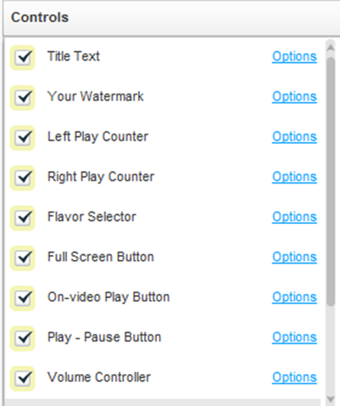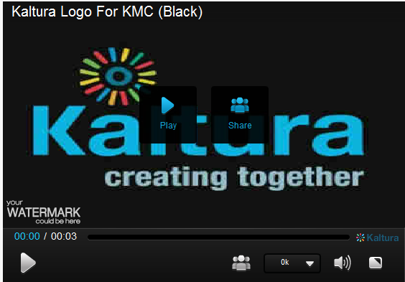

#### Viral & Distribution

The Viral & Distribution area includes features that assist in content distribution, such as the download and share buttons. Note that the download button only supports downloads of single video files and does not support mix downloads - [contact Kaltura Professional Services](mailto:kalturasupport@kaltura.com) to enable download of mix content.

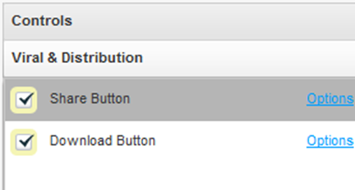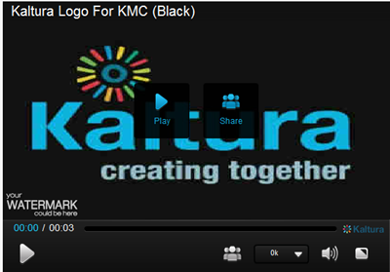

#### UGC & User Interaction

The UGC & User Interaction area includes participatory features such as media uploading and remixing.

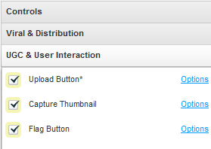

#### Subtitles and Transcriptions

In the Subtitles and Transcriptions area, you can select the type of captions files to use. See Setting Up Captions for Display.

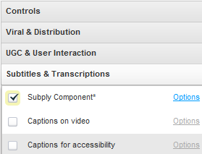

#### Related Videos Gallery

Displays a gallery of related videos. See Related Videos Gallery.

#### Custom Buttons

The Custom Buttons area requires a higher level of expertise, and enables you to customize your player via JavaScript. Buttons evoke pre-defined JavaScript functions.

#### Additional Parameters and Plugins

To simplify the management of many of the player features, Kaltura has implemented the “UIVars” to override and configure player features.

Kaltura UIVars are an incredibly powerful feature of the Kaltura Players that h allows publishers to pre-set or override the value of any FlashVar (object level parameters), show, hide and disable existing UI element, add new plugins and UI elements to an existing player and modify attributes of all the player elements. For more information see [How to use the Kaltura Player Studio's Additional parameters and plugins.](http://knowledge.kaltura.com/faq/how-use-kaltura-player-studios-additional-parameters-and-plugins-uivars)

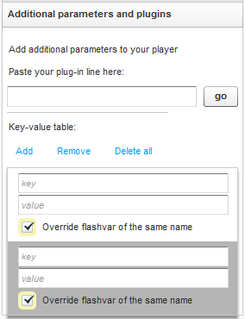

#### Playlist Items (For players with playlist)

The Playlist Items area allows you to select which information is presented for each item on the playlist (for example, show thumbnail, rank, tags and more).

Preview Pane

The Preview Pane enables you to preview the selections you make in the Features List area as well as define the player size and preview the player in different states (during play, pause, end, etc.).

Player Size

Set the player size by selecting the width. The player height will adjust accordingly based on the width and the video screen ratio selected in the Template Tab.

Auto Preview

In the Studio tab the player is automatically rendered every time you change a control. Uncheck Auto-preview to discontinue this behavior.

Preview States Buttons

These buttons enable you to preview the player in different states: before play, during play, paused and end screen. Alternatively you can simply play the demo content within the player, pause the video manually, etc.

* To configure the player’s features

1. Select the Features tab.

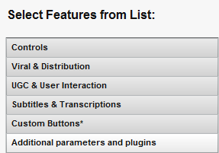

1. Expand the menus to configure your player.

Any changes you make will appear in the preview area. (Click the Preview button to see the changes.)

1. Click Save Changes.

#### Examples

The following player displays an example of the default player design with a watermark display.

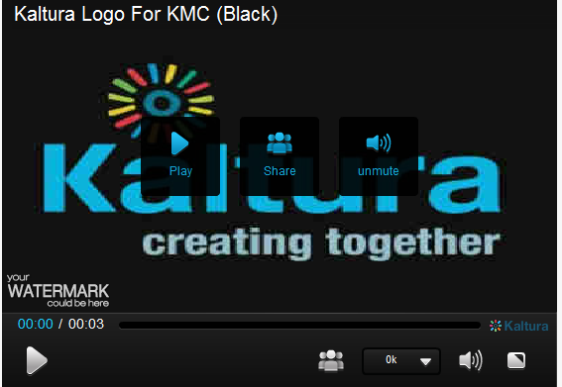

|  |  |
| --- | --- |
|  | NOTE: This sample presents only one of many set-up scenarios. There are many configuration options within this section. |

* To change where the watermark is displayed in a player

1. Select Controls, see Player Control Options, check Your Watermark and then click Options.
2. In the Watermark Location on the video drop-down menu select Top Left.
3. Click Preview and then Apply to confirm your choice.

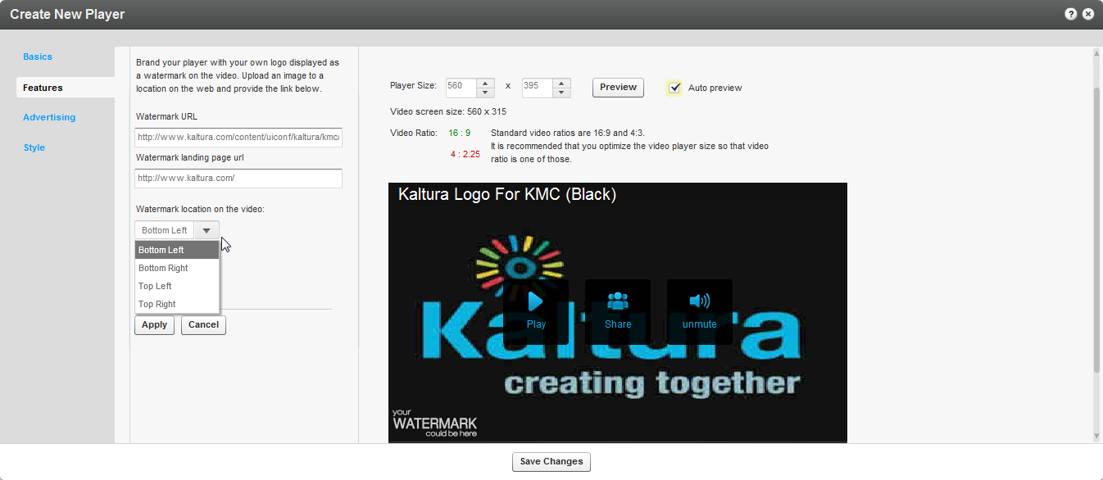

* To change the label of the Share button

1. Select Viral & Distribution; see Player Viral and Distribution Options.
2. Check the Share button and click Options.
3. In the Label field, enter new text (for example, Share Now!).
4. (Optional) In the Tooltip field, enter new text.
5. In the Preview area, click the Preview button to see the changes.
6. On the Share Button pane, click Apply to confirm your choice and return to the Features list.
7. Click Save Changes.   
     
   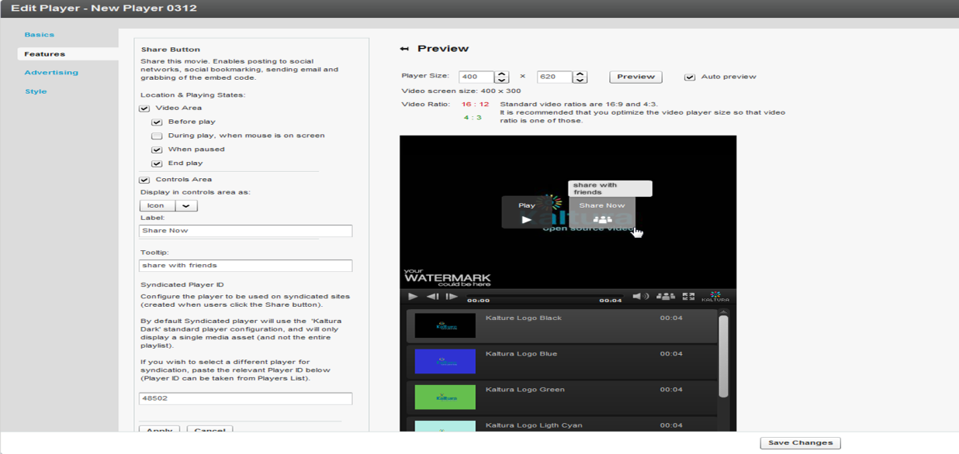

* To add a download button to the video area only

1. Select Viral and Distribution.
2. Check Download button feature and click Options.
3. Clear the Controls Area option.
4. Under Location & Playing States, check Video Area.
5. Under Video Area, check or clear playing states to determine when to display the download button in the video area.
6. In the Preview area, click the Preview button to see the changes.
7. On the Download Button pane, click Apply to confirm your choice and return to the Features list.
8. Click Save Changes.

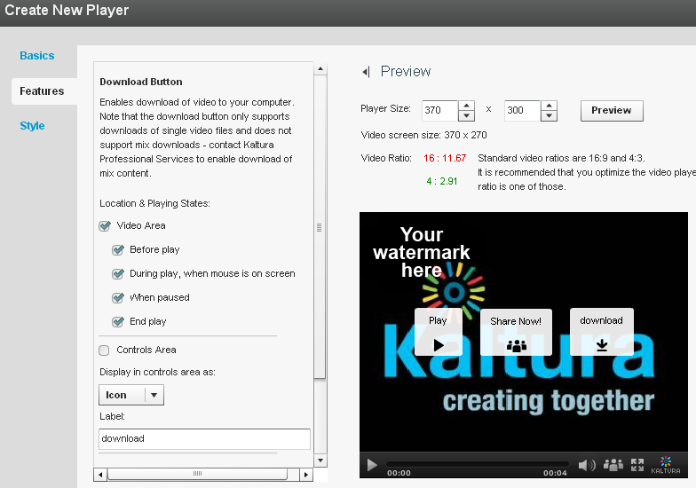

* To change a Full Screen button in the control area of a player to text button

1. In the Edit Player or Create New Player window, select the Features tab.
2. On the Controls menu, check Full Screen Button and then click Options.
3. On the Full Screen Button pane:

* Check Controls Area.
* In the Display in controls area drop-down menu, select Label.
* (Optional) In the Button Label field, enter new text.

1. (Optional) In the Tooltip fields, enter new text.
2. In the Preview area, click the Preview button to see the changes.
3. On the Full Screen Button pane, click Apply to confirm your choice and return to the Features list.
4. Click Save Changes.

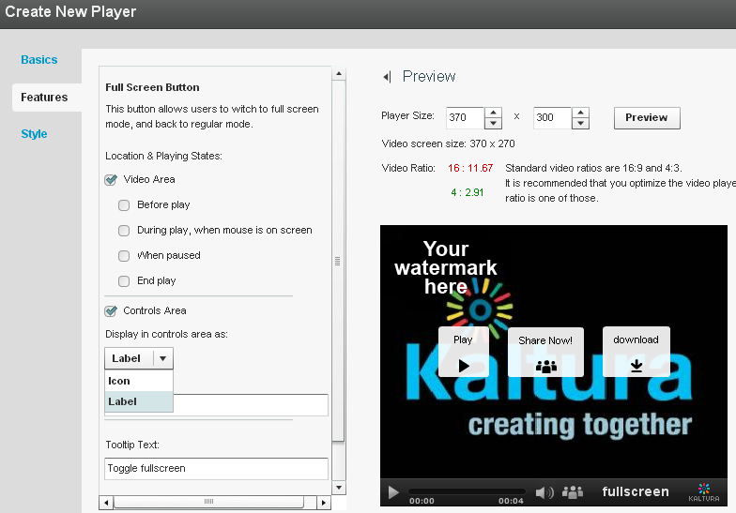

### Configuring the Player Style

Use the Style tab to select the theme, colors and fonts for your player.

* To configure the player style

1. Select the Style Tab.
2. Under Style and Color, select **Dark** or **Light**in the Select theme drop-down menu.
3. Under Control bar buttons and On-video buttons, click the small colored square next to each option to open a color picker.  
   For each option, select a color or enter a color value.  
   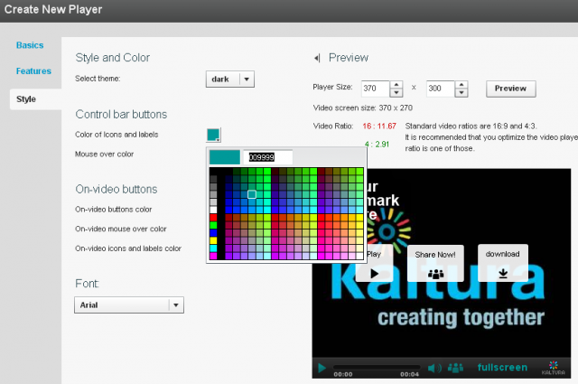
4. Under Font, select a font in the drop-down menu.
5. In the Preview area, click the **Preview** button to see the changes.
6. Click **Save Changes**.
7. After you define your player template, features and style, click Save Changes to complete your player configuration and design.

Your new player is displayed in the Players List.

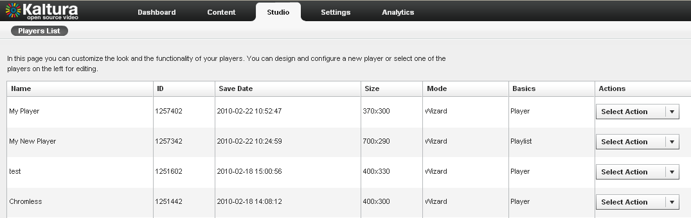

Chapter

# Managing Metadata

This section descibes the different types of metadata is and how to apply metadata to content.

## Entry Metadata

Entry Metadata fields are used to tag, manage, search and expose content. You can populate out-of-the-box fields, or create your own custom metadata schema. Kaltura provides extensive asset management and metadata capabilities. Each media entry has a list of predefined metadata fields including: Name, Description, Tags, Categories, Thumbnails, Duration, Views, and other fields.

### Types of Metadata

Kaltura supports three types of metadata for its media assets.

1. Technical metadata (read only) – includes the technical attributes of the media file. For example, the file type, duration, file format. See [KalturaMediaInfo](http://www.kaltura.com/api_v3/testmeDoc/index.php?object=KalturaMediaInfo) in the API Documentation, for a full list of predefined fields.
2. Basic metadata – includes Name, Description, Tags, and Categories’ fields. In addition, Kaltura allows referencing the media entry using an external identifier which can be stored in the Reference ID field.
3. Custom metadata – includes custom fields, defined under one or more schemas, which allow enhancing any media object into a custom business object.

Commercial users, please contact your account manager to enable this feature in your account.

Technical metadata, also known as system metadata, is generated automatically during ingestion and encoding of the file. All technical metadata information can be accessed through the Kaltura APIs.

Basic metadata is the information you input to the KMC through the Metadata tab. The Reference ID field allows storing an external identifier for supporting integrations with systems external to Kaltura or can be used to match a filename to an entry using the Drop Folder feature. See [Automated Content Ingestion via a Drop Folder](http://knowledge.kaltura.com/sites/default/files/Kaltura_Drop_Folder_Service_for_Content_Ingestion.pdf). Tags are comma separated and can be used as filters for searching through your content. Categories allow assigning media objects to taxonomies.

Custom metadata, also referred to as Custom Data is stored in a schema, also known as a metadata profile. You can create multiple schemas and assign them to any Kaltura object. The KMC supports schemas for entries and categories only. To extend the metadata of an entry, you need to create a custom schema for entries. See Adding a Schema.

Custom data is stored as an XSD schema that you can use to create, edit, and manipulate data. You can also use the XSD schema to generate you own metadata interface. Custom data XSDs are account specific.

### Metadata Actions

You can manage assets and metadata through the:

* KMC UI - You can edit basic and custom metadata for a single asset, or apply a change of a few basic metadata fields to multiple selected assets.
* KMC Entries Bulk upload (CSV/XML) – You can add assets in batch, combining both media files and associated metadata. (See Bulk Upload and FTP Upload).
* Kaltura APIs – All metadata-related functionality available through the KMC can also be performed using the Kaltura APIs. The APIs also expose additional functionality not available through the KMC. For more information see [here](http://www.kaltura.com/api_v3/testmeDoc/index.php?service=metadata_metadata).

## Uploading Content and Setting Metadata

|  |  |
| --- | --- |
|  | Uploading Content and Setting Metadata Workflow:   1. Upload a media file then set its metadata. 2. Ingest a media file bundled with metadata (CSV, XML, API) 3. Prepare a metadata-only "draft" entry for future ingestion of media files. |

### Upload a Media File and Set Its Metadata

* To upload a media file and set its metadata

1. Go to the Upload tab.
2. Upload a media file. See The Upload Tab.
3. Go to the Content tab and select the Entries tab.
4. Select a Video/Audio entry.
5. In the Metadata tab, add or edit the following metadata information.

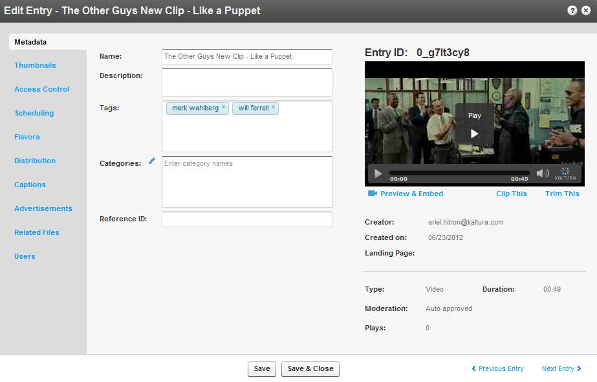

1. Name
2. Description (Optional)
3. Tags
4. Categories
5. Reference ID (Optional).
6. If you have Custom Data for entries, you can edit the Custom Data fields for the entry. For multiple schemas, use the drop down Jump To menu to select the schema for the entry. See Upload a Media File and Set Its Metadata.
7. Click Save & Close.

The Entry ID assigned to a metadata entry can be used to assign metadata to multiple files. See Editing and Creating Transcoding Profiles.

### Ingest a Media File Bundled with Metadata (CSV, XML, API)

To enable more advanced content ingestion options, the provided CSV/XML samples can be extended to include multiple/custom metadata items, account specific settings, update action and advanced content ingestion options (for example, ingestion of multiple transcoding flavors, multiple thumbnails etc.) Each item element within the XML, and each line in the CSV, represents a single entry created in the publisher account. Each entry will be populated with the metadata listed in its item element and the content referenced from it. When submitted, the bulk upload XML/CSV is validated on the Kaltura server. The validation includes an inspection of the XML structure, and verification of elements' structure and order compliance with Kaltura's bulk upload XSD (XML schema). For more information see Bulk Upload and FTP Upload.

* To ingest a media file bundled with Metadata

1. Select the Upload tab.
2. Click Download CSV/XML Samples.
3. Enter the metadata in the relevant fields.
4. For more information on the XML Custom data upload see the following:

<http://www.kaltura.com/api_v3/xsdDoc/?type=bulkUploadXml.bulkUploadXML#element-customDataItems>

http://www.kaltura.com/api_v3/xsdDoc/?type=bulkUploadXml.bulkUploadXML#element-customData

### Prepare a Metadata-only "Draft" Entry for Future Ingestion of Media Files

* To create a draft entry

1. Go to the Upload tab.
2. Prepare a Video/Audio Entry.

* To add the content (media source file) into the metadata entry

1. Go to the Content tab and select the Entries tab.
2. Select a Draft (No Media) entry.

The Edit Entry- Draft Entry form is displayed.

1. Select the Flavors tab.
2. Add the media source file. Select from one of the following options:

* **Upload Files –** upload from your desktop
* **Import Files –** import from the web.
* Enter the File URL and select the Transcoding Flavor.
* Click Import.

## Metadata and Related Files

Related Files are relevant to metadata in relation to transcript and captions/subtitles. Captions and Subtitles files are considered as metadata files that are time based and related you an entry. For more information, see Uploading and Modifying Related Files.

### Kaltura Custom Metadata Functionality

You can create a unique metadata schema. The entire schema management is done via the KMC UI. You can add fields of the following types:

* **Text field** – values are free text
* **Text select list** – this is similar to the text field, also known as List of Values, This option allows the publisher to define a predefined list of fields to be used. After you enter the values, you are presented with a select box element to select a value from the existing list (for example countries, months)
* **Date** - a date field
* **Entry ID list** - a list to a different entry (asset) that can be used to create compound structure. Examples of this would be, Related Videos, linking trailer to full-length film etc.

The following is an example of a Custom Metadata Schema.

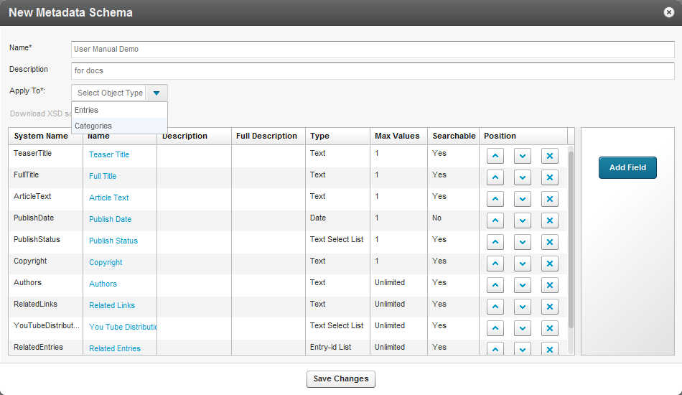

#### Using Custom Data for Entries

As a best practice we recommend richly mapping your media assets with metadata to make your assets more findable and better used as business objects.

You can fill in the values for the defined schema for each media asset (entry). The UI elements are built per the field type supporting text fields, checkboxes for multiple selections (from predefined values list), date selector (for date fields), text list (for multiple value fields), and linked entries (for creating structure).

The schemas you customize may be used for viewing and editing, as well as for filtering, search, and syndication rules. Custom data may be used as a condition for distributing content. For example if you are trying to distribute data and a custom data field has been defined and expected by the distribution channel, if the custom data is not received, the content will not be distributed.

Searching (and creating syndication rules) by a custom field is integrated into the KMC UI and workflows.

#### Using Custom Data for Categories

Using Custom Data for categories is useful when you need to set the category itself with non-standard metadata. You can manage metadata for display on the channel page in your application, within the category object and not through entries’ metadata. You can create complex filters to control which categories and channels to display in different areas of your website, and specify other options.

Creating and managing categories’ custom data is identical to how entries’ custom data schemas and values are managed and set in the KMC. Custom Data schemas should be set to apply on entries or on categories and cannot apply on both.

|  |  |
| --- | --- |
|  | NOTE: The categories’ custom data is not inherited by the entries associated with each category. Categories’ custom data is solely related to the category object and applies on category related Kaltura API calls only. |

## Managing Schemas

A schema is a model for describing the structure of information. Each data schema holds a list of customized fields. An XSD (XML Schema Definition) provides a way to describe and validate data in an [XML](http://www.webopedia.com/TERM/X/XML.html) environment.

### Adding a Schema

* To add a schema

1. Select the Settings tab and then select the Custom Data tab.
2. Click Add New Schema.

The New Metadata Schema window appears.

1. Enter a Name and Description.
2. Select what entity to apply the metadata to. The options are Entries or Categories.
3. Enter the System Name (optional). This field is required if you are uploading content using Bulk XML files or if you need access to the schema via the API.
4. Click Add Field.
5. Add custom data fields.

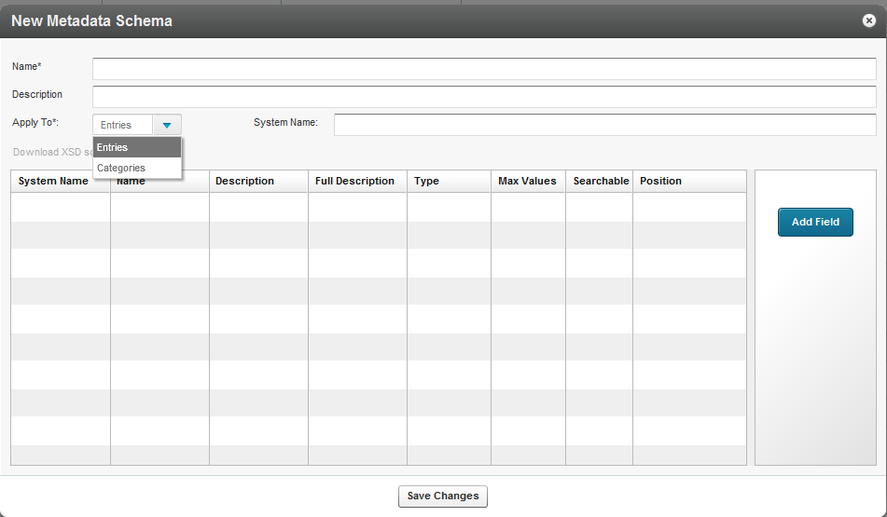

### Adding Custom Data Fields

* To add custom data fields

1. Select the Settings tab and then select the Custom Data tab.
2. Add a schema. See Adding a Schema.
3. Click Add Field.

The New Field window appears.

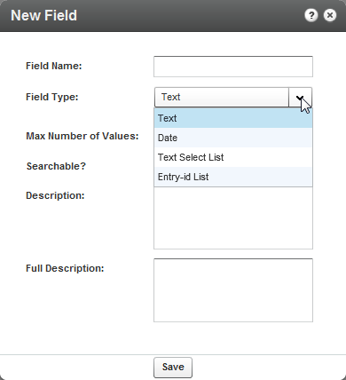

1. Select the Field type. See Kaltura Custom Metadata Functionality.
2. Enter values for the field or list.
3. (Optional) Add a Description, or Full Description.
4. Click Save. The Custom Fields List is displayed.
5. Use the up and down arrows to change the order of the fields.

The following is an example of entering data as a Text Select list for the field Publish Values.

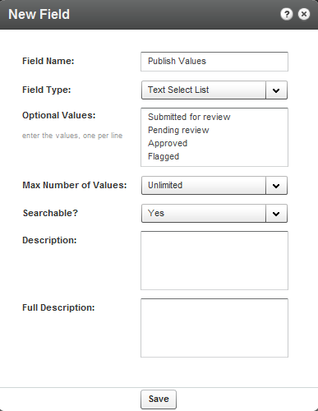

The following screen displays a schema with an entry ID chosen.

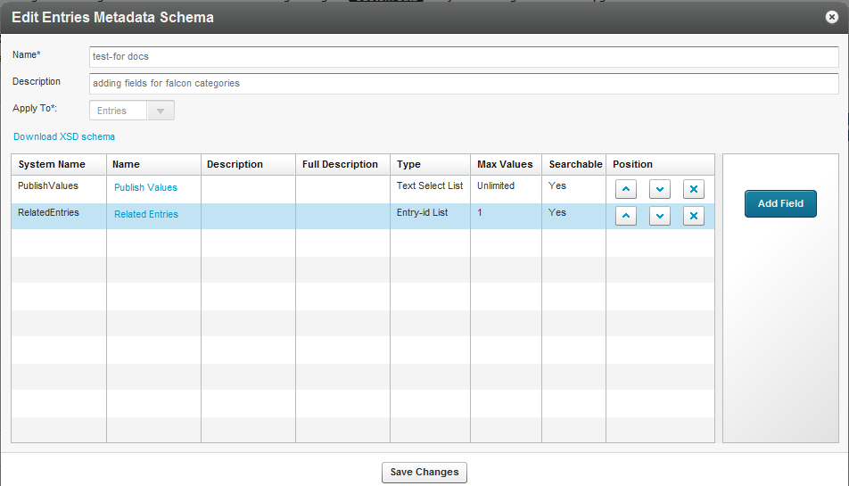

### Setting Values for Custom Metadata Fields - Per Entry

* To add values to the custom metadata fields

1. Select the Content tab and select Entries.
2. Click on entry in the Entries table.

The custom data is displayed in the Metadata tab.

1. Add or modify the Custom Data values and click Save & Close.

The following screen demonstrates the values insertion page within a specific schema. Use to scroll to view the entire schema information.

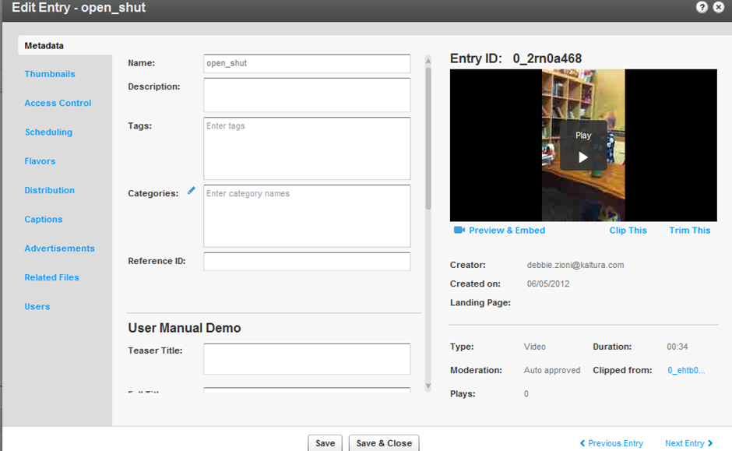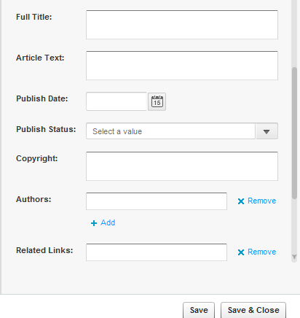

* To add or remove related entries

1. Create a schema and add the Related Entries field. See Adding Custom Metadata Fields.
2. Select an Entry and select the Metadata tab.
3. Scroll to the Related Entries field and click +Add/remove Linked Entries.

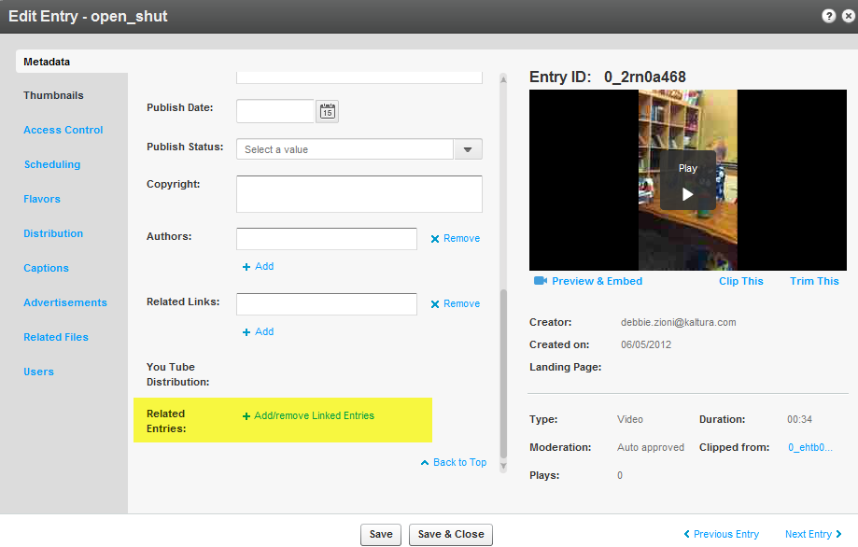

1. Move the Related Entries from the Entries table to the Selected Entries list and click Save.

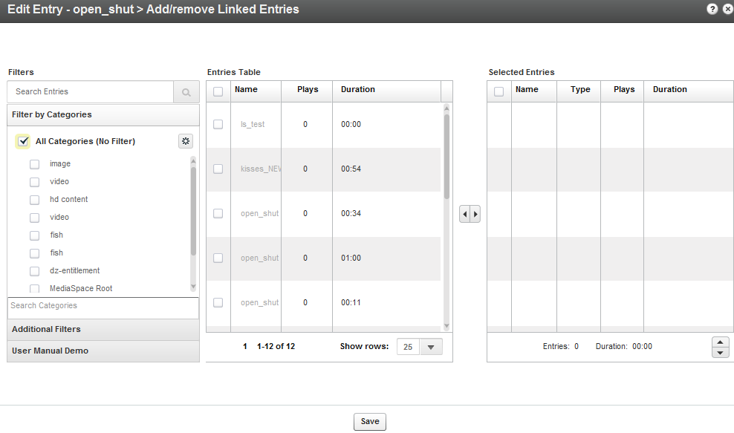

### Setting Values for Metadata Fields - Per Category

Custom Data values are set to categories in a similar way they are set for entries, but from the metadata tab of the Edit Category window.

* To add values to the custom metadata fields

1. Select the Content tab and select Categories.
2. Click on a category in the Categories table.

The custom data is displayed in the Metadata tab.

1. Add or modify the Custom Data values and click Save & Close.

The following screen demonstrates the values insertion page within a specific schema. Use to scroll to view the entire schema information.

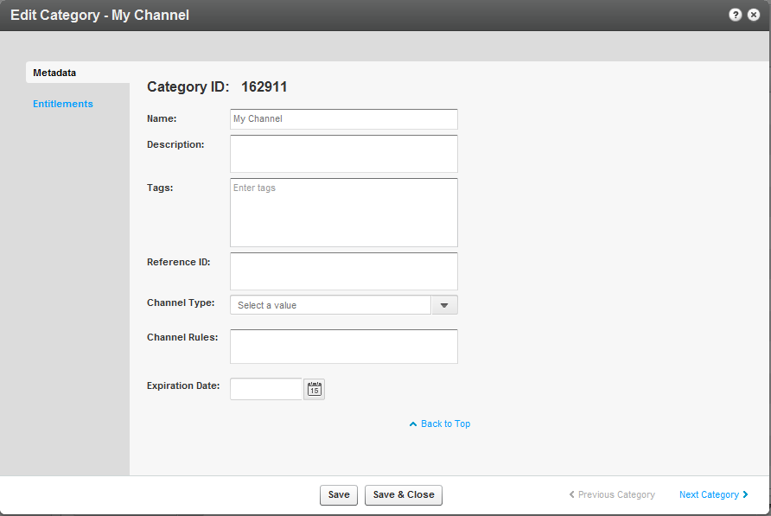

## Related Videos Gallery

The Related Videos feature can be used to display and share related videos to your viewers. Related videos are displayed according to your selection, either when a video is completed. When you select a related video, the viewer is either redirected to the specified URL, or the related video is loaded in the player.

* To configure Related Videos

1. Select the source.
2. Configure Autoplay for Related Videos.

### Related Videos Source

The source of the related videos display may be from one of the following:

**Automatic-** Automatically generated by Kaltura (default). The player will fall back to this option if you specify another Source that does not return a minimum of 12 related items.

You can view this information regarding how Kaltura will generate the Related Videos for all videos watched using this player. Please note: in order to define which Entries will be used when Kaltura is searching for related videos, you can change the configuration in the below specified Playlist

* To select automatically generated related videos
* Enter the Playlist Id.

**Reference Ids** - Related videos are contained in a list of Reference Ids from either pre-defined in a custom metadata field or passed to the Player at the application page level as a Flashvar or via the KDPs JavaScript API.

* To select related videos using the Reference ID fields
* Enter the Reference Ids fields as follows:

{mediaProxy.entryMetadata.ReferenceIds}

**Global Playlist** - For all videos played with this player, use the same playlist as the source of the related videos.

* To use the global playlist as the source for related videos
* Enter the Playlist Id.

**Entry Id List** - For each video, a list of Entry Ids is manually entered in a custom metadata field of type 'Entry-id List'.

* To use the Entry Ids as the source for related videos
* Fill out the following fields:

{mediaProxy.entryMetadata.EntryIds}

### Configure Autoplay for Related Videos

**Automatically begin playing the related videos**

After the current video has finished playing, the player automatically begins to play the related videos~~.~~ Auto-play begins if the user did not interact with the player for the set number of seconds, and this option is enabled.

* To configure autoplay for related videos

1. Enable the feature Select True.
2. Enter the number of seconds to wait until the related video is played.
3. Select which related video should be auto-played.

* First in Gallery
* Random from Gallery

1. Specify the Actions for when you select a related video from a gallery.

* Load video in player
* Load URL in Browser – enter the URL patter
* Call JavaScript on page – enter the JavaScript function name

1. Click Apply.

Chapter

# Locating Content in the KMC

This section decribes how to use categories, tags, or any of your custom metadata fields to locate content in the KMC.

## Searching Through Entries

The search box in the Entries page enables you to search for specific entries existing in your account.

* To search for any word in the entry name, tags or text fields

1. Go to the Content tab and select the Entries tab.
2. Enter your search criteria and click the magnifying icon on the right, or press Enter.

The search will apply on textual metadata fields, on the entry ID and on the User ID of the entry’s owner. For canned lists use the Metadata Filters.

You can search for content and then create playlists containing the filtered content.

* To create playlists based on filtered content

1. Search for content based on a filter.
2. Click Add Playlist to create a playlist.

* To clear the search box
* Click the X icon on the right.

## Filtering Content in the Entries Table

The list of entries can be filtered according to the parameters that are specified in the filter bars on the left side of the page. You can filter entries using the search criteria, specific categories, Additional Filters, or custom metadata based filters

|  |  |
| --- | --- |
|  | NOTE: You can sort the Entries Table by clicking on the various columns or using the scroll bar. You can also select how many items to display per page (10 to 500). |

### Using Categories as Filters

You can filter the entries in the Entries Table by selecting specific categories in the categories filter bar on the left side of the page.

You can open the Categories Filter Preferences from the preferences icon at the top right corner of the categories filter area. Your preferences will impact the behavior of the category filter.

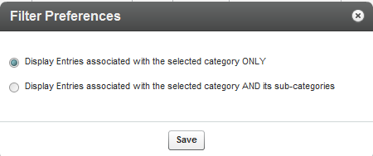

You can navigate within the categories tree to select the categories you want to filter entries by. Each category selection refreshes the Entries Table.

You may also use the Search Categories field to search for categories you want to filter by, instead of navigating to these categories from the categories tree.

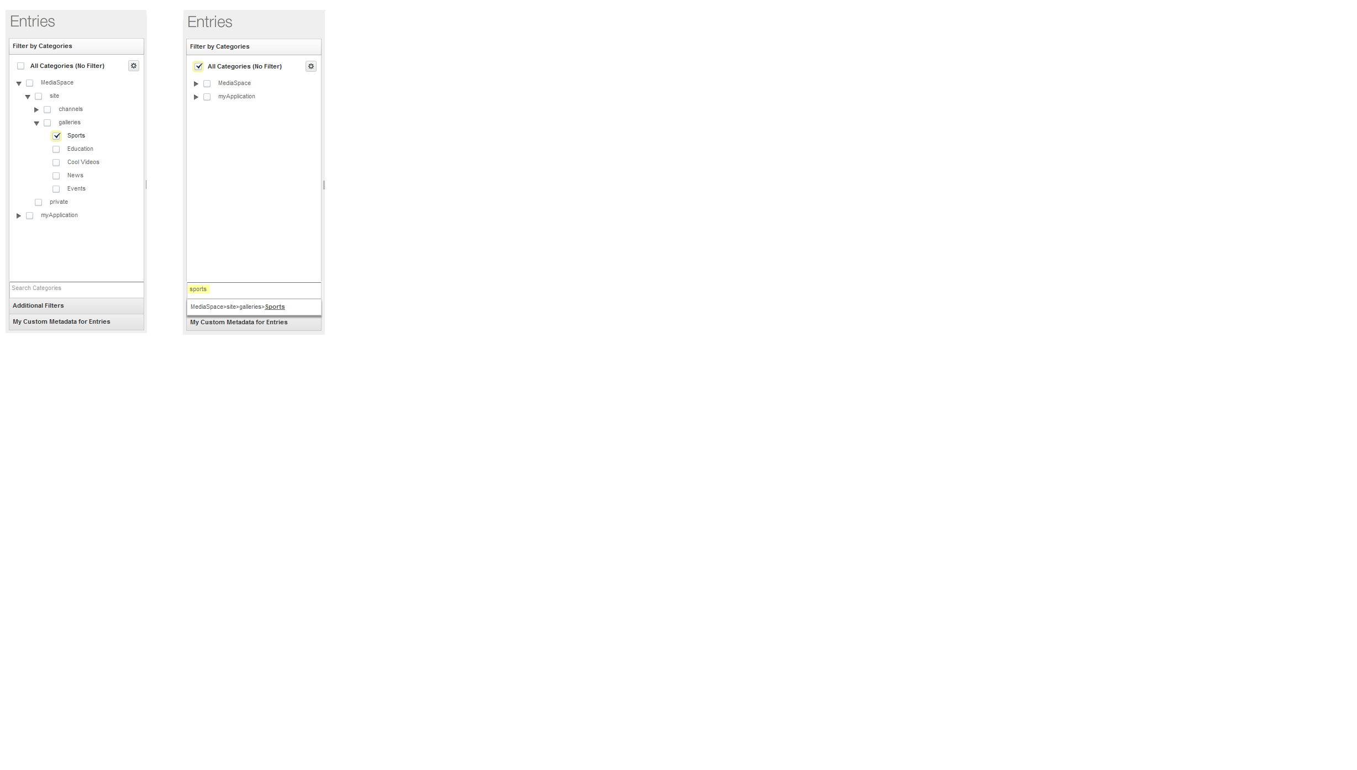

|  |  |
| --- | --- |
|  | NOTE: When a category has more than 1000 sub categories, the category cannot be expanded in the category tree. Use the Search categories option. |

### Using Additional Filters

* To use additional filters
* Click "Additional Filters" to open more filter options, including:
* Between any two specific dates
* By media type (Audio, Video, Image, Video Mix, Live Stream)
* By Ingestion Status (Ready, No Media, Pending, Uploading, Transcoding, Error)
* By duration — Short clips (up to 4 minutes), Medium clips (4 to 20 minutes), Long clips (more than 20 minutes)
* By Original or Clipped entries – original media, entries created by clipping
* By Scheduling status (Past, Live now, Scheduled to go live at a later date, Scheduled between specified dates)
* By moderation status
* By Media Replacement Status
* By Access Control Profile (See Access Control Profiles for more details.)
* By video quality (Transcoding Flavor)
* By Distribution Destination (See Distribution and Syndication for more details.)

You can filter content using a single or multiple criteria.

### Performing a Search Based on Metadata Fields

You can use custom fields to search for content and create playlists. To search textual fields, use the search box, for canned lists use the custom Metadata Filters. See Searching Playlists.

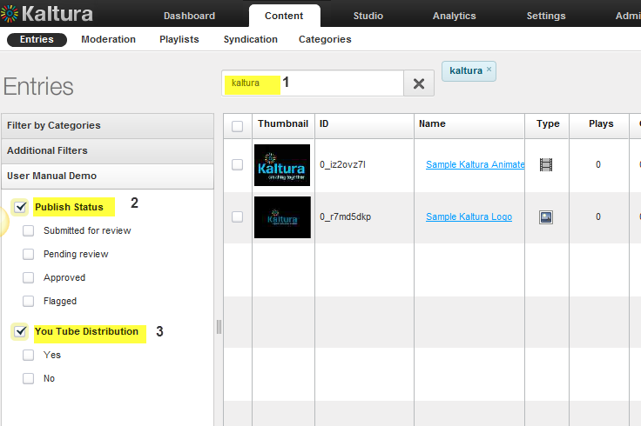

|  |  |  |
| --- | --- | --- |
| Footnote | Label | Specification |
| 1 | Search text | Search text to apply to all textual custom data, for example teaser title, authors |
| 2 | Search filter for Publishing Status | For publishing status |
| 3 | Search filter for Distribution settings | For content based on distribution channel’s settings |

### Entries Table Filter Indications

When the Entries table is filtered by categories, filters and/or search criteria, indications for the selected filters are displayed above the Entries Table. You can remove a filter directly from this display by clicking on the x on the name of the filter.

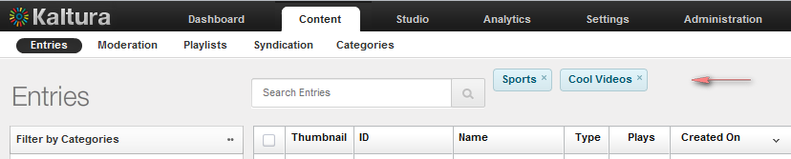

## Searching Through Categories

When managing your categories, the search box in the Categories page enables you to search for specific categories existing in your account.

* To search for any word in the category name, tags or text fields

1. Go to the Content tab and select the Categories tab.
2. Enter your search criteria and click the magnifying icon on the right, or press Enter.

The search is applied on textual metadata and custom data field. For canned lists, use the Categories Metadata Filters.

## Filtering Categories in the Categories Table

When managing categories, the Categories Table can be filtered according to the parameters that are specified in the filter bars on the left side of the page. You can filter categories using the search criteria, by categories. For listing categories under a specific parent category, use Additional Filters or use the custom data based filters.

### Using Categories as Filters

When managing categories, you can filter the categories in the Categories Table by selecting specific categories in the categories filter bar on the left side of the page.

You can open the Categories Filter Preferences from the preferences icon at the top right corner of the categories filter area. Your preferences impact the behavior of the categories filter.

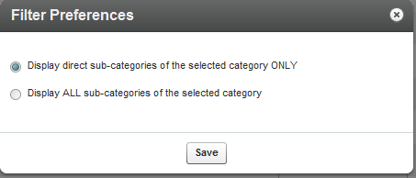

You can navigate within the category tree to select the categories you want to filter the Categories Table by. Each selected category refreshes the Categories table.

You may also use the Search Categories field to search for categories you want to filter by, instead of navigating to the categories from the categories tree.

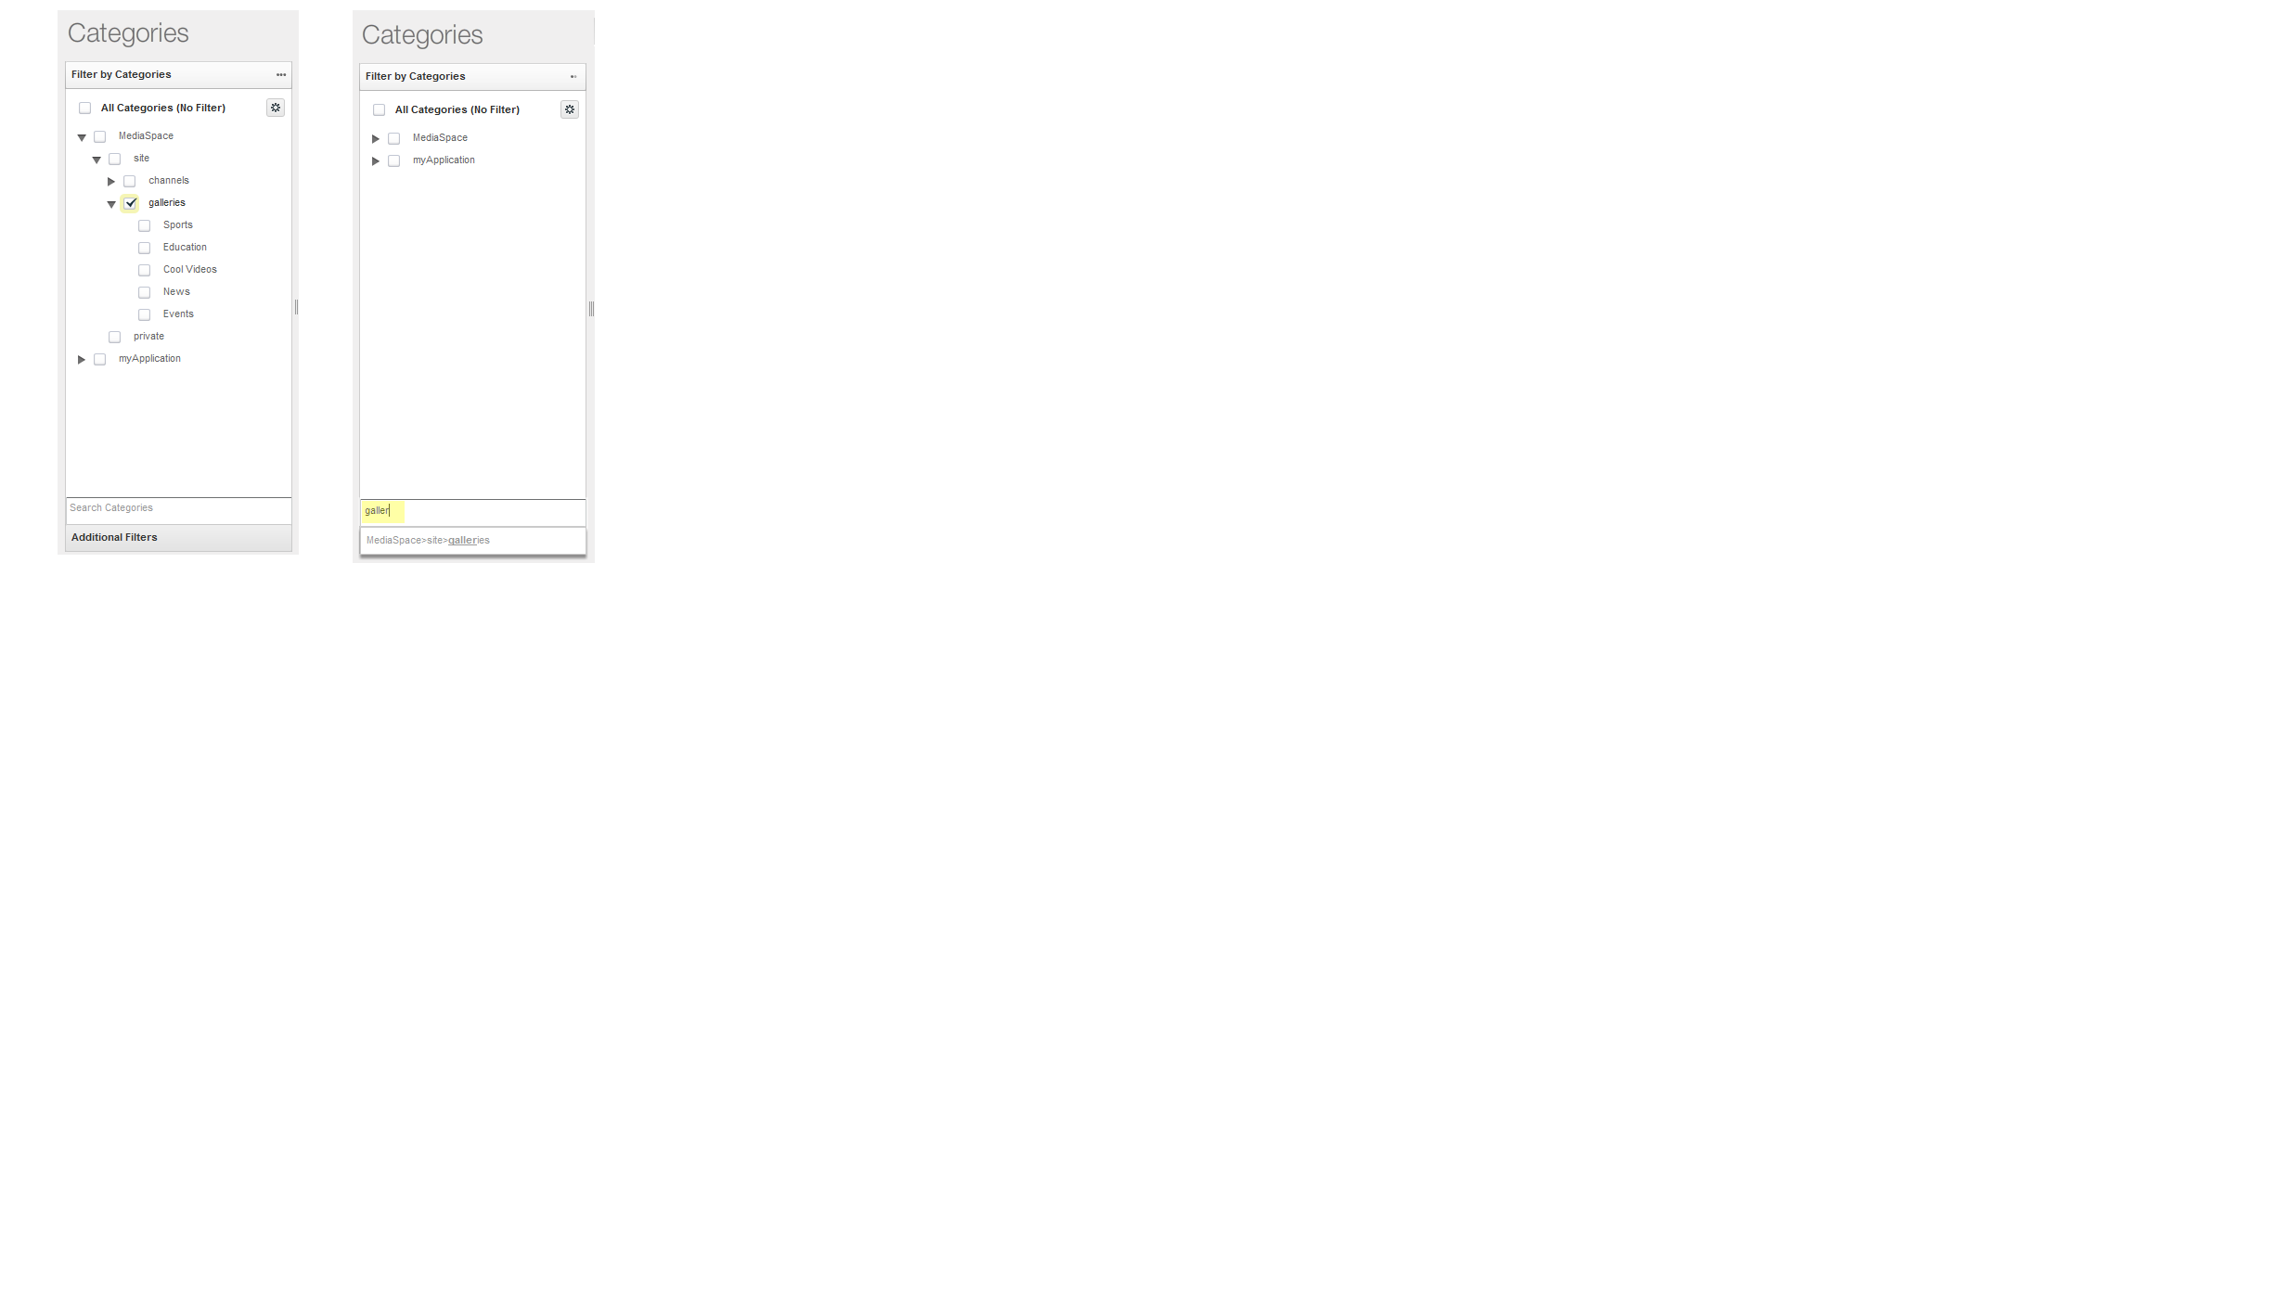

|  |  |
| --- | --- |
|  | NOTE: When a category has more than 200 sub categories it cannot be expanded in the category tree. Use the Search categories option. |

### Using Additional Filters

* To use additional filters
* Click "Additional Filters" to open more filter options, including:
* Created Between any two specific dates
* By content privacy options (available with entitlement configuration only)
* By category listings(available with entitlement configuration only)
* By contribution policy(available with entitlement configuration only)
* By the availability of specific end –user permissions(available with entitlement configuration only)

### Categories Table Filter Indications

When the Categories table is filtered by categories, metadata filters or search criteria, indications for the selected filters are displayed above the Categories Table. Click on the X to remove a filter directly from this display.

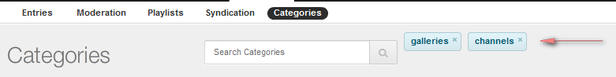

## Searching Playlists

Use the Filters pane to search for playlists in your account. You can search for any word in the playlist name, tags or both. You can also filter by date by select a date range or by clicking the calendar icons on the Created between fields.

Chapter

# Managing Access Control Profiles

This section describes access control profiles and how to create and apply access control information to your content.

## Access Control Profiles

Kaltura supports several publication restrictions allowing limited access to content when business requirements dictate it. These restrictions can be placed on the entry level but can also be streamlined to be set automatically or on demand, on a group of items based on a set of criteria, during upload via a bulk upload CSV file, or during an update transaction using Kaltura’s APIs. See [Kaltura API](http://www.kaltura.com/api_v3/testmeDoc/index.php?object=KalturaResource) documentation.

An Access Control Profile defines authorized and restricted domains where your content can or cannot be displayed, countries from which it can or cannot be viewed, white and black lists of IP addresses and authorized and unauthorized domains in which your media can be embedded. Use the Access Control tab to view existing profiles and create new ones.

Controlled access provides authentication and authorization capabilities. Developer authentication is done using a combination of the Partner ID and one of two “secrets”, each providing a different set of authorization capabilities. In return, a Kaltura Session token (“KS”) is generated, through which API calls can be made.

You can segregate your content based on your various user groups and audiences. You can create content channels to be accessed only by certain users, and allow other content items to be available to all.  Access profiles also allow you to manage groups and users on your own identity.

* To view Access Control settings
* Select the **Settings** tab and then select the **Access Control** tab.

The Access Control Profiles window is displayed. A default access control profile that permits access to all is configured automatically.

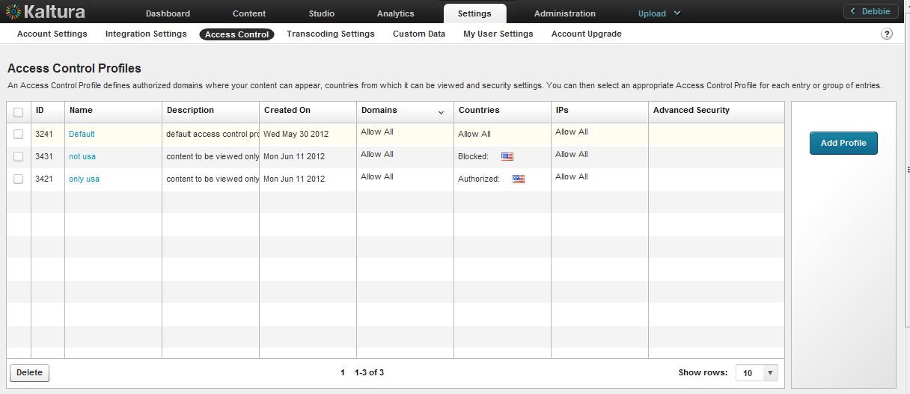

## Creating an Access Profile

* To create an access control profile

1. Select the Settings tab and then select the Access Control tab.

The Access Control Profiles window is displayed.



1. Click Add Profile.

The New Access Control Profile window is displayed.

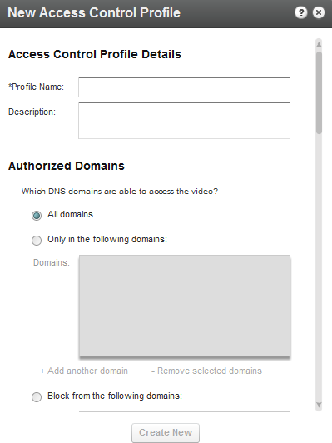

1. Enter an informative Profile Name and Description for the profile.
2. Configure the Authorized Domains. See Restricting Domains.
3. Configure the Authorized Countries. See Restricting Countries for Viewing.
4. Configure the Authorized IP Addresses. See Restricting Views by IP Address.
5. Configure the Advanced Security. See Restricting Views with a Server Side Secret
6. Click Create New.

## Editing an Access Profile

* To edit an access control profile

1. Select the Settings tab and then select the Access Control tab.

The Access Control Profiles window is displayed.

1. Select the access profile you want to edit.

The Edit Access Control Profile window is displayed.

Modify the profile according to the sections described in Creating an Access Profile.

### Restricting Domains

Kaltura’s Access Control mechanism provides the means to restrict content playback from specific domains. This is useful to prevent scraping of content from your website or re-sharing of content on other sites that are not yours.

Domain restrictions allow you to define a “white list” of domains that allow only playback attempts of content placed on these domains to be granted. Any playback attempt via the Kaltura Dynamic Player placed on a domain *not* on this list will be denied. In the same manner a “black list” can be defined performing the opposite constraint. Any playback attempt from these domains will be denied. You can create a combination of both “white listed” and “black listed” domains.

* To restrict content to specific domains.

In the **Authorized Domains** section, select one of the following options:

* Toggle All Domains – content will display in all domains.
* Toggle Only in the following domains - enter a site or list of approved sites to display content. See Add or Remove a Domain.
* Toggle Block from the following domains - enter a domain or list of approved of domains to exclude. See Add or Remove a Domain.

#### Adding or Removing a Domain

* To add a domain

1. Click + Add another domain.

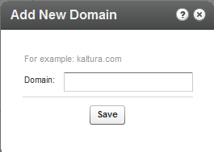

1. Enter the domain name in the format of *company.com*

* To remove a domain

1. Select a domain from the listed domains.
2. Click the Remove selected domains.

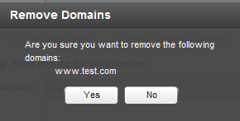

1. Click Yes.

### Restricting Countries for Viewing

Geographic restrictions, similar to domain restrictions, allow you to define a “white list” or a “black list” of specific geographical locations, limiting or enabling playback attempts of content for users located in these locations. For example, a Kaltura Player entry assigned with geo-restrictions where the white list contains only Spain can be placed on any domain but will only be playable by viewers located in Spain.

* To restrict content to specific countries

In the **Authorized Countries** section, select one of the following options

* Toggle Anywhere– content will be displayed in all countries.
* Toggle Only from the following countries- select a country or list of approved countries that will display content. See Add or Remove Geographic Regions (Countries) .
* Toggle Block from the following Countries - enter a country or list of approved of countries to exclude. See Add or Remove Geographic Regions (Countries).

#### Adding or Removing Geographic Regions (Countries)

* To add a geographic region

1. Click + Add Remove Countries.

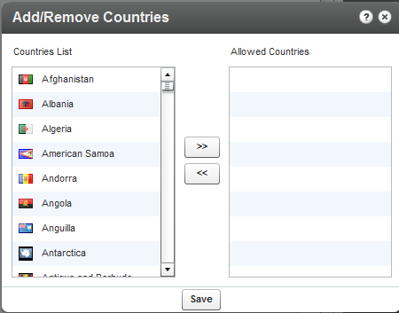

1. Use the scroll (Ctrl button for multiple selections) and select the countries from the Countries List.
2. Use the arrow buttons to transfer the selected countries to the Allowed Countries.
3. Click Save.

* To remove a geographic region

1. Click+ Add Remove Countries.

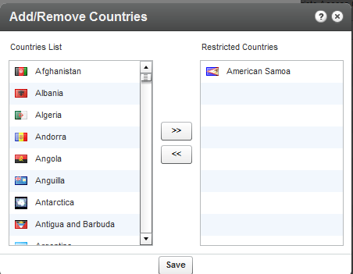

1. Use the scroll (Ctrl button for multiple selections) and select the countries from the Restricted Countries.
2. Use the arrow buttons to transfer the selected countries to the Allowed Countries.
3. Click Save.

### Restricting Views by IP Address

You can restrict content view by IP addresses or ranges and determine which IP ranges will be allowed to view the content.

* To restrict Views by IP Address
* In the **Authorized IPs** section, select one of the following options
* Toggle All IPs – content will be displayed for all IP addresses.
* Toggle Only from the following IPs- select a range of approved IPs that will display content. See Add or Remove IP Addresses.
* Toggle Block from the following IPs- enter a range of approved IPs that should be excluded from content viewing. See Add or Remove IP Addresses.

#### Adding or Removing IP Addresses

* To add or block IP addresses

1. Click + Add Another IP.

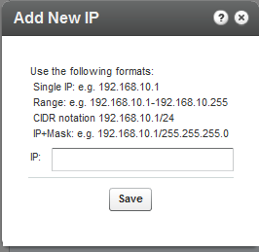

1. Use the notation indicated to enter IP addresses.
2. Click Save.

* To remove IP addresses

1. Highlight the IPs you want to remove from the restricted list.
2. Click +Remove Selected IPs.

A warning message is displayed.

1. Click Yes.

## Restricting Views with a Kaltura Session

Often, the user authentication/entitlement mechanism that decides whether a user is entitled to access a specific media entry or not, will reside outside of Kaltura. When the authentication mechanism resides outside Kaltura, we recommend that you use an Advanced Kaltura Session (KS) based Access Control mechanism, that permits access to the media only when a valid Kaltura Session is provided. .The external entitlement mechanism will then generate the valid Kaltura Session when users should be permitted to view the content.

The session is created using a secret. The external entitlement mechanism will then generate the valid KS when users should be permitted to view the content. Common examples include -

When implementing paid content where the payment gateway is not Kaltura, the server processing the payment will be the mechanism deciding on entitlement. After the payment is processed, the payment server creates a valid Kaltura Session by calling the Kaltura API and passes that KS to the Kaltura player.

When implementing a single-sign-on and permissions mechanism using LDAP or other authentication mechanism outside of Kaltura, the server responsible for user authentication contains the entitlement logic. The authentication server will call the Kaltura API and generate a valid KS when appropriate.

A Kaltura Player marked with tokenized access requires a “session token” to be created and provided during every playback. A session token can only be created by a developer possessing valid credentials and expires after a limited amount of time. Thus, even if an attempt to grab the item’s direct URL is successful, the playback session will soon expire and without possession of the valid credentials, regeneration of a new token will not be possible.

This option is useful to prevent scraping of content from your website or re-sharing of content on other sites that are not yours and provides an additional amount of security to content display.

### Pay-Per-View

You can enable paid programming with a video preview, and easy, on-the-fly payment options for full video access.

* To create a Kaltura Session restriction to view content
* Check Secure viewing of this video with Kaltura Session (KS).
* To enable a free preview

1. Check Free Preview.
2. Enter the amount of time in seconds for the free preview display.

## Assigning an Access Control Profile to an Entry

You can assign an Access Control Profile to an entry.

* To assign an access control profile to an entry

1. Go to Content tab and select the Entries tab.
2. Click on the entry to which you want to assign an Access Control Profile.
3. Go to the Access Control tab and select an existing profile from the drop-down menu.
4. Click Save & Close to complete the process.

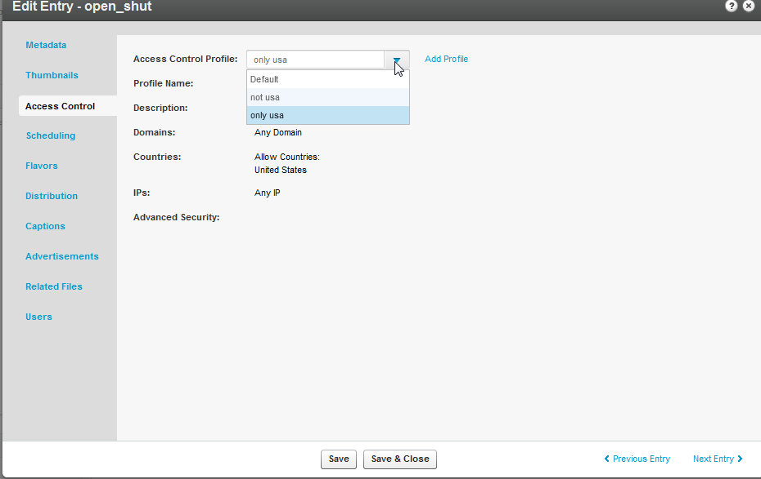

### Assigning an Access Profile to a Bulk Upload

A default access profile is included with the KMC. After you create an Access Profile, an ID is created and listed in the Access Control page.

* To assign an access profile to a bulk upload
* Set the ID from the Access Control List to the accessControlProfileId in your CSV
* Set the profile ID from the Access Control List to the accessControlId in your XML file.

## Content Scheduling

Content Scheduling determines when your media entries will be permitted for viewing (“sunrise”) and when access should be automatically discontinued (“sunset”). You can set specific scheduling parameters for your content. You can set the entry to be available for display at any time (for example, no schedule limitations) or you can set the entry to be available during a limited timeframe (for example, display this video starting on X date with no end time, or display this video only between X date and Y date).  Note that when users try to access a video that is no longer valid (in terms of its scheduling), they will receive an error message explaining that this content is no longer valid.

* To configure content scheduling

1. Go to Content tab and select the Entries tab.
2. Click on an entry.
3. Select the Scheduling tab and select and set your specific time range.
4. Click Save & Close to complete the process.

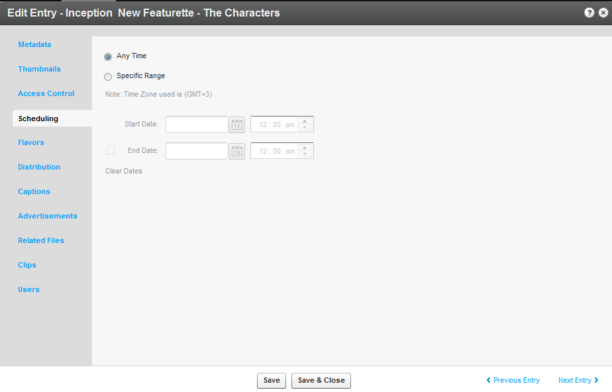

Chapter

# Managing Content Entitlement

Kaltura provides a built-in infrastructure for controlling and managing end-user entitlements to content. This infrastructure includes the required attributes and permission controls as well as the server utilities for enforcing those controls.

Using Kaltura’s entitlement services, end-user facing applications such as Kaltura MediaSpace can be extended to add the following capabilities:

* **Groups’ media channels -** Provides the ability to set media channels that limit access and contribution of content to members of a specific group of users.
* **Granular control over user permissions to content -** Provides the ability to define different privacy and permission levels for accessing and managing content in media channels.
* **Personalized global search engine -** Provides the ability for users to easily search and find relevant content from the entire set of media they are entitled to access.

### Kaltura’s Entitlement Model

Kaltura’s entitlement model relies on the extension of Kaltura’s categories. Categories may hold entitlement settings as well as specific end-user permissions. These entitlement settings and end-user permissions are inherited by media entries associated with these types of categories.

The entitlement model provides a direct association between end-users and the collection of media items they are entitled to access, and enables a simple and efficient way to add entitlement controls to both flat and hierarchal application/website navigation layout.

## Category’s Entitlements Tab

Entitlement settings may be set on categories in different ways, for example, from the application, via the CSV or through a Kaltura API. The Category’s Entitlements tab in the KMC is where content entitlement settings are managed by account administrators. The Entitlements tab only appears in KMC accounts that are set with the entitlement feature and in categories that were set to have entitlement settings for an application.

|  |  |
| --- | --- |
|  | NOTE: The Entitlement Settings are added to categories as part of the MediaSpace installation. For other purposes entitlement settings can be added to categories from the Integration Settings page under the Settings tab. See Adding Entitlements to Categories for more information. |

The following sections describe the different setting options available in the Entitlements tab and their impact on end-user entitlements in applications such as MediaSpace.

|  |  |
| --- | --- |
|  | Workflow to set Entitlement Settings   1. Create a category. See Adding/Editing a Specific Category. 2. Add Entitlements to categories. See Adding Entitlement to Categories. 3. Go to the Content tab and select the Categories tab. 4. Click on a category or select Edit from the Actions drop down menu. 5. Select the Entitlements tab. 6. Set the Entitlement Settings. |

### Setting the Entitlement Settings

Perform the tasks in the workflow to configure the KMC with Entitlement Settings.

* To set Entitlement Settings

1. Set the Content Privacy. See Content Privacy.
2. Select the Category Listing.
3. Select the Contribution Policy.
4. Select whether to inherit specific end-user permissions.
5. Set Specific End User Permissions.
6. Change Owner.

Click Manage to manage end-user permissions.

Configure Additional Category Entitlement Settings.

1. Click Save & Close.

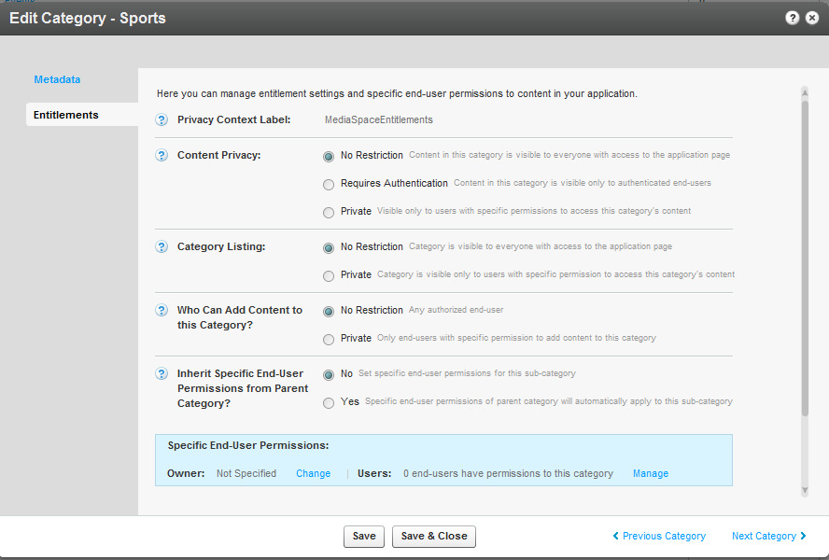

### Content Privacy

The content privacy defines the visibility of content associated with a category, including its related metadata. The Content Privacy setting is applied to:

* Who has access to content published in channel pages
* Which content will be available to the user in the application global search results
* Who can access to a single media item in the application.

The Content Privacy options are:

* **No Restriction** – Content in the category is visible to everyone with access to the application page it is published in. **In MediaSpace** - this option is mostly relevant for setting Media Galleries that are open on the web and can be accessible by everyone, including anonymous viewers.
* **Requires Authentication** – Content in the category is visible only to authenticated end-users – **In MediaSpace** this option is mostly relevant for setting Media Galleries or Open/Restricted Media Channels that are available to all authenticated users (users of the company/Institution, customers with login etc.) User authentication is made by MediaSpace against the customer Identity Management system, or with using Kaltura’s authentication services. In both cases, the authenticated user ID is then passed to the Kaltura server through the application session.
* **Private** – Content in this category is visible only to users with specific permission to access this category's content and to the owner of the content. **In MediaSpace** this option is mostly relevant for setting Private Media Channels - available only to a group of users.
* Note: With any content privacy option the owner of the content is entitled to access and manage his content

### Visibility of Content Associated with Multiple Categories

For content associated with more than one category, the privacy and visibility of this content via global search or a direct link to the video page, is determined based on the category with the lowest restriction level the content is associated with (within the application category tree).

#### Examples

**In a MediaSpace based media portal**:

* A video that is published in a few private channels but also in at least one public gallery (Content Privacy = No Restriction) will be visible to everyone with access to the portal. Access to this video in this case is available to all from the public gallery page itself, via the portal’s Global Search or via a direct link to the MediaSpace page of this video.
* A video that is published in a few private channels but also in at least one organizational shared gallery (Content Privacy = Requires Authentication), will be visible to all members of the organization (following login to the portal) from the organizational shared gallery page itself, but also via the portal’s Global Search or via a direct link to the MediaSpace page of this video. This content will not be available to anonymous viewers with a direct link to the MediaSpace page of this video - a login page will be prompted in this case.
* A video that is published in a few private channels but is also set in Kaltura categories managed in the KMC account that are not integrated with the media portal (for example, categories integrated with Kaltura extensions to CMS/LMS, categories set by the account KMC administrator for different purposes, etc.). Access to the video via the Media Portal is determined only by the entitlements settings of the categories the Media Portal is integrated with. This is controlled by the application specific “privacy content” label set to these categories.
* A video that uploaded by an end-user but was not published in any gallery or channel in MediaSpace (private media), could only be accessed by the content owner.

### Visibility of Content in Outside of the Application

When the entitlement feature is enabled for the account, an internal enforcement level is also set and managed by Kaltura.

The options for entitlement enforcement are:

* **Entitlement enforcement is enabled by default.**

When entitlement enforcement is enabled for the account - access to content under categories with entitlement is only possible via applications that implement entitlement and are integrated with these categories. This is the recommended setting in MediaSpace accounts for the highest level of content security.

**Note**: that embed codes that are grabbed by authorized users from within the MediaSpace application are bypassing the entitlement enforcement for the specific entry. Thus the entry will become publically available within the grabbed player outside of MediaSpace.

* **Entitlement enforcement is disabled by default and enabled by the application.**

When entitlement enforcement is disabled for account - access to content under categories with entitlement is possible via any application, including player embed codes that are grabbed from the KMC. With this option the application itself activate the entitlement enforcement so entitlement rules are kept within the application but all content in categories the application is integrated with can be accessed via other applications as well. This is the default setting for Kaltura trial accounts.

Contact Kaltura to change the entitlement enforcement level for your account.

### Category Listing

The Category Listing option defines who can see the category's name and metadata in MediaSpace. The Category Listing options are:

* **No Restriction** - With this option, the category name and metadata is visible to everyone with access to the application page it is listed in. **In MediaSpace** - this option is used for having MediaSpace Galleries always listed in the top menus and side navigation layout and for having MediaSpace open or restricted channels included in the Channels listing page.
* **Private** – With this option, the category name and metadata are visible only to users with permission to access the category and its content. In MediaSpace this option is used for having private channels visible only to group members.

### Contribution Policy

The contribution policy option defines which end-users can add content to this category through applications. The applicative permission to publish in MediaSpace’s shared Galleries is set from the MediaSpace Application Role of the user. See the [Kaltura MediaSpace Setup Guide](http://knowledge.kaltura.com/node/559/edit?destination=admin/content/node) for more information. The category contribution policy adds the ability to have this type of authorization for publishing content in specific galleries/channels.

The Category Contribution Policy options are:

* **No Restriction –** With this option, any end-user authorized to publish content in MediaSpace can publish content in the gallery/channel associated with this category. In MediaSpace this option is used in shared galleries to which every user with a MediaSpace Admin Application Role can add content to, and in Open Channels to which all MediaSpace users with content can add their content to.
* **Private -** With this option, only end-users with specific permission to add content to this category are able to add content to it. In MediaSpace this option is used in Restricted/Private Channels.

### Specific End-User Permissions

When any one of the Category Entitlement Options is set to Private, the respective access level is based on specific end-user permissions. User permissions to a category and content associated with it are set through 4 permission levels: Member, Contributor, Moderator, and Manager. The basic access permissions listed below are enforced by the Kaltura server. In MediaSpace the permission levels are used to control the availability of the relevant UI controls and user flows, for example, Channel Settings, Channel’s moderation panel, Publish Module and others.

| Permissions  Permission  Levels | View Content and Category | Add Remove Content to Category | Approve Content added to the category | Edit Category’s settings, privacy options and user permissions | Remove Category |
| --- | --- | --- | --- | --- | --- |
| Member | X |  |  |  |  |
| Contributor | X | X |  |  |  |
| Moderator | X | X | X |  |  |
| Manager | X | X | X | X | X |

The settings of end-user permissions can be made from the KMC, in Bulk Process via a CSV formatted schema, or via Kaltura APIs.

**In MediaSpace:** Channel Managers are able to set their channel’s groups members and may assign different permission levels to members of their group.

**Note:** the content owner has always full access and editing permissions to his own content. He is also able to remove his content from any category, regardless of the category’s settings.

**Tip:** the category end-user permissions may also be used by applications when the category is not set as private – for granting category specific applicative permissions to specific users. **In MediaSpace:** users that is not set to with an Admin Application Role can still be granted with permission to publish content in specific galleries. In this case the category’s contribution policy is set to **No Restriction** while ability to publish content in the respective gallery is granted by the application to all MediaSpace **Admin** users, but also to a few specific users that are set as contributors in the category.

#### End-User Permission Attributes

* **Status –** indication to the state of the user permission set to the category. This attribute may be used for supporting different applicative flows.
* **Active** – Access permission is active and enforced
* **Deactivated** – Access permission is not active anymore. (can be activated again)
* **Update Method** - indication on how a specific end-user permission is updated, this may be used for supporting automatic processes for setting permissions to channels from groups managed in on organizational information systems, while being able to set manual overrides to specific end-user permissions.
* **Automatic -** user permission is updated via an automatic process (either via a CSV formatted schema or an API based integration). User permission level may be updated by the automatic process.
* **Manual –** user permission is updated manually only and will not be updated by an automatic process.

### Managing Categories Specific End-User Permissions

* To manage categories specific end-user permissions

1. Set the Entitlement Settings.

The Specific End-User Permissions window is displayed.

1. Click Add Users.

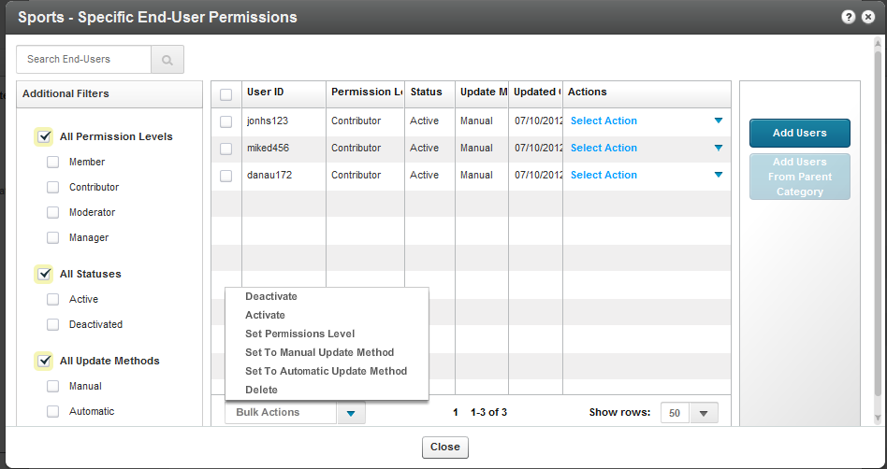

1. Select the Permission Level. See Specific End-Users Permissions.
2. Select the Update Method. See End User Permission Attributes.
3. Select End Users. Enter user names.
4. Click Save & Close.

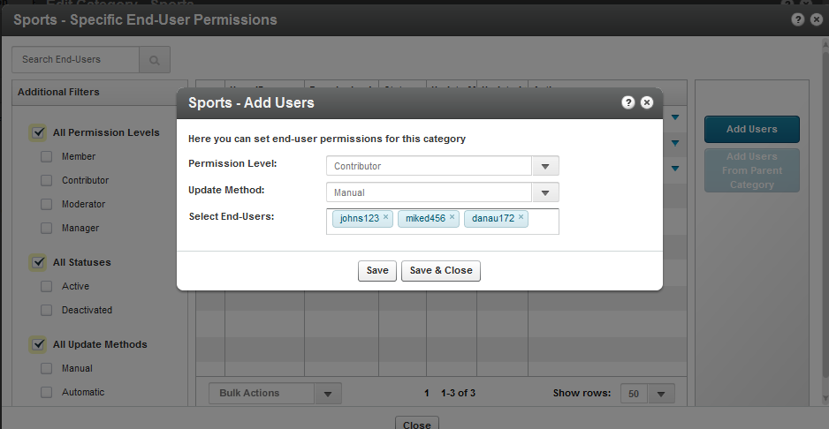

### Bulk Actions for Managing Categories Specific End-User Permissions

* To perform bulk actions on specific end-user permissions

1. Check the box or multiple boxes next to the user name and select Bulk Actions on the bottom of the page.
2. Select one of the following options

* Deactivate – deactivates the specific end user permissions for the category
* Activate – activates the specific end user permissions for the category
* Set permission levels- overrides the permission level of all selected end-users
* Set to manual update method. See End-User Permission Attributes.
* Set to automatic update method. See End-User Permission Attributes.
* Delete- deletes specific end-user permission for the category.

1. Click Close.

### Additional Category Entitlement Settings

The following additional settings are available at the lower part of the Entitlements tab:

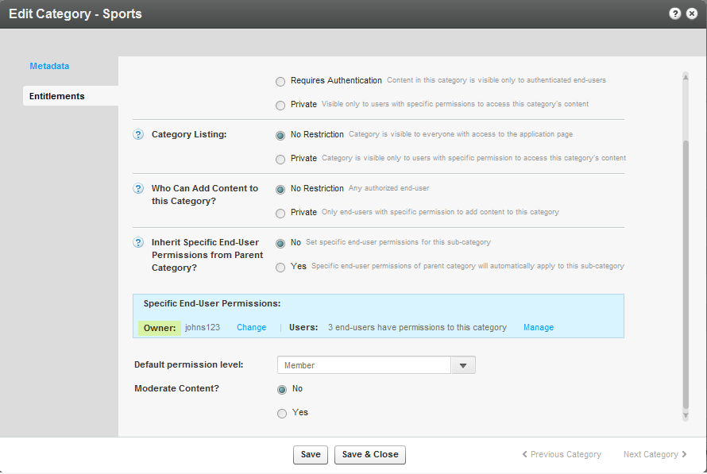

* **Category Owner** – a category attribute, for setting one of the channel managers as the channel owner for any applicative need. The category owner is automatically set with a manager permission level for the category. See Change Owner.
* **Default Permission Level** – a category attribute for setting a specific default permission level to the category, for supporting different applicative flows.
* **Moderate Content** - a category attribute, for supporting the moderation of content prior it’s publishing in the channel. (Moderation is configured through MediaSpace.)

Chapter

# Managing Categories

Media entries may be divided into categories. The different categories are built in a tree-like hierarchy where each category can include multiple sub-categories.

Categories provide a logical structure for your site and assist with content management. You can use categories, along with metadata and filters to create manually or dynamically generated playlists.  Categories may also be used for setting content entitlements to end-users in various applications. See Entitlement Settings.

## Defining and Assigning Entry Categories

Categories are built in a tree-like hierarchy where each category can include multiple sub-categories. You can add, remove and edit categories from the Categories Tab. You can assign a media entry to a specific category from the Entries Tab.

* To assign an entry to a specific category

1. Go to the Content tab and select the Entries tab.
2. Click on the Entry.
3. Enter the Category in the Metadata tab.
4. Click Save and Close.

* To remove an entry from a category

1. Go to the Content tab and select the Entries tab.
2. Click on the Entry.
3. Remove the category settings in the Metadata tab.
4. Click Save.

|  |  |
| --- | --- |
|  | NOTE: When you click Delete in the Entries table, the entry will be deleted from the account and not only from the category that is currently selected. See Delete Entry. |

## Categories Table

The Categories Table lists the categories in your account and provides a way to edit the category’s specific metadata and entitlement settings. You can edit each a specific category from the Edit Category window or apply actions on several categories simultaneously from the Bulk Actions Menu.

### Adding/Editing a Specific Category

* To add a category

1. Select the Content tab and then select the Categories tab.
2. Select Add Category.

The New Category window is displayed.

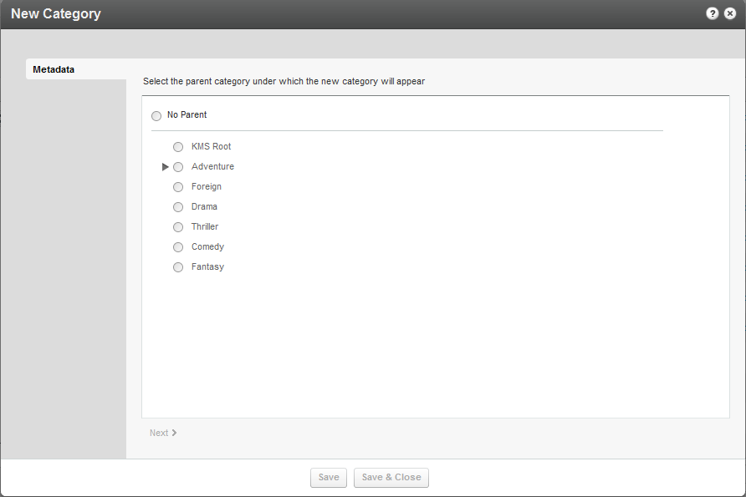

1. Select No Parent if you want the category to be at the top level or select the parent category under which the new category should be created and select Next. We recommend that you minimize categories at the top level. The New Category window is displayed.

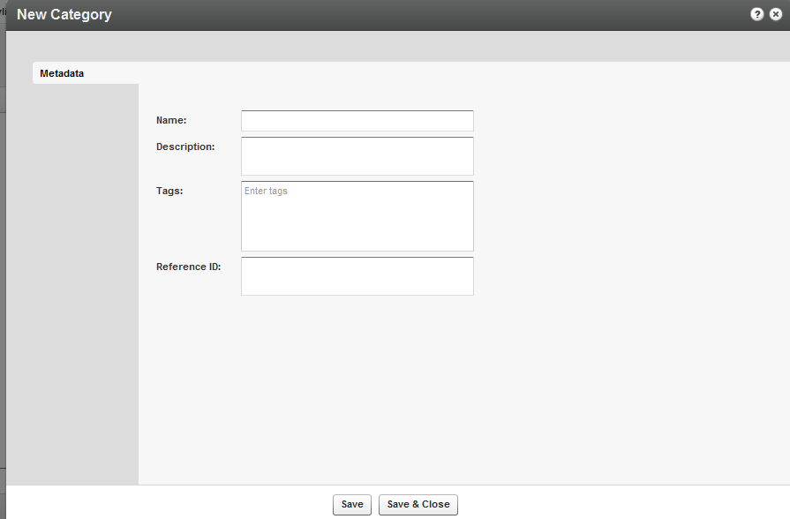

1. Add metadata and click Save & Close.

### Adding Metadata to a Category

You can add or edit metadata to a category or to multiple categories.

* To add/edit metadata to a category

1. Select the Content tab and then select the Categories tab.
2. Click on a category. Edit Category window is displayed.
3. In the Metadata tab, add or edit the metadata information. Enter a
4. Name
5. Description (Optional).
6. Tags.(Optional)
7. Reference ID (Optional).

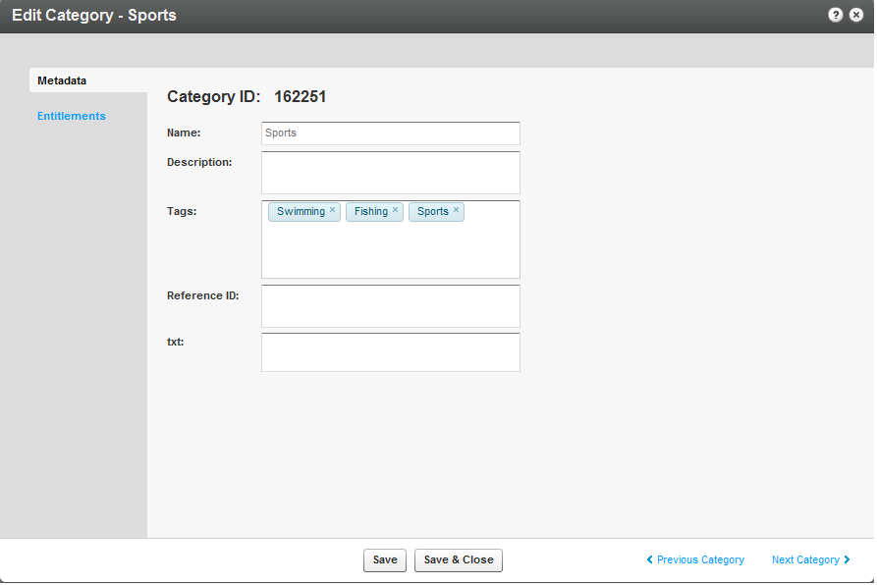

1. If you have Custom Data for categories, you can edit the Custom Data fields for the category. For multiple schemas, use the drop down Jump To menu to select the schema values you want to edit for the category. See Managing Schemas for more information.
2. Click Save & Close.

### Editing the Entitlement Settings of a Category

When a category is set to have entitlement settings for an application, the category’s Entitlements tab is displayed for editing. See Managing Content Entitlement for more information.

|  |  |
| --- | --- |
|  | NOTE: Entitlement Settings are added to categories as part of the MediaSpace installation. For other purposes, Entitlement Settings can be added to categories from the Integration Settings page under the Settings tab. |

* To edit Entitlement Settings of a category

1. Select the Content tab and then select the Categories tab.
2. Click on a category. The Edit Category window is displayed.
3. In the Entitlements tab, edit the Entitlement Settings options, set a category owner and any specific end-user permissions you want to set to the category for your application. Informative tooltips are available for each one of the options. See Managing Content Entitlement for more information.
4. Click Save & Close.



### Reordering Sub Categories

When a category has up to 50 sub-categories the Sub-Categories tab is available for editing. Use the Sub Categories tab to order the sub categories. Sub Categories will appear in the application as they are ordered.

Use the Sub- Categories tab to order MediaSpace Galleries. For other applications: the ordering set through the Sub- Categories tab can be used through the Kaltura API while [ordering category lists](http://www.kaltura.com/api_v3/testmeDoc/index.php?object=KalturaCategoryOrderBy) based on the partnerSortValue category attribute.

* To reorder sub categories

1. Select the Content tab and then select the Categories tab.
2. Click on a category. The Edit Category window is displayed.
3. Select the Sub-Categories Tab,
4. Set the order of the sub-categories. Position the sub categories as you want them to be ordered in your application.
5. Click Save & Close.

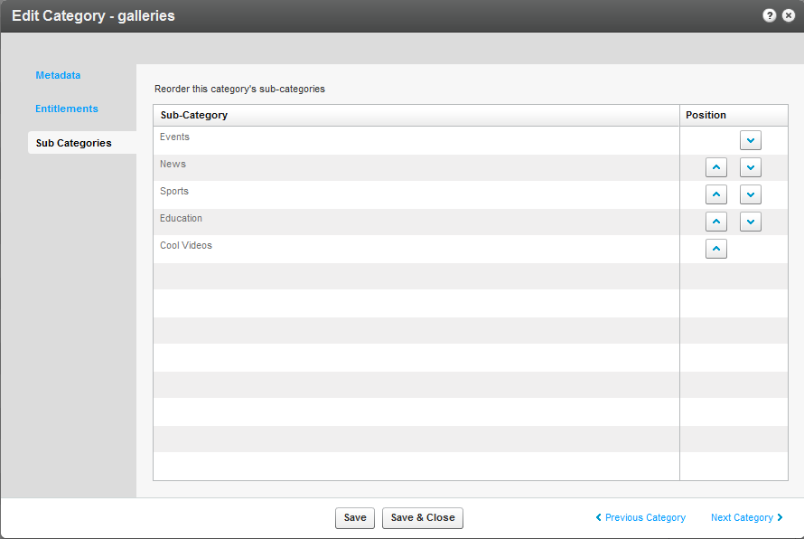

### Editing Multiple Categories in Bulk

You can edit multiple categories in bulk.

* To edit multiple categories in bulk

1. Select the Content tab and then select the Categories tab.
2. Check the boxes near the names of the categories you want to edit.
3. Select Bulk Actions at bottom of the list.

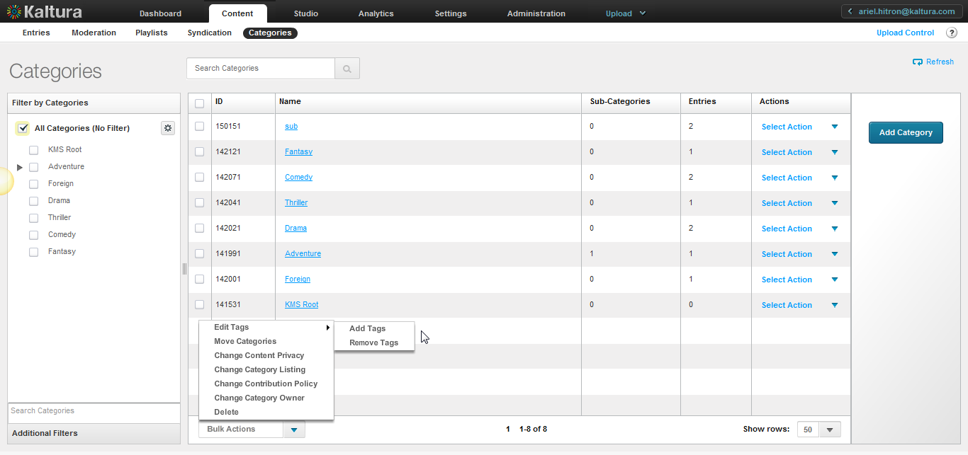

Use the Categories tab to:

* Add Tags
* Remove Tags
* Move Categories
* Change Content Privacy (available with entitlement configuration only
* Change Category Listing (available with entitlement configuration only)
* Change Contribution Policy(available with entitlement configuration only)
* Change Category Owner (available with entitlement configuration only)
* Delete Categories

### Add Tags to Categories

You can add tags to categories in the KMC that will propagate to other applications.

* To add tags to a category listing

1. Select the Content tab and then select the Categories tab.
2. Select a category or multiple categories and select Bulk Actions on the bottom of the page.
3. Select Add Tags from the drop-down menu.
4. Enter tags to append to all selected categories.
5. Click Save Changes.

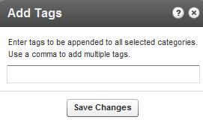

### Remove Tags from Categories

You can remove tags from categories in the KMC. Tag deletion will propagate to other applications.

* To remove tags from a category listing

1. Select the Content tab and then select the Categories tab.
2. Select a category or multiple categories and select Bulk Actions on the bottom of the page.
3. Select Remove Tags from the drop-down menu.
4. Select the tags to remove from the selected categories.
5. Click Remove.

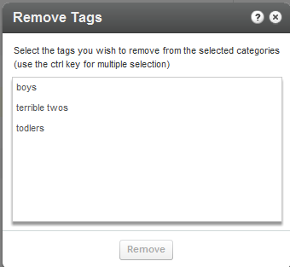

### Move Categories

You can move categories from one level to another.

* To move a category to another parent category

1. Select the Content tab and then select the Categories tab.
2. Select a category or multiple categories that area currently under the same parent category and select Bulk Actions on the bottom of the page.
3. Select Move Categories from the Bulk Actions options.
4. Select the new parent category under which the selected categories will appear.
5. Click Apply.

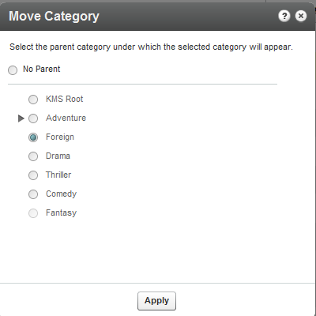

Following a Move Categories action, the category tree is updated on the Kaltura backend. When more than a few categories are affected, this operation may take a few minutes. Until the completion of this process, the editing options in the Categories page are disabled and are automatically released when the update process is completed.

### Change Content Privacy

Content privacy is a category entitlement setting option that defines the visibility of content associated with a category.  For more information see Content Privacy.

This option is available with entitlement configuration only.

* To change the content privacy

1. Select the Content tab and then select the Categories tab.
2. Select a category or multiple categories.

Select Bulk Actions on the bottom of the page and then select Change Content Privacy from the drop-down menu. The content privacy options are:

* **No Restriction** – Content in this category is visible to everyone with access to the application page it is published in.
* **Requires Authentication** – Content in this category is visible only to authenticated end-users. User authentication is made by the application against the customer Identity Management system, or using Kaltura’s authentication services. In both cases access to content in this category requires that an authenticated user ID is passed to the Kaltura server through the application session.
* **Private** – Content in this category is visible only to users with specific permission to access this category's content.

1. Click Apply.

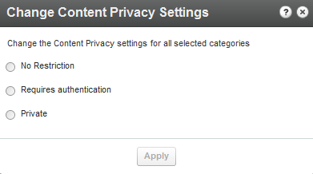

Note that the Changing the Content Privacy will only apply to categories that have entitlement settings.

### Change Contribution Policy

The contribution policy is a category entitlement setting option that defines which end-users can add content to a category through applications. For more information see Change Contribution Policy. This option is available with entitlement configuration only.

* To change the contribution policy

1. Select the Content tab and then select the Categories tab.
2. Select a category or multiple categories and select Bulk Actions on the bottom of the page.
3. Select Change Contribution Policy from the drop-down menu.
4. Select one of the following options:

* **No Restriction –** With this option, any end-user authorized by the application can add content to this category
* **Private -** With this option, only end-users with specific permission to add content to this category are able to add content to it.

1. Click Apply.

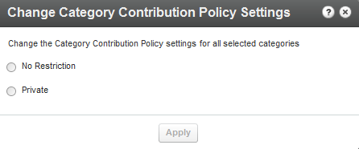

Note that the Change Category Contribution Policy action will only apply on categories that have entitlement settings.

### Change Category Listing

The category listing is a category entitlement setting option that defines who can see the category's name and metadata in the application’s category menus, navigations and listing or anywhere a category list is present. See Category Listing for more information.

This option is available with entitlement configuration only.

* To change a category listing

1. Select the Content tab and then select the Categories tab.
2. Click on a category. The Edit Category window is displayed.
3. Select a category or multiple categories and select Bulk Actions on the bottom of the page.
4. Select Change Category Listing from the drop-down menu.
5. Select one of the following options:

* **No Restriction** - The category name and metadata is visible to everyone with access to the application page it is listed in.
* **Private** – The category name and metadata are visible only to users with permission to access the category and its content.

1. Click Apply.

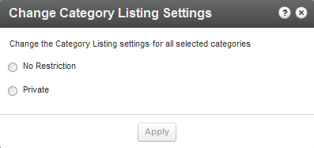

Note that the Change Category Listing action will only apply on categories that have entitlement settings.

### Change Category Owner

The Category Owner is a category entitlement option supporting applicative case in which an end-user should be set as the owner of the category. This will automatically set the user with a manager permission level for this category and enable him to manage the category settings from the application.

This option is available with entitlement configuration only

* To change the ownership on a category listing

1. Select the Content tab and then select the Categories tab.
2. Select a category or multiple categories and select Bulk Actions on the bottom of the page.
3. Select Change Category Owner from the drop-down menu.
4. Enter the new owner’s User Name or User ID.

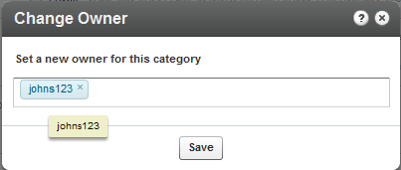

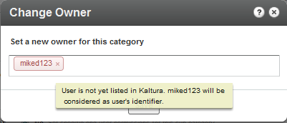

When the selected user is already listed in Kaltura, the user’s ID or name appears in blue. When the selected user is not listed in Kaltura the typed text appears in red shape and after Saving, the user is added to Kaltura as the user ID.

1. Click Save.

### Delete Categories

You can delete categories in the KMC. Category deletion is propagated to other applications.

When categories are deleted from the KMC, the entries in these categories are automatically added to the parent of the deleted category.

* To delete categories

1. Select the Content tab and then select the Categories tab.
2. Select a category or multiple categories and select Bulk Actions on the bottom of the page.
3. Select Delete from the drop-down menu.
4. Select the categories to remove.

A warning message is displayed.

1. Click Remove.

### Updating Categories’ State

Some of the category related actions taken in the KMC may trigger a category update process on the Kaltura backend. This is mainly to allow continuous work through the KMC interface even when actions affect large portions of the category tree or apply on a very high number of categories.

While the Kaltura backend process is running, an ‘Updating Categories’ indication is set on the top right corner of the categories filter bar.

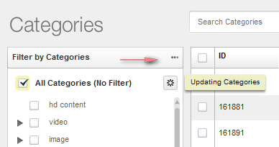

The ‘Updating Categories’ state may last a few minutes and until its completion. Some category settings and tree displays in the KMC may not be fully updated.

After the updating process is completed the ‘Updating Categories’ indication automatically disappears.

Chapter 10

# ****KMC Users and Roles****

This section descirbes the KMC User Roles and Permissions.

## Roles and Permissions

Roles and permissions enable organizations to define a user's ability to perform actions based on the user's responsibilities. Only users with admin permissions can add users, create roles and define permissions.

A publisher uses the roles and permissions infrastructure to specify actions that a user is allowed to perform. User roles define permissions granted to the user for the different KMC functionalities.

### Adding a User

The following table lists the information that should be provided for adding a new KMC admin user. Please note that a limited number of users are allocated by default to each KMC account. If you reached the KMC users quota for your account and need to set additional users, please contact Kaltura with a [request for additional KMC admin users](http://site.kaltura.com/Request-Users.html).

| Field | Description |
| --- | --- |
| **Email address** | The user’s email address serves as a unique identifier of the user in the Kaltura system, as the user login username and as a recipient address for system-generated messages. Upon the creation of a new user account, a welcome email notification will be sent to this email address with a link for setting the initial password. |
| **First name, Last name** | User’s name |
| **Publisher ID (Optional)** | A unique identifier that may be in use by the publisher in different systems. This will serve as the KMC user identifier as content contributor in all KMC-related locations. When a publisher ID is not provided, the user email address will be used as a default value. |
| **User Role** | Defines the set of permissions granted to the user for the different KMC functionalities. This role should be set according to the tasks that the user needs to work on and the functionalities that the user needs access to within the KMC. The different KMC user roles are set (by users who are granted with permission to do so) from the KMC Roles page (under the Administration tab). |

* To add a user

1. Go to the Administration tab and select the Users tab.
2. Click Add User, and fill in the details in the Add User window.
3. Select a User Role from the drop-down menu.

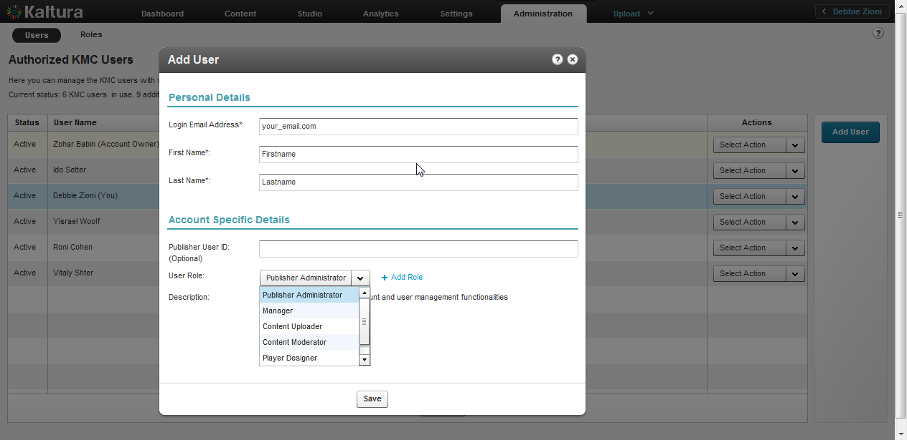

1. Select a User Role from the drop down menu.
2. (Optional) Click Add Role to create a custom role. See Creating Custom Roles.
3. Click Save.

When a user is created, an email will be sent to the specified email address containing a link to set the account password.

### Editing a User

After a user account is set in the system, the user’s personal details can only be set by the user personally, from the **My User Settings** page in the **Settings** tab. See My User Settings.

* To edit user information

1. Go to the Administration tab and select the Users tab.
2. Click on a User and then select Edit from the drop down tab.

Only the Publisher User ID and the User Role may be edited in Edit User window. Please note that it is not possible to edit the user role that is defined as the Account Owner. In addition, a KMC user with access to user management functionalities cannot edit the user role selection in their account.

### Deleting and Blocking Users

You can prevent users from logging into the KMC temporarily or permanently. Blocking a user will prevent the user from logging into the KMC. This restriction can be removed by applying the unblock action.

Deleting a user is a permanent action. The deleted user's content contribution records will be kept in the system.

* To block or unblock a user

1. Select the Administration tab and select the Users tab.
2. Click on a User Name.
3. Select Block/Unblock from the Select Action drop-down menu to block a user temporarily.
4. Select Delete from the Select Action drop-down menu to remove a user permanently.

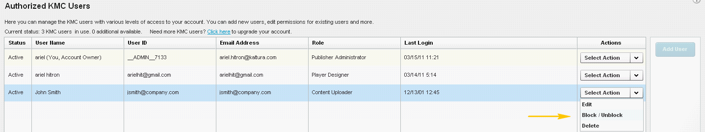

### Purchasing a License for Additional Users

Each KMC account is allocated three users.

* To request additional users

1. Select the Administration tab and then select the Users tab

The Current Status lists the number of KMC users and the number of available users.

1. Click on the Click here to upgrade your account link.

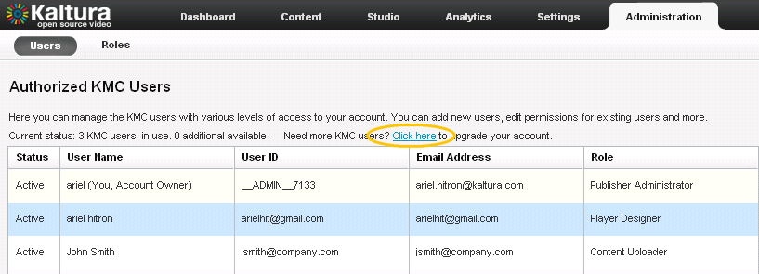

### Creating Custom Roles

When you add a KMC admin user role to a specific publisher account, you should add the relevant set of permissions in the **Add Role** window. You can select which KMC functionalities are available to users with the defined role. Clicking the checkmark next to each permission group name will toggle the permission level for the specific KMC functionality to the following modes:

* **Full Permission (checked)** – Grants access to all KMC functionalities listed under the permission group.
* **View-Only Permission (partially checked)** –Only part of the functionality listed in the group is selected.
* **No Permission (unchecked)** – No access to the KMC pages that are relevant to the KMC functionalities listed under the permission group.
* To create custom roles

1. Go to the Administration tab and select the Roles tab.
2. Click Add Role to create a custom role.

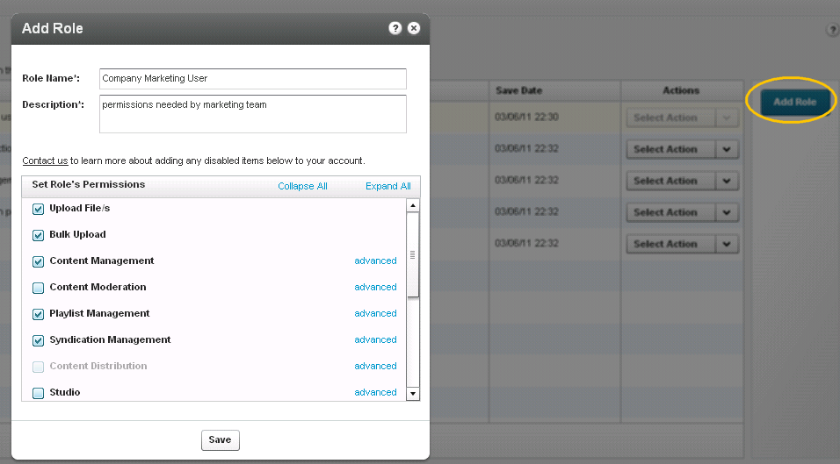

1. Enter the Role Name and provide a description.

After naming the role and providing a description you will be able to select the specific permissions required.

1. Most of the permissions are organized under KMC high-level functionalities. For granular permissions within each category click Expand All. Or click Advanced to open a more detailed list of the specific KMC functionalities related to the group.
2. Click Save.

You can edit, duplicate or delete any existing role via the using the Select action drop-down menu.

### Role Management

After you create roles you can:

* Edit a role
* Duplicate a role.
* Delete a role.
* To modify roles

1. Go to the Administration tab and select the Roles tab.
2. Click on a role.
3. Select an option from the Actions menu.

* **Edit a role**

Editing a user role affects the access level of the KMC user associated with this role only after the user logs in to the KMC. We recommend that you edit an “in-use” role when users associated with this role are not logged into the KMC.

* **Duplicate a role**

Duplicating a role is a quick way to create a new KMC user role with a similar, but not identical, set of permissions as an existing user role. The duplicated role is populated with the permission set of the duplication source role, so minor changes to this permission set can be easily made. After you duplicate a role, use the Edit option to modify the permissions.

* **Delete Role**

Deleting a role is a permanent action. It is not possible to delete a user role record as long as KMC admin users are associated with the role. In such cases, make sure to update the relevant KMC user accounts with another user role before attempting to delete their existing role.

Chapter

# ****Moderation and Editorial Workflows****

This section describes Content Moderation Workflows and the Moderation Tab.

## Content Moderation Workflows

You can review content before it is published to eliminate spam and abusive content in User Generated Content (UGC) portals. You can also implement complex editorial workflows for your various editorial team roles.

## The Moderation Tab

The Moderation tab located in the Content tab in the KMC, allows publishers to see the moderation queue, where all entries marked as pending, are waiting to be approved or rejected. Content moderators can change the moderation status (approve/reject).

This window displays a list of all content that has been flagged as inappropriate by users. By default, the list is filtered and sorted according to the amount of flags that each entry has received. You can sort the list by clicking on the various columns and scroll through the pages at the bottom of the list.

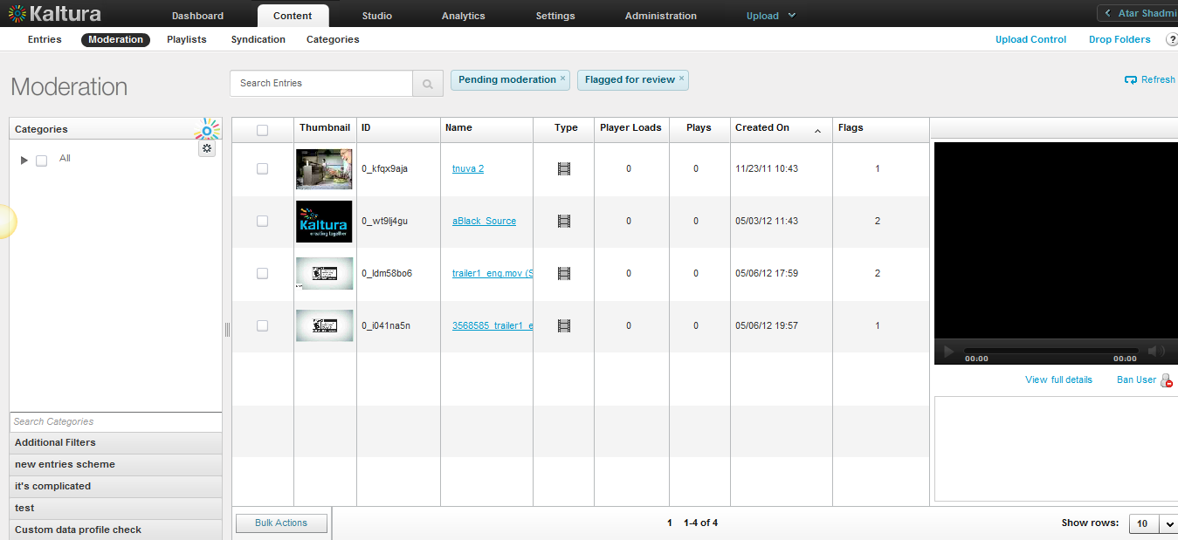

* To display content for moderation

1. Select the Content tab and then select the Moderation tab.
2. Click on the name of an entry.

The Edit Entry window is displayed. Similar to the Entries tab, the Filters bar to the left of the entries table is displayed.

1. Filter your moderation entry list according to various parameters and search criteria. See Filtering Content in the Entries Table.

By default, the list is already filtered by content that was flagged for review. To change this, click on the "Additional Filters" button (see Use Additional Filters).

### Previewing Content using the Moderation Tab

* To preview content

1. Select the Content tab and then select the Moderation tab.
2. Click on the name of an entry.

The entry is displayed in the small player to the right of the list.

1. Click on the bottom right of the preview pane, "View full details" link for quickly reviewing or editing the content of an entry.

### Rejecting Content using the Moderation Tab

* To reject content (one or more entries)

1. Select the Content tab and then select the Moderation tab.
2. Select the relevant entries (for multiple choices, use either the CTRL key or the selection drop-down menu at the bottom of the page) and press the "Reject Selected" button.

You can reject more than one entry at a time, but only for entries appearing on the same page of the main list.

Approving Content using the Moderation tab

* To approve content (one or more entries)

1. Select the Content tab and then select the Moderation tab.
2. Select the relevant entries (for multiple choices, use the CTRL key or use the selection drop-down menu at the bottom of the page) and press the "Approve Selected" button.

You can approve more than one entry at a time, but only for entries appearing on the same page of the main list.

Banning Users using the Moderation tab

* To ban users

1. Select the Content tab and then select the Moderation tab.
2. Click on the "Ban User" link under the preview player. This triggers a notification to be sent to your website's CMS with a request to ban the specific user that created the selected entry.

[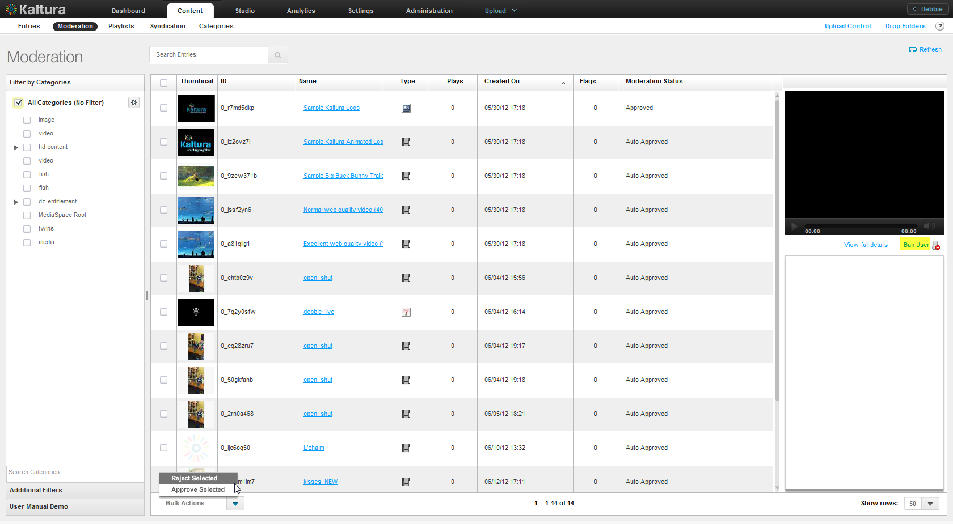](http://blog.kaltura.org/wp-content/uploads/2011/10/Moderation-Screen2.png)

Chapter

# Using Subtitles and Captions

This section describes how to use subtitles and captions in the KMC.

## Caption File Types

You can upload multiple subtitle and caption files (SRT, DXFP, and XML) and transcripts (TXT), or reference an external link to a captions file in the KMC. Viewers can then select and toggle between different language subtitles and captions. Subtitles and captions are fully searchable as a metadata field. Kaltura’s accessibility player plugin also makes the captions readable via screen readers and therefore helps organizations adhere to 508 compliancy regulations. Kaltura’s “In Video Search” API allows users to for a specific phrase within a library of videos and within the search results directs the user to the exact point in the video where the phrase appears. For more information see [Kaltura Demo Apps for Captions](http://demo.kaltura.com/showcase/).

You can also automate the creation of subtitles and captions, and transcriptions through our partners in Kaltura Exchange. For instance check out [3Play Media Interactive Transcript / Captioning Plugin](http://exchange.kaltura.com/category/tags/3play-plugin).

### Searching within Captions

Publishers can use the Kaltura API and code skeleton to search within the captions and point the viewer directly to the relevant point in time. The search is done across a catalogue of videos, making the discovery process easy and accessible, especially when searching in a large amount of content.

Contact your account manager to learn more on how to integrate this functionality into your website and environment.

## Subtitles and Captions Terminology

A **caption file** contains *both the text and information* about when each line of text should be displayed.

A caption is synonymous with **subtitle** and is usually displayed at the bottom of the screen.

SRT and DXFP are text file formats that contain captions; **including the time** each subtitle should be displayed followed by the text of the subtitle.

If the caption includes non-dialog text, the file is considered a **closed caption**.

**Transcriptions** are files that contain text of the video without time stamps.

Captions can either be a form of written [translation](http://en.wikipedia.org/wiki/Translation) of a dialog in a foreign language or a written rendering of the dialog in the same language. Closed captions files contain added information to help viewers who are [deaf](http://en.wikipedia.org/wiki/Deaf) and hard-of-hearing to follow the dialog, or people who cannot understand the spoken dialogue or who have accent recognition problems.

For greater accessibility and compatibility with equipment like screen readers, use Kaltura’s 508 Compliant Player. For more information, see 508-Compliant Video Player .

## Adding Captions to an Entry

|  |  |
| --- | --- |
|  | Adding Captions to an Entry Workflow:   1. In the Upload tab, upload an entry. 2. Create a player and add content to the player. 3. Configure the player’sSubtitles and Transcriptions. 4. Select an entry and add captions to the entry. 5. View the entry with the captions. |

You can add multiple captions files to each entry. For example, you can create subtitles captions in multiple languages and label each language.

* To assign a caption file to an entry

1. Select the Content tab and click on an entry.
2. Select the Captions tab.
3. Click Add Another Caption.
4. Select the Type. Choose SRT or DXFP.
5. Paste an external URL in the File Location or click Upload File and upload an SRT or DFXP file from your computer.

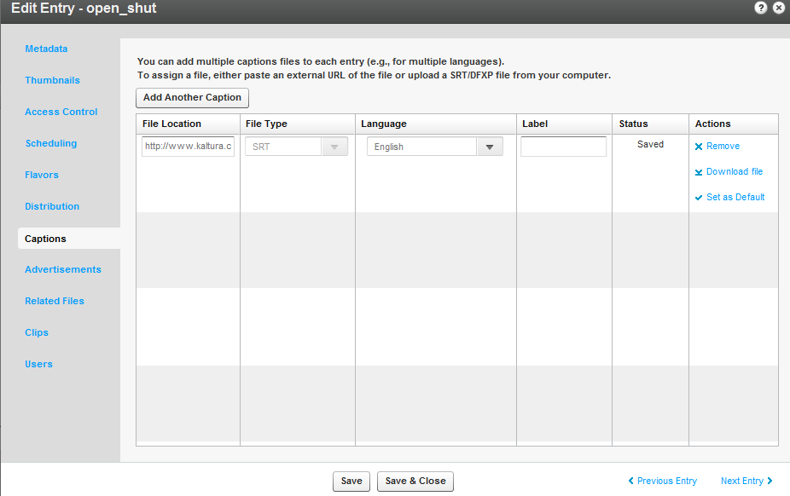

1. Assign a Language to the caption from the drop down menu.
2. Enter a Label that will appear in the player’s captions drop-down menu. For example: Japanese.
3. In the Actions column click Set as Default.(optional – use for multiple languages)
4. Select Add Another Caption to add additional captions files and repeat steps 5 to 7.
5. Click Save.

### Editing a Captions File

After you upload a captions file you can edit the file, remove it, or set it as the default captions file.

* To edit a captions file

1. Select the Content tab and click on an entry.
2. Select the Captions tab.
3. In the Actions column, click Download File.
4. Edit the file and then upload the file again as described in Adding Captions to an Entry.
5. Select Remove to delete the captions file.

## Setting Up Captions for Display

You will need to enable captions in your player or select a player with captions already enabled.

* To display captions during playback

1. Go to the Studio tab, and select Player or Create New Player.
2. Select a player and select Edit from the drop down menu.
3. In the Edit Player window, select the Features tab.
4. Scroll down and select Subtitles and Transcriptions.

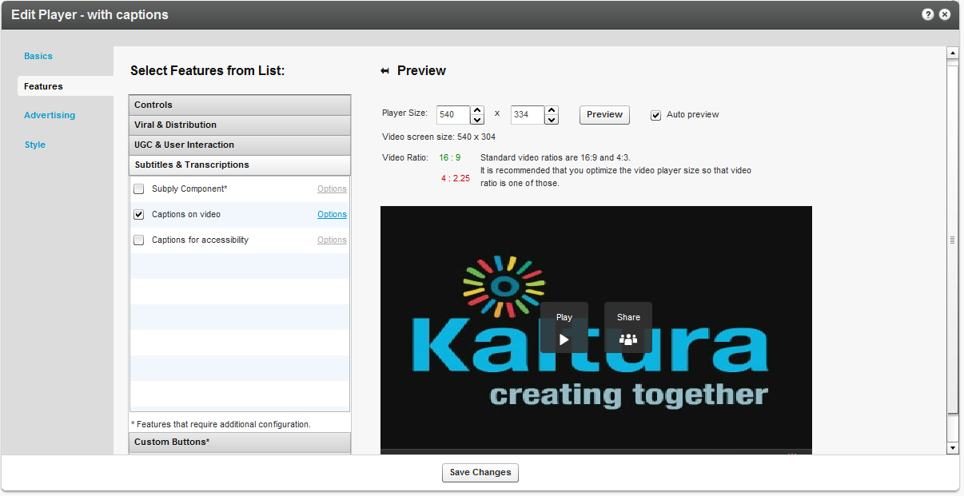

1. Check one of the following:

* **Subply Component** – Uses the PlyMedia solution. For more information, see [Plymedia](http://exchange.kaltura.com/search/luceneapi_node/subply) on the Kaltura Exchange site. Additional transcoding and captioning services can also be used. See the [Kaltura Exchange](http://exchange.kaltura.com/category/solution-types/subtitles) for more information.
* **Captions on video -** The subtitles/captions will be displayed as an overlay at the bottom of the video area. You can control the area where the captions will appear on the player.
* **Captions for accessibility** – Creates a dedicated area under the video area to display captions. Check this option if you intend to use the 508 Player.

1. Click Options to modify the text style and background. See Captions Options.
2. Click Apply.

### Viewing an Entry with Captions in a Player

* To view the captions in a player

1. Select the entry that you added the captions file to.
2. Click Preview and Embed.
3. In the Player window select the player to use to display this entry.
4. Use the URL indicated in the View as a standalone page with this player.

The following is an example of an entry with 2 subtitle files where the default language is English.

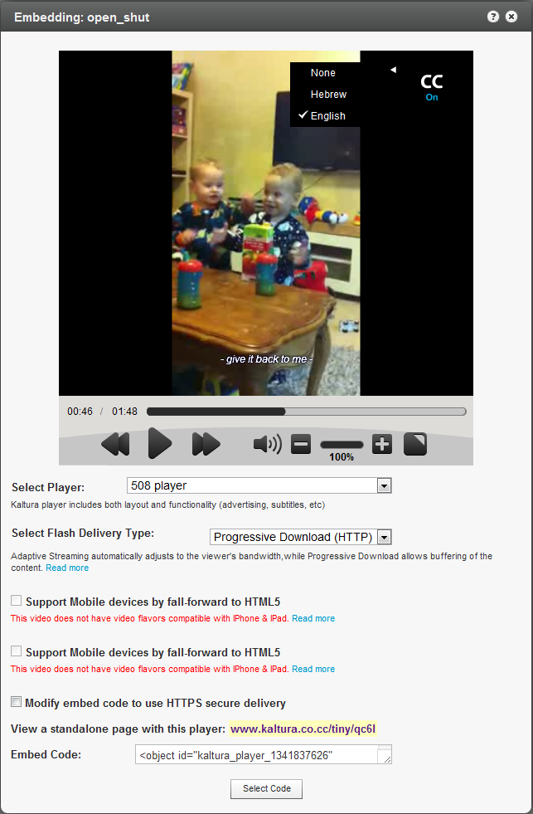

### Captions Options

The following lists the options you can use to customize your caption file display.

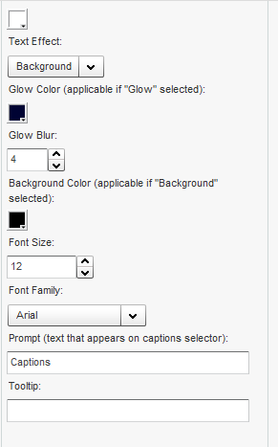

Chapter

# Live Streaming

This section contains describes how to configure live streaming in the KMC.

## Live Streaming Using the KMC

Kaltura’s Live Streaming solution is the easiest and most cost effective way to incorporate live streaming video into your website or application. Backed by world-class data centers, and fault tolerant software architecture, Kaltura is able to provide the reliability and capacity necessary to handle encoders that are supported by Akamai.

You can broadcast live streams through a Content Delivery Network (CDN) such as Akamai, through the KMC. The encoding software installed (such as FMLE) encodes your real-time camera signal and sends it out through a secure RTMP connection to the CDN. Then, using a Kaltura Player, you can embed the live broadcast in your websites. You can set the live stream entry metadata and specify broadcasting settings in the KMC in the same way VOD content is managed.

By using a CDN for live streaming, you guarantee a better experience for your viewers world-wide.

|  |  |
| --- | --- |
|  | NOTE: In the Kaltura SaaS Edition, Live Streaming is an additional service. To add Live Streaming to your account, contact your Account Manager.  In Kaltura Community Edition, Live Streaming requires a Flash Streaming Server software installed such as Adobe FMS, Red5 and Wowza or alternatively, an Akamai CDN account. |

* To enable live streaming for your account
* [Contact us](http://corp.kaltura.com/about/contact) or call +1-800-871-5224

After your account is enabled you can set up Kaltura’s Live Streaming service.

## Workflow for Setting up Live Streaming

This section describes how to set up the KMC, the encoder, and a device for the live streaming service.

|  |  |
| --- | --- |
|  | 1. Set up the Hardware and Software. 2. Create a Live Streaming Entry in the KMC. 3. Configure the Live Streaming Parameters in the KMC 4. Set up the Broadcasting Computer. 5. View the Broadcasting Setup (optional). |

### Setting up the Hardware and Software

* To set up the hardware and software for live streaming

1. Download the Flash Media Live Encoder (FMLE) from [here](http://www.adobe.com/products/flashmediaserver/flashmediaencoder/).
2. Install the FMLE on your local Windows machine.

|  |  |
| --- | --- |
|  | NOTE: Be certain that your system has the minimum requirements. See <http://www.adobe.com/products/flashmediaserver/flashmediaencoder/systemreqs/> for details. |

1. Connect your camera to the installed computer.

### Creating a Live Streaming Entry in the KMC

* To create a live streaming entry in the KMC

1. Login into the KMC and go to the Upload tab.
2. Select Live Stream Entry.



The Add New Stream window appears.

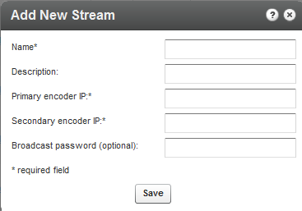

1. Fill in the values and click Save.

The following table describes the input fields.

|  |  |
| --- | --- |
| Field | Description |
| Name | The name of the stream that will appear in the KMC entries list. |
| Description | A description of the stream (optional). |
| Primary encoder IP | The public address that will be used for streaming (the computer where the client encoder such as Adobe FMLE is installed).  Note: your IP address can be retrieved by browsing from the computer where the FMLE is installed to <http://www.whatismyip.com/> 0.0.0.0 cannot be used as your IP address. |
| Secondary encoder IP | If you are using two encoders (for redundancy), fill in the secondary encoder IP. If you are using a single encoder, copy the Primary encoder IP to the Secondary encoder IP field. |
| Broadcasting password | This password is required in the client encoder (FMLE) software. If you do not enter a password the system will automatically create one for you and it will be displayed in the Live Stream tab of the entry details window under “Broadcasting credentials”. |

|  |  |
| --- | --- |
|  | NOTE: When using Kaltura’s SaaS edition, Kaltura will provision your new Live Stream with the CDN (for example, Akamai). The CDN will then populate the information about the new Live Stream to the CDN’s servers. This may incur up to a 20 minute delay, for the stream to become available for broadcasting. You should always provision your Live Stream ahead of time, and be certain that you have at least 20 minutes lead time to going live. |

Kaltura's uses Akamai as the default CDN. You can also use a CDN other than Akamai, however, you will have to provision the stream via the CDN portal, or through technical support, and then ask Kaltura Support to create a live stream entry pointing to the provisioned stream.

### Multiple Bitrate Encoding

To maintain the best possible viewing experience and video quality, it is often necessary to stream different versions of the encoded video to different clients using different devices and over variable connection speeds.

Multiple Bit Rate (MBR) encoding is designed to adjust to fluctuations in bandwidth while maintaining an acceptable quality. MBR combines several bit rates into a single encoded file. When the file is accessed, the player determines the appropriate bit rate based on the available bandwidth, and then retrieves the encoded file at the optimal bit rate. If the available bandwidth decreases for any reason, a stream at a lower bit rate can then be served. With a lower bit rate, there is often a decrease in quality. See Video Delivery Settings for more information.

### Configuring the Live Stream Parameters in the KMC

* To configure the live stream parameters

1. Go the Content tab in the KMC.
2. Click on the Live Stream Entry in the Entries table.
3. Select the Live Stream tab.

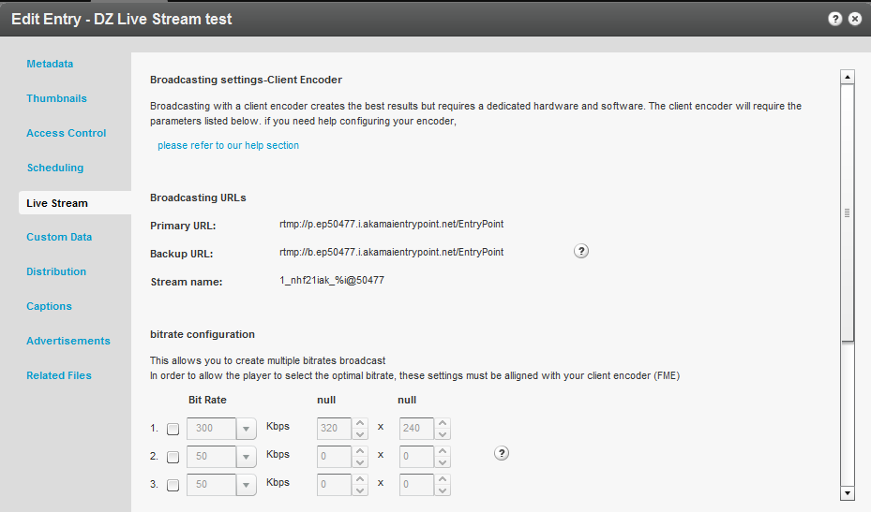

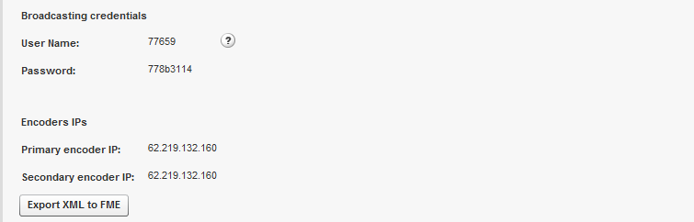

1. Set the MBR. (Optional)
   1. When broadcasting with MBR the player will choose the most appropriate bitrate to stream. Be certain that your client encoder is aligned with the same settings.
   2. Determining the right bit rates for your Live Stream is generally dependent on the quality of your video, the size of the player your viewers will use, the bandwidth your client encoder computer has and the bandwidth of your viewers. It is common to have widths of 240, 360, 480, 720 and 1080 with HD content streaming. If you are broadcasting a webcam, it is generally best to use the default KMC settings. To get professional assistance, please contact Kaltura’s support.

### Setting up the Broadcasting Computer

* To set up the broadcasting computer

1. Connect your camera /recording device to the broadcasting computer.
2. Run the Adobe Flash Media Live Encoder (FMLE).
3. Select the relevant recording Device from the drop-down menu. Copy the details of the live entry to the Flash Media Live Encoder. You can copy the details manually, or use the “Export XML to FME” option.
   1. Enter or copy the Primary URL in the FMS URL field, and the Backup URL in the Secondary URL as configured in the KMC.
   2. Enter the Stream Name as displayed in the KMC.
   3. Enter the MBR settings if you have defined them. See Multiple Bitrate Encoding.
   4. Use the Preset dropdown menu in the FMLE to select the MBR.

Enter the Bit Rates as configured in the KMC. If you select to Save to File, you must append %i to the file name.

|  |  |
| --- | --- |
|  | NOTE: When using the FMLE, the Stream name includes the %i. If you are using an encoder other the FMLE, you must append ” _1” to the Stream name. |

1. Click Connect.
2. Enter the Broadcasting credentials, (User Name and Password) as configured in the KMC Live Stream tab and click OK. The system will prompt you twice for the Broadcasting credentials.

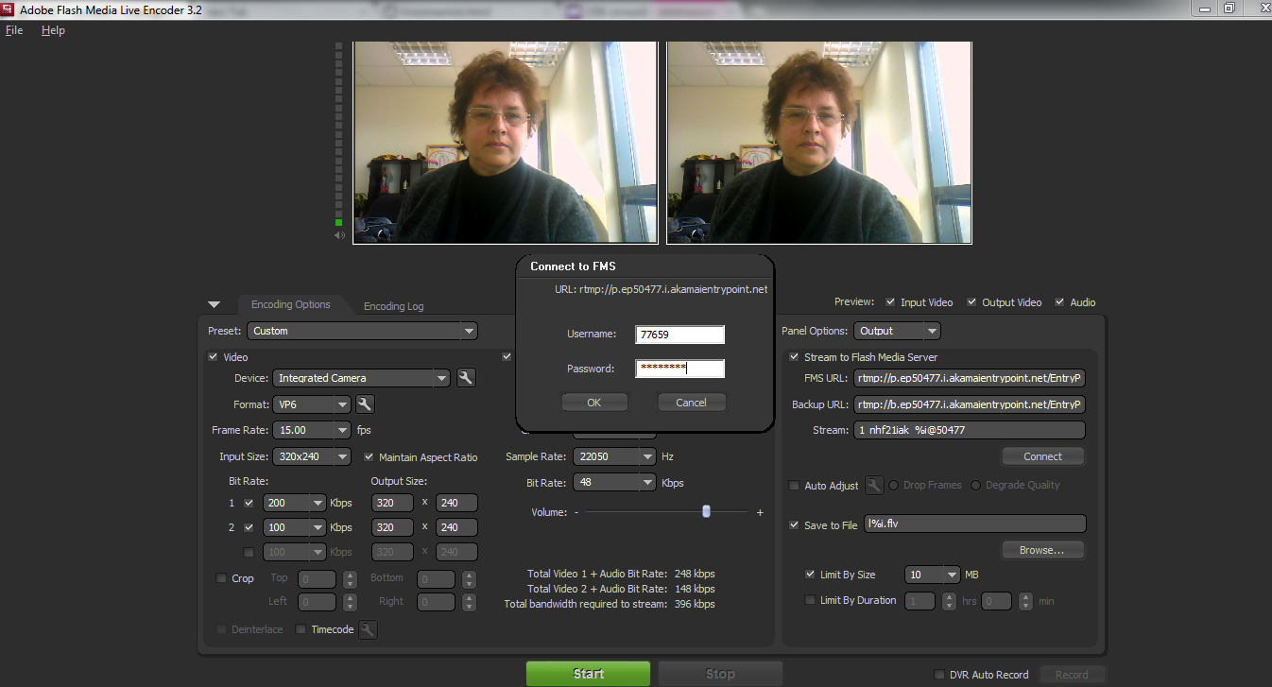

1. Click Start.

You are now broadcasting live.

1. When your broadcast is finished, click Stop.

### Viewing the Broadcasting Setup (Optional)

* To view the broadcasting setup

1. Return to the KMC and select the Content tab.
2. In the KMC Entries Table, click the Preview & Embed link for the live stream entry.

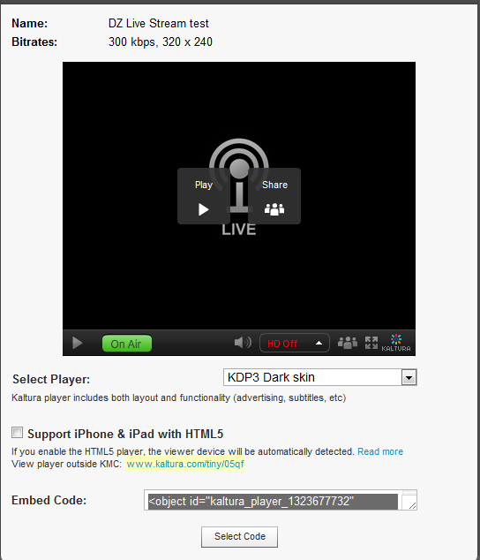

1. Select the player from the drop-down menu and copy the Embed Code.
2. Paste the Embed Code within an HTML page.
3. Browse to the page where the embed code was inserted and press Play on the video player.

### Advanced Live Streaming Configuration Options

There are multiple factors that can influence the video quality for live streaming. To receive good results you should optimize the settings based on your specific needs.

The following table can be used as a starting point for optimization and setup. A rough estimate is provided for the different factors, based on the video dimensions.

| Video Dimensions | Bitrate  Required  (Mbps) | Camera Requirements | FMLE HW Requirements | Broadcaster Uplink, Viewer Downlink Requirements (Mbps) | Throughput example for 1000 concurrent viewers of  1 hour broadcast |
| --- | --- | --- | --- | --- | --- |
| 320x240 | 0.3 | support frame size &bitrate | Dual Core  2GB RAM | 0.4 | 135 GB |
| 640x480 | 1.4 |  | Quad Core Xeon 3GB RAM | 2 | 630 GB |
| 1024x720 | 3.5 |  | 8 Core  Xeon  3GB RAM | 5 | 1600 GB |

For more information about setting up these parameters in the Flash Media Live Encoder, as well as additional advanced configuration options, see the [FMLE guide](http://help.adobe.com/en_US/FlashMediaLiveEncoder/3.0/Using/flashmedialiveencoder_3_help.pdf).

Chapter

# ****Content Authoring Tools****

This sectiondescribes the various options and features in the Content Tab.

## The Content Tab

The Content tab is used to manage your media library and provides all the tools you need, in one intuitive interface. You can organize your content and metadata, easily search media, edit, moderate, create playlists, and much more through the Content tab.

The Content Tab has the following tabs:

* Entries Tab

* Moderation Tab

* Playlists Tab

* Syndication Tab

* Categories Tab

## Entries Tab

Your first step in the KMC is to upload files to the Entries Table. See The Upload Tab.

After you upload content to the KMC you can perform various modifications to your content, for example, categorize, clip, and create ads. However, the most logical thing you may want to do is to embed your video into your website. See Preview and Embed.

## Entries Table

The Entries Table lists the entries in your account and provides a way to edit the entry’s specific metadata and settings. You can perform several actions on a specific entry or several entries simultaneously. To choose multiple entries, check the boxes near the entry name and then, select Bulk Actions at bottom of the list. You can search through entries; delete entries, preview entries as well as other actions.

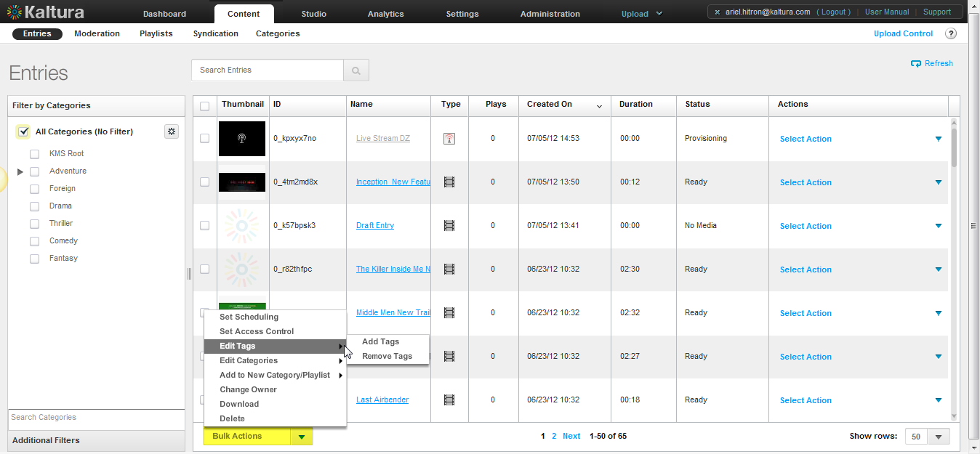

Use the Entries tab to perform the following actions on multiple entries:

* Set Scheduling – See Content Scheduling for applying scheduling to a single entry.
* Set Access Control
* Edit Tags
* Add Tags
* Remove Tags
* Edit Categories
* Add Categories
* Remove Categories
* Add to New Category Playlist
* Add to New Category
* Add to New Playlist
* Change Owner
* Download
* Delete

### Set Scheduling

Set specific scheduling parameters for your content.

* To set a scheduling for an entry

1. Select the Content tab and then select the Entries tab.
2. Select an entry or multiple entries and select Bulk Actions on the bottom of the page.
3. Select Set Scheduling from the drop-down menu.
4. Enter the scheduling times that should be applied to the selected entries.
5. Click Apply to all Selected Entries.

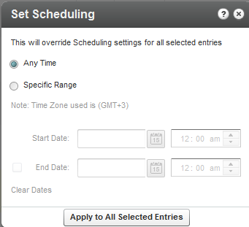

### Set Access Control

Set access control permissions for your entries. (See Managing Access Control Profiles for more details).

* To set access control permissions for entries

1. Select the Content tab and then select the Entries tab.
2. Select an entry or multiple entries and select Bulk Actions on the bottom of the page.
3. Select Set Access Control from the drop-down menu.
4. Select the access control profile that should be applied to the selected entries or click Add Profile to create a profile. See Creating an Access Profile.
5. Click Apply to all Selected Entries.

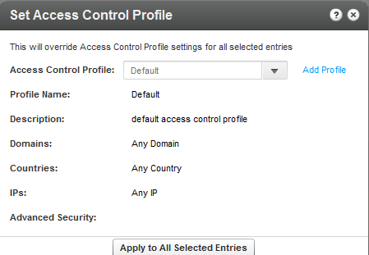

### Edit - Add Tags to and Entry

You can add tags to entries in the KMC that will propagate to other applications.

* To add tags to an entry

1. Select the Content tab and then select the Entries tab.
2. Select an entry or multiple entries and select Bulk Actions on the bottom of the page.
3. Select Add Tags from the drop-down menu.
4. Enter tags to append to all selected entries.
5. Click Save Changes.

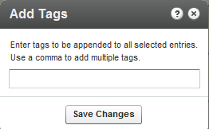

### Edit - Remove Tags from an Entry

You can remove tags from entries in the KMC. Removal will propagate to other applications.

* To remove tags from an entry

1. Select the Content tab and then select the Entries tab.
2. Select an entry or multiple entries and select Bulk Actions on the bottom of the page.
3. Select Remove Tags from the drop-down menu.
4. Enter tags to append to all selected entries.
5. Click Save Changes.

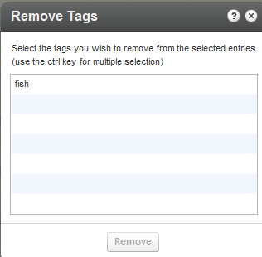

### Edit - Add Categories

You can add categories to entries in the KMC that will propagate to other applications.

* To add categories to an entry

1. Select the Content tab and then select the Entries tab.
2. Select an entry or multiple entries and select Bulk Actions on the bottom of the page.
3. Select Add Categories from the drop-down menu.
4. Select or search for a category to apply to all the selected entries.
5. Click Apply.

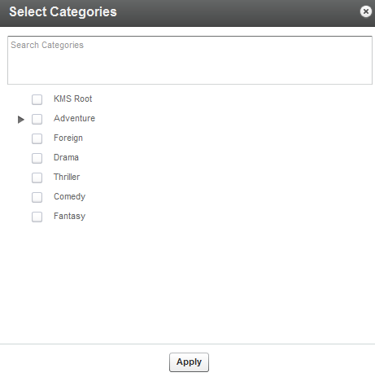

### Edit - Remove Categories

You can remove categories from entries in the KMC. Removal will propagate to other applications.

* To remove categories from an entry

1. Select the Content tab and then select the Entries tab.
2. Select an entry or multiple entries and select Bulk Actions on the bottom of the page.
3. Select Remove Categories from the drop-down menu.
4. Check the categories to remove from the all selected entries.
5. Click Apply.

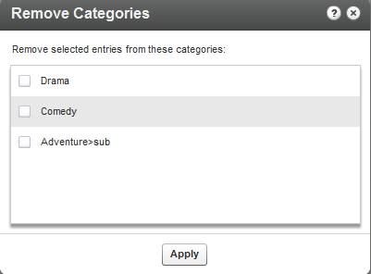

### Add to New Category

You can select multiple entries in the entries list and then click "Add to New Category to create a new category with the specific entries included. See Adding Editing a Specific Category for information on how to create categories.

### Add to New Playlist

You can select multiple entries in the entries list and then click "Add to New Playlist" to create a new playlist with the specific entries included in the playlist. See the Playlists Tab for information on how to create playlists.

* To create and add entries to a new playlist

1. Select the Content tab and then select the Entries tab.
2. Select an entry or multiple entries and select Bulk Actions on the bottom of the page.
3. Select Add to new Playlist from the drop-down menu.
4. Check the entries to add to the new playlist.
5. Click Apply.

### Change Entry Owner

By default, channel managers are the channel owner for any applicative need. A channel owner cannot be deleted by other channel managers; however you can set a new owner for an entry.

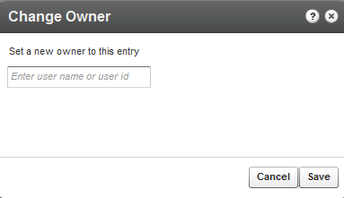

### Download Files

* To download files to your computer for offline use

1. Select an entry and select Bulk Actions on the bottom of the page and select Download from the drop down menu.

Note that you can download more than one entry at a time, as long as the entries appear on the same page of the entries list.

A flavor (format/quality) selection window is displayed for the video files you select to download.

1. Select your preferred flavor from the drop-down menu and click "Submit" to proceed. A message will appear stating that links to your downloaded files will be sent to your email. Click "OK" to proceed.

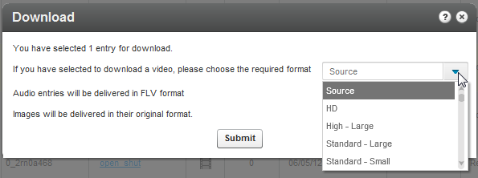

### Delete Multiple Entries

You can delete multiple entries in the KMC.

* To delete entries

1. Select the Content tab and then select the Entries tab.
2. Select an entry or multiple entries and select Bulk Actions on the bottom of the page.
3. Select Delete from the drop-down menu.
4. Select the entries to remove.

A warning message is displayed.

1. Click Remove.

### Preview and Embed

To preview and get the embed code for entries in the Entries Table; click the Preview & Embed" link under the Actions column on the main list of entries. In the new window that opens, you can preview the entry and select the player that you would like to use.

* To preview and embed your content to a website

1. Go to the Content tab and select the Entries tab.
2. Click on an entry in the Entries table.
3. Select Preview and Embed in the actions drop down menu.
4. In the new window that opens, you can preview the entry and select the player that you would like to use.
5. Grab the embed code.

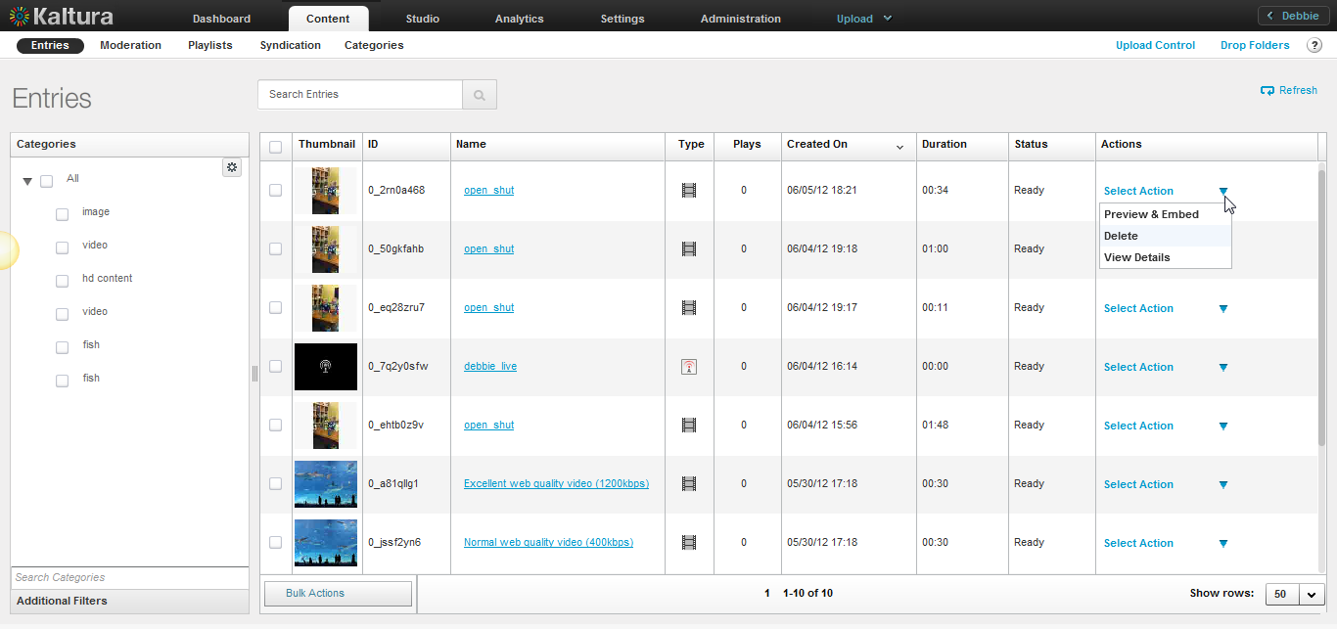

## Editing Entries

* To edit an entry
* Click on an entry name. The Edit Entry window is displayed.

Use the Edit Entry window to manage all information relating to the entry.

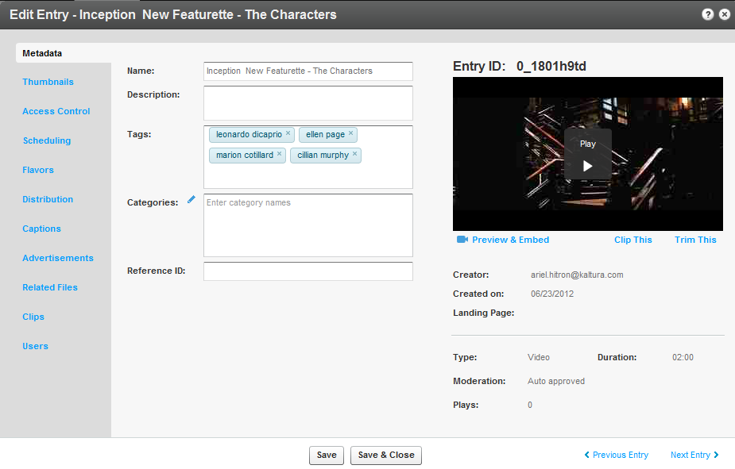

### Edit Entry Tabs

* **Metadata**: Use to display the entry and edit basic metadata: Name, Description, Tags, Categories and Reference ID. See Managing Metadata for more information. For video and audio entries, you can also trim or clip the entry. You can see the Entry ID, type of entry (video, video mix, image or audio), moderation status (approved, flagged for review or rejected), flags, duration, date of creation, creator, rating, votes count and number of plays. In this tab you can also trim or create multiple clips from a single video. Each clip gets its own embed code and metadata, while remaining associated to the original video. Trimming and clipping tools are available both to administrators and site users. See Clipping and Trimming Media Files. You can leverage metadata fields to tag, manage, search and expose content. Populate out-of-the-box fields, or create your own custom metadata schema.
* **Thumbnails**: Use to upload thumbnails, grab a thumbnail from video, crop thumbnails and select a default thumbnail. You can generate thumbnails from videos or upload external images. Capture, crop and adjust to get the best result. See Choosing a Thumbnail for your Video.
* **Access Control**: Use to assign an access control profile to an entry. See Managing Access Control Profiles.
* **Scheduling**: Use to specify date ranges for scheduling an entry. See Content Scheduling.
* **Flavors**: Lists all related flavors. Use to convert an entry to additional flavors or to re-convert existing flavors. See Transcoding and Processing.
* **Distribution:** Lists distribution channels associated with an entry and use to manage distributors. See Content Distribution.
* **Captions:** Use to manage captions. Use to upload captions, link to external caption files, and to add additional captions to an entry. See Subtitles and Captions.
* **Advertisements:** Use to create midrolls and overlays for each entry. Add cue points to your video files to enable time-based functionality such as chaptering, display of related files at specific points, and timed advertisements. See Adding a Midroll.
* **Related Files:** Use to upload related files and to assign the files to an entry. See Uploading and Modifying Related Files.
* **Clips:** Displayed if clips were created from an original video or audio entry. See Clipping an Entry.
* **Users:** Use to add editing and publishing rights for additional end-users to work with this entry across applications. See Users Tab.

### Clipping and Trimming Media Files

You can create clips from existing videos, set in and out points. Each clip becomes its own media entry encoded to multiple flavors, and can be downloaded, distributed and played back on any device. You can also trim the length of a video directly from within the Kaltura Management Console. The clipping tool enables you to edit your videos visually or by setting the start time and end time of your clip. For additional information see [Server Side Clipping and Trimming](http://blog.kaltura.org/server-side-clipping-and-trimming).

Clipping creates a new entry from an existing entry and allows you to specify the start and end time for the new entry. For example you can clip an entry that can be used to create a 2 minute intro video to a long lecture, or clip part of an entry, such as homework assignments. You can also clip a long lecture to several shorter clips divided by subjects. The new entry will point to its source entry so that you can always identify the source entry for the clip.

Trimming does not create a new entry. Sometimes, you may want to trim the start and/or end of a video to remove redundant parts. Trimming is performed on the source flavor of the entry, modifying that video permanently.

* To clip a media entry

1. Select the Content tab and then select an entry from the Entries Table.
2. In the Metadata tab, click Clip This.

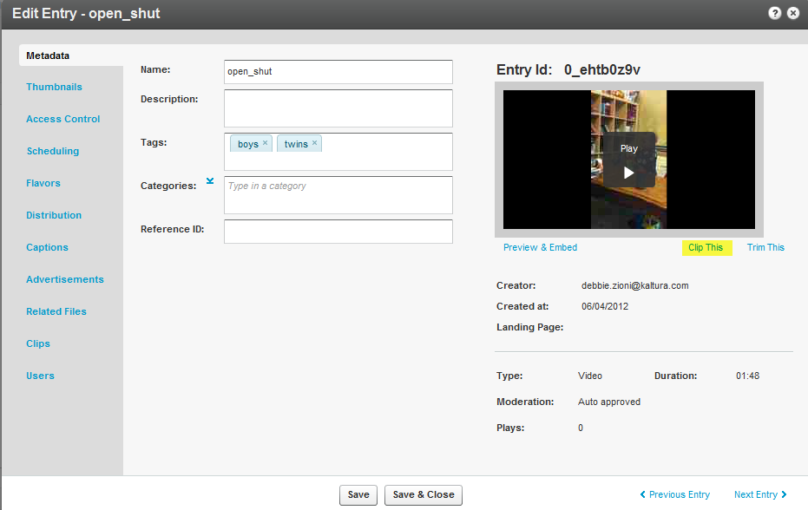

The Clipping Tool window is displayed.

1. Click Add New Clip.

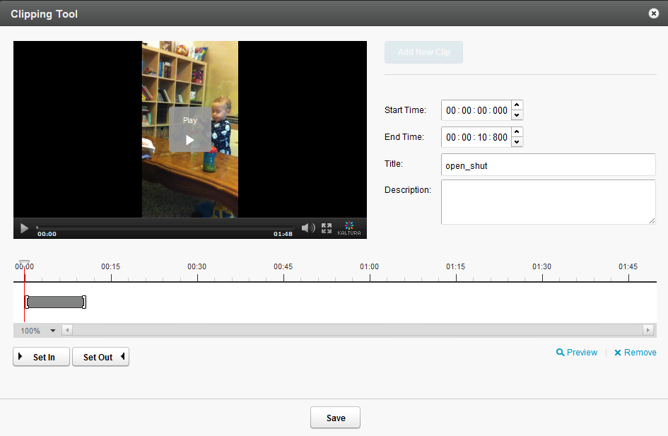

1. Use the arrow to choose the granularity level for the display.

The choices are:

* 100%
* 5 sec
* 1 sec
* Frames.

1. Press Play and click Set In as the starting point of the video clip, or alternatively, select the start time.
2. Select Set Out as the end point of the video clip, or alternatively select the end time.
3. Provide a New name and Description for the clip (optional).
4. Click Save.

The new clip appears in the Entries Table.

This Clips tab is available after you create a clip. The read-only list of all created clips includes the following information:

* Name
* ID
* Creator
* Plays
* Duration
* To trim a media entry

1. Select the Content tab and then select an entry from the Entries Table.
2. In the Metadata tab, click Clip This.
3. Select Add New Clip.
4. Use the trimming timeline or enter exact in and out times.
5. Press Play and click Set In as the starting point of the video clip or alternatively, select the start time.
6. Select Set Out as the end point of the video clip, or alternatively select the end time.
7. Provide a New name and Description for the clip (optional)
8. Click Save.

The trimmed video appears in the entries table.

### Troubleshooting Trimming and Clipping

The Trim and Clip feature may be disabled if your transcoding profile does not include the flavor for the file you want to trim or clip.

When you upload content, new flavors are created from the Source flavor and transcoded to the flavors you define in your Transcoding Settings.

* To add the Source flavor to your transcoding profile

1. Go to Settings tab and select the Transcoding Settings tab.
2. At the bottom of the page, click Switch to Advanced mode.
3. Click on the name of your default transcoding profile
4. In the Edit Transcoding profile check the Source flavor and then Save Changes.

### Users Tab

The Users tab is displayed when your account is configured to support the end-user management feature.

The Users tab provides information about the users that are associated with the entry. The users are

* the creator of the entry in Kaltura - usually the person that uploaded the media
* the administrative owner of the entry - the user that is assigned with ownership to manage the entry. By default it is the entry creator, however you can assign ownership to a different user from this tab.

By editing the co-editors and co-publisher fields, you can add editing and publishing rights for additional end-users to work with this entry across applications.

* To edit the entry’s users settings

1. Go to the Content tab and then select an entry from the Entries Table.
2. Select the Users tab.

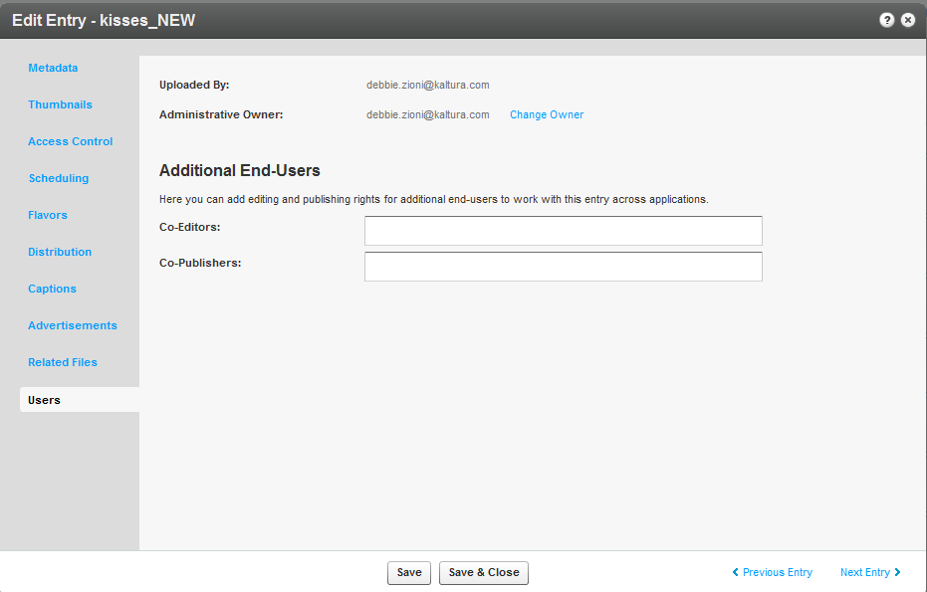

1. Click Change Owner.

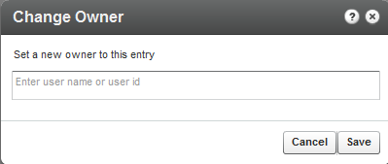

1. Enter the new owner name and click Save.
2. The CoEditor(s) and Co-Publishers field is displayed only when configured in your acount.
3. Click Save and Close.

## Choosing a Thumbnail for your Video

You can select a thumbnail for your video after the file transfer is complete and the file is embedded in your website. Thumbnails are configured in the **Thumbnails** tab in the **Contents** tab. By default, a thumbnail is automatically grabbed from the first frames of the video. You can choose to have multiple thumbnails of different qualities associated with your video, or grab any frame from the video to use as a thumbnail.

You can search for a thumbnail and its dimensions, size, distributors and status and perform the following actions: Set as default, Download and Delete.

* To edit the thumbnails associated with the video

1. Go to the Content tab and select the Entries tab.
2. Select an entry and select the Thumbnails tab.
3. Select Upload, Grab from Video or New Crop.

* Upload - uploads an external image as a thumbnail.
* Select Upload and specify the file location and name, then click Open.
* Grab from Video -Capture a new thumbnail from the video.

Play the video in the "Grab from Video" window. Pause on the frame you want to use and click the thumbnail capture icon (camera). A thumbnail will be captured from the highest quality video flavor. Exit to return to the Thumbnails tab.

* New Crop - Modify thumbnail dimensions.

1. Select a thumbnail and create a thumbnail with a new position and size.
2. Adjust the display area with the handles on the image and click **Generate Thumbnail**.

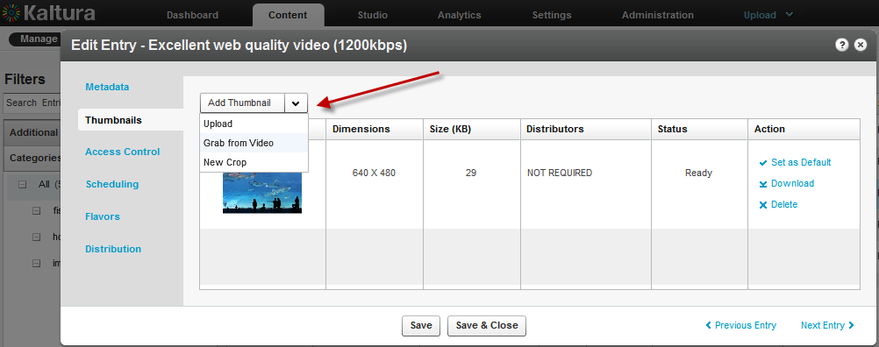

The default thumbnail is now displayed in the entries list.

Chapter

# **Publishing to your Site**

This section describes how to embed a player to your site and the various video deliver settings available.

## Embedding a Player with a Single Entry on your Site

* To embed a player on your site

1. Create a Player. See Configuring the Player Basics Settings.
2. Add content (an entry) to the player. See Adding Content to a Player.  
   The Entries table from the Content tab is displayed.
3. Click Preview and Embed.  
   The Embedding window is displayed to select the delivery options.

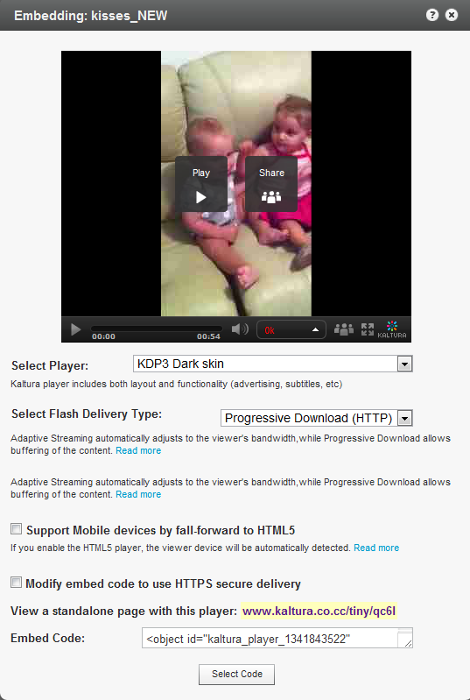

1. Select your preferred player skin from the drop-down menu. See Configuring the Player Features. Select the Flash Delivery Type. See Video Delivery Settings.
2. Check Support Mobile devices by fall forward to HTML5, if applicable. See Mobile Support.
3. Check Modify embed code to use HTPPS secure delivery.
4. You can view a standalone page with this player by clicking on the provided link.
5. Click Select Code or click CTRL+C (on a PC) or option+C on a Mac to copy the embed code to your clipboard, or grab the Embed Code, and add/paste it to your website HTML source.

## Embedding a Player with a Playlist on your Site

After you've created a playlist, and have assigned the playlist to a player, see Designing and Configuring A Player you can publish the player to your site.

* To embed a player with a playlist on your site

1. Go to the Content tab and select the Playlists tab.
2. Locate the playlist you want to publish on your website and click Preview & Embed.

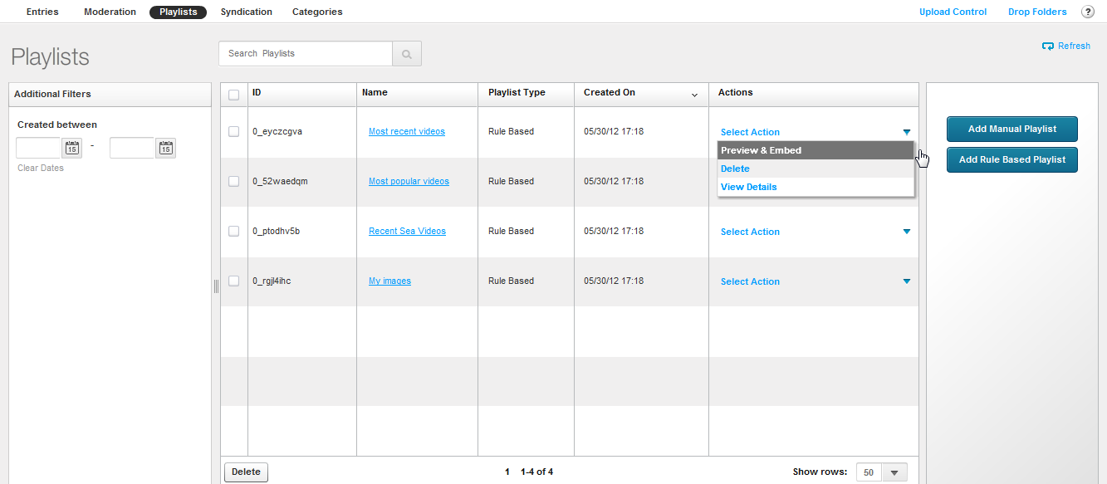

The Embedding window is displayed to select the delivery options.

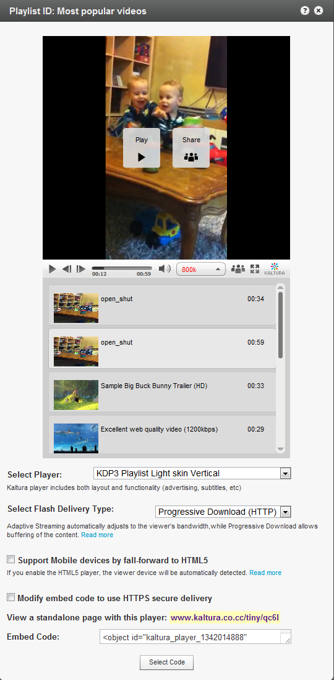

1. Select your preferred player skin from the drop-down menu. See Configuring the Player Features.
2. Select the Flash Delivery Type. See Flash Delivery Type.
3. Check Support Mobile devices by fall forward toHTML5. See Mobile Support.
4. Click Select Code.
5. Click CTRL+C (on a PC) or option+C on a Mac to copy the embed code to your clipboard or

grab the Embed Code, and add/paste it to your website HTML source.

### Video Delivery Settings

You can choose between the following types of video delivery settings

* HTTP Progressive Download Delivery– Allows you to pause the video playback and wait for the content to download. Typically used where viewers have very limited bandwidth.
* Adaptive Streaming RTMP Delivery with Adaptive Bitrate– Allows adaptive bit-rate. The player can adjust the video quality on the fly based on network and CPU conditions. Based on RTMP protocol.
* Secure Transport (RTMPE) – Allows adaptive bit-rate. Encrypted Real Time Messaging Protocol (RTMPE or RTMPTE) is a proprietary protocol created by [Macromedia](http://wiki.multimedia.cx/index.php?title=Macromedia) used for streaming video.
* Akamai HD Network– Allows adaptive bit-rate. The player can adjust the video quality on the fly based on network and CPU conditions. Based on Akamai CDN technology.

This option requires that the CDN associated with your publisher account is Akamai which is the default for all Kaltura customers.

For more information see Best Practices for [Multi-Device Transcoding.](http://knowledge.kaltura.com/best-practices-multi-device-transcoding)

### HTTP Progressive Download Delivery

With HTTP Progressive download, the digital media begins downloading and after a specified amount of data becomes available to the video player, the media begins to play while the rest of the data continues to buffer.

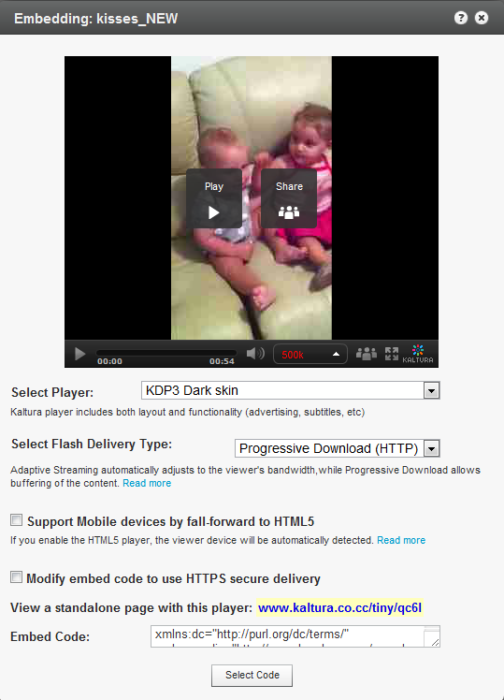

### Adaptive Streaming RTMP Delivery with Adaptive Bitrate

Adaptive Bit Rate (ABR) streaming is a technique of detecting a viewer's bandwidth capabilities in real time, and then adjusting the quality of the video stream accordingly, always delivering the best possible picture quality. ABR streaming results in less buffering, fast start time and an overall better experience for both high-speed and low-speed connections.

ABR dynamically shifts bandwidth to higher and lower levels based on availability. For Adaptive Bitrate Streaming to work, a video is first encoded at different bitrates to accommodate varying bandwidth connections. Each bitrate version is sliced up into tiny fragments — typically 2 to 10 seconds. The Kaltura player pulls fragments from the different encodings and inserts them into the stream as bandwidth dictates resulting in faster video start times and a continuous, uninterrupted video experience.

For example, a movie called The “Big Movie” is streaming. The end user would view a smoothly playing video. Unknown to the user, multiple streams are actually available and may be seamlessly switched to, if their connection drops lower or improves.  The key here is “seamless”. When adaptive bit streaming is done correctly, there should be no interruption of playback.

For The Big Movie, a player might be serving up the following all at once:

The Big Movie @ 2612 kbps

The Big Movie @ 1600 kbps

The Big Movie @ 1200 kbps

The Big Movie @ 800 kbps

USE CASE

If a user’s connection dropped from over 2.5 Mbps to 1600kbps, the Kaltura player would switch, again seamlessly, from the 2612 bit rate down to the 1600. Often the Kaltura player is designed to begin playing using the lowest possible bit rate so that playback starts immediately. For this example, the 800 kbps stream might be served up first and then as the Kaltura player realizes that the user can handle a higher bitrate, the streaming rate would then be switched up higher.

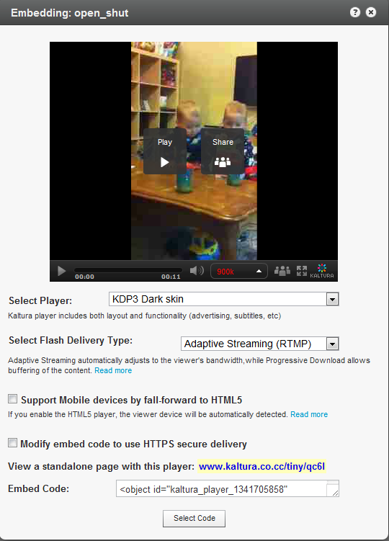

### Secure Transport RTMPE

RTMPE (Real-Time Media Protocol Encrypted) is a secure streaming protocol that encrypts the stream between the server and the client. Because RTMPE was designed specifically to protect video content between Flash Media Server and supporting clients, it results in a better user experience and eases the management burden on the server. RTMPE uses 128-bit encryption to help prevent third-party applications or “network sniffers” from capturing the video from the stream. The client and Flash Media Server negotiate a session key between them, helping block “replay” attacks.

### Akamai HD Network – Allows adaptive bit-rate

Akamai's advanced adaptive bitrate streaming technology intelligently adjusts the bit rate of a video stream to ensure the optimum playback quality based on changing bandwidth conditions. It also allows for flavor switching without the loss of content. You can send streaming video over HTTP from an ordinary web server for playback on iPhone and iPad, or other devices, such as desktop computers, without the limitations of Progressive Downloads.   
  
The Akamai HD streaming protocol supports Multiple Bitrates and adaptively switches to the optimal bit-rate based on network conditions for a smooth quality playback experience. An optional feature with this selected delivery setting is that the implementation also provides for media encryption and user authentication over HTTPS, allowing publishers to protect their work.  
  
The Akamai HD Network is designed and optimized for large-scale broadcasters and film distributors to increase audience engagement and expand revenues by complementing traditional mediums such as TV and DVD with the Internet.

## Adding the Flavor Selector Module

Any entry is available in various transcoding flavors. The flavor selector module allows you to manually select the video flavor you want to watch, based on your preferences. The options are HD on or HD off.  
Note: If you are broadcasting with Adaptive RTMP then the flavor selector will be set to “auto”.

* To add the flavor’s selector module

1. Go to Studio tab and create a new player or edit an existing one.
2. In the Features tab, go to the Features List and click Controls.
3. Check Flavor Selector.
4. Select Options (optional) to configure display options.
5. Click Preview to view your selection and click Save Changes to complete the process.

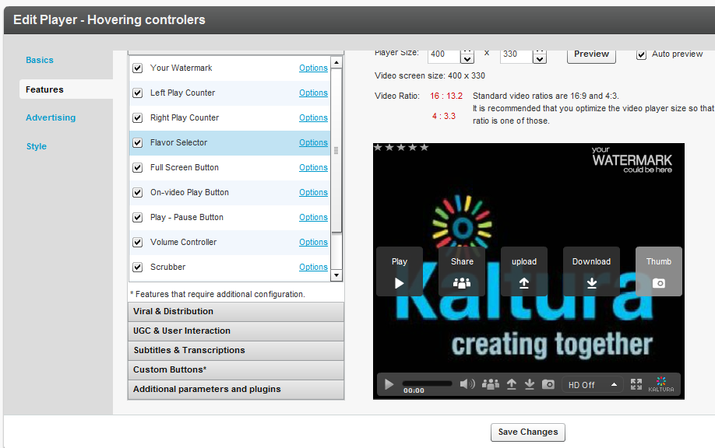

### Mobile Support

If you enable the HTML5 player, on the Preview and Embed screen, the viewer device will be automatically detected.

If you require mobile display, you must configure a specific encoding flavor for mobile support (iPhone, iPad). To transcode a file to this flavor, go to the Edit Entry window's Flavors tab. See Transcoding and Processing and check the applicable mobile flavors.

Chapter

# **Distribution and Syndication**

Kaltura offers several advanced syndication and distribution services to ensure that publishers maximize their content’s reach and increase their audience. Kaltura’s tools help publishers save time and money by making content distribution to a wide range of video destination sites and search engines extremely easy and streamlined.

## Kaltura Distribution Module

Kaltura’s Distribution Module allows you to reach your users on the web and across any mobile device. The module provides a streamlined and simple workflow so you can distribute your content to distribution partners, such as YouTube, Hulu, Comcast, MySpace, MSN or an FTP drop folder, directly from within the KMC.

### Key Benefits:

* Full control over where and when the content is presented.
* Manage all of your distribution partners through a single user-friendly interface
* Deliver assets automatically as they are added to your Kaltura account, or require a manual review, at your discretion
* Seamlessly push updates to distributed content from a central dashboard
* Control scheduling sunrise and sunset per asset and per distribution partner
* Track your content across all distribution partners
* Simple and straightforward pricing, with no hidden fees or “guesstimates”
* Kaltura’s system validates content to make sure it’s ready to be distributed to each distributor, and alerts about any errors that need to be fixed prior to distribution (missing thumbnails, missing metadata, etc.)
* Successful delivery to each distribution partner is confirmed for each asset (if supported by the partner)

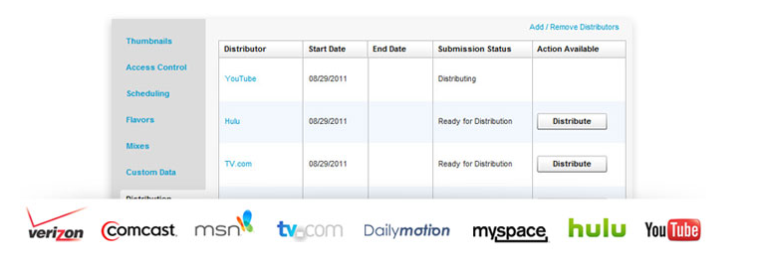

## How Does Distribution Work?

Distribution ensures that your content is viewed by as many customers as possible across multiple video destination sites and improves total views for your content. Kaltura pushes the actual contents of the video assets to distribution partners for them to host on their sites. Each distribution channel is unique and depends on the distributor’s capabilities and the extent of their desired exposure.

The Kaltura Distribution Module supports several workflows. You can configure simple as well as complex asset information to distribute. For example, simple asset information may include the entry name, description and tags, or metadata alone, that may be used for example, to configure ads based on metadata. More complex distribution data is configurable by your project manager and depends on the distributor’s capabilities.

You can define the destinations for each video package and control aspects such as the video qualities, number and size of thumbnails, metadata, and scheduling data for each distribution destination.

You can display distributors for each entry, the distribution start and end dates, submission status.

|  |  |
| --- | --- |
|  | NOTE: You can distribute ALL videos to be pushed automatically to the destination or you can distribute selected entries MANUALLY to be sent to the destination. |

|  |  |
| --- | --- |
|  | NOTE: Tag based or Rule Based distribution options are currently not available. You can either distribute ALL entries or NONE. If none, you can manually select which entries will be distributed to the destination. |

A sample distribution configuration may contain the following components for an entry: video, metadata, thumbnail, scheduling, content availability by Kaltura and removal of distributed content.

The Distribution Module can be configured to update distributed content for metadata, so that the most updated information is propagated to the distribution site. Other customizable parameters may be configured for distribution. The Distribution Module also can be configured to remove distributed content for metadata, so that information that was propagated to the distribution site can be retracted.

With the Kaltura Distribution Module, administrators can control the destinations for each video package, and for each distribution destination. In addition, administrators can control video transcodes, multiple thumbnails in different sizes, metadata translations, scheduling data, and more.

The Distribution Module is an add-on module to the KMC, and incurs additional fees based on the amount of distribution destinations supported for your account. Additional connectors to distribution destinations can also be developed as custom work. Contact your Kaltura project manager or sales representative for complete pricing.

### Adding a Distributor to an Entry

|  |  |
| --- | --- |
|  | NOTE: To enable automatic distribution of all new entries, [contact us](http://corp.kaltura.com/about/contact), or call +1-800-871-5224.  To add more distribution destinations, contact your project manager. |

* To add a distributor

1. Go to the Content tab and select the Entries tab.
2. In the Entries Table, click the name of the entry you want to distribute.
3. In the Edit Entry window, select the Distribution tab.
4. Click Add / Remove Distributors.

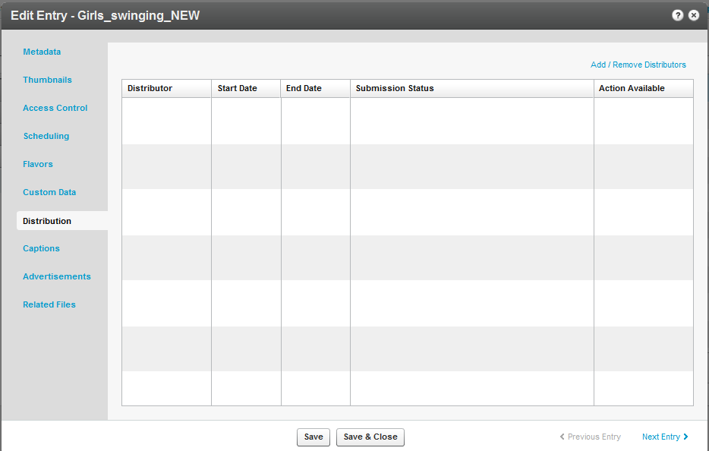

The Add/Remove Distributors window is displayed.

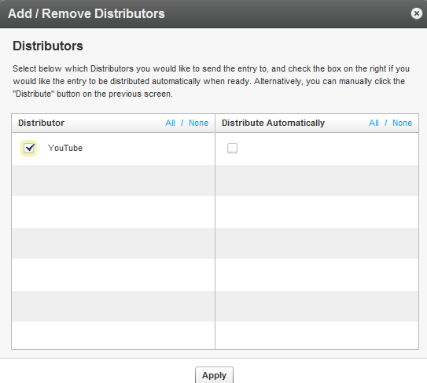

* To add distributor destinations to your account
* Contact your account manager.
* To select distributors

1. Check the distributors from the Distributor list. Click All or None at the top of the column to select or clear all the items in a column.
2. Check the Distribute Automatically column to distribute an entry as soon as it is ready. Click All or None at the top of the column to select or clear all the items in a column.

All includes all distributors. For example, if you have configured Daily Motion and YouTube as distributors, content will be distributed to both destinations.

1. Click Apply to save your changes and return to the Distribution tab.
2. Click Save Changes to complete the process.

## Scheduling a Video Package

By default, an entry's general scheduling is inherited by all distributors. The instructions here are for setting scheduling for a specific distributor. A Remote ID is the ID assigned to the distributed content in the distributor, and is only available after content has been distributed. The Remote ID may be used as a response from the distributor as well as a reference, for example, to reach the page where the distributed content appears in the distributor.

* To schedule when an entry should be distributed

1. Select the Content tab and select the Entries tab.
2. In the Entries Table, click the name of the entry that you want to schedule.
3. In the Edit Entry window, select the Distribution tab and then select the name of a distributor.

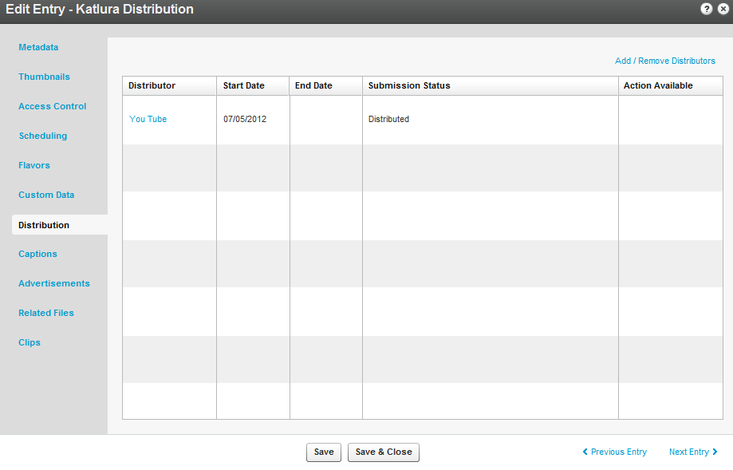

The Distribution Details window is displayed.

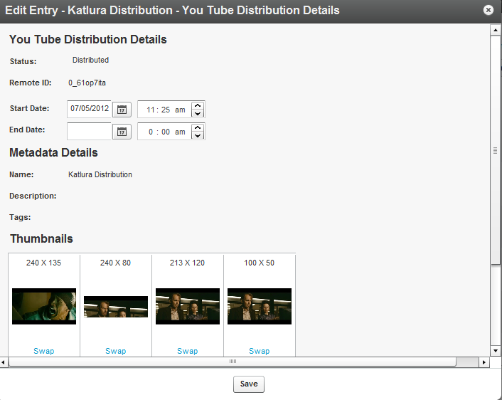

1. Set the Start Date and End Date and enter the hour.
2. Click Save to return to the Distribution tab.
3. Click Save and Close to complete the process.

### Validating a Video Package

Errors may occur when you specify a video package distributor.

* To find and resolve errors

1. Go to the Content tab and select the Entries tab.
2. In the Entries Table, click the name of an entry for which you added a distributor.
3. In the Edit Entry window, go to the Distribution tab and click the error name in the Submission Status column to display a description of the error.

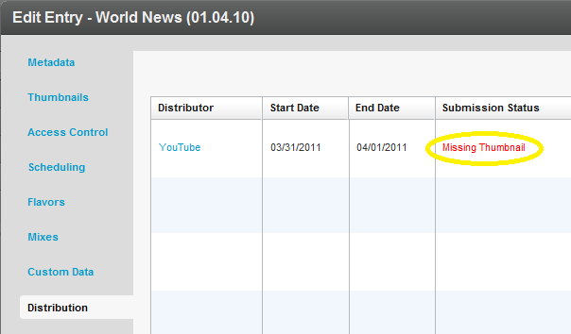

You can also click on the Distributor in the Distribution tab, and then click the error name in the Distribution Details window.

1. Follow the instructions in the error description.

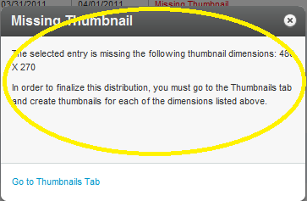

The following errors may occur:

Missing Flavor Error

* To add a flavor:

|  |  |
| --- | --- |
|  | NOTE: If you click "Go to Flavors Tab" in the error description, skip to step 4. |

1. Go to the Content tab and select the Entries tab.
2. In the Entries Table, click the name of the entry that is missing a flavor.
3. In the Edit Entry window, go to the Flavors tab.
4. In the Action column, click Convert or Reconvert for each transcoding flavor specified in the error description, and click Save Changes.

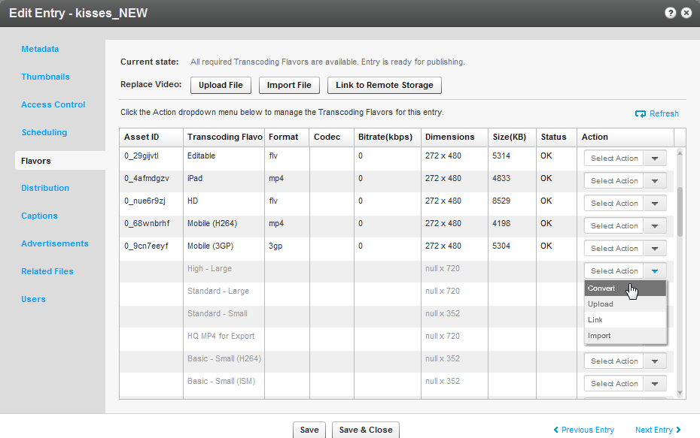

Metadata Error

* To correct metadata:

|  |  |
| --- | --- |
|  | NOTE: If you click "Go to Metadata Tab" in the error description, skip to step 4. |

1. Go to the Content tab and select the Entries tab.
2. In the Entries Table, click the name of the entry that has a metadata error.
3. In the Edit Entry window, go to the Metadata tab or the Custom Data tab.
4. Modify the information in the metadata field specified in the error description, and click Save and Close.

If the submission status error is still displayed in the Edit Entry window's Distribution tab: go back to the Edit Entry window, and select the Custom Data tab.

1. Add the missing information specified in the error description, and click Save and Close.

Missing Thumbnail Error

* To add a thumbnail

|  |  |
| --- | --- |
|  | NOTE: If you click "Go to Thumbnails Tab" in the error description, skip to step 4. |

1. Go to the Content tab and select the Entries tab.
2. In the Entries Table, click the name of the entry that is missing a thumbnail.
3. In the Edit Entry window, go to the Thumbnails tab.
4. Click Add Thumbnail and select Grab from Video.

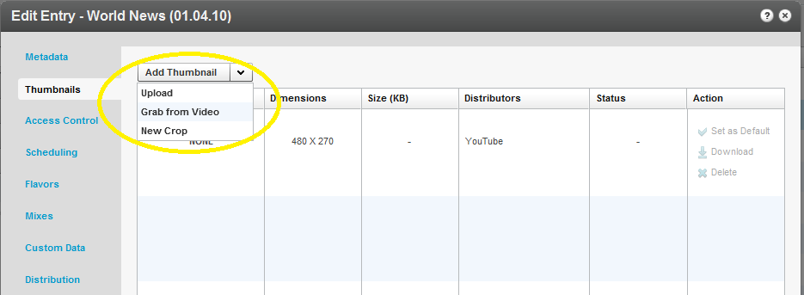

1. If you have a thumbnail file, select Upload, specify the file location and name, and click Open.
2. Play the video, pause on the frame you want, and click the thumbnail capture button (camera).

A thumbnail will be captured from the highest quality video flavor.

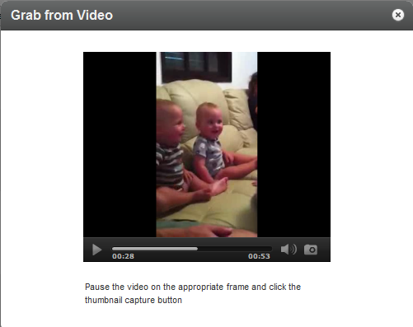

1. Exit to return to the Thumbnails window.

* To modify the thumbnail dimensions

1. In the Edit Entry window, click **Add Thumbnail** and‎ select New Crop.
2. Select the Thumbnail to modify.
3. Check the Lock aspect ratio and scale to option and select the values specified in the error description.
4. Adjust the display area with the handles on the image.
5. Click Generate Thumbnail, and exit to return to the Thumbnails window.

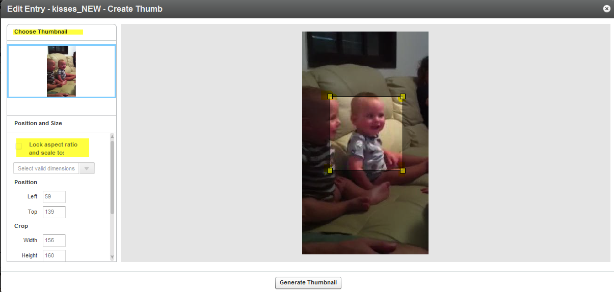

1. Click Save Changes to complete the process.

### Removing a Distributor from a Video Package

You may want to change your distribution destinations for video packages.

* To remove a distributor from a video package

1. Go to the Content tab and select the Entries tab.
2. In the Entries Table, click the name of the entry with a distributor that you want to remove.
3. In the "Edit Entry" window, go to the "Distribution" tab and click "Add / Remove Distributors".

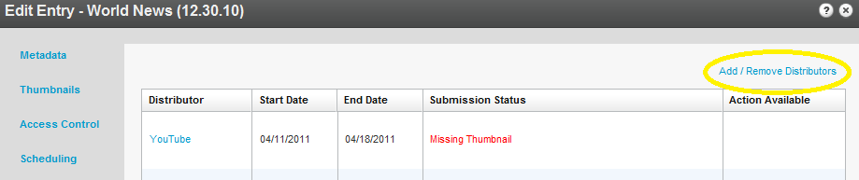

1. In the "Add / Remove Distributors" window, clear a distributor checkbox.

To clear all items in a column, click "None" at the top of the column.

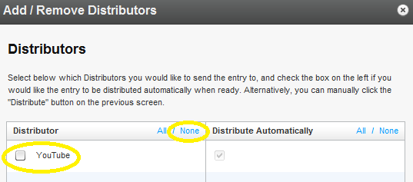

1. Click Apply to save your changes and return to the Distribution tab.
2. Click Save Changes to complete the process.

### Managing Distributor Details

* To manage an entry's distributor details

1. Click the distributor's name on the "Distribution" tab.

In the "Distribution Details" window, you can see the distributor's distribution details (status, remote ID and schedule), the entry's metadata details, the available thumbnails and the video flavors.

1. In the "Distribution Details" section:
2. To fix an error, click the error name to display an error description and follow the instructions.
3. To schedule when an entry is available at the distributor, set the start and end dates and times, and click "Save".

You can set scheduling separately for each distribution so that the same content may have a different schedule depending on the distributor.

1. In the "Thumbnails" section, Thumbnails are matched to the distribution point's required thumbnail size.  If you have multiple thumbnails of the same size, click "Swap" to manually select the one you want.
2. In the "Video Flavors" section, to preview the entry in a specific flavor, click "Preview" and play the entry in the "Flavor Preview" window.

# The Syndication Tab

Details on how to syndicate your content to specific destinations are included here.

## Content Syndication

Content syndication is a way of making your content available to multiple other sources. This creates a form of leverage that gives you the ability to create your content once while maximizing your exposure on the Internet by distributing your content in many places at the same time. Content syndication is a win-win for both the publisher and the webmaster. As a result of this type of distribution, publishers receive increasingly more exposure for their content and webmasters receive new source for additional content.

Kaltura allows you to create video feeds in multiple formats that are ready for submission to 3rd party platforms such as Google, Yahoo!, iTunes and other video sharing sites and social networks.  Videos are distributed via playlist feeds (such as MRSS) to the channels of your choice. The content remains on the Kaltura host.

RSS syndicates your web content to other sites and builds inbound links, making RSS one of the most effective SEO strategies today. Using RSS as part of your SEO strategy is advantageous. If you need help with web content syndication, contact your account manager.

Syndicating to Google in the KMC is used mainly to create video site maps to submit into Google search engines for indexing.

iTunes syndication in the KMC is used to show content in iTunes and to create a feed for iTunes.

## How Does Syndication Work?

Kaltura provides syndication to the following out of the box formats:

* Google
* Yahoo
* iTunes
* TubeMogul

Partners and developers can also syndicate content in Flexible Feed Format, or you can contact Professional Services to create a customize feed in XSLT or XML. See Flexible Feed Format.

Kaltura’s MRSS Feeds and Syndication services allow publishers to syndicate and track their videos on a wide range of video sharing sites and social networks via playlist feeds managed through the Kaltura Management Console. Publishers can then track their videos and tweak their programs and campaigns based on the results.

Publishers can set up MRSS feeds into major video search engines including Google, Yahoo! and iTunes from within the KMC. You can create a feed based on all of the content in your KMC account, or a subset of the content that is determined by a specific playlist see the Playlists Tab. You can then add the selected content to a feed by selecting its destination site. The content of a playlist can change, for example a rule-based playlist can be modified by changing a rule, or a manually created playlist may be modified by manually adding content to the playlist. The feed will automatically change according to the modifications. Feeds are cached in the Kaltura server for 24 hours. The feed refresh is automatic, and the changes are available after that time.

You can shorten the caching time by limiting the feed size.

* To shorten the caching time for a syndication feed
* Manually add the parameter (&limit=50) to the feed URL.

Adding this parameter will limit the feed size to up to 50 items and will reduce the caching time to 30 minutes

### Syndicating to a Standard MRSS Feed (Yahoo)

Yahoo is the standard MRSS feed type which can be used by any MRSS reader for various use cases. Yahoo also uses the standard MRSS feed to submit site maps. For example, if you create an MRSS, you can place the link in your site and allow end users to subscribe to the feed, or use the feed for your own integration. You can create your own video galleries that refresh when you update the feed, as well as integrate the feed to your site, and extract data from the feed to display the content, depending on fields you define. There are many clients (for example all browsers), and desktop applications, and site integrations that know how to read MRSS feeds.

### Search Engine Optimization (SEO)

Submitting feeds to major search engines helps to increase your content’s SEO, and ultimately direct more traffic to your website. See [Maximizing Video SEO With Kaltura](http://blog.kaltura.org/?p=1773&preview=true).

### Key benefits

* Setting up a new feed is simple and quick - easily set-up multiple playlists in the KMC to be distributed, videos within each playlist are automatically distributed to the relevant channels on the video sharing sites.
* Automatic updates – after a one-time set-up, any additional videos that are added to the selected playlist will automatically be syndicated accordingly based on the feed’s specific configuration. There is no need for manual updates to the feed.

## Setting Up Syndication

* To configure syndicatio**n** settings

1. Go to the Content tab and select the Syndicate tab.

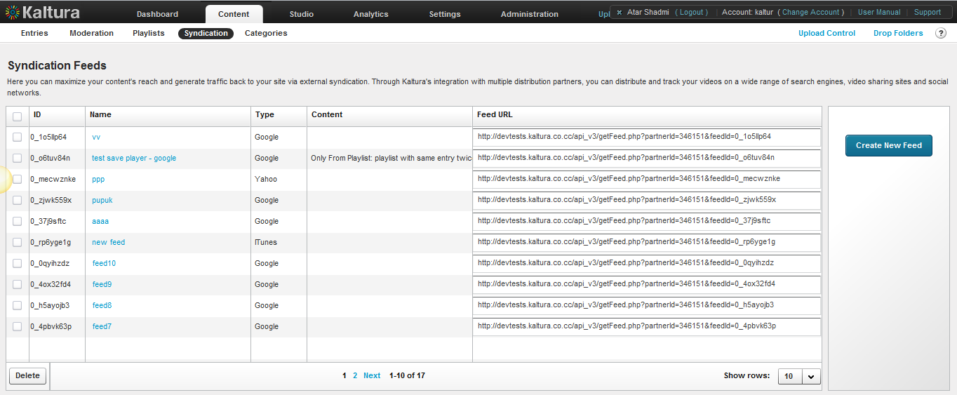

1. Click Create New Feed.
2. Enter the Feed Name (required).
3. Select the content to syndicate.

* All Content – syndicates all entries.
* Only content from this playlist – syndicates content from the playlist you select.

1. Select the Feed Type.

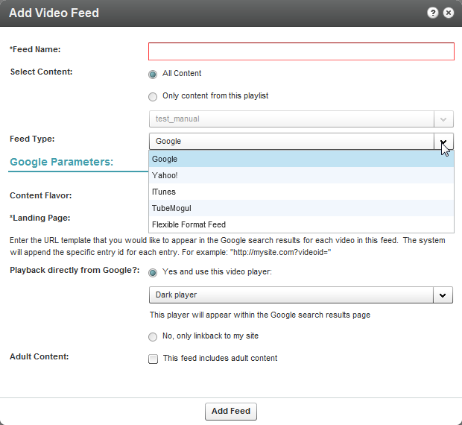

### Syndicating to Google

You can submit your videos to the Google search engine which will ultimately direct more traffic from Google to your website. Submission of video feeds to Google is free of charge, yet requires some technical knowledge. It is recommended that your website's webmaster be available for assistance. Google syndication is used mainly for submitting your site map and being certain that your media is indexed by Google.

The workflow for setting up Google syndication is divided into two tasks:

* Google Webmaster tasks
* KMC Publisher tasks

### Google Webmaster Tasks

* To configure syndication settings for Google

1. Setup a [Google Webmaster](https://www.google.com/webmasters/tools/home) account for your website.
2. Setup your website in the Google Webmaster Tool.

[Follow the directions here](http://www.google.com/support/webmasters/bin/answer.py?hl=en&answer=34592). Make sure your site is valid based on the Google instructions.

1. Submit the Feed to a URL.

Create a server page on your website that redirects to this feed URL.

For example, for a php implementation, save a php file named redirect.php with the following content (replace the XXXX with your feed URL):

<?php  
Header( "HTTP/1.1 301 Moved Permanently" );   
Header( "Location : XXXX");   
?>

1. [Login to the Google Webmaster Tool](https://www.google.com/webmasters/tools/home).
2. In the Google Webmaster Tool, go to Site configuration > Sitemaps > Submit a sitemap.
3. Submit the feed as your redirect page in your site, for example:   
   http://mysite.com/redirect.php.

### KMC Publisher Tasks for Google Syndication

* To configure syndication settings for Google

1. Configure the Syndication Settings. See Setting Up Syndication.
2. Select Google from the Feed Type drop-down menu.

The Google parameters are displayed.

1. Enter the Google Parameters, see Google: Feed Parameters and click Add Feed.

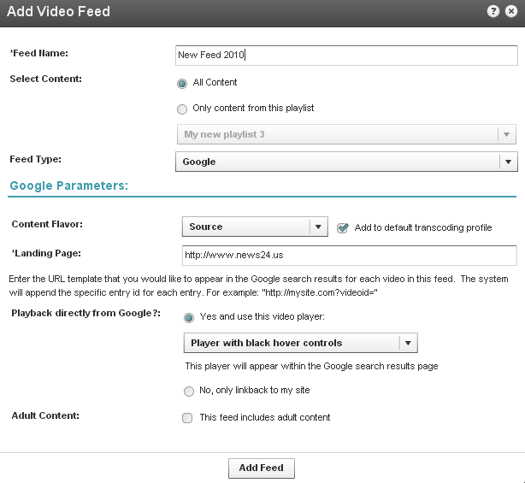

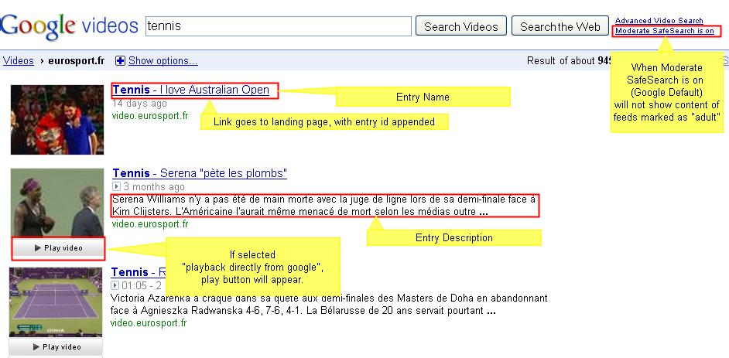

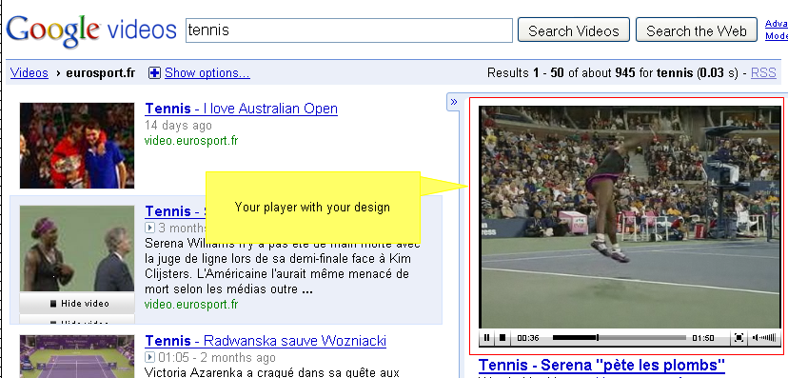

#### Google: Feed Parameters

| Field | Description |
| --- | --- |
| Content Flavor | The format and quality of the content to be syndicated |
| Landing page | The URL template that you would like to appear in the Google search results for each video in this feed. The system will append the specific entry ID for each entry. See feed example below. |
| Add to default transcoding profile | Check to add the chosen Content flavor to content that will be uploaded subsequently, using the default transcoding profile |
| Playback directly from Google - | Select if you prefer for Google to display a link to your website only or if you'd like Google to display the actual video directly within the search results page (see screenshot below). If you allow Google to playback the videos directly from the search results page, you can select the player that will be used for playback. The player may include your branding, watermark, etc. |
| Adult content | If selected, videos in this feed should be available only to users with SafeSearch turned off. |

### Syndicating to TubeMogul

Kaltura and TubeMogul have partnered to provide a premium syndication service at the most attractive pricing available.

This service allows you to seamlessly syndicate your content to over 20 video portals including YouTube, Daily Motion, Metacafe, etc. and to receive aggregated analytics across video portals.

Each time you add a video to your syndicated content, it will be automatically distributed to your channel in the video portal you selected.

To learn more about this feature and pricing information [contact us](http://corp.kaltura.com/about/contact?subject=tubemogul) or call +1-800-871-5224.

### KMC Publisher Tasks for TubeMogul Syndication

* **T**o configure syndication settings for TubeMogul

1. Configure the Syndication Settings. See Setting Up Syndication.
2. Select TubeMogul from the Feed Type drop-down menu.

The TubeMogul parameters are displayed.

1. Enter the TubeMogul Parameters, see TubeMogul: Feed Parameters and click Add Feed.

The URL for the feed is generated.

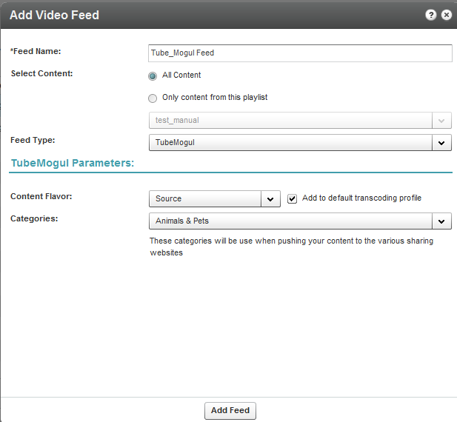

#### TubeMogul: Feed Parameters

| Field | Description |
| --- | --- |
| Content flavor | The format and quality of the content to be syndicated. |
| Add to default transcoding profile | Check to add the chosen Content flavor to content that will be uploaded subsequently, using the default transcoding profile. |
| Feed categories | These categories will be used when pushing your content to the various sharing websites |

### TubeMogul Webmaster Tasks

To submit the video feed to TubeMogul

1. Copy the feed URL you obtained after you added the feed. See KMC Publisher Tasks for TubeMogul Syndication.

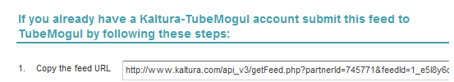

1. Login to your [Kaltura–TubeMogul account](http://www.tubemogul.com/auth/login?source=kaltura).
2. Go to Advanced Tools, select More Tools, and then select MRSS Feed Manager.
3. Submit your feed.

### Syndicating to iTunes

You can submit your content to the iTunes Store as a podcast. You will need an active Apple ID and the iTunes application installed. The flavors for feeds for iTunes must either be MP4, or a flavor that is compatible with Apple iTunes.

### KMC Publisher Tasks for iTunes Syndication

* To configure syndication settings for iTunes

1. Configure the Syndication Settings. See Setting Up Syndication.
2. Select iTunes from the Feed Type drop-down menu.

The iTunes parameters are displayed.

1. Enter the iTunes Parameters, see iTunes: Feed Parameters and click Add Feed.

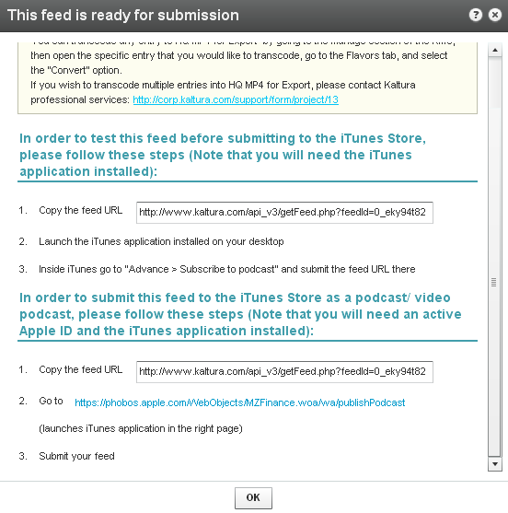

#### iTunes: Feed Parameters

| Field | Description |
| --- | --- |
| Name | Name of the feed. |
| Content selection | You can either select all content, or create a feed of a specific playlist only. |
| Content flavor | The format and quality of the content to be syndicated. iTunes supports these formats: .m4a, .mp3, .mov, .mp4, and .m4v. Refer to [here](http://www.apple.com/itunes/podcasts/specs.html#submitandfeeback) for more information. |
| Add to Default Transcoding Profile | Check to add the chosen Content flavor to content that will be uploaded subsequently, using the default transcoding profile. |
| Landing page | The URL template that you would like to appear in the iTunes Store for each video in this feed. The system will append the specific entry ID for each entry. The following parameters will be presented in the iTunes store, as demonstrated in the illustration below:  Feed Author  Feed Landing Page (link back to your website)  Feed Category (will direct iTunes store how to categorize your feed)  Feed Description  Feed Image URL (should be 600x600)  In addition, the system will add the following relevant information for every entry: Name, Duration, Create date, Description. |
| Contact information | The name and email you enter for the feed will be used for iTunes Store to contact you if necessary. This information will not be presented in the iTunes Store. |
| Language | The language of the videos/ audio files in this feed. |
| Adult content | If you select this, an "explicit" parental advisory graphic will appear next to your podcast artwork on the iTunes Store, and in the Name column in iTunes. |

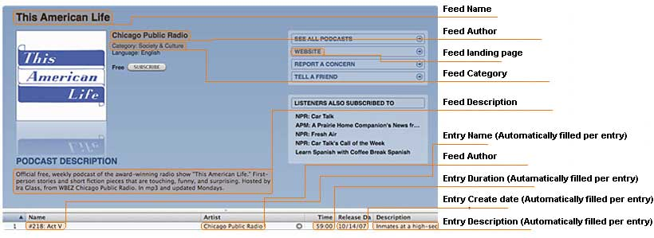

* To test the feed before submitting to the iTunes Store

1. Copy the URL you obtained after adding the feed.
2. Launch the iTunes application installed on your desktop.
3. Go to Advance > Subscribe to podcast and submit the feed URL.

* To submit the feed to the iTunes Store as a podcast/ video podcast:

1. Copy the feed URL.
2. Go to <https://phobos.apple.com/WebObjects/MZFinance.woa/wa/publishPodcast>(launches iTunes application in the right page)
3. Submit your feed.

### Syndicating to Yahoo

Syndicating to Yahoo in the KMC is used mainly to create standard MRSS feeds. Yahoo syndication can also be used to create site maps to submit into Yahoo search engines for indexing.

### KMC Publisher Tasks for Yahoo Syndication

* To configure syndication settings for Yahoo

1. Configure the Syndication Settings. See Setting Up Syndication.
2. Select Yahoo from the Feed Type drop-down menu.

The Yahoo parameters are displayed.

1. Enter the Yahoo Parameters, see iTunes: Feed Parameters, Yahoo: Feed Parameters and click Add Feed.

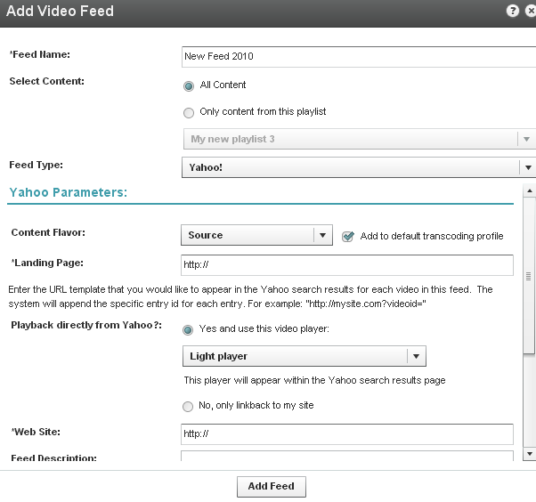

### Yahoo Webmaster Tasks

* To submit the video feed to Yahoo

1. Copy the feed URL you obtained after you added the feed. See KMC Publisher Tasks for Yahoo Syndication.
2. Go to <http://video.search.yahoo.com/mrss/submit>.
3. Fill in the form and submit your feed as a “Full feed”.

#### Yahoo: Feed Parameters

| Field | Description |
| --- | --- |
| Name | Name of the feed. |
| Content selection - | You can either select all content, or create a feed of a specific playlist only. |
| Content flavor | The format and quality of the content to be syndicated |
| Add to Default Transcoding Profile | Check to add the chosen Content flavor to content that will be uploaded subsequently, using the default transcoding profile. |
| Landing page | The URL template that you would like to appear in the Yahoo search results for each video in this feed. The system will append the specific entry ID for each entry. |
| Playbacks directly from Yahoo | Select if you prefer for Yahoo to display a link to your website only or also if you'd like Yahoo to display the actual video directly within the search results page. If you allow Yahoo to playback directly from within the search results page, you can select the player that will be used for playback. This player may include your branding, watermark, etc. |
| Adult content | If selected, videos in this feed should be available only to users with SafeSearch turned off. |

The table below maps categories between the different websites.

| TubeMogul | Arts & Animation | Comedy | Entertainment | Music | News & Blogs | Science & Technology | Sports | Travel & Places |
| --- | --- | --- | --- | --- | --- | --- | --- | --- |
| 5min | Arts/Others | People/Others | Home/Entertaining | Music/Others | Business/Others | Tech/Others | Sports/Others | Wheels/Others |
| Blip.tv | Art | Comedy | Movies and Television | Music and Entertainment | The Mainstream Media | Technology | Sports | Travel |
| Break | Animation | Funny Videos | Entertainment | Entertainment | News Videos | Entertainment | Sports Videos | Entertainment |
| DailyMotion | Arts | Funny | Film & TV | Music | News & Politics | Science & Technology | Sports & Extreme | Travel |
| eBaums World | Arts Animation | Comedy | Entertainment | Music | News Blogs | Science Tech | Sports | Travel Places |
| Graspr | Arts & Crafts | Other | Other | Music | Other | Computers & Internet | Sports & Recreation | Travel |
| GrindTV | N/A | N/A | N/A | music | N/A | N/A | N/A | N/A |
| Howcast | Animation Techniques | Humor & Comedy | General Performing Arts | Making Music Videos | Politics & Citizenship | General Technology | General Sports | General Travel |
| i2TV | Arts, Film, Animation | Comedy | Entertainment | Music | News | Technology | Sports & Games | Travel & Places |
| Metacafe | Art & Animation | Comedy | Entertainment | Music & Dance | News & Events | Science & Tech | Sports | Travel & Outdoors |
| MSN Video | Movies | Movies | TV | Music | News | Web | Sports | Events |
| MySpace | Animation/CGI | Comedy and Humor | Entertainment | Music | News and Politics | Science and Technology | Sports | Travel and Vacations |
| Sclipo | Arts / Design | Other | Other | Music | Other | Science / Technology | Sports | Hobby / Games |
| StreetFire | N/A | N/A | N/A | N/A | N/A | N/A | N/A | N/A |
| StupidVideos | Just Plain Stupid: Laugh Out Loud | Just Plain Stupid: Laugh Out Loud | Just Plain Stupid: Laugh Out Loud | Just Plain Stupid: Laugh Out Loud | Just Plain Stupid: Office/Workplace | Just Plain Stupid: Laugh Out Loud | Sports: Other | Just Plain Stupid: Laugh Out Loud |
| Veoh | Animation | Comedy | Entertainment | Music | News | Tech & Gaming | Sports | Travel & Culture |
| VideoJug | Creative & Culture | Humour & Bizarre | Entertainment | Music | Current Affairs | Technology & Cars | Sports & Outdoors | Travel |
| Yahoo | Art & Animation | Funny | Entertainment | Music | News | Technology & Products | Sports & Games | Travel |
| YouTube | Film & Animation | Comedy | Entertainment | Music | News & Politics | Science & Technology | Sports | Travel & Events |

### Flexible Feed Format

Developers may to create custom syndication feeds. You can customize syndication feeds by creating an XSLT.

Flexible feed format allows for greater flexibility for creating syndication feeds. You can transform your feed into any format programmatically and include additional data such as custom data fields, system data fields, and other fields. For example, you may want to re-format a standard MRSS field, to move a media item’s description place, or, for example, add the entry duration.

Flexible feed format allows you to determine what content goes into the feed field and the location of the field. You can change the structure and the content of the feed.

Chapter

# Advertising and Ad Networks

Kaltura’s monetization features contain a comprehensive set of advertising tools, pay-per–view, subscription models, and built-in reports that let you optimize your strategy based on viewer behavior.

You can target viewers with ads on live videos or VOD, and across multiple devices such as mobile, PC and set-top-box. With support for a wide range of video ad formats (including all major IAB standards), and integrated plugins for video ad networks, such as Google DoubleClick DART, FreeWheel, Ad Tech, Eye Wonder, AdapTV, Tremor Video and others, managing you can optimize your monetization.

The Kaltura Player supports pre-rolls, mid-roll post-rolls, Flash companion ads and HTML companion ads. The Kaltura Player is VAST-compliant, supports custom SWFs, bumper videos, and has plugins for AdapTV, Tremor, and Eyewonder.

## Player Branding

Players can be designed and skinned to match any brand and used for your own brand or for advertisers on your site. See Configure the Player Features.

## Connecting with an Ad Server

Integrating your Ad Server with the KMC is a one-time activity performed when you initially set up video advertising. The ad server has to be VAST compliant or available as a Kaltura plugin. You may also create a custom swf for the Kaltura Player to support.

After you have selected an ad server and set up an account with that ad server, you integrate the ad server with the KMC by establishing a connection between that ad server and KMC. After the connection is established, all ad requests generated by the Kaltura Dynamic Player are in a format which the ad server expects, allowing seamless communication between the Kaltura Player and the ad server.

The Digital Video Ad Serving Template (VAST) is an industry standard for the XML response from an ad server. Most of the leading Ad Servers and Ad Networks are VAST compliant, and support IAB standard (VAST 1.0 / VAST 2.0).

Popular ad servers include DoubleClick, Dart For Publisher (DFP), Microsoft Atlas, OpenX, ScanScout. To see the full list of servers and networks that comply with VAST, refer to the IAB website:

<http://www.iab.net/iab_products_and_industry_services/508676/compliance/679253>

In general, ads, tracking, scheduling, and other parameters, are configured on the ad server side. With VAST, other parameters need to be configured through the KMC or Kaltura Player. Ad parameters are configured through the Studio tab in the KMC.

### Kaltura Player and Ad Plugins

Kaltura partners have the ability to create a custom .swf file to stream ads from their own ad server to the Kaltura Player. The.swf file acts as an ad plugin. The configured key-value pairs must be defined to play the relevant ads.

You have to subscribe to an ad server and configure the ads on the ad server side.

### Supported Ad Servers

All VAST compliant ad servers are supported. For more information see [Kaltura’s Generic Ads Player Plugin for VAST](http://knowledge.kaltura.com/sites/default/files/Kaltura%E2%80%99s%20Generic%20Ads%20Player%20Plugin%20for%20VAST.pdf).

The Kaltura Player all VAST compliant ad servers and supports the following ad plugins:

* AdapTV
* Tremor
* Eyewonder
* DoubleClick
* FreeWheel

For more information see Configuring Third Party Ad Plugins.

### Ad Terminology

**Ad tracking** – the ability to define which/if ads play based on specific metadata.

**Overlay** – an ad that appears as an image (usually with text) over a video, while the video is playing.

**Companion ad**– a banner ad that accompanies the ad that plays over the video player – this can either be located in the list area of the playlist or somewhere else on the HTML page.

**Ad Tag URL** – a URL that is XML that contains all the information about the ad(s) that should be displayed. VAST works with an ad tag URL system. The XML needs to conform to VAST standard in order to be considered “VAST-compatible”. That means that it needs to have the proper tags.

**The following is an example of a VAST ad tag URL:** <http://ad3.liverail.com/?LR_PUBLISHER_ID=1331&LR_CAMPAIGN_ID=229&LR_SCHEMA=vast2>

To see the example, insert this URL into your browser.

**Ad Cue Points** – time based points on an entry that can be used to view mid- roll advertisements.

## Creating Kaltura Video Ads

The following is the workflow for configuring a KMC VAST compliant ad.

* Adding the VAST Ad Server
* Configuring VAST Ads

## Adding the VAST Ad Server

* To add an ad server that supports the VAST standard
* Obtain an Ad tag URL from your ad server. See How to Locate the Ad Tag URL.

## Configuring VAST Ads

* **To configure VAST Ads**

1. Select the Studio tab and select an existing player or create a new one. See Designing and Configuring a Player. The player is configured to display VAST ads only.
2. *S*elect the Advertising tab.

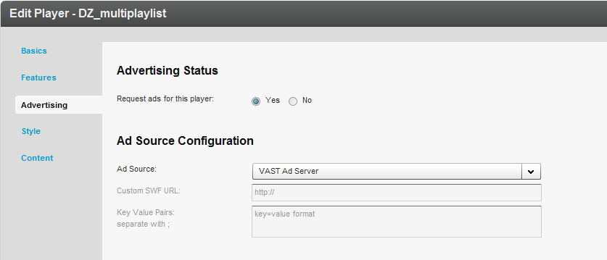

1. Enable Request ads for this player.
2. Configure the Ad Source as VAST Ad server.

### Configuring VAST Pre-roll Ads

Pre-roll ads are ads that appear prior to an online video.

* To configure pre-roll ads

1. Configure the Player Advertising Settings.
2. Click on Pre-Roll Ads.
3. Toggle on Request PreRoll Ads Enabled.
4. Paste the Ad Tag URL received from the ad server. See How to Locate the Ad Tag URL.
5. Select the Display options.
6. Display X ads assumes that there is more than one ad configured in the ad tag URL.
7. Before every X video starting with the X video assumes that there is either a playlist on the page or a gallery. This functionality works with galleries as well as playlists.

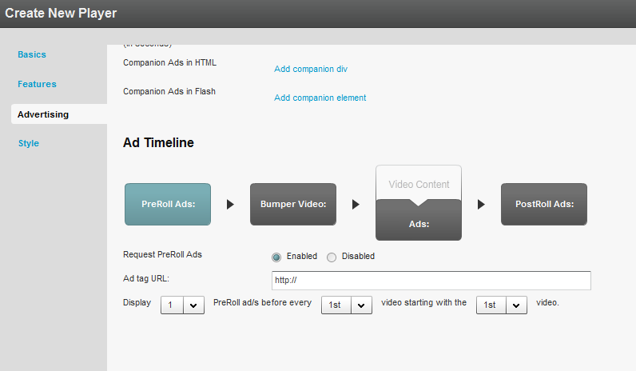

### Configuring VAST Post Rolls

PostRoll ads are ads that appear after an online video.

* To configure PostRoll ads

1. Configure the Player Advertising Settings.
2. Click on PostRoll Ads.
3. Toggle on Request PostRoll Ads Enabled.
4. Paste the Ad Tag URL received from the ad server. See How to Locate the Ad Tag URL.
5. Select the Display options.

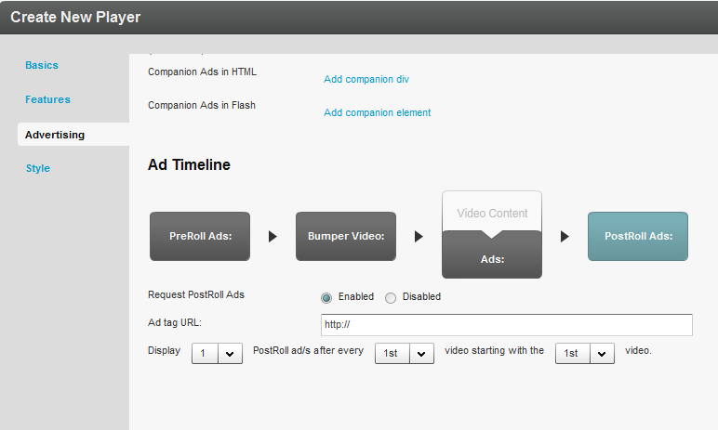

### Adding a Midroll

Midrolls and overlays are cue points that are defined on an entry level in the player configuration section of the Studio Advertising tab.

* To add a midroll

1. Configure the Player Advertising Settings.
2. Select the Content Tab and select an entry.
3. Select the Advertisements tab.

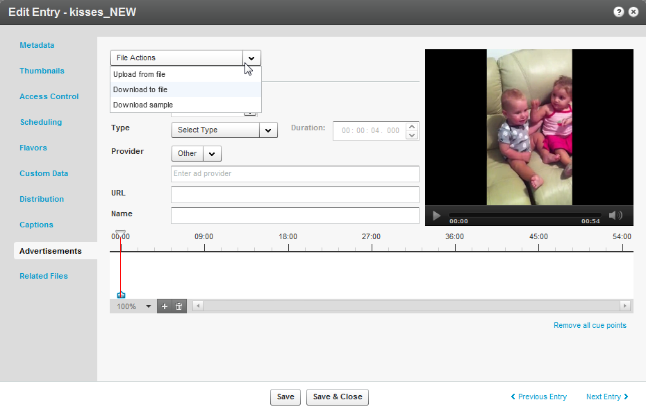

1. Select the method to obtain the midroll add from the File Actions drop down menu.
2. Choose the granularity level for the time-based display. The choices are:

* 100%
* 5 sec
* 1 sec
* Frames.

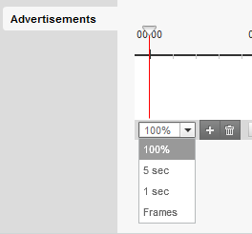

1. Identify the exact scene or frame to display the advertisement and insert a cue.

This can be done on the timeline: 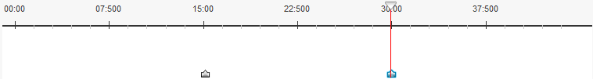

1. To edit a cue point, select whether the advertisement will be a video or an overlay.
2. For a video - the entry will stop playing, the ad will play, and then the entry will resume.

For an overlay - while the entry is playing, a banner will appear on the screen. The entry never stops playing.

1. For both video and overlay, there are 2 options in the provider section: VAST and OTHER. VAST allows a user to insert a VAST ad tag URL. OTHER is for customers who have created a custom plugin that allows for creating cue points Other, does NOT refer to existing ad plugins such as Tremor, Adap.tv, etc.
2. If you select overlay, the display time will be indicated next to the Overlay option: 

You can modify the amount of time you want the overlay to appear on the video using the up and down arrows.

1. To apply the selected cue points to the player, create a new player or edit an existing one under the “Studio” tab. Within the advertisement portion of the player, make sure that the “Request Ads From Entry’s Cue points” is set to “Yes”.

### Adding an Overlay

An overlay ad is an ad banner that is displayed over the video.

* To add an overlay at the entry level

1. Configure the Player Advertising Settings.
2. Select the Content Tab and select an entry.
3. Select the Advertisements tab.
4. Click on the + icon to add an overlay.
5. Select the method to obtain the overlay add from the File Actions drop down menu.
6. (Required) Select the Ad Type (video/overlay).

For Video the Duration is the length of the video and the field will be greyed out.

For Overlay – enter the amount of time to display in the Duration field.

1. Enter the provider name: VAST or Other and optional values.
2. For VAST enter the Tag URL and a descriptive name for the Midroll or Overlay, For other providers enter values that you want to pass to the player.
3. Click Save.

* To configure an overlay on the player level

1. Configure the Player Advertising Settings.

Within the advertisement portion of the player, make sure that the “Request Ads From Entry’s Cue points” is set to “Yes”.

1. Click on Ads.
2. Toggle on Request Overlay Ads Enabled.
3. Paste the Ad Tag URL received from the ad server. See How to Locate the Ad Tag URL.
4. Select the Display options.

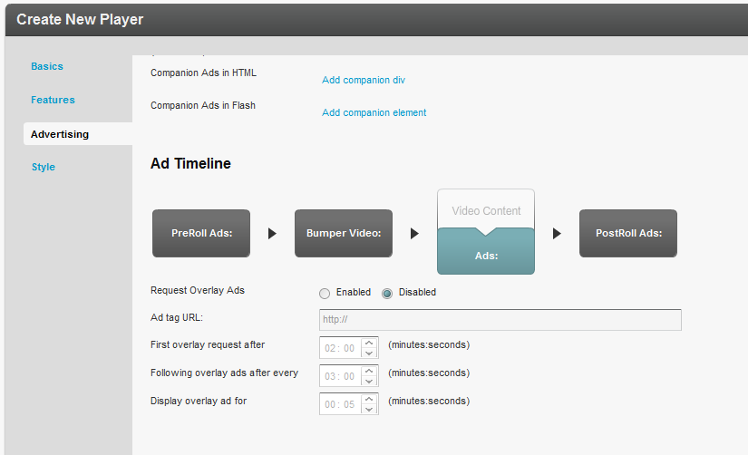

## Creating Bumper Ads

Bumpers are videos that act as ads and do not use an ad server. Bumper videos uploaded to Kaltura can be inserted before or after a video, to function as pre-rolls or post-rolls. Bumper videos are associated with a player, and are not associated with a specific video. Bumper videos are independent of actual pre/post-rolls and can be played in addition to ads. Bumper videos are helpful for Kaltura partners that would like to advertise their logo, or other information, before or after a video, and for smaller partners that would like to advertise, but do not expect to monetize from their ads.

Bumper videos can be configured in addition to any other ads that are configured. On the bottom of the Advertising tab, the option to add bumper videos only is available.

* To configure a Bumper ads

1. Go to the Studio tab and select or create a player.
2. Select the Advertising tab.
3. In the Ad Timeline *se*ction, click on Bumper Video.
4. Toggle on Bumper Video Enabled.
5. Paste the Kaltura Entry ID that will be used as the bumper.
6. Enter the URL in the Click URL field.

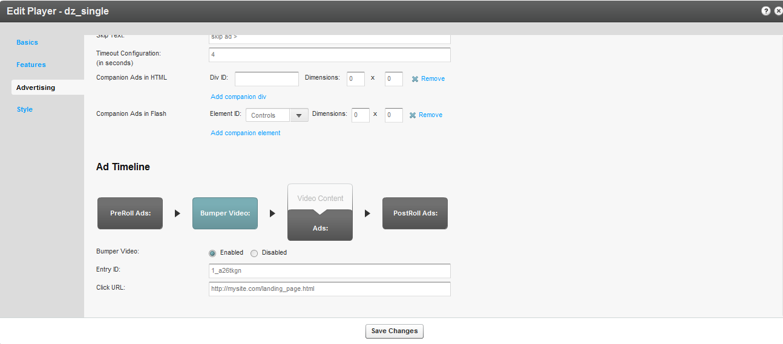

A Kaltura partner also has the ability to enable ONLY bumper ads by choosing Bumper Only as the Ad Source:

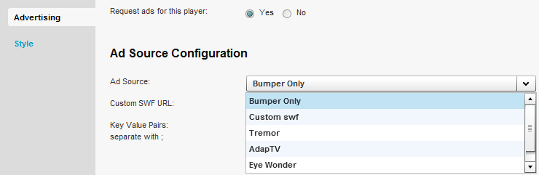

While in the Advertising tab, you can also configure bumper pre-rolls, and or bumper post-rolls.

* To configure bumper post-rolls

1. Create a bumper video. See Creating Bumper Ads.
2. In the Features tab on the left, select the Additional Parameters and Plugins section.

Enter the following:

postbumper.plugin=true&postbumper.width=0&postbumper.height=0&postbumper.lockUI=false&postbumper.playOnce=false&postbumper.path=bumperPlugin.swf&postbumper.relativeTo=video&postbumper.position=before&postbumper.includeInLayout=false&postbumper.preSequence=false

1. Click Go.

Whenever both pre-rolls and bumper videos are enabled, pre-rolls will always play before the bumper video. This is because the pre-roll is configured as, preSequence=1, and the bumper video is, preSequence=2. You can change the play order via the uiconf. Post-roll ads will always play AFTER the bumper post-rolls.

## Configuring Third Party Ad Plugins

This section describes how to configure third party ad plugins.

### Tremor Media

Tremor Media is an ad network that acts as a connector between ad companies/servers and their customers. Tremor Media connects with numerous ad sources and partners from a single control center and works with their customers to provide the appropriate ads from the appropriate ad servers.

* To configure the Tremor Media plug in

1. Go to your Tremor account; define ads, scheduling, targeting, etc. on the Tremor end.
2. Go to the Studio tab and edit an existing player or create a new one.
3. Select the Advertising tab.
4. Enable ads for the selected player.
5. Select Tremor as the Ad Source.

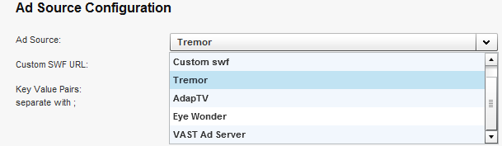

1. In the key=value section, enter the policy ID. Type in progId=[policy ID].

|  |  |
| --- | --- |
|  | NOTE: TremorMedia allows users to utilize other ad sources. |

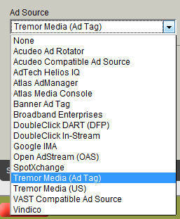

|  |  |
| --- | --- |
|  | NOTE: Tremor also allows users to utilize a different ad source as a fallback. |

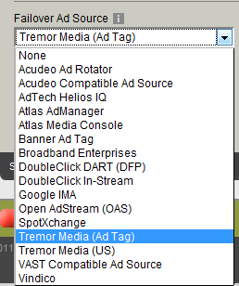

The Tremor plugin is in charge of displaying specific ads, and all the configurations are done on the Tremor end.

### Tremor Media Added Functionality

The following lists functionality that has been added to the Tremor plugin.

| Functionality | Description | Example |
| --- | --- | --- |
| Passing dynamic data | By inserting specific key-value pairs in the uivars, a Kaltura partner can define that any Kaltura metadata gets passed to TremorMedia via the TremorMedia plugin. Then, using the Tremor ad server, the partner can decide how to target ads via the metadata.  To enable this functionality, a custom ad path must be inserted into the uiconf. | : <var key="customAd.paramKey1" value="duration" /> <var key="customAd.paramValue1" value="{mediaProxy.entry.duration}" /> <var key="customAd.paramKey2" value="entryId" /> <var key="customAd.paramValue2" value="{mediaProxy.entry.id}" /> <var key="customAd.paramKey3" value="categories" /> <var key="customAd.paramValue3" value="{mediaProxy.entry.categories}" /> <var key="customAd.paramKey4" value="ContentRating" /> <var key="customAd.paramValue4" value="{mediaProxy.entryMetadata.ContentRating}" /> <var key="requiredMetadataFields" value="true" />  Note: The Content Rating custom data field, has a slightly different value from the rest of the metadata. |
| Internal companion ads | The ability to insert a companion ad directly on the list part of the playlist.  The companion ad must be inserted as a custom ad path via the uiconf or via Additional Parameters and Plugins. |  |
| Capping ads | A Kaltura partner can cap ads via the KMC based on the creation date.  To configure the Tremor plugin with the startDateOffset, with the parameter key maxAge, add the following 2 attributes to the XML (if the file is maintained manually):  paramKey1="duration" paramValue1="{tremor.createdAtOffset}"  or the equivalent uivars/flashvars line  paramKey1=duration&paramValue1={tremor.createdAtOffset}  This is based on the assumption that the Tremor xml node has the id set to 'tremor '. If using a studio player the id would be 'customAd'. |  |

### AdapTV

AdapTV has two different models – the standard model and the marketplace. The standard model allows Kaltura partners to define their own ads. The marketplace provides the customer the ability to connect with all sorts of ad companies to choose the most fitting ads.

* To configure the AdapTV ad plug in

1. Go to your AdapTV account; define ads, scheduling, targeting, and other parameters, on the AdapTV end.
2. Go to the Studio tab and edit an existing player or create a new one.
3. Select the Advertising tab.
4. Enable ads for the selected player.
5. Select AdapTV as the Ad Source.

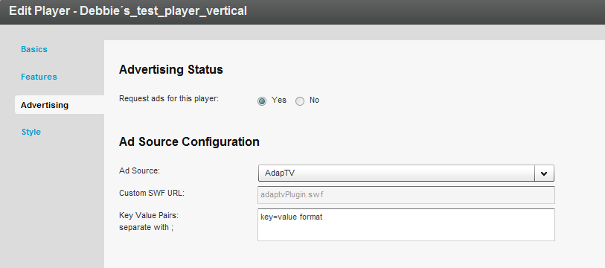

1. Enter the Custom SWF URL.
2. The Kaltura partner administrator should contact their ad server company to obtain the SWF URL and the proper Key-Value Pairs to insert.
3. In the key-value section insert key=[your AdapTV key]. In AdapTV, many users utilize the zone to differentiate between different ads. In this case, the customer needs to insert zone=[zone name] in the key-value section as well.
4. To utilize the latest AdapTV plugin, (The current out of the box plugin utilizes AdatpTV’s legacy integration of AS2. The new plugin utilizes AS3 integration.) in the Additional Parameters and Plugins section of the player, insert key= customAd.path value=<http://cdnbakmi.kaltura.com/flash/kdp3/v3.5.7.6/plugins/adaptvas3Plugin.swf>.

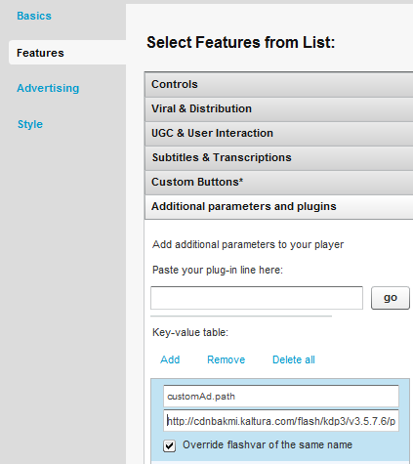

## **Configuring Companion** A**ds**

Companion Ads are “text, display ads, rich media, or skins that wrap around the video experience, and can run alongside either or both the video or ad content. The primary purpose of the Companion Ad product is to offer sustained visibility of the sponsor throughout the video content experience.” See <http://www.iab.net/wiki/index.php/Companion_Ad>

VAST

Kaltura’s platform makes it easy to add Companion Ads in either HTML or Flash. After you’ve configured your player (see Designing and Configuring a New Player or Playlist ), edit the player and navigate to the Advertising tab. Scroll down to the “Player Configuration” section

Choose whether to configure HTML or Flash-based Companion Ads.

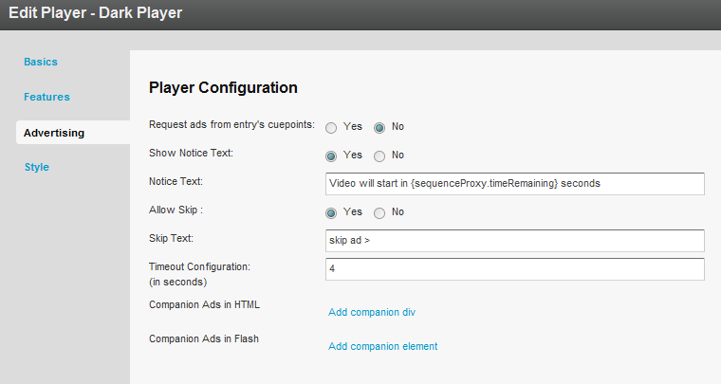

### Companion Ads in HTML

* To add companion ads in HTML

1. Click on the “Add companion div” text in the “Player Configuration” section. Entry fields to enter the CSS “id” of your companion ad and the dimensions in pixels appear.
2. Enter the CSS div id and dimensions (in pixels) for each ad region. Be certain to enter the dimensions to match the dimensions of your served ads.
3. Click on the “Add companion div” text multiple times to enter more ad regions.

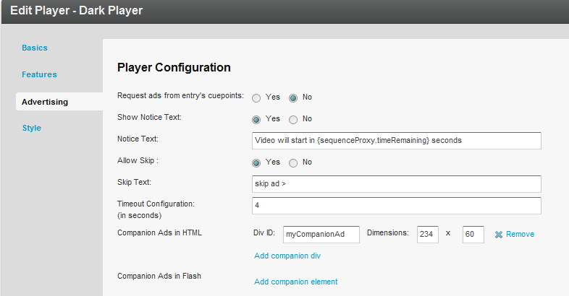

In the web page where your Companion Ads will display, you need to include a JavaScript file as well as a corresponding HTML <div> tag with a matching id for each region you create.

<html>

<body>

<head>

….

**<script src="http://www.kaltura.com/javascript/VAST/companionAdFunc.js" type=**

**"text/javascript"></script>**

….

</head>

<body>

….

<object id="kaltura_player" name="kaltura_player" type="application/x-shockwave-flash" ……… </object>

**<div style= "width: 234px; height: 60px;" id="myCompanionAd">**

**</div>**

….

</body>

</html>

### Companion Ads in Flash

* To add companion ads in **F**lash

1. Click on the “Add companion div” text in the “Player Configuration” section. You’ll get entry fields to enter the CSS “id” of your companion ad and the dimensions in pixels. Be certain to enter the dimensions to match the dimensions of your served ads.

Click on the “Add companion div” text multiple times to enter more ad regions: 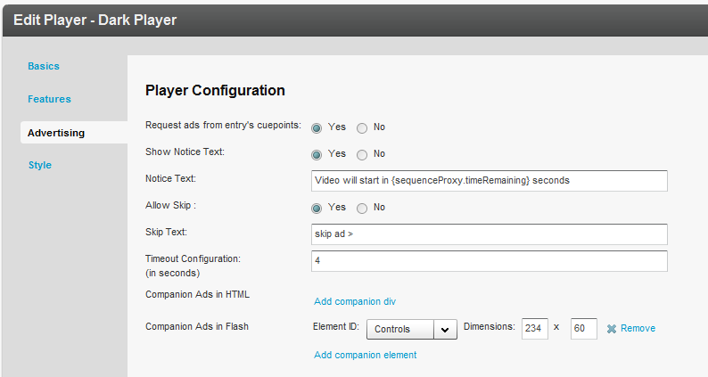There are either two or three possibilities for the “Element ID” pulldown menu. If you created a Kaltura Playlist Player, you will see three options:

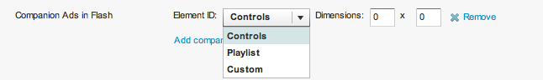

If you created a regular (non-Playlist) Player, you will see two options:

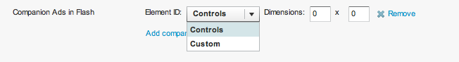

The “Custom” option is not available. If your companion ad will appear in the regular player window above the player controls, then select “Controls”. If your ad will overlay the Playlist, then select “Playlist”. Enter the dimensions of your ad (in pixels) in the “Dimensions” text fields.

Example

Here’s a Kaltura Playlist Player in a horizontal configuration:

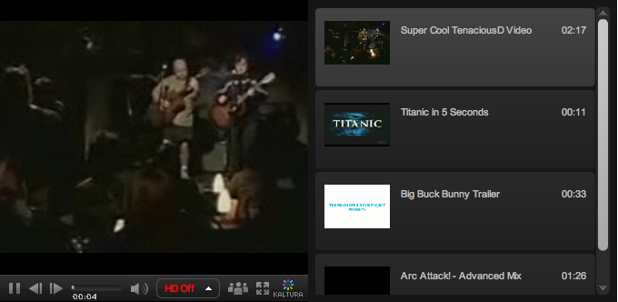

In the following example, the same player plays a preroll ad in the main player area while a Flash Companion Ad is displayed in the playlist area:

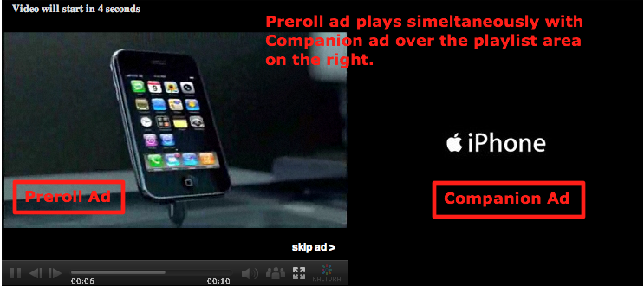

#### Tremor

* To configure companion ads with Tremor Media.

The companion ad needs to be enabled on the Tremor end. Perform the following steps.

1. Add the following script to your page:

<!-- script type="text/javascript" src="<http://cdna.tremormedia.com/acudeo/banners.js>"></script>

<script type="text/javascript">

        function displayCompanionBanners(banners) {

               tmDisplayBanner(banners, "adCompanionBanner", 300, 250);

               }

        function hideCompanionBanners(banners) {

               tmHideBanner("adCompanionBanner")

               }; </script -->

1. Add the following script import:

<script type="text/javascript" src="<http://cdna.tremormedia.com/acudeo/banners.js>"></script>

1. Add this div that will act as the ad.

<div id="adCompanionBanner300x250"></div>

#### AdapTV Companion Ads

* To configure companion ads

1. Add this code to the Additional Parameters and Plugins.

key: adaptv.companionId

value: companiondiv

1. Add a div with a matching id in the HTML that holds the following player:

<div id="companiondiv" style="width: 300px; height: 250px;">

</div>

Custom SWF

The Kaltura partner should contact their ad server in order to understand what JavaScript code needs to be implemented on their page in order to enable companion ads.

### Targeting with an Ad Server

While ads targeting is performed within the ad server, Kaltura’s VAST advertising module is designed to pass all the relevant targeting information to the ad server.

Targeting information can be set in several levels:

* Targeting per player and ad slot – you can add additional key value pairs within the adtag URL. The ad server will use these for targeting.
* Targeting per content item - The Kaltura VAST module supports dynamic pulling of metadata from the content item, and passes it to the ad server.  
  For example for targeting a specific content category.
* To target information

1. Drag content items into the category within the KMC.  
   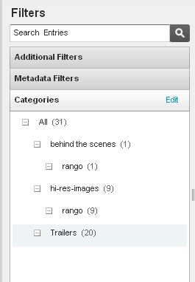
2. Define the additional parameter in your ad server.   
   For example, in OpenX set the “category” parameter through “Site - Variable”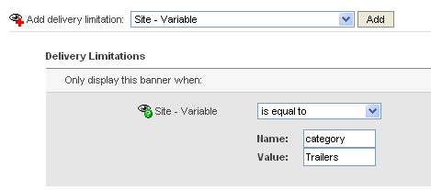
3. Add category template category={mediaProxy.entry.categories} into the AdTag URL. At runtime this template will be populated with the actual values for each video played.

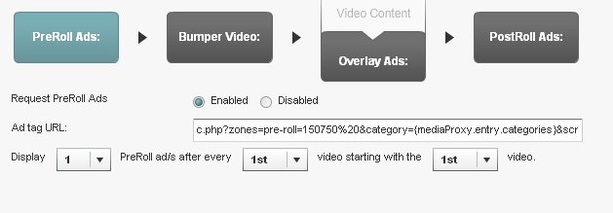

The following targeting templates are available for targeting  
category={mediaProxy.entry.categories}  
tags={mediaProxy.entry.tags}  
name={mediaProxy.entry.name}  
id={mediaProxy.entry.id}

### Targeting per Viewer

In some cases targeting information is not defined per content item, but per viewer.  
To support these cases the Kaltura VAST module dynamically pulls metadata from the website via flashvars passed to the player.  
For example targeting per a specific age group. This example assumes that the hosting site has a user database and would like to further target known users.

* To target per viewer

1. Pass the variable (for example, viewer age) from your internal DB to the player via Flashvar.

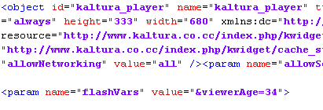

1. Define the additional parameter in your ad server.   
   For example in OpenX, set the “viewerAge” parameter through “Site - Variable”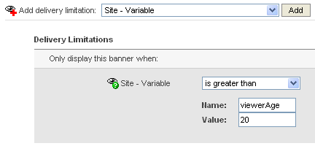
2. Add the flashvar template into the AdTag URL, this template will be populated in runtime with the actual values.   
   The template is FLASHVAR_NAME={configProxy.flashvars.FLASHVAR_NAME }and in the viewerAge example it would be:  
   viewerAge={configProxy.flashvars.viewerAge}

### Ad Targeting via ad plugin

Each ad plugin individually defines which metadata the Kaltura Player passes to the plugin. Generally, it is very basic metadata such as entry ID. Additional metadata enables the Kaltura user to target ads with that specific metadata.

### Ad Targeting with Tremor

Passing dynamic data

By inserting specific key-value pairs in the uivars, a Kaltura partner can define that any Kaltura metadata gets passed to Tremor via the Tremor plugin. Then, through the Tremor ad server, the partner can decide how to target ads via the metadata.

Examples:

<var key="customAd.paramKey1" value="duration" />

<var key="customAd.paramValue1" value="{mediaProxy.entry.duration}" />

<var key="customAd.paramKey2" value="entryId" />

<var key="customAd.paramValue2" value="{mediaProxy.entry.id}" />

<var key="customAd.paramKey3" value="categories" />

<var key="customAd.paramValue3" value="{mediaProxy.entry.categories}" />

<var key="customAd.paramKey4" value="ContentRating" />

<var key="customAd.paramValue4" value="{mediaProxy.entryMetadata.ContentRating}" />

<var key="requiredMetadataFields" value="true" />

Note that ContentRating, which is a custom data field, has a slightly different value from the rest of the metadata.

To enable the custom data field, you must insert a custom ad path into the uiconf.

### Advertising for Mobile Devices

The advertising settings applied to your player will also apply for mobile delivery. Visit the advertising section for more information on advertising. As a general rule, VAST ads fully support ads in mobile. However, the ads will only play in a mobile device if the ad has the proper mobile flavors.

The following table summarizes current advertising support for mobile:

| Device | Supported Ad type | Notes & Limitations |
| --- | --- | --- |
| iPhone | VAST Pre-roll  Bumper video  VAST Post-roll | Ads are played back in the native player  Player controls are not disabled during playback  (user can skip the ads)  Ads are not clickable  Ads must be encoded for the iPhone (H264) |
| iPad | VAST Pre-roll  Bumper video VAST Overlay  VAST Post-roll | Ads must be encoded for the iPad (H264) |
| Android  (ver 2.2 and up) | All | Android from version 2.2 supports Flash playback with all ads integration as in Flash player. |

How to Locate the Ad Tag URL

DFP  
In DFP there is a “Tag Generator” utility in the dashboard to generate the ad tag url.   
The ad tag url (<http://ad.doubleclick.net/pfadx/mysite.com/>. ) is at the bottom of the widget.  
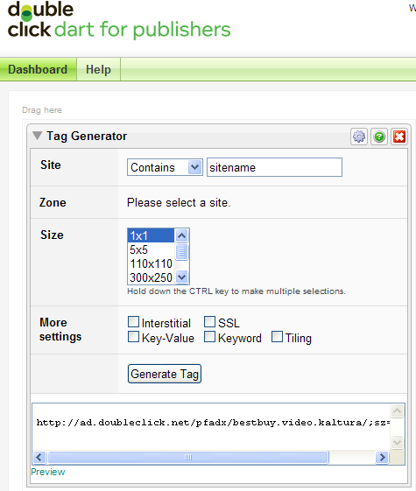  
OpenX  
In OpenX the adtag URL is linked to an OpenX Zone, in the following format:

http://[OPENX_INSTALL]/fc.php?script=bannerTypeHtml:vastInlineBannerTypeHtml:vastInlineHtml&source=&format=vast&charset=UTF_8&nz=1&zones=z1=[ZONE_ID]  
for openX hosted, the URL is d1.openX.org. ,   
from within your OpenX account you can retrieve the zone Id.  
for example for zone id 150750 in openX hosted the ad tag url would be:  
<http://d1.openx.org/fc.php?script=bannerTypeHtml:vastInlineBannerTypeHtml:vastInlineHtml&source=&format=vast&charset=UTF_8&nz=1&zones=z1=150750>

### AdapTV (via VAST)

Copy the “Specific Ad Tag” from the Ad screen.

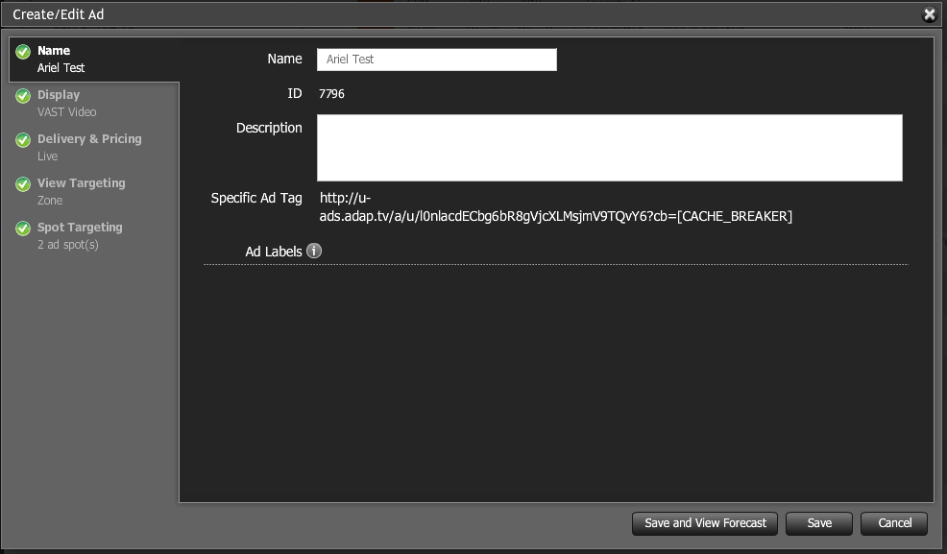

### Connecting with Ad Servers and Networks via Adap.tv

* To add Adap.tv’s service to your Kaltura players

1. Sign up with adapt.tv ([Contact us](http://corp.kaltura.com/about/contact) to learn more) – you will then receive an adapt.tv Partner Key.
2. Go to the Studio tab and edit an existing player or create a new one
3. Go to the Advertising section.
4. Enable ads for this player.
5. Select adapTV from the “Ad Source” drop down.

Enter your adapt.tv Partner Key in “Key Value Pairs” section, in the following format “key=[YOUR ADAPTV KEY]”.

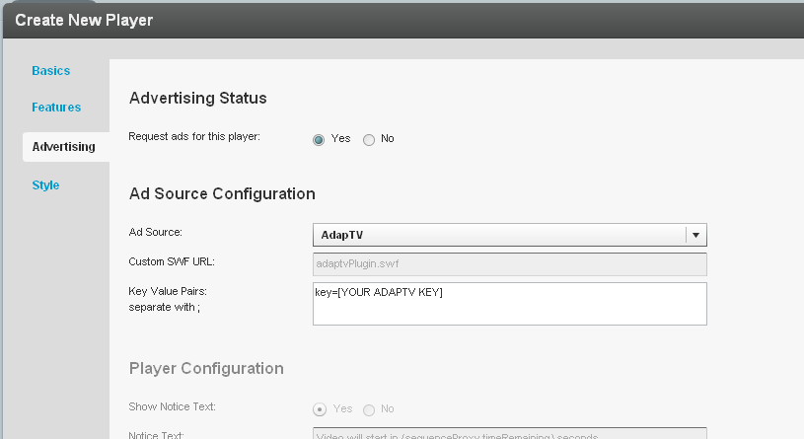

1. Target, manage and customize your ads via the [adap.tv console](http://publishers.adap.tv/osclient/).
2. Via adapt.tv you can also connect to additional ad servers & ad networks such as AdTech, Atlas, DART, OpenX, Advertising.com, ScanScout , SpotExchange, Google AFV, AdBrite, AdDynamic, AdEngage, AdFish, AdoTube and over 20 other networks and servers.

For example connecting to DART via adapt.tv would simply require pasting the Ad Tag URL that the AdTech Server supplies.

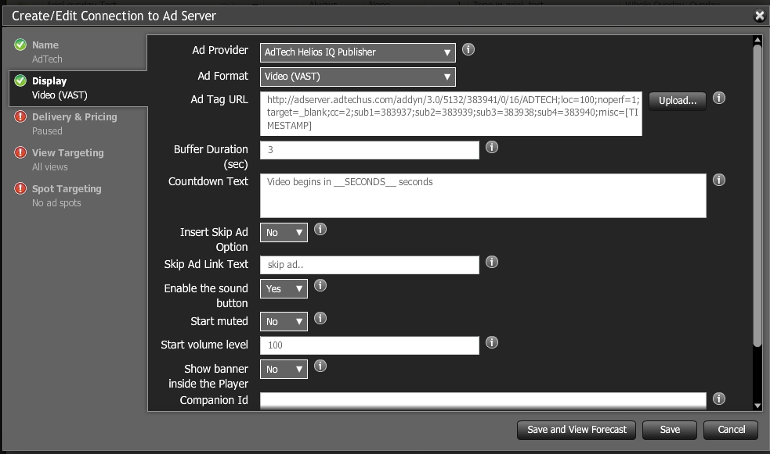

### Connecting with Tremor Media

* To add Tremor Media’s service to Kaltura players

1. Sign up with Tremor Media ([Contact us](http://corp.kaltura.com/about/contact) to learn more) – you will receive a Tremor Media Program ID.
2. Go to the Studio tab and edit an existing player or create a new one.
3. Go to the Advertising section.
4. Enable ads for this player.
5. Select Tremor from the “Ad Source” drop down
6. Enter your ACUDEO Ad Policy ID as your Program ID in the “Key Value Pairs” section.

Program ID’s are available in the program list and are displayed as Ad Policy IDs in the ACUDEO Console. Select “Ad Policy ID” in the “Show Ad Policies with” drop down menu.

Use the following format:

progId=your ACUDEO Ad Policy ID.

Additional targeting parameters should be separated with semicolons.

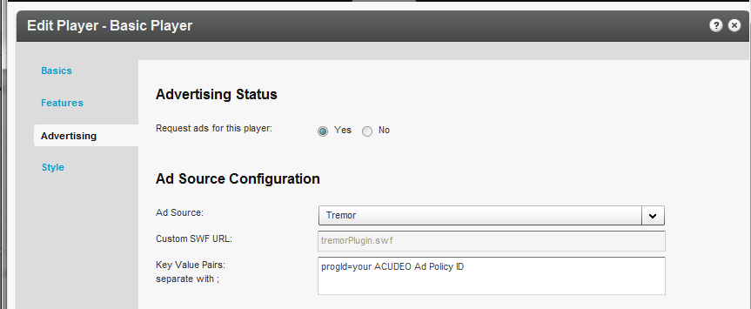

You can specify ad sources for each ad slot within your content through the Tremor Media’s ACUDEO console.

1. Target, manage and customize your ads via the [Tremor Media console](https://acudeo.tremormedia.com/) (Acudeo).

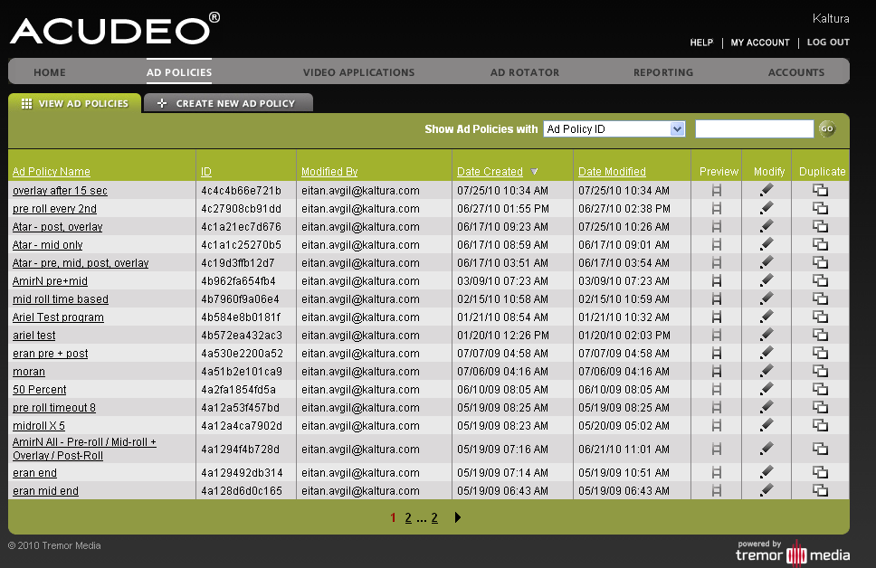

### Different Types of Ad Servers

There are additional ad servers that Kaltura supports, which are a bit more complex than just plugins. For example, Kaltura is now fully integrated with **DoubleClick and Freewheel**. Their integrations are more complex since there is a server-side connector that allows you to define the metadata to submit to the ad server for ad targeting purposes. The Kaltura metadata gets mapped to ad server’s metadata. Then, just like with a distribution module, see Kaltura Distribution Module, when a Kaltura partner wants an entry to be included in the ad server, it is marked as such in the KMC. The ad server connector passes all of the metadata to the ad server, where the Kaltura partner can then decide how ads should be targeted based on the metadata.

## Kaltura Player Additions Related to Ads

If a Kaltura partner wants to create their own type of ad targeting and prevent pre-rolls from playing on specific entries, they can utilize the flashVar vast.preSequence=0, defined in the embed code in the Additional Parameters and Plugins.

Advanced functionality is enabled to provide for a better workflow of ad plugins. The Kaltura Player build its UI only when the plugin is completely ready, enabling for a smooth loading of player and plugin together after the plugin is ready.

## Troubleshooting

Here are a few helpful steps to configure advertising:

For VAST ads:

1. Check that you have a working ad tag URL. Be certain that VAST 2.0., 1.0 are also supported for the media file content.

* An example of a working ad tag URL is at: <http://ox-d.hbr.org/v/1.0/av?auid=35998>
* In addition to this, a very helpful site that has working VAST ad tag URLs can be found here: <http://www.iab.net/iab_products_and_industry_services/508676/digitalvideo/vast/vast_xml_samples> .

1. Put the ad tag URL in your browser. You should see an XML that clearly shows that it is a VAST XML. Various other criteria will appear in the URL. An important tag to look for is the media file. Take the URL of the media file and make sure it plays properly.

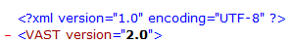

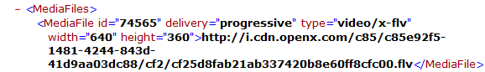

If the URL is not a VAST XML or if the media file does not play properly, create a working VAST XML with a working media file on your ad server.

1. If the VAST ad tag URL looks valid and the media file plays properly, the next step is to go to Fiddler. (Debugger) The first important thing to look for here is to make sure that the crossdomain is working properly. Here is a working Fiddler response: 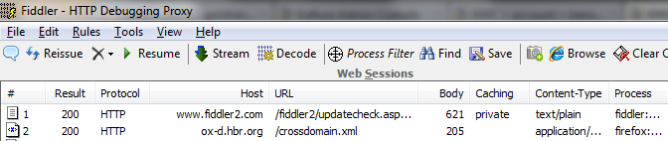
2. If the Crossdomain request/response is red or has some abnormal result like 404, you will need to enable your domain’s crossdomain to allow Kaltura to access it. Here is Kaltura’s crossdomain.xml, which can be provided as an example of a proper crossdomain.xml : <http://www.kaltura.com/crossdomain.xml> .

The next steps are to make sure that the ad is properly being called via Fiddler: 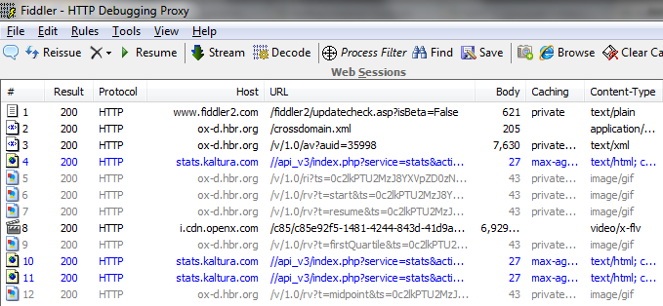

Chapter

# Creating and Tracking Analytics

Use the Analytics tab to track and display analytical information for bandwidth usage, video content usage and to produce user and community reports. You can extract and analyze data from the publisher level to information for a specific user as well as from account’s content level to any specific entry.

This section contains the following topics:

* Content Reports - display information about the entire content of the account, for example which is the most viewed video or which videos were100% play-through.
* User and Community Reports – displays information about all the end-users of this account, for example who was the excel content contributor.
* Bandwidth Usage Reports - provide clear visibility into the resources (storage, bandwidth) used by the publisher or the user.
* User Level Reports - displays reports for a specific user (which video was watched in a given time frame and for how long) and per specific content (which users watched the video and for how long)
* Exporting Analytics to a CSV File

## Content Reports

Content reports display aggregated analytics showing how well your content is performing across your sites.  Use the content reports to gain business insights and learn if your content discovery and exposure strategies have paid off or when things need to be tweaked to improve outreach or user engagement.

The following Content Reports are available:

* Top Content Reports

* Content Drop-off Reports

* Content Interactions Reports

* Content Contributions Reports

### Top Content Reports

Top Content reports display the following data for your most popular content:

* Plays – The number of times a user clicked "Play"
* Minutes Viewed – The sum of minutes that were viewed
* Average View Time – The average time calculated by dividing the minutes viewed by number of views
* Player Impressions – The number of times the video player was loaded
* (Not included in the line chart) Player to Impression Ratio – The number of plays divided by the number of impressions.

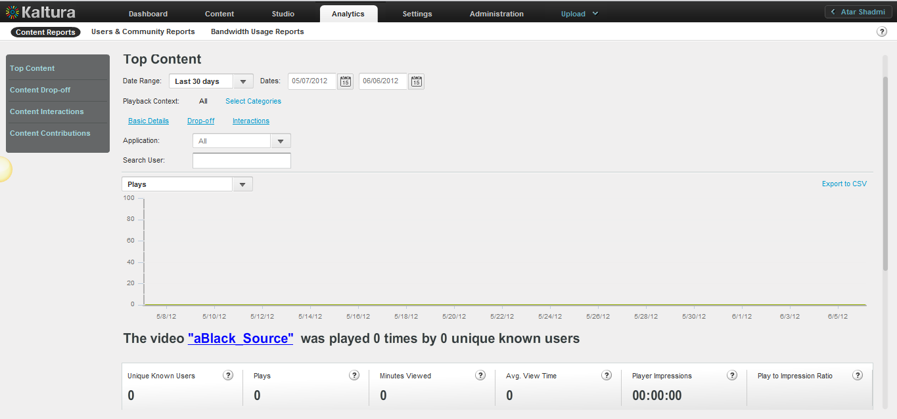

* To display Top Content Reports

1. Select the Analytics tab and then select Content Reports.
2. Click Top Content.
3. Select a date range in the drop-down menu or enter dates in the Dates field.
4. Select one of the following for the Playback Context:

**All** (default) – uses all the categories defined in your account

**Select Categories** – uses selected categories in your account for filtering report data

* In the Categories window: Select the name of a category. Use the CTRL key to select multiple categories.
* Click Filter.   
  To clear the category filter, click All.

1. Click on the links to the video's Drop-off and Interactions reports. (See Content Drop-off Reports and Content Interactions).
2. (Optional) In the Search Filter field, enter text that appears in content Names, Tags or Descriptions, and click Apply.  
   The filter description is displayed above the report.  
   To clear the filter, delete the text from the Search Filter field and click Apply.
3. In the drop-down menu, select one of the data types for the line chart report.
4. (Optional) Export the line chart report to a CSV file. See Exporting Analytics to a CSV File
5. In the line chart, hover over the data to display the exact data quantity for the date.

Under the line chart, a summary is followed by reports that display total and individual video results.

For the individual video table, you can:

* Scroll through the pages at the bottom of the table.
* Select the number of rows to display per page (10 to 500).
* Click a video name to display the Specific Entry Report for the video.

### Specific Entry Report

Specific Entry reports display the following data for a specific entry:

* Plays- The number of times a user clicked "Play".
* Minutes Viewed – The sum of minutes that were viewed
* Average View Time – The average time calculated by dividing the minutes viewed by number of views
* Player Impressions – The number of times the video player was loaded
* (Not included in the line chart) Player to Impression Ratio – The number of plays divided by the number of impressions.

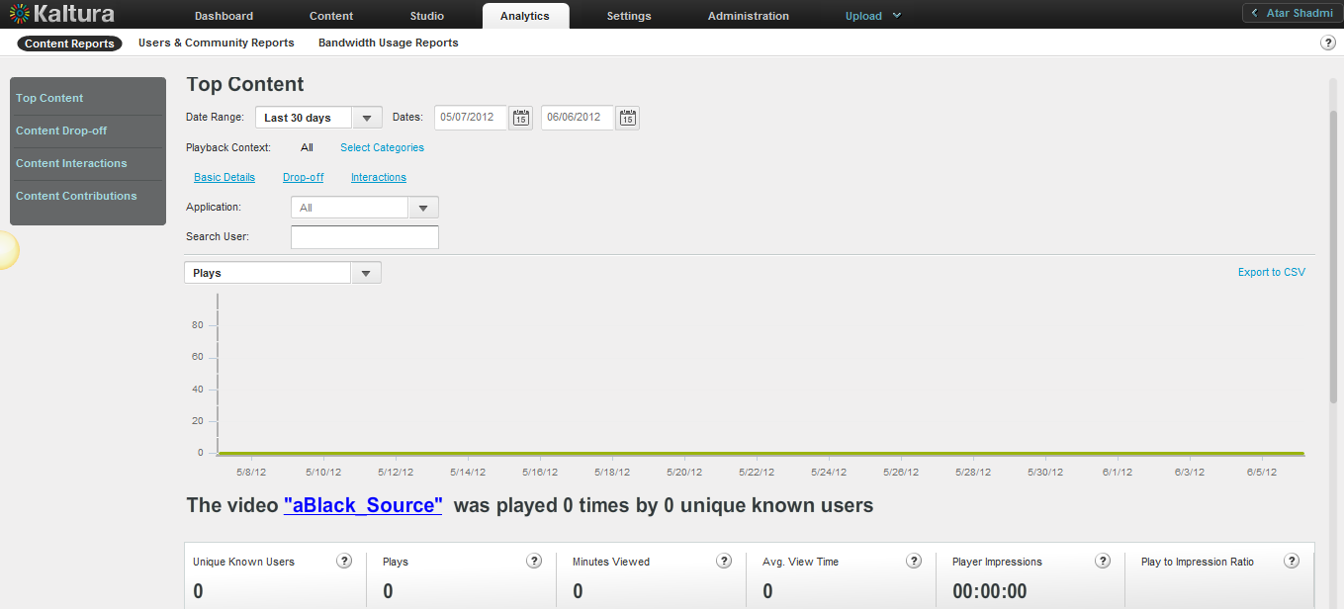

* To display a Specific Entry Report

1. Create a Top Content report. See To display Top Content Reports.
2. Click a video name to display the Specific Entry Report for the video.
3. Select one of the following for the Playback Context:

**All** (default) – uses all the categories defined in your account

**Select Categories** – uses selected categories in your account for filtering report data

* In the Categories window: Select the name of a category. Use the CTRL key to select multiple categories.
* Click Filter.   
  To clear the category filter, click All.

(Optional) Click the links to the video's Drop-off and Interactions reports.

1. Select the Application from the drop-down menu. The choices presented are the applications delivered by the publisher during playbacks.
2. (Optional) In the Search User field, enter text that appears in content Names, Tags or Descriptions, and click Apply.  
   The filter description is displayed above the report.  
   To clear the filter, delete the text from the Search Filter field and click Apply.
3. In the drop-down menu, select one of the data types for the line chart report.

* (Optional) Export the line chart report to a CSV file. See Exporting Analytics to a CSV File.

1. Click on the video's Name to preview the entry.
2. In the line chart, hover over the data to display the exact data quantity for the date.

### Content Drop-off Reports

Content Drop-off reports display the following data for play-through by viewers of your content:

* Plays – The number of times a user clicked "Play"
* 25 per cent play-through – The number of plays that reached 25% of the video
* 50 per cent play-through – The number of plays that reached 50% of the video
* 75 per cent play-through – The number of plays that reached 75% of the video
* 100 per cent play-through – The number of plays that reached 100% of the video
* (Not included in the bar chart) Play-through Ratio – The percentage of completed plays. The number of 100% play-throughs divided by the total number of plays.

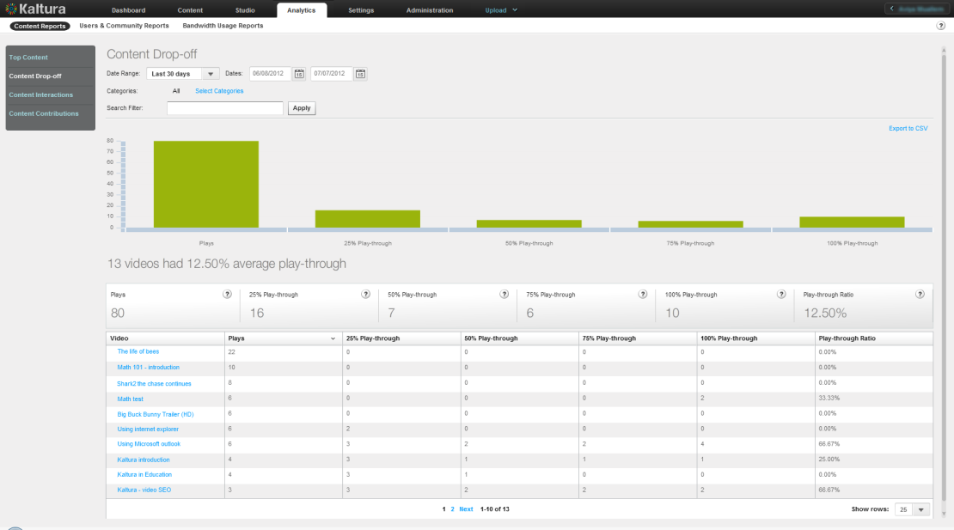

* To display Content Drop-off Reports

1. Select the Analytics tab and then select Content Reports.
2. Click Content Drop-off.
3. Select a date range in the drop-down menu.
4. Select one of the following for the Categories

**All** (default) – uses all the categories defined in your account

**Select Categories** – uses selected categories in your account for filtering report data

* In the Categories window: Select the name of a category. Use the CTRL key to select multiple categories.
* Click Filter.   
  To clear the category filter, click All.

1. (Optional) In the Search Filter field, enter text that appears in content Names, Tags or Descriptions, and click Apply.  
   The filter description is displayed above the report.  
   To clear the filter, delete the text from the Search Filter field and click Apply.
2. (Optional) Export the line chart report to a CSV file. See Exporting Analytics to a CSV File.

For the individual video table, you can:

* Scroll through the pages at the bottom of the table.
* Select the number of rows to display per page (10 to 500).
* Click a video name to display the Specific Entry Content Drop-off Report.
* Sort the table by clicking the column headings.

### Specific Entry Content Drop-off Reports

Specific Entry Content Drop-off reports display the following data for your most popular content:

* Unique Known Users – Sum of unique users, for which a user ID was passed from the publisher
* Plays – The number of times a user clicked "Play"
* 25 per cent play-through – The number of plays that reached 25% of the video
* 50 per cent play-through – The number of plays that reached 50% of the video
* 75 per cent play-through – The number of plays that reached 75% of the video
* 100 per cent play-through – The number of plays that reached 100% of the video
* Play-through Ratio (not one of the bar chart views) – The percentage of completed plays. The number of 100% play-throughs divided by the total number of plays.

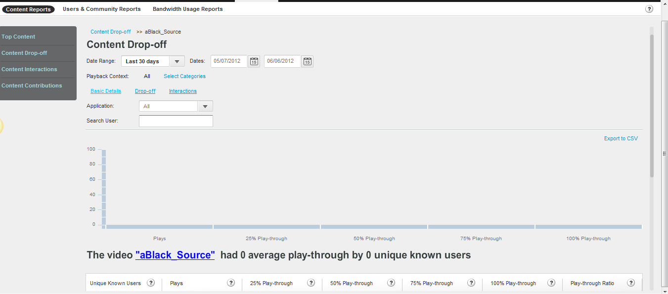

* To display a Specific Entry Content Drop-off report

1. Create a Content Drop-off report. See Content Drop-off Reports.
2. Click a video name to display the Specific Entry Content Drop-off Report for the video.
3. Select a date range in the drop-down menu.
4. Select one of the following for the Playback Context (the categories in which the movie was played from):

**All** (default) – uses all the categories defined in your account

**Select Categories** – uses selected categories in your account for filtering report data

* In the Categories window: Select the name of a category. Use the CTRL key to select multiple categories.
* Click Filter.   
  To clear the category filter, click All.

1. Click the links to the video’s  Specific Entry Report and Specific Content Interactions Report|topic=Specific Content Interactions Report|topic=Specific Content Interactions Report.
2. Select the Application from the drop-down menu. The choices presented are the applications delivered by the publisher during playbacks.
3. (Optional) In the Search Filter field, enter text that appears in content Names, Tags or Descriptions, and click Apply.  
   The filter description is displayed above the report.  
   To clear the filter, delete the text from the Search Filter field and click Apply.
4. (Optional) Export the line chart report to a CSV file.See Exporting Analytics to a CSV File.
5. Click on the video's Name to preview the entry.

### Content Interactions Reports

Content Interactions reports display the following data for viewer interaction with your content:

* Plays – The number of times a user clicked "Play"
* Edits – The number of clicks on the "Edit" button
* Shares (Viral) – The number of clicks on the "Share" button
* Downloads – The number of clicks on the "Download" button
* Reports of Abuse – The number of clicks on the "Report" button

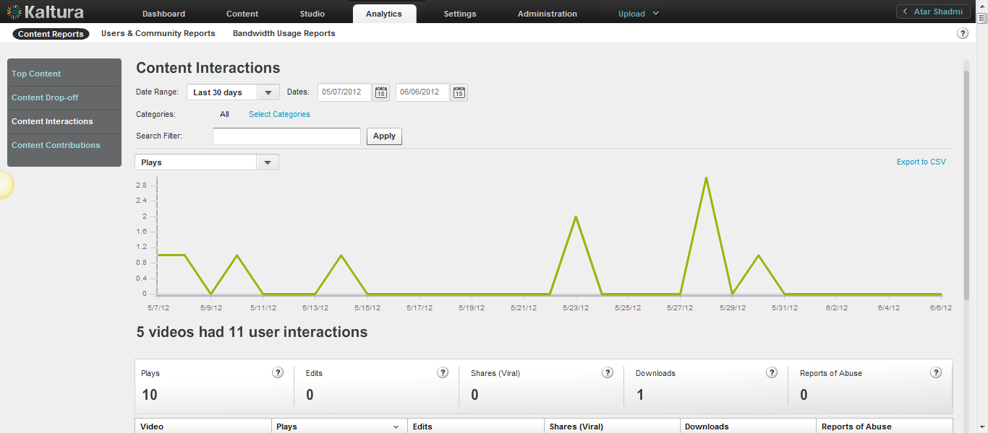

* To display Content Interaction Reports

1. Select the Analytics tab and then select Content Reports.
2. Click Content Interactions.
3. Select a date range in the drop-down menu.
4. Select one of the following for the Categories:

**All** (default) – uses all the categories defined in your account

**Select Categories** – uses selected categories in your account for filtering report data

* In the Categories window: Select the name of a category. Use the CTRL key to select multiple categories.
* Click Filter.   
  To clear the category filter, click All.

1. (Optional) In the Search User field, enter text that appears in content Names, Tags or Descriptions, and click Apply.  
   The filter description is displayed above the report.  
   To clear the filter, delete the text from the Search Filter field and click Apply.
2. In the drop-down menu, select one of the data types for the line chart report.
3. (Optional) Export the line chart report to a CSV file. See Exporting Analytics to a CSV File.
4. In the line chart, hover over data to display the exact data quantity for the date.
5. Click on the video's Name to preview the entry.

Under the line chart, a summary is followed by reports that display total and individual video results.

For the individual video table, you can:

* Sort the table by clicking the column headings.
* Scroll through the pages at the bottom of the table.
* Select the number of rows to display per page (10 to 500).
* Click a video name to display a Specific Content Interactions Report for the video.

### Specific Content Interactions Report

Specific Content Interactions reports display the following data for your most popular content:

* Unique Known Users – Sum of unique users, for which a user ID was passed from the publisher
* Plays – The number of times a user clicked "Play"
* Edits – The number of clicks on the "Edit" button
* Shares (Viral) – The number of clicks on the "Share" button
* Downloads – The number of clicks on the "Download" button
* Reports of Abuse – The number of clicks on the "Report" button

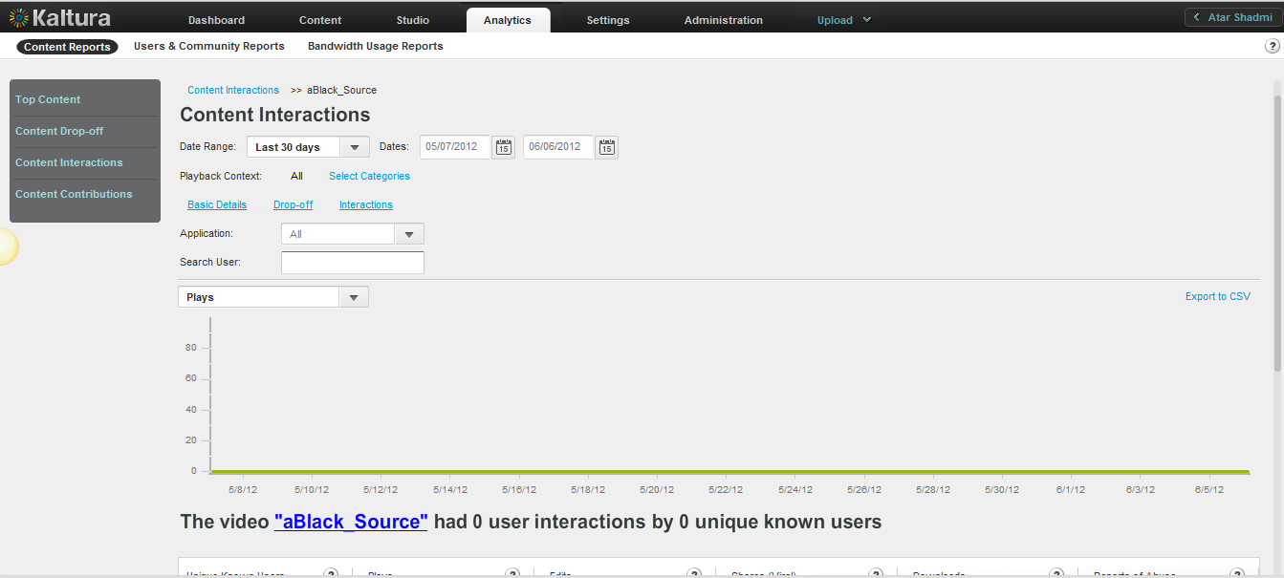

* To display a Specific Content Interactions report

1. Create a Content Interaction Report. See Content Interaction Reports.
2. Click a video name to display the Specific Content Interaction Report for the video
3. Select a date range in the drop-down menu.
4. Select one of the following for the Playback Context (the categories in which the movie was played from):

**All** (default) – uses all the categories defined in your account

**Select Categories** – uses selected categories in your account for filtering report data

* In the Categories window: Select the name of a category. Use the CTRL key to select multiple categories.
* Click Filter.   
  To clear the category filter, click All.
* Click the links to display the Specific Entry Report for the video and the Specific Entry Content Drop-off Report.

1. Select the Application from the drop-down menu. The choices presented are the applications delivered by the publisher during playbacks.
2. (Optional) In the Search Filter field, enter text that appears in content Names, Tags or Descriptions, and click Apply.  
   The filter description is displayed above the report.  
   To clear the filter, delete the text from the Search Filter field and click Apply.
3. (Optional) Export the line chart report to a CSV file.See Exporting Analytics to a CSV File.
4. Click a video name to display the entry’s preview.

### Content Contributions Reports

The Content Contributions reports display the following data for media entry contributions by your users:

* Total – The number of media entries contributed, including video, audio, image and mix.
* Video – The number of video entries contributed.
* Audio – The number of audio entries contributed.
* Image – The number of image entries contributed.
* Mix – The number of mixes created.
* (Not included in the individual source table) UGC – The number of media entries contributed by "User"-type users
* (Not included in the individual source table) Admin – The number of media entries contributed by "Admin"-type users that includes all uploads from the KMC.

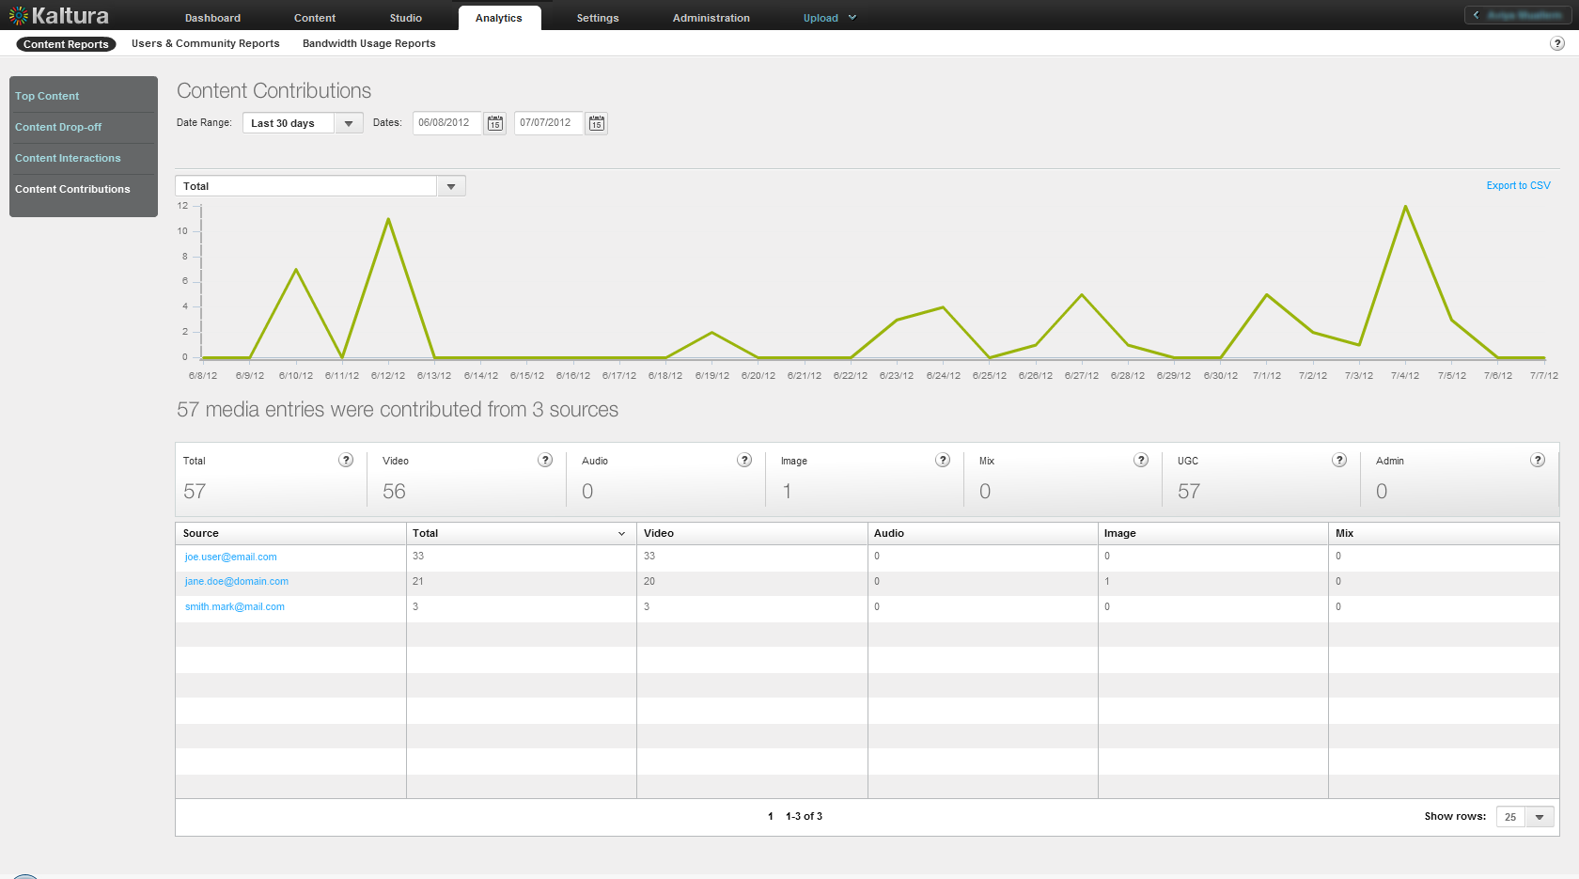

* To display Content Contribution reports

1. Select the Analytics tab and then select Content Reports.
2. Click Content Contributions.
3. Select a date range in the drop-down menu.
4. In the drop-down menu, select one of the data types for the line chart report.
5. (Optional) Export the line chart report to a CSV file. See Exporting Analytics to a CSV File.
6. In the line chart, hover over data to display the exact data quantity for the date.

Under the line chart, a summary is followed by reports that display total and individual results.

For the individual video table, you can:

* Sort the table by clicking the column headings.
* Scroll through the pages at the bottom of the table.
* Select the number of rows to display per page (10 to 500).
* Click a source name to display a Specific Entry Media Source Contributions Report for the source.

### Specific Entry Media Source Contributions Report

Specific Entry Media Source Contributions reports display the following data for your most popular content:

* Total- number of media entries contributed, includes, video, audio, images and mixes
* Video- Number of video entries contributed
* Audio – Number of audio entries contributed
* Image – Number of image entries contributed
* Mix – Number of mixes created
* UGC - Number of media entries created by users that are type User (not admin)
* Admin – Number of media entries created by users that are type admin - this includes all uploads via KMC

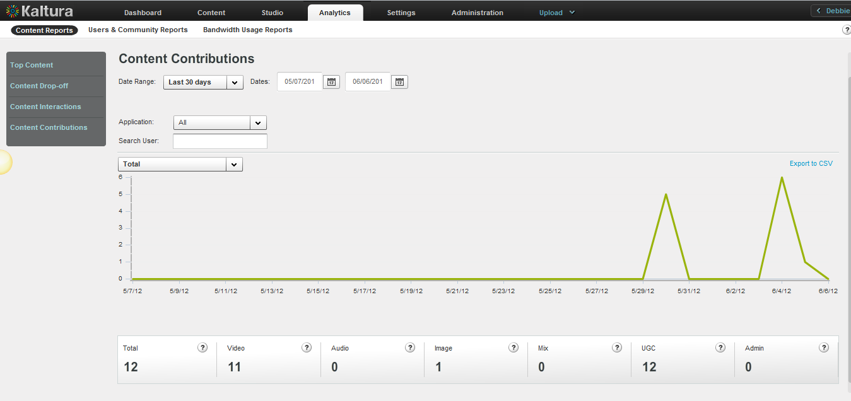

* To display a Entry Media Source Contributions report

1. Create a Content Contributions report. See To display Content Contribution Reports.
2. Click a video name to display the Specific Entry Media Source Contributions Report for the video
3. Select a date range in the drop-down menu or enter dates in the Dates field.
4. In the drop-down menu, select one of the data types for the line chart report.
5. (Optional) Export the line chart report to a CSV file. See Exporting Analytics to a CSV File.
6. In the line chart, hover over the data to display the exact data quantity for the date.

## User and Community Reports

User and Community reports display demographics and User Generated Content related reports of where content was contributed, played and shared.

* Total – The number of media entries contributed, including video, audio, image and mix
* Video – The number of video entries contributed
* Audio – The number of audio entries contributed
* Image – The number of image entries contributed
* Mix – The number of mixes created

### Top Contributors Report

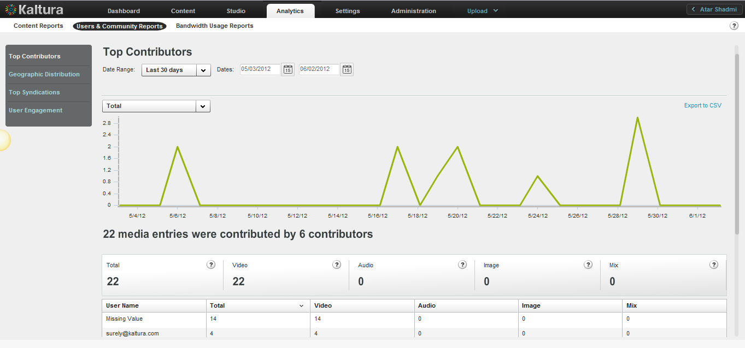

* To view Top Contributors Reports

1. Select the Analytics tab and then select User and Community Reports.
2. Click Top Contributors.
3. Select a date range in the drop-down menu or enter dates in the Dates field.
4. In the drop-down menu, select one of the data types for the line chart report.
5. (Optional) Export the line chart report to a CSV file. See Exporting Analytics to a CSV File.
6. In the line chart, hover over the data to display the exact data quantity for the date.

Under the line chart, a summary is followed by reports that display total and individual contributor results.

For the individual contributor table, you can:

* Sort the table by clicking the column headings.
* Scroll through the pages at the bottom of the table.
* Select the number of rows to display per page (10 to 500).

### Geographic Distribution Reports

Geographic Distribution reports display the following data for play-through according to the geographic location of your content viewers:

* Plays – The number of times a user clicked "Play"
* 25 per cent play-through – The number of plays that reached 25% of the video
* 50 per cent play-through – The number of plays that reached 50% of the video
* 75 per cent play-through – The number of plays that reached 75% of the video
* 100 per cent play-through – The number of plays that reached 100% of the video
* Play-through Ratio – The percentage of completed plays. The number of 100% play-throughs divided by the total number of plays.

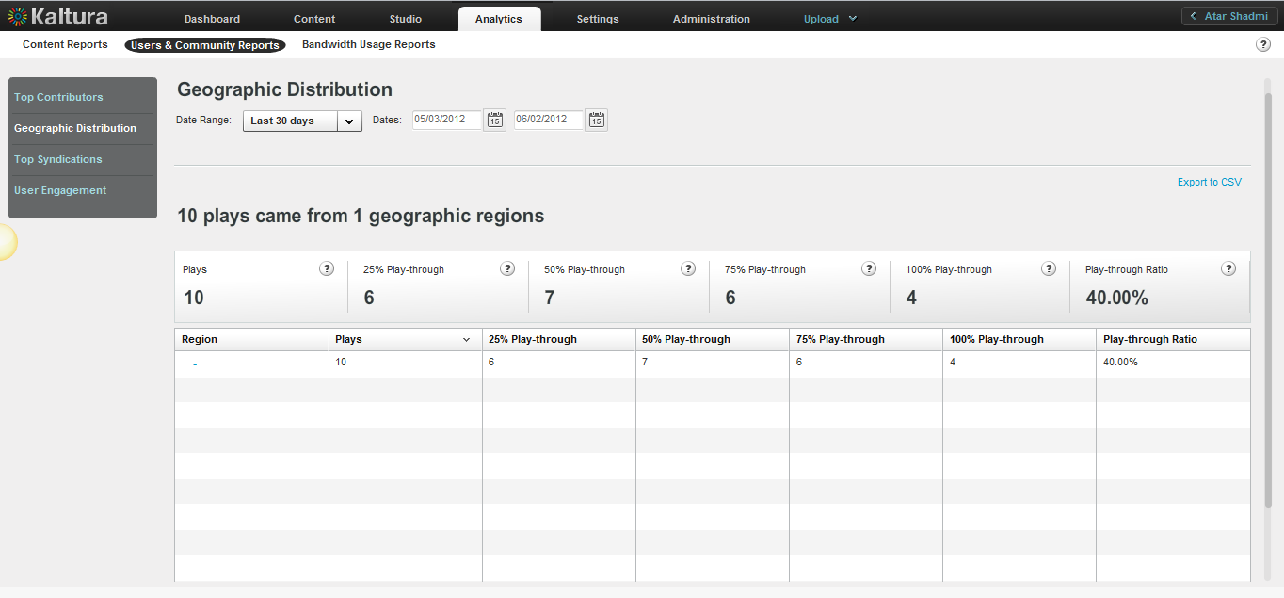

* To view Geographic Distribution reports

1. Select the Analytics tab and then select User and Community Reports.
2. Click Geographic Distribution.
3. Select a date range in the drop-down menu or enter dates in the Dates field.
4. (Optional) Export the line chart report to a CSV file. See Exporting Analytics to a CSV File.

A summary is followed by reports that display total and individual regional results.

For the individual regional table, you can:

* Sort the table by clicking the column headings.
* Scroll through the pages at the bottom of the table.
* Select the number of rows to display per page (10 to 500).
* Click a region name to display:
* Geographic Distribution reports for the region's zones (for example, state, province, district or city)
* The date range options for the reports. Specific Geographic Region Distribution Report

### Specific Geographic Region Distribution Reports

Specific Geographic region Distribution reports display the following data for play-through for a specific geographic location of your content viewers:

* Plays – The number of times a user clicked "Play"
* 25 per cent play-through – The number of plays that reached 25% of the video
* 50 per cent play-through – The number of plays that reached 50% of the video
* 75 per cent play-through – The number of plays that reached 75% of the video
* 100 per cent play-through – The number of plays that reached 100% of the video
* Play-through Ratio – The percentage of completed plays. The number of 100% play-throughs divided by the total number of plays.
* To display a Specific Geographic Region Distribution report

1. Create a Geographic Distribution report. See  Geographic Distribution Reports.
2. Click on Region name to display the Specific Geographic Region Distribution Report for the video.
3. Select a date range in the drop-down menu or enter dates in the Dates field.

### Top Syndications

Top Syndications reports display the following data for the most popular syndicators of your content:

* Plays – The number of times a user clicked "Play"
* Minutes Viewed – The sum of minutes that were viewed
* Average View Time – The average time calculated by dividing the minutes viewed by the number of views
* Player Impressions – The number of times the video player was loaded
* (Not included in the line chart) Player to Impression Ratio – The number of plays divided by the number of impressions.

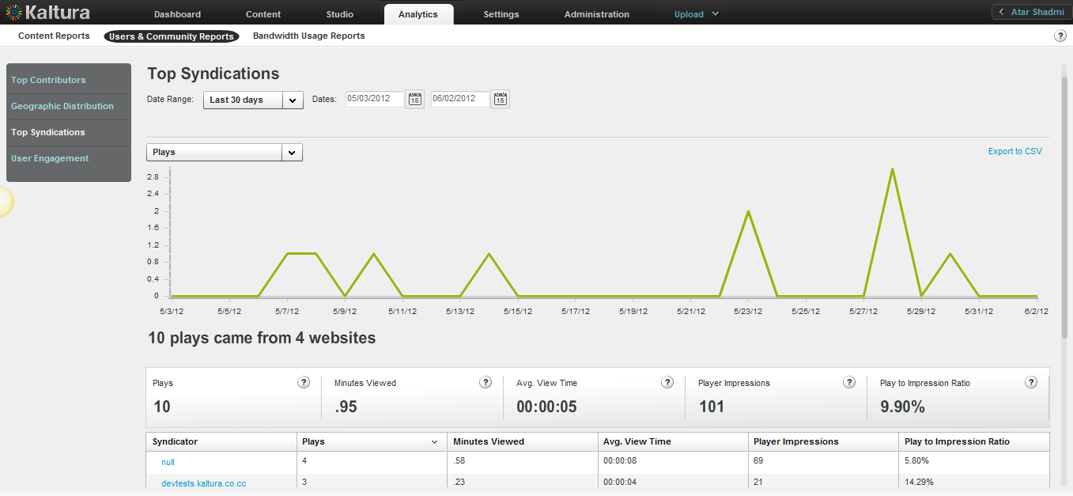

* To display Top Syndication reports

1. Select the Analytics tab and then select User and Community Reports.
2. Click Top Syndications.
3. Select a date range in the drop-down menu or enter dates in the Dates field.
4. In the drop-down menu, select one of the data types for the line chart report.
5. (Optional) Export the line chart report to a CSV file. See Exporting Analytics to a CSV File.

For the individual syndicator table, you can:

* Sort the table by clicking the column headings.
* Scroll through the pages at the bottom of the table.
* Select the number of rows to display per page (10 to 500).
* Click on a Syndicator to display the Specific Syndicator Reports.

### Specific Syndicator Reports

Specific Syndicator reports display the following data for the most popular syndicators of your content:

* Plays – The number of times a user clicked "Play"
* Minutes Viewed – The sum of minutes that were viewed
* Average View Time – The average time calculated by dividing the minutes viewed by the number of views
* Player Impressions – The number of times the video player was loaded
* (Not included in the line chart) Player to Impression Ratio – The number of plays divided by the number of impressions.

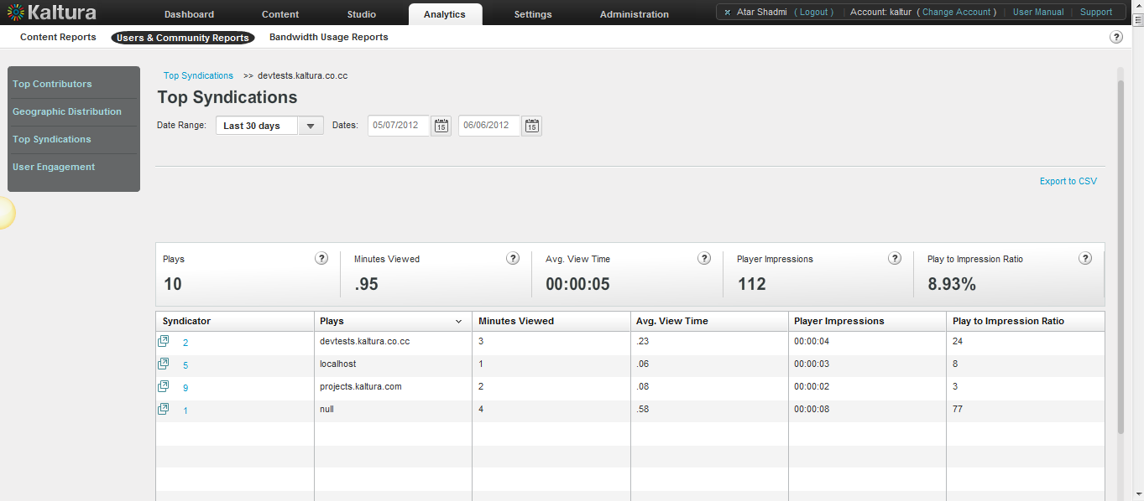

* To display a Specific Syndicator report

1. Create a Top Syndication report. See Top Syndication Reports.
2. Click on a syndicator to display the Specific Syndicator Reports.
3. Select a date range in the drop-down menu or enter dates in the Dates field.
4. (Optional) Export the line chart report to a CSV file. See Exporting Analytics to a CSV File.

### User Engagement Reports

User Engagement reports display the following data for the most:

* Unique Known Users - - Sum of unique users, for which a user ID was passed from the publisher
* Unique Videos - - Sum of unique entries that had at least 1 player impression or 1 play in the given timeframe
* Plays – The number of times a user clicked "Play".
* Minutes Viewed – The sum of minutes that were viewed.
* Average View Time – The average time calculated by dividing the minutes viewed by the number of views.
* Player Impressions – The number of times the video player was loaded.
* Player to Impression Ratio – The number of plays divided by the number of impressions.

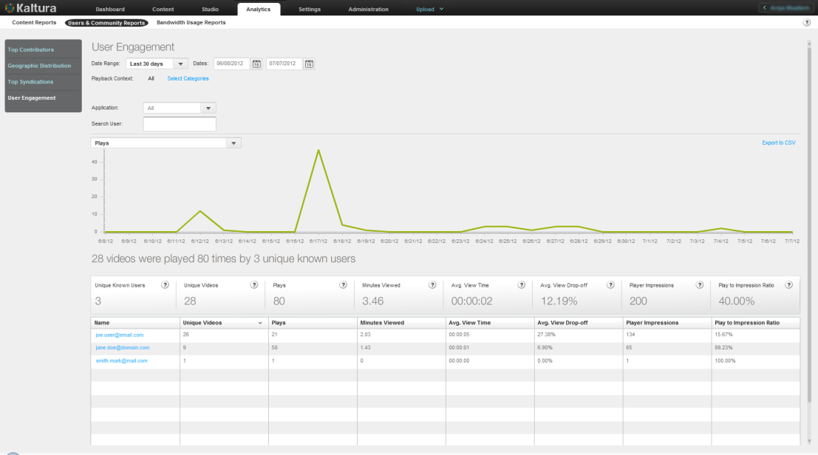

* To display User Engagement reports

1. Select the Analytics tab and then select User and Community Reports.
2. Click User Engagement.
3. Select a date range in the drop-down menu or enter dates in the Dates field.
4. Select one of the following for the Playback Context:

**All** (default) – uses all the categories defined in your account

**Select Categories** – uses selected categories in your account for filtering report data

* In the Categories window: Select the name of a category. Use the CTRL key to select multiple categories.
* Click Filter.   
  To clear the category filter, click All.

1. Select the Application from the drop-down menu. The choices presented are the applications delivered by the publisher during playbacks.
2. (Optional) In the Search User field, enter text that appears in content Names, Tags or Descriptions, and click Apply.  
   The filter description is displayed above the report.  
   To clear the filter, delete the text from the Search Filter field and click Apply.
3. In the drop-down menu, select one of the data types for the line chart report.
4. (Optional) Export the line chart report to a CSV file. See Exporting Analytics to a CSV File.
5. In the line chart, hover over the data to display the exact data quantity for the date.

Under the line chart, a summary is followed by reports that display total and individual user engagement results.

For the individual video table, you can:

* Scroll through the pages at the bottom of the table.
* Select the number of rows to display per page (10 to 500).
* Click a Unique Known User to display the Specific User Engagement Report for the video

### Specific User Engagement Report

The Specific User Engagement report displays the following data for a specific user.

* Plays – The number of times a user clicked "Play"
* Minutes Viewed – The sum of minutes that were viewed
* Average View Time – The average time calculated by dividing the minutes viewed by the number of views
* Player Impressions – The number of times the video player was loaded
* (Not included in the line chart) Player to Impression Ratio – The number of plays divided by the number of impressions.
* To display the Specific User Engagement Report

1. Create a User Engagement Report. See To display User Engagement reports.
2. Click on a Unique Know n User.
3. Select a date range in the drop-down menu or enter dates in the Dates field.
4. Select one of the following for the Playback Context:

**All** (default) – uses all the categories defined in your account

**Select Categories** – uses selected categories in your account for filtering report data

* In the Categories window: Select the name of a category. Use the CTRL key to select multiple categories.
* Click Filter.   
  To clear the category filter, click All.

1. (Optional) Export the line chart report to a CSV file.See Exporting Analytics to a CSV File.

## Bandwidth Usage Reports

Bandwidth usage reports include helpful information about resources the publisher has been using for their account

### Publisher Bandwidth and Storage Report

The Publisher Bandwidth and Storage report presents the bandwidth and storage used in the account level.

The report displays the following data:

* Bandwidth Consumption – the amount of consumed bandwidth in the given timeframe.
* Average storage – the average storage used in the given timeframe.
* Peak Storage – the highest storage consumed in the given timeframe.
* Added storage – the storage change (added or removed) in the given timeframe.
* Combined Bandwidth and Consumption – the sum of the average storage and bandwidth consumption.

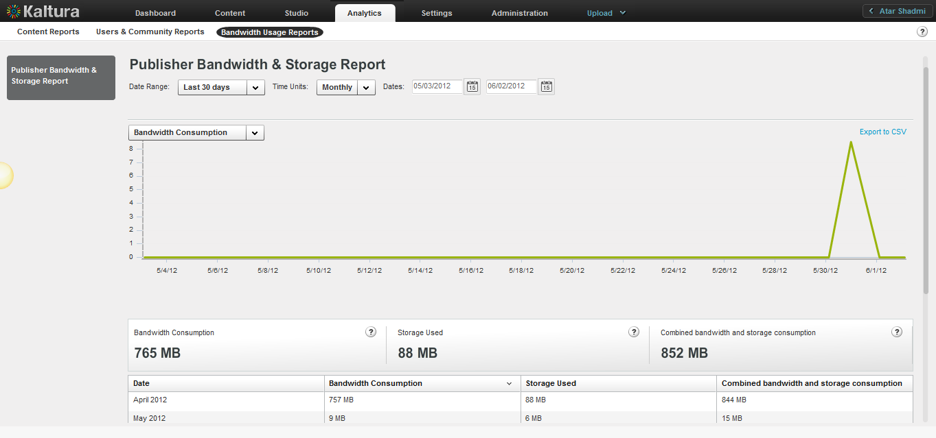

* To display the Publisher Bandwidth and Storage report

1. Select the Analytics tab and then select Bandwidth Usage Reports.
2. Click Publisher Bandwidth and Storage Report.
3. Select a date range in the drop-down menu or enter dates in the Dates field.
4. Select the Time Units: Monthly or daily.

The report displays the total amount of bandwidth in gigabytes used on each day of the month you selected, or the total amount of bandwidth in gigabytes used in each month of the year you selected.

1. Hover over a day's or month’s data to display the exact usage for the day/month.
2. In the drop-down menu, select one of the data types for the line chart report.
3. (Optional) Export the line chart report to a CSV file.See Exporting Analytics to a CSV File.

### End Users Storage Report

The End Users Storage Report displays the amount of storage end-users used.

The report displays the following data:

* Added entries - Sum of added entries owned by the user in the given timeframe.
* Total Entries - Sum of entries owned by the user.
* Added Disk Space - Total added disk space of the user owned entries in the given timeframe.
* Total Disk Space - Total disk space of the user owned entries.
* Added Minutes - Total duration of the entries owned by the user that was added in the given timeframe.
* Total Minutes - Total duration of the entries owned by the user.

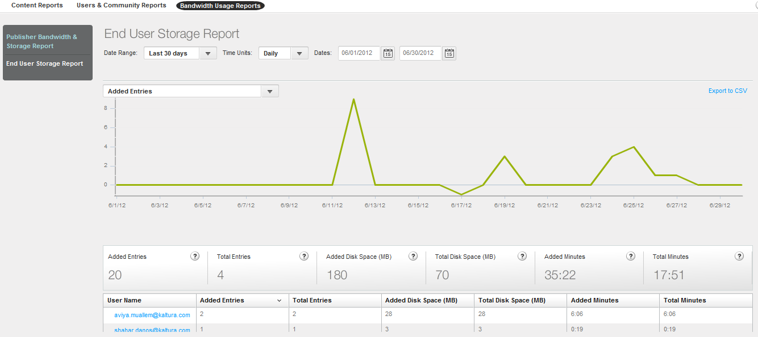

* To display the End User Storage report

1. Select the Analytics tab and then select Publisher and Bandwidth Usage Reports.
2. Click End Users Storage Report.
3. Click on a user name to display the Storage Report for a Specific User.
4. Select a date range in the drop-down menu or enter dates in the Dates field.
5. Select the Time Units: Monthly or daily.

The report displays the total amount of bandwidth in gigabytes used on each day of the month you selected, or the total amount of bandwidth in gigabytes used in each month of the year you selected.

1. Hover over a day's or month’s data to display the exact usage for the day/month.
2. In the drop-down menu, select one of the data types for the line chart report.
3. (Optional) Export the line chart report to a CSV file.See Exporting Analytics to a CSV File.

### Storage Report for a Specific User

The Storage Report for a Specific User displays the amount of storage a specific user used

The report displays the following data:

* Added entries - Sum of added entries owned by the user in the given timeframe
* Total Entries - Sum of entries owned by the user
* Added Disk Space - Total added disk space of the user owned entries in the given timeframe
* Total Disk Space - Total disk space of the user owned entries
* Added Minutes - Total duration of the entries owned by the user, that were added in the given timeframe
* Total Minutes - Total duration of the entries owned by the user.

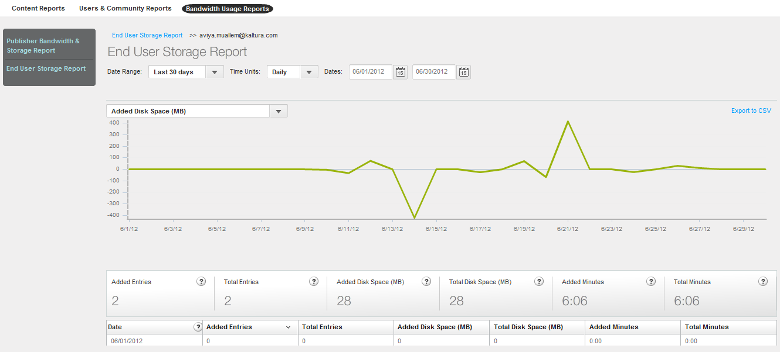

* To display the Storage Report for a Specific user

1. Select the Analytics tab and then select Bandwidth Usage Reports.
2. Click End Users Storage Report.
3. Click on a user name to display the Storage Report for a Specific User.
4. Select a date range in the drop-down menu or enter dates in the Dates field.
5. Select the Time Units: Monthly or daily.

The report displays the total amount of bandwidth in gigabytes used on each day of the month you selected, or the total amount of bandwidth in gigabytes used in each month of the year you selected.

1. Hover over a day's or month’s data to display the exact usage for the day/month.
2. In the drop-down menu, select one of the data types for the line chart report.
3. (Optional) Export the line chart report to a CSV file. See Exporting Analytics to a CSV File.

### Date Ranges for Analytical Reports

You can specify the date range for each analytical report you generate.

The date ranges are:

* Yesterday
* Last 7 days
* This week
* Last week
* Last 30 days (default)
* This month
* Last month
* Last 12 months
* This year
* Custom: Click the calendar icons to specify a range.

## Exporting Analytics to a CSV File

* To export a report to a CSV file

1. Click Export to CSV on the top right of the line chart.  
   A message is displayed: "The file is ready for download".
2. Click OK to proceed.
3. Select a location and file name for the CSV file, and click Save.

### Sending Analytics Events to Third Parties

After you create a Kaltura Player,, you can configure third party plug-ins to view analytics information.

### Kaltura Player Supported Plug-ins

The following lists some of the third party plug-ins supported by the Kaltura Player.

* [Google](http://exchange.kaltura.com/search/luceneapi_node/google%20analytics)

* [Omniture](http://exchange.kaltura.com/welcome)

* [Nielson](http://exchange.kaltura.com/welcome)

* [Comscore](http://exchange.kaltura.com/search/luceneapi_node/comscore)

|  |  |
| --- | --- |
|  | NOTE: When you create a player through the **Studio** tab in the KMC, the Kaltura Analytics configuration is automatically included |

All other plug-ins must be added manually. For more information about using third party Analytics providers see Configuring Third Party Analytics Provider Plug-ins. To learn how to implement a player plugin that sends Analytics data to third-party servers, contact Kaltura.

Chapter

# Account Information

This section describes the options available in the Settings tab,

## Account Settings

The Account Settings information includes the data you submitted during the registration process and is accessed through the **Settings** tab. You can change or update any of the details in this section. Multiple content categories can be selected by holding down the CTRL key.

* To view your account information
* Select the **Settings** tab and then select the **Account Settings** tab.

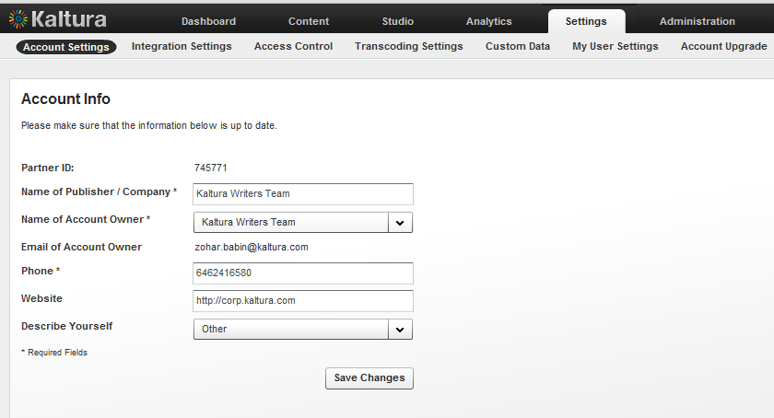

The following table describes the fields for account information.

| Field | Description |
| --- | --- |
| Partner ID | Your Kaltura Publisher Account id. This id is required in every call to the Kaltura API. |
| Name of Publisher/Company- | This field contains the name of your organization. |
| Name of Account Owner | The user who created the KMC account and is the recipient of account level email communication. The drop-down menu lists the names of all users of the KMC account who are associated with the ‘Publisher Administrator’ role  (Full permission to account’s KMC functionalities), so it is possible to set a different account owner, when needed. |

## Integration Settings

This tab displays the Integration settings for the KMC. Integration settings contain the information that provides unique IDs to Kaltura, including your partner ID, which is your site’s identification and ticket to the Kaltura platform and API. Your Partner ID enables you to connect to Kaltura, display media, upload media and experience all of Kaltura’s functionality.

### Account Info

The account info displays account information. The Partner ID is your Kaltura account identification number. The Sub Partner ID is generally deprecated and kept for backward compatibility of older Kaltura based applications.

The Administrator Secret and User Secret are the API private keys used to generate authentication tokens for sessions with the Kaltura servers when using the API. Since the keys can be used to run API commands on your content in Kaltura, you should keep these secret. Usually, the user secret is enough for all activities and therefore this is the key that should be provided to parties wishing to access your Kaltura account via API. The Admin Secret can be used to login as an administrator, and therefore can be used to perform any action on your account.

For more information, please refer to the [Kaltura API documentation](http://knowledge.kaltura.com/page/kaltura-products-and-services-documentation#kaltura_api).

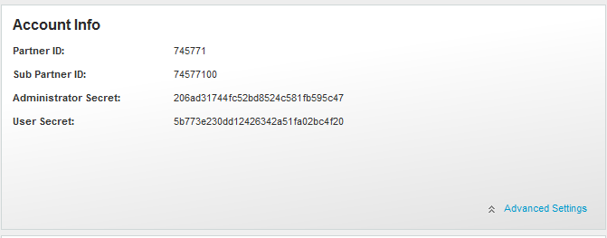

* To view additional low-level account settings information
* Click **Advanced Settings** to open the advanced Account Settings display. Changing the advanced settings will take effect only for new content ingested (from the moment changes have been saved) and is not retroactive.

### Entitlement Settings

Entitlement settings may be added to categories integrated in applications to support content entitlement.

From the Integration Settings page you control to which categories in your account, entitlement settings are added and enforced. See Managing Content Entitlement for more information.

The Entitlement Settings option in the Integration Settings page is available with entitlement account configuration only.

#### Adding Entitlement to Categories

Use the "Privacy Context" to add entitlement to categories.

Privacy Context is a free text label that indicates to which application the entitlement settings apply, for example, “MediaSpace” .The Privacy Context label is used for specific indexing of categories and content associated with it, and should also be configured in the application session (KS) itself. The Privacy Context configuration for an application guarantees the following:

* User’s entitlements to content in the application are determined based on the specific categories the application is integrated with.
* Categories that are not directly integrated with the application can be used for any content organization and applicative classification purposes. A content item can be shared with such categories with no impact on their visibility to end-users through the application.

In the common case, a single Privacy Context should be set to an entire ‘branch’ within the category-tree, and indicate the application integrated with it.

In more complex scenarios, multiple privacy contexts can be set to categories to enable access to content shared between multiple applications within the account, and under the same organizational context.

|  |  |
| --- | --- |
|  | NOTE: The Privacy Context is set to categories as part of the MediaSpace installation process. Following this configuration, the MediaSpace categories can be edited to include entitlements settings.  For any other purposes, entitlements and privacy context can be added to categories from the Integration Settings page in the KMC. |

* To add entitlements to categories

1. Select the Settings tab and then select Integration Settings.
2. In the Entitlement Settings sections click Add Entitlements to Categories.

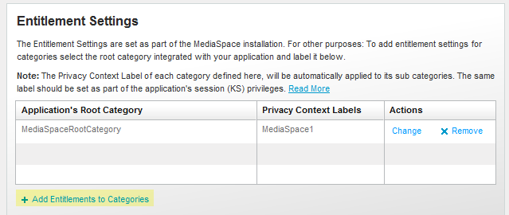

1. Enter the name of the root category integrated with your application/s.
2. Enter the privacy context label. Multiple labels can be separated by commas. In MediaSpace, the privacy context label is visible through the MediaSpace configuration panel.

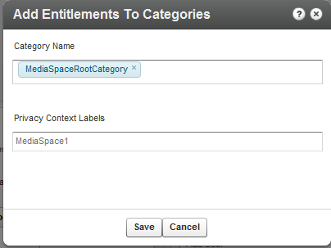

1. Click Save.

Following this action the categories tree is updated in the Kaltura backend, and the privacy context is gradually propagated into all sub categories. This operation may take a few minutes.

|  |  |
| --- | --- |
|  | NOTE: If entitlement enforcement is enabled by default in your account, after you complete this step, all content under the category that was set with entitlements (including all sub-categories) will only be accessible through an application that was updated to work with Kaltura’s entitlement services and that is set with the defined privacy context label as part of its session privileges. |

### Notifications

When creating Kaltura applications or integrating various Kaltura features into existing applications or sites, it is often required that the application be notified of various actions that occurred in Kaltura. For example: When a user on your site uploads a new video file, you might want your site code to be notified of when Kaltura has finished processing the video file and made it ready for publishing.

While it is possible to easily query the Kaltura API periodically, Kaltura’s API Notifications utilize a “push” methodology where a code on your site will be called automatically by Kaltura whenever a certain actions occur like video upload or media status changes.

Kaltura provide two types of Notifications:

* [Kaltura Client Notifications](http://www.kaltura.org/kaltura-terminology#kaltura-client-notifications) – Notifications that are sent from the Kaltura widget (e.g. Kaltura Contribution Wizard) when a user performs an action like uploading a new video file. The notification will be called from the Kaltura widget directly to the publisher’s notification handler code hosted on the publisher’s server.
* [Kaltura Server Notifications](http://www.kaltura.org/kaltura-terminology#kaltura-server-notifications) – Notifications that are sent from the Kaltura server to the publisher’s server using http post requests. The publisher is expected to host a notification handler script on his server, to which the Kaltura server will call providing information about the actions that occurred.
* To setup client and/or server notifications

1. Enter the Notification URL.
2. Select the type of notifications from the displayed list.

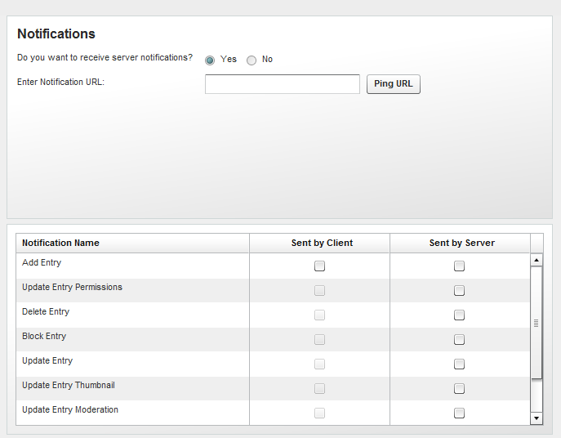

For more information about the various notifications and how to implement a notification handler script on your server, refer to: <http://www.kaltura.com/api_v3/testmeDoc/index.php?page=notifications>

## Access Control

See Access Control Profiles for more information.

## Transcoding Settings

See Editing and Creating Transcoding Profiles for more information.

## Custom Data

See Kaltura Custom Metadata Functionality more information.

## My User Settings

All KMC admin users can change their personal details - name, email address (KMC login) and password from the My User Setting page.

* To change personal details

1. Select the Settings tab and then select My User Settings.
2. Click on Edit to modify the information.

For authentication purposes, you will need to provide your current password before being able to make any changes in the system.

* To change your password

1. Select the Settings tab and then select My User Settings.
2. Click on Change KMC Password to modify the information.

## Account Upgrade

To learn more and upgrade your account, fill in the online form and our Sales Team will contact you.

* To upgrade your account

1. Select the Administration tab and then select Users.
2. Click on “Click Here” or go to <http://site.kaltura.com/Request-Users.html> to upgrade your account.